**Satanic Fashion Show Inside a Church at London Fashion Week**

September 19, 2017

<https://vigilantcitizen.com/latestnews/satanic-fashion-show-inside-church-london-fashion-week/>

[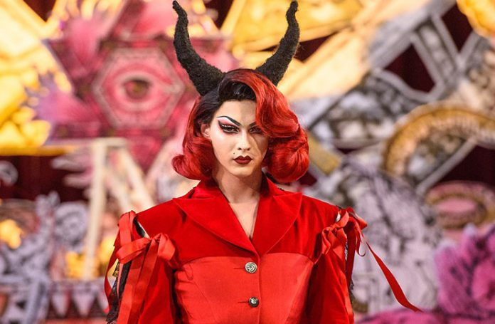](https://vigilantcitizen.com/wp-content/uploads/2017/09/leadfashionshow.jpg)

Turkish designer Dilara Findikoglu’s presented her Spring/Summer 2018 collection at London Fashion Week and it was nothing less than a satanic Black Mass. Indeed, the event took place at the altar of St Andrew Church in London and incorporated heavy occult and satanic symbolism. In short, the event summed up everything the fashion world is truly about.

While Dilara Findikoglu is said to an “up-and-coming rebel of the fashion world”, she’s perfectly in line with the industry’s philosophy. She’s not rebelling at all, she’s doing what exactly the type of stuff “they” want her to do.

For this reason, celebrities such as Rihanna, FKA Twigs, and Grimes wear seen wearing Findikoglu’s creations.

Her latest fashion show featured artist Brooke Candy ([her videos are full of MK imagery](https://vigilantcitizen.com/musicbusiness/brooke-candys-a-study-in-duality-is-actually-a-study-in-monarch-mind-control/)) and drag artist Violet Chachki.

[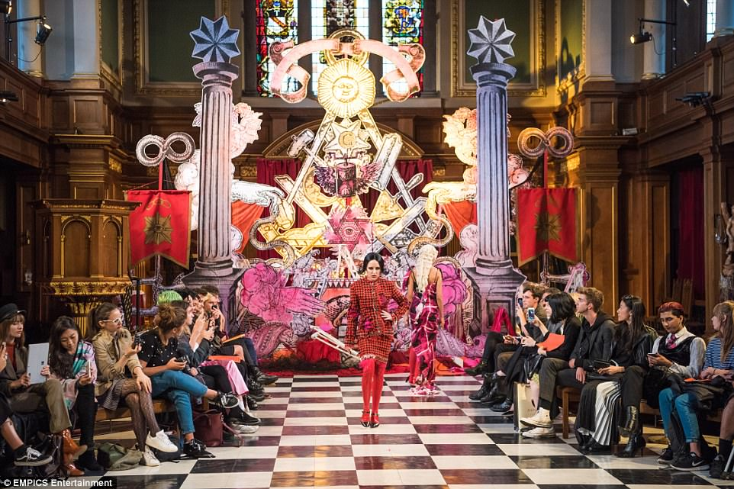](https://vigilantcitizen.com/wp-content/uploads/2017/09/4472D3D900000578-4896520-image-a-47_1505761396443.jpg)Brooke Candy walks down the runway. For this event, the Church was transformed into an occult temple. More precisely: A Masonic lodge.

The backdrop is basically a mish-mash of Masonic-inspired imagery. On each side are the Masonic twin pillars. Between the pillars is the letter G inside an inverted pentagram. Underneath it is the all-seeing eye inside a hexagram. There is also the Masonic square and compass in there. To top it off, the runway was a checkerboard pattern. Here’s a classic Masonic painting for comparison.

[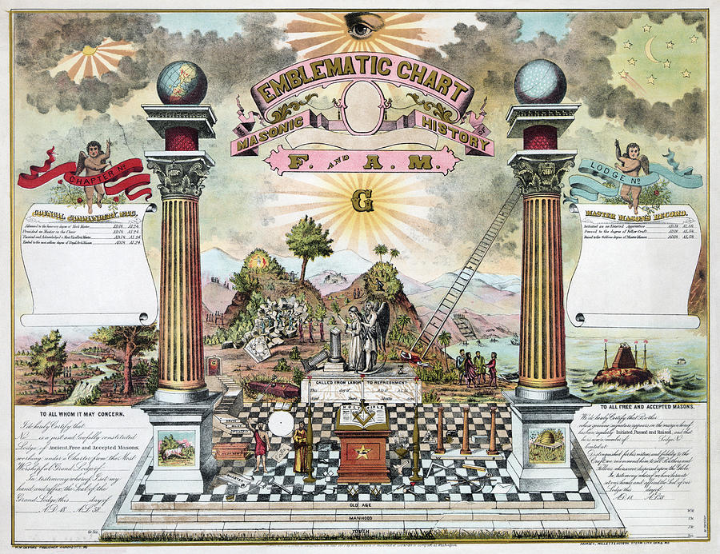](https://vigilantcitizen.com/wp-content/uploads/2017/09/freemason-emblematic-chart-granger.jpg)A Masonic emblematic chart.

In this heavily occult context, the models were dressed and arranged with a plethora of symbols. Of course, this had to be combined with the current agenda of androgyny and blurring of the genders.

[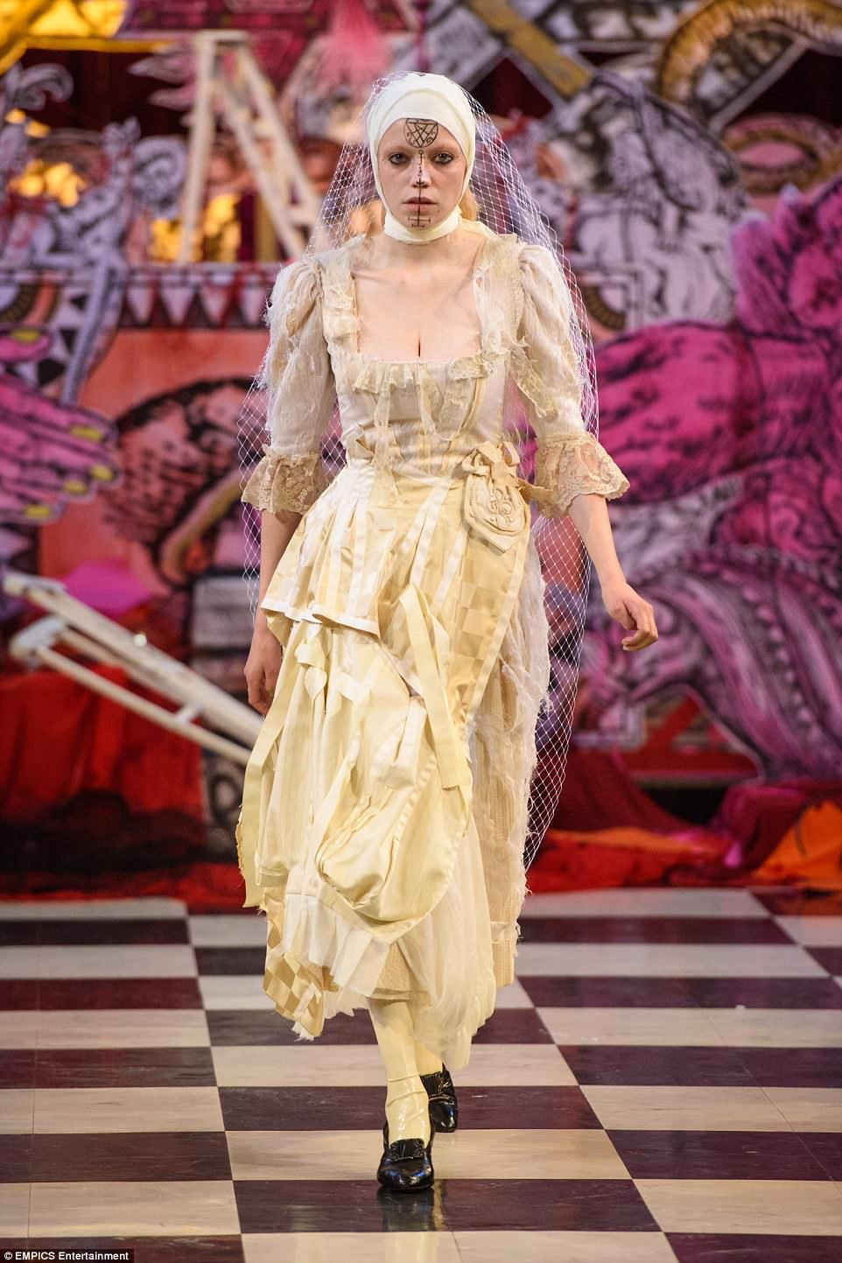](https://vigilantcitizen.com/wp-content/uploads/2017/09/4472D30D00000578-4896520-image-a-79_1505763508996.jpg)This model is wearing a bride’s dress, complete with a white veil. On her face is drawn a sigil.

A sigil is an inscribed or painted symbol considered to have magical power. The term has usually referred the pictorial signature of a demon or other entity and is used in ceremonial magic. The particular sigil on the model’s forehead is strongly reminiscent to the Sigil of Lucifer.

[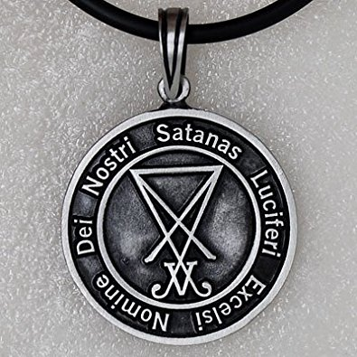](https://vigilantcitizen.com/wp-content/uploads/2017/09/51zxSzs8nWL._UY395_.jpg)A pendant containing the Sigil of Lucifer (also known as the Seal of Satan).

In short, the model is basically a “bride of Satan”.

[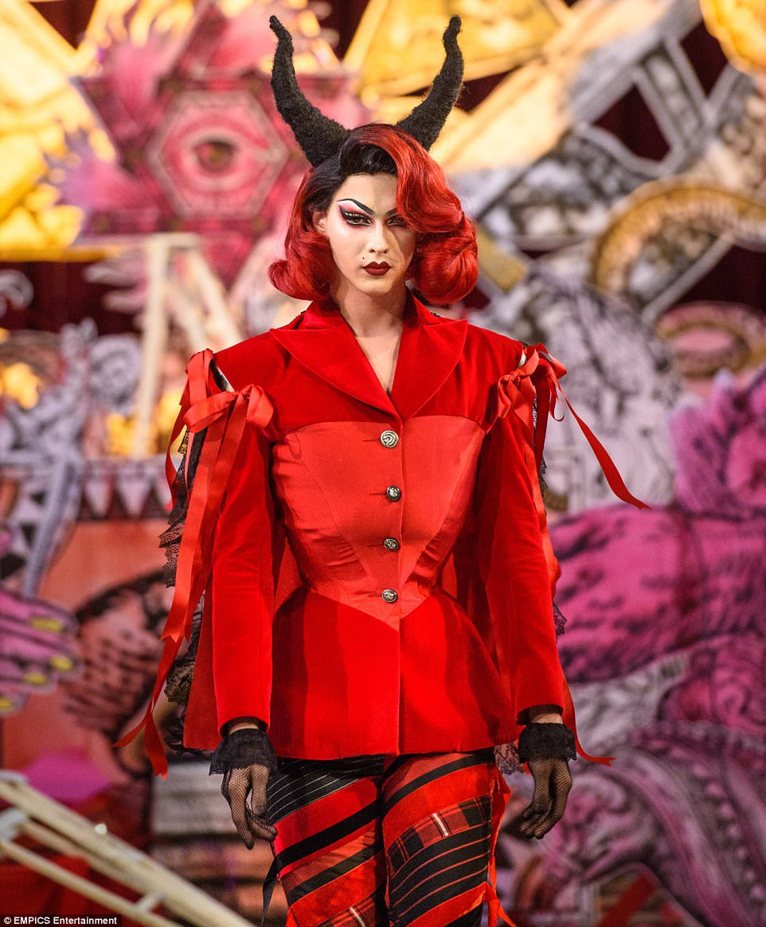](https://vigilantcitizen.com/wp-content/uploads/2017/09/4472D2AB00000578-4896520-Dilara_used_drag_artist_Violet_Chachki_and_rapped_Brooke_Candy_a-m-2_1505766314323.jpg)Drag artist Violet Chachki wore a very red outfit … and some devil horns. That’s happening inside a church.

Historically, a Black Mass is a ritual characterized by the inversion of the Traditional Latin Mass celebrated by the Roman Catholic Church and the desecration of Christian objects for Satanic purposes. The fact that models walk around a Church wearing devil horns recalls the concept of Black Mass.

[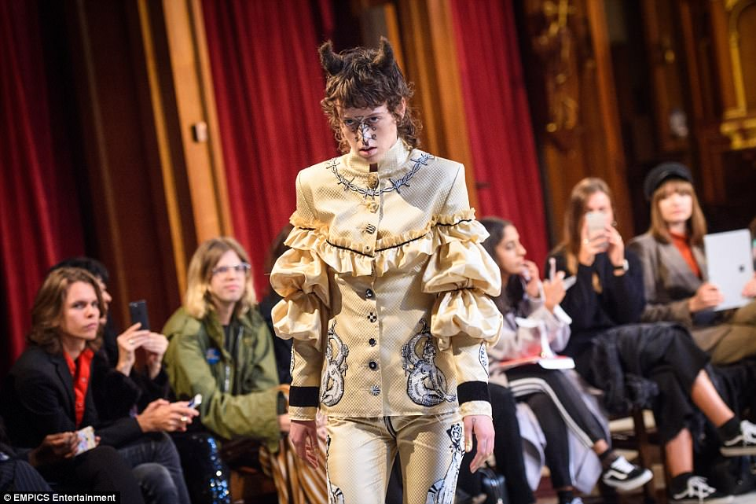](https://vigilantcitizen.com/wp-content/uploads/2017/09/4472D40F00000578-4896520-image-a-68_1505763316716.jpg)This jolly looking person walks around with a couple of horns made of hair. Also, a sigil is drawn on the model’s face.[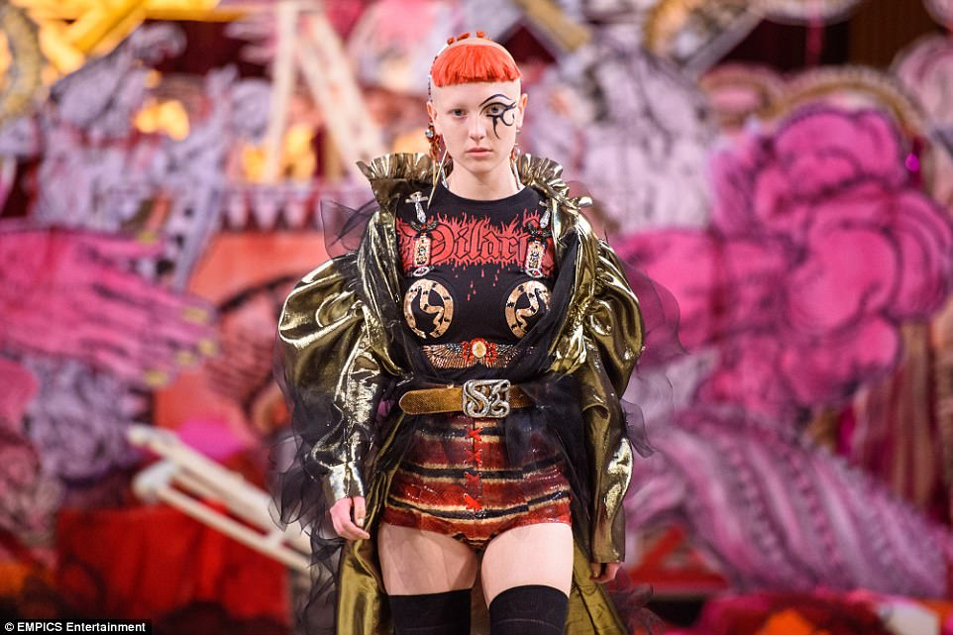](https://vigilantcitizen.com/wp-content/uploads/2017/09/4472D48900000578-4896520-image-a-63_1505763297302.jpg)This model has a big Eye of Horus drawn on her face. This signals us that this event was “sanctified” by the occult elite.[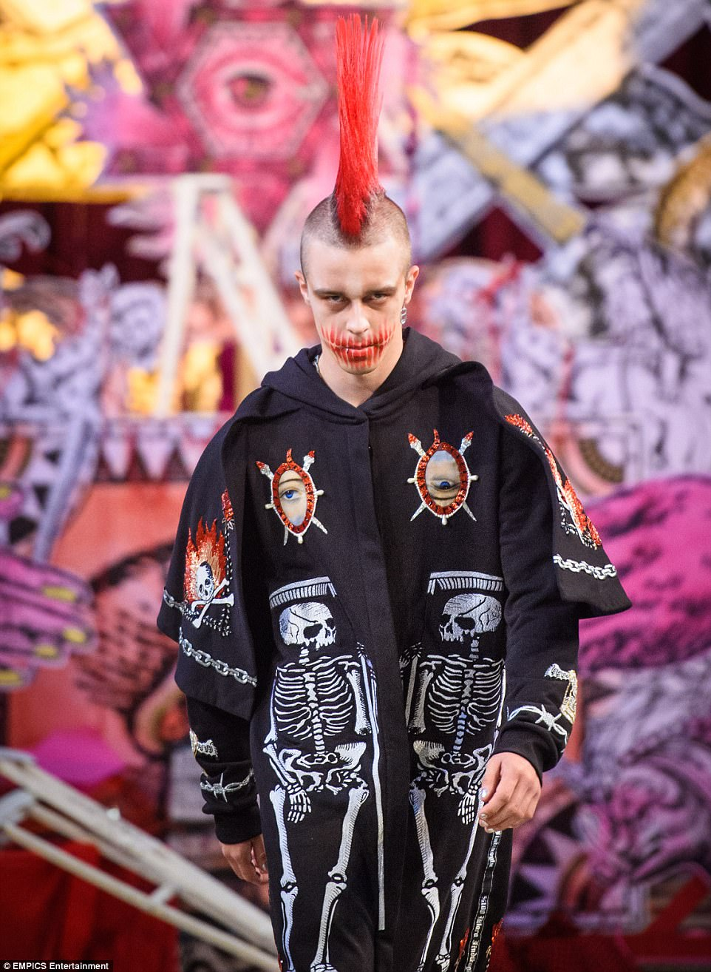](https://vigilantcitizen.com/wp-content/uploads/2017/09/4472D14500000578-4896520-Heavy_on_the_punk_rock_vibe_again_this_model_dons_a_pretty_impre-m-3_1505766451690.jpg)There’s some punk rock influence. But mostly, there’s some one-eye sign influence.

On the left, is the symbol of the Skull & Bones – the elite secret society.

[](https://vigilantcitizen.com/wp-content/uploads/2017/09/Early-Skull-Image-GraphicsFairy.jpg)Early logo of the Skull & Bones.[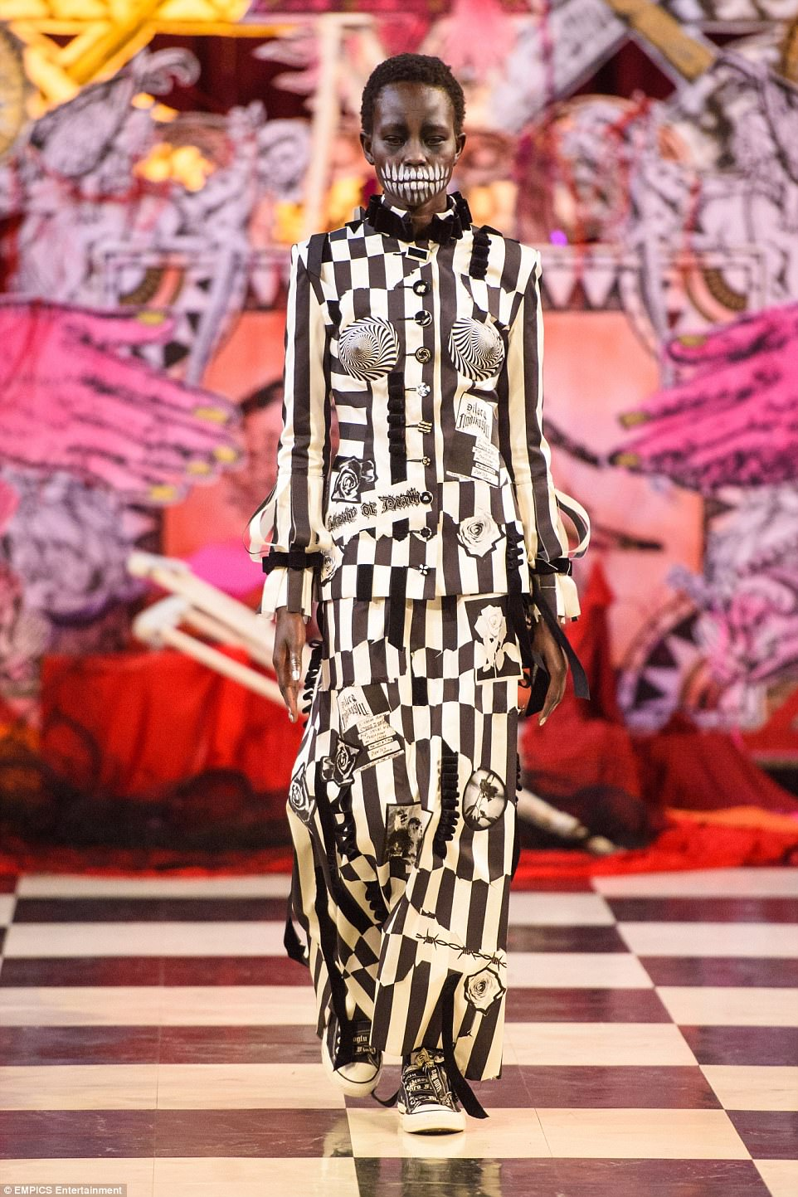](https://vigilantcitizen.com/wp-content/uploads/2017/09/4472D2C300000578-4896520-image-a-81_1505763517207.jpg)This dress is all about the Hermetic concept of duality (also exemplified by the checkerboard pattern floor).[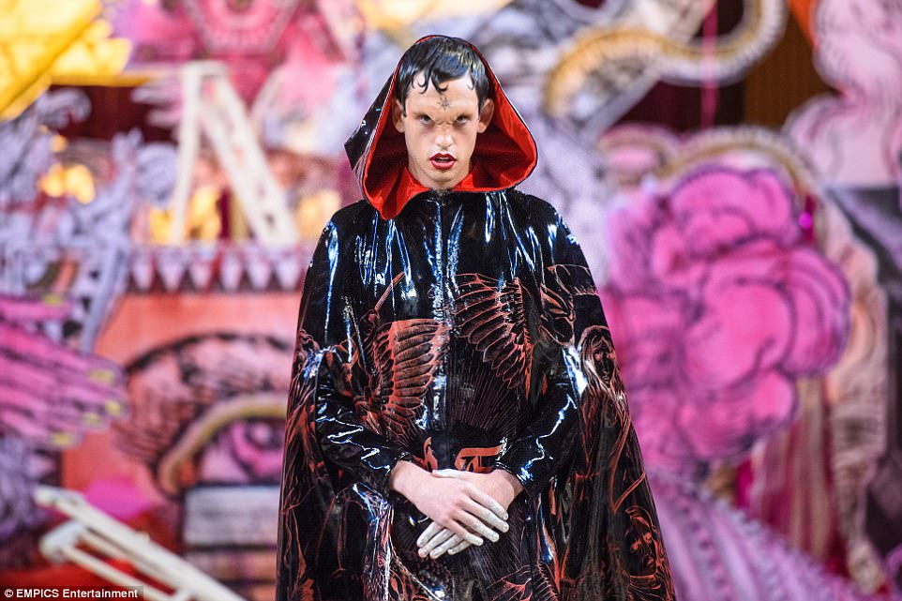](https://vigilantcitizen.com/wp-content/uploads/2017/09/4472D3ED00000578-4896520-image-a-45_1505761345947.jpg)This vampire guy has a sigil on his forehead. On his cloak appears to be a fallen angel. Lucifer was a fallen angel.[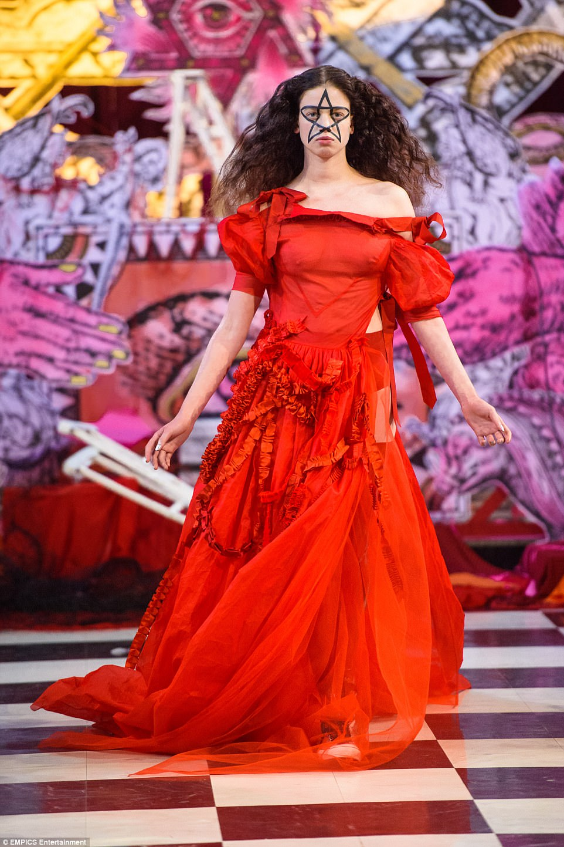](https://vigilantcitizen.com/wp-content/uploads/2017/09/4472D4BD00000578-4896520-image-a-60_1505763284340.jpg)This model is wearing a ritualistic red dress with a big pentagram drawn on her face. Most models are turned into magical objects as if they were part of a magical ritual.[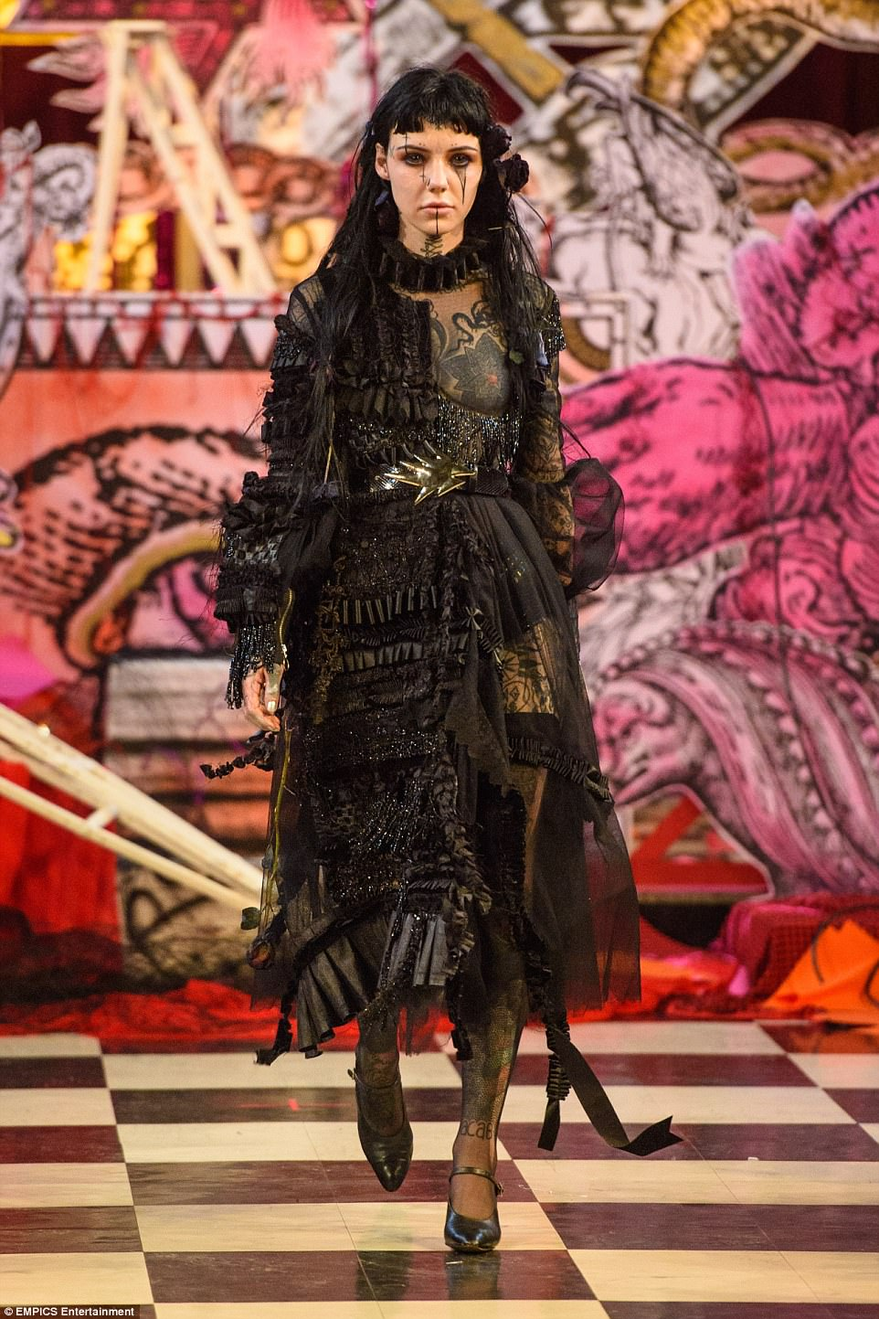](https://vigilantcitizen.com/wp-content/uploads/2017/09/4472D29B00000578-4896520-image-a-84_1505763526059.jpg)Other than the inverted cross drawn on her face, this has her left leg and left breast exposed. Also, large thingie hangs around her neck. Does this remind you something?[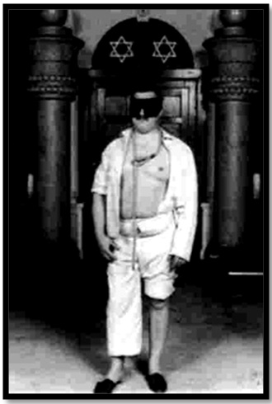](https://vigilantcitizen.com/wp-content/uploads/2017/09/SECRET-SOCIETIES-good-or-evil-Masonic-Initiate.jpg)This is a picture of a Masonic initiation candidate. Following ritual, his left breast and left leg are exposed while wearing a noose around his neck.[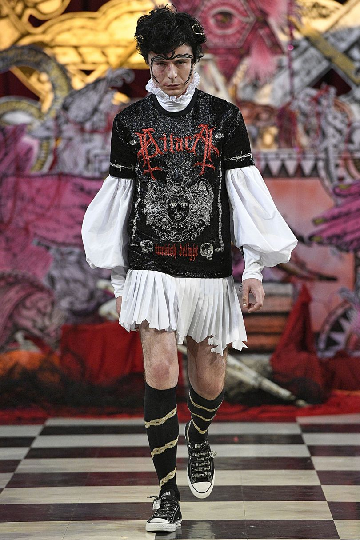](https://vigilantcitizen.com/wp-content/uploads/2017/09/810.jpg)This fella has a couple of inverted crosses on his shirt.

This fashion show is a perfect representation of the mindset of fashion industry today. It is not simply about “clothing” or “fashion”, it is about ritualistic events, an artistic celebration of the satanic mindset of the occult elite.

As they walk around with magical sigils, occult symbols and other ritualistic props all over their bodies, the models are turned into magically charged objects, turning this “fashion show” – which took place inside a Church – into a satanic ritual with high magical potency.