Max Heindel 1865 - 1919

http://en.wikipedia.org/wiki/Max_Heindel

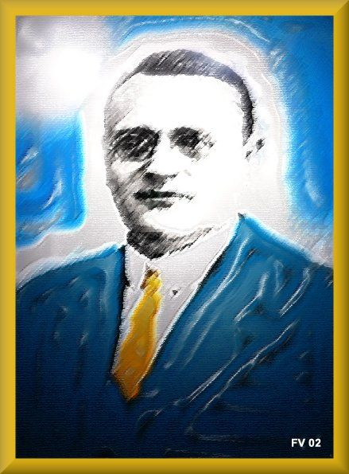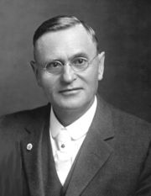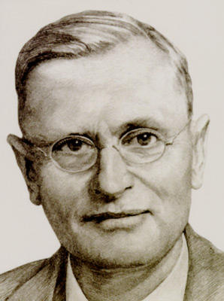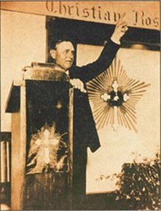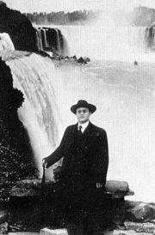

Max Heindel - born Carl Louis von Grasshoff in Aarhus, Denmark on July 23, 1865 - was a Christian occultist, astrologer, and mystic. He died on January 6, 1919 at Oceanside, California, United States.

Contents
[hide]
- 1 Early infancy
- 2 Life experience
- 3 Rosicrucian initiate
  - 3.1 Magnum opus
  - 3.2 Esoteric school
- 4 Occult writings
- 5 Quotations
- 6 See also
- 7 External links

Early infancy
He was born of the royal family of Von Grasshoffs, who were connected with the German Court during the lifetime of Prince Bismark. The father of Max Heindel, Francois L. von Grasshoff, migrated, when quite a young man, to Copenhagen, Denmark, where he married a Danish woman of noble birth. They had two sons and one daughter. The oldest of these sons was Carl Louis Von Grasshoff, who later adopted the pen name of Max Heindel. The father died when the eldest son was six years of age, leaving the mother with her three small children in very straitened circumstances. His infancy was lived in genteel poverty. His mother's self-denial was carried to an extreme in order that the small income would suffice that her sons and daughter could have private tutors so that they might take their place in society as members of nobility.

Life experience
At the age of sixteen years, refusing a foreseeable future among the nobility class, he left home to enter the ship-yards at Glasgow, Scotland in order to learn the engineering profession. He was soon chosen as Chief Engineer of a trading steamer, position which took him in trips all over the world and gave him a great deal of knowledge of the world and its people. For a number of years he was Chief Engineer on one of the large passenger steamers of the Cunard Line plying between America and Europe. From 1895 to 1901, he was an ill luck consulting engineer in New York City and during this time he married, the marriage being terminated by the death of his wife in 1905. A son and two daughters were born of this marriage.
In 1903, Max Heindel moved to Los Angeles, California, in order to look for a job. Meanwhile, due to his earlier years that had been full of sorrow and to sad events in his own life, an increasingly intense desire to understand the cause of the sorrows and sufferings of humanity began to grow within him, as well as a desire to help alleviate them. Giving a new course to his life, he became interested in the study of metaphysics and, after attending lectures by the theosophist C.W. Leadbeater, he joined the Theosophical Society of Los Angeles, of which he was vice-president in 1904 and 1905. He also became a vegetarian and began the study of astrology, which he found to his delight gave him the key by means of which he found he could unlock the mysteries of man's inner nature. At this time, he met Augusta Foss who was also interested along similar lines of research and in astrology; she would become his future wife. However, overwork and privation brought on him a severe heart trouble in 1905 and for months he lay at the point of death but upon recovery he was even more keenly awake to the needs of humanity. It is said that much of the time during this illness he spent out of the body, consciously working and seeking for the truth as he might find it on the invisible planes.
From 1906 to 1907 he started a lecture tour, in order to spread his occult knowledge, in San Francisco and then in Seattle and in the northern part of the country. After a course of lectures in that city he was again forced to spend some time in a hospital with valvular heart trouble. Still undaunted, he once more took up his work of lecturing in the northwestern part of the United States.

Rosicrucian initiate
In the fall of 1907, during a most successful period of lectures in Minnesota, he travelled to Berlin (Germany) with his friend Dr. Alma Von Brandis, who had been for months trying to persuade him, in order to hear a cycle of lectures by a teacher in the occult field called Rudolf Steiner. During his stay at Germany, he developed a sincere admiration by the personality of this knowledgeable lecturer, as latter shown in a dedication of his magnum opus, but at the same time he understood that this teacher had little to give to him. It was then, with his mind already made up to return, feeling that in vain he had given up a big work in America to take this trip, that Heindel reports to have been visited by a Spiritual being (clothed in his vital body).
This highly evolved entity later identified himself as an Elder Brother of the Rosicrucian Order, an Order in the inner worlds formed in the year 1313 and having no direct connection to physical organizations which call themselves by this name. As he afterwards mentions, the Elder Brother gave him information which was concise and logical and beyond anything he was capable of writing. Later, he found out that during a previous visit of the Elder Brother, he was put to a test to determine his worthiness to be messenger of the Western Wisdom Teachings. He recounts that only then he was given instruction how to reach the etheric Temple of the Rose Cross, near the German/Bohemian border, and how at this Temple he was in direct communication with and under the personal instructions of the Elder Brothers of the Rose Cross. The Rosicrucian Order is described as being composed of twelve Elder Brothers, gathered around a thirteenth who is the invisible Head. These great Adepts, belonging to human evolution but having already advanced far beyond the cycle of rebirth, are reported as being among those exalted Beings who guide mankind's evolution, the Compassionate Ones.

Magnum opus
See article: The Rosicrucian Cosmo-Conception
Heindel returned to America in the summer of 1908 where he at once started to formulate the Rosicrucian teachings, the Western Wisdom Teachings, which he had received from the Elder Brothers, published as a book entitled The Rosicrucian Cosmo-Conception in 1909. It is a reference work in the Christian mysticism practice and in the Occult study literature, containing the fundamentals of Esoteric Christianity from a Rosicrucian perspective. The Cosmo contains a comprehensive outline of the evolutionary processes of man and the universe, correlating science with religion.

Esoteric school
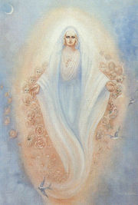
Painting of the Invisible Helper (symbolical representation)

See article: The Rosicrucian Fellowship
From 1909 to 1919, suffering a severe heart condition and with an adverse financial situation, but with an indomitable will and great energy, Max Heindel was able to accomplish the great work for the Brothers of the Rose Cross. With the help, support and inspiration of his wife Augusta Foss, to whom in August 1910 he was joined in marriage, he gave successful teaching lectures; he sent correspondence lessons to the students, who formed groups in many of the larger cities; he wrote volumes which are translated into many languages all over the world; he founded The Rosicrucian Fellowship in 1909/11 at Mount Ecclesia, Oceanside (California); he published the Christian Esoteric magazine Rays from the Rose Cross in 1913 and, above all, he launched the Fellowship's Spiritual Healing service.
It is described that, at his death, his body dropped slowly as if loving hands were holding him and laying him down gently; as he looked up, smiling into Mrs. Heindel face, he spoke his last words: "I am all right dear".
Last, it is worthy of mention that the work prepared by Max Heindel, has been, since then, continued through students of the Western Wisdom Teachings who, as Invisible Helpers of mankind, assist the Elder Brothers of the Rose Cross to perform the Spiritual Healing around the world. This is the special work in which the Rosicrucian Order is interested^{[1]} and is provided according to the commands of Christ, namely, "Preach the gospel and heal the sick."

Occult writings
- The Rosicrucian Cosmo-Conception, first edition in 1909 (ISBN 0-911274-34-0) www www2
- The Rosicrucian Christianity Lectures (ISBN 0-911274-84-7) www
- The Rosicrucian Philosophy in Questions and Answers - Volume I (ISBN 0-911274-89-8) www
- The Rosicrucian Philosophy in Questions and Answers - Volume II (ISBN 0-911274-90-1) www www2
- The Rosicrucian Mysteries (ISBN 0-911274-86-3) www a review
- Letters to Students (ISBN 0-911274-09-X) www
- Gleanings of a Mystic (ISBN 0-911274-87-1) www www2
- Mysteries of the Great Operas (ISBN 0-911274-88-X) www
- Teachings of an Initiate (ISBN 0-911274-19-7) www
- Ancient and Modern Initiation (ISBN 0-911274-82-0) www
- The Web of Destiny (ISBN 0-911274-17-0) www www2
- Freemasonry and Catholicism (ISBN 0-911274-04-9) www www2 www3
- The Vital Body (ISBN 0-911274-16-2) www
- The Desire Body (ISBN 0-911274-03-0) www
- The Rosicrucian Principles of Child Training (ISBN 0-911274-62-6) www
- How Shall We Know Christ at His Coming? (ISBN 0-911274-64-2) www
- The Mystical Interpretation of Christmas (ISBN 0-911274-65-0) www
- The Mystical Interpretation of Easter (ISBN 0-911274-69-3) www
- Nature Spirits and Nature Forces (ISBN 0-911274-70-7) www
- The Message of the Stars (ISBN 0-911274-18-9) www www2
- Simplified Scientific Astrology (ISBN 0-911274-01-4) www www2
- Astro-Diagnosis - A Guide to Healing (ISBN 0-911274-06-5) www
- Occult Principles of Health and Healing (ISBN 0-911274-81-2) www
- Blavatsky and The Secret Doctrine, from his 1905/6 lectures (edited 1933; Introduction by Manly Palmer Hall) www, an addendum
- ^ Their agreement was this: First, That none of them should profess any other thing, then to cure the sick, and that gratis (Fama Fraternitatis, 1614)

Quotations
An insight into the starting point of the author's writings:
- When a new philosophy is presented to the world it is met in different ways by different people. (...) Both these classes stand in their own light. "Set" ideas render them impervious to rays of truth.
- Buddha, great, grand and sublime, may be the "light of Asia," but Christ will yet be acknowledged the "Light of the World." As the sun outshines the brightest star in the heavens, dispels every vestige of darkness and gives life and light to all beings, so, in a not too distant future, will the true religion of Christ supersede and obliterate all other religions, to the eternal benefit of mankind.
- In our civilization the chasm that stretches between mind and heart yawns deep and wide and, as the mind flies on from discovery to discovery in the realms of science, the gulf becomes ever deeper and wider and the heart is left further and further behind.
- Only when that co-operation is attained and perfected will man attain the higher, truer understanding of himself and of the world of which he is a part; only that can give him a broad mind and a great heart.
- Across every threshold the skeleton form of Death throws his fearsome shadow. Old or young, well or ill, rich or poor, all, all alike must pass out into that shadow and throughout the ages has sounded the piteous cry for a solution of the riddle of life--the riddle of death.
- The man who realizes his ignorance has taken the first step toward knowledge.
- Christ said, "The Truth shall make you free," but Truth is not found once and forever. Truth is eternal, and the quest for Truth must also be eternal.

See also
- Christian Rosenkreuz
- Afterlife - Life review - Silver cord
- Age of Aquarius - Astrology - Epochs (Anthropogenesis)
- Alchemy - Astrology and alchemy - Rose Cross: Alchemy and Astrology
- Bible - Bible and rebirth
- Clairvoyance - Memory of Nature - Music of the Spheres
- Christ - Second Coming
- Christian mysticism - Esoteric Christianity - Vegetarianism
- Esoteric cosmology - Plane (cosmology) - Subtle bodies
- Esoteric knowledge - Esotericism - Mysticism - Occultism - Theosophy
- Rebirth - Law of Cause and Effect
- The Rosicrucian conception of God and the scheme of evolution
- Rosicrucian Manifestos

External links
- MAX HEINDEL: A Short Biography
- Texts in Spanish and Google Earth resources
- Chronology about Max Heindel and The Rosicrucian Fellowship
- The Mystic and Occult in Max Heindel's Writings
- The Heindel-Steiner Connection
- Description of Heindel's books
- The Rosicrucian Fellowship

