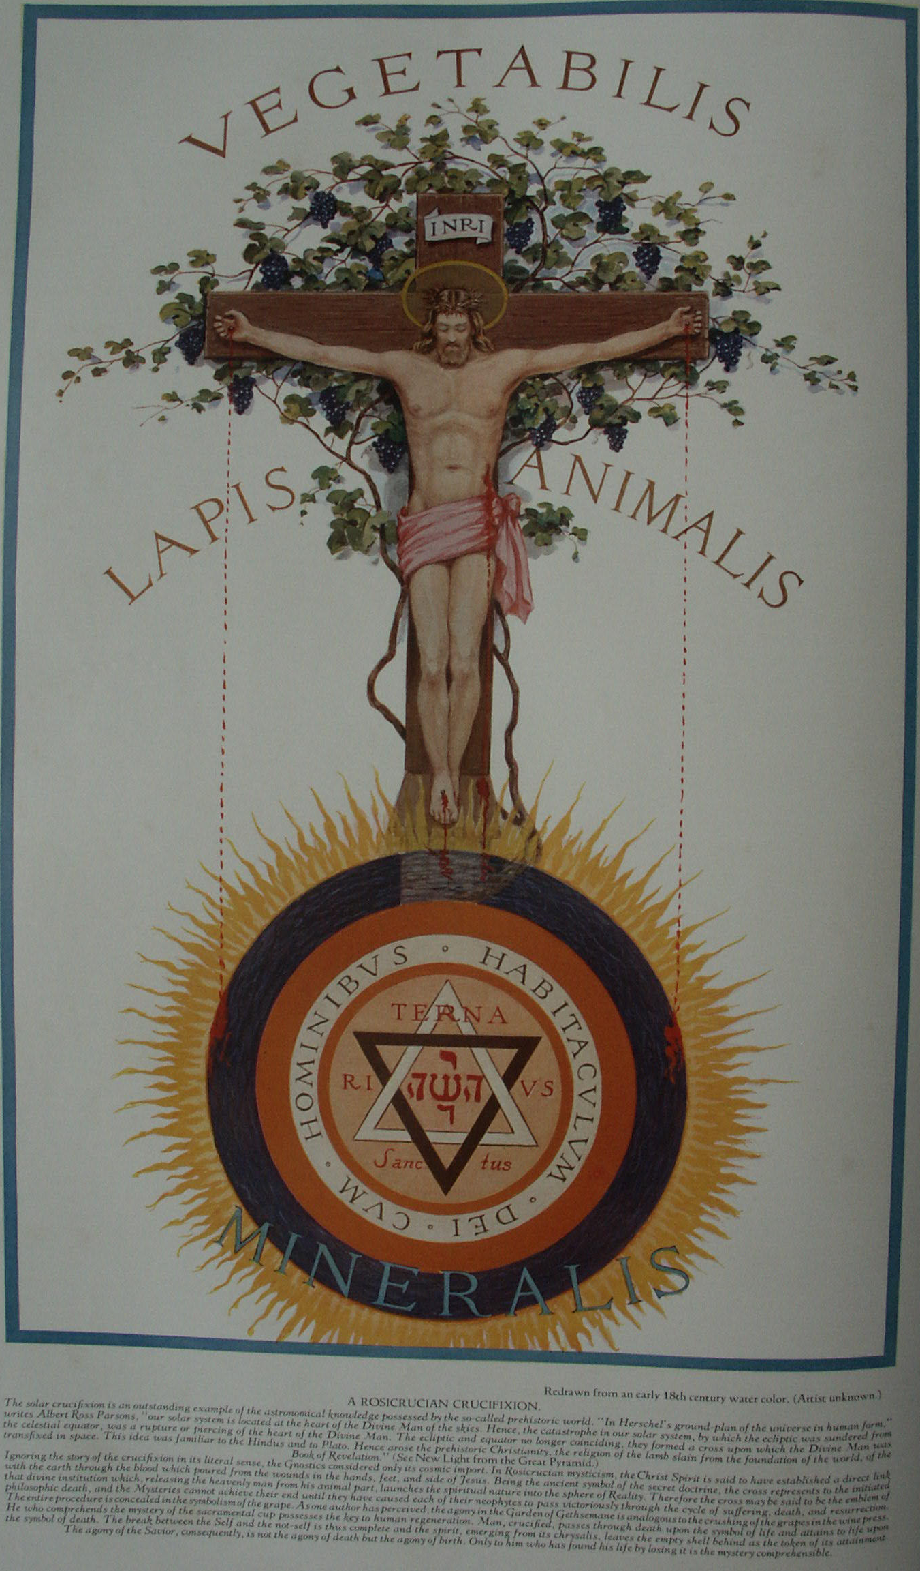

Mystic Christianity
The Secret Teachings of All Ages - Manly P. Hall 1928

MYSTIC CHRISTIANITY
St. Iranæus on the life of Christ--The original name of Jesus--The Christened man--The Essenes--The Arthurian cycle--Merlin the Mage.

THE true story of the life of Jesus of Nazareth has never been unfolded to the world, either in the accepted Gospels or in the Apocrypha, although a few stray hints may be found in some of the commentaries written by the ante-Nicene Fathers. The facts concerning His identity and mission are among the priceless mysteries preserved to this day in the secret vaults beneath the "Houses of the Brethren." To a few of the Knights Templars, who were initiated into the arcana of the Druses, Nazarenes, Essenes, Johannites, and other sects still inhabiting the remote and inaccessible fastnesses of the Holy Land, part of the strange story was told. The knowledge of the Templars concerning the early history of Christianity was undoubtedly one of the main reasons for their persecution and final annihilation. The discrepancies in the writings of the early Church Fathers not only are irreconcilable, but demonstrate beyond question that even during the first five centuries after Christ these learned men had for the basis of their writings little more substantial than folklore and hearsay. To the easy believer everything is possible and there are no problems. The unemotional person in search of facts, however, is confronted by a host of problems with uncertain factors, of which the following are typical:
According to popular conception, Jesus was crucified during the thirty-third year of His life and in the third year of His ministry following His baptism. About A.D. 180, St. Irenæus, Bishop of Lyons, one of the most eminent of the ante-Nicene theologians, wrote Against Heresies, an attack on the doctrines of the Gnostics. In this work Irenæus declared upon the authority of the Apostles themselves that Jesus lived to old age. To quote: "They, however, that they may establish their false opinion regarding that which is written, 'to proclaim the acceptable year of the Lord,' maintain that He preached for one year only, and then suffered in the twelfth month. [In speaking thus], they are forgetful of their own disadvantage, destroying His whole work, and robbing Him of that age which is both more necessary and more honourable than any other; that more advanced age, I mean, during which also as a teacher He excelled all others. For how could He have had His disciples, if He did not teach? And how could He have taught, unless He had reached the age of a Master? For when He came to be baptised, He had not yet completed His thirtieth year, but was beginning to be about thirty years of age (for thus Luke, who has mentioned His years, has expressed it: 'Now Jesus was, as it were, beginning to be thirty years old,' when He came to receive baptism); and, (according to these men,) He preached only one year reckoning from His baptism. On completing His thirtieth year He suffered, being in fact still a young man, and who had by no means attained to advanced age. Now, that the first stage of early life embraces thirty years, and that this extends onward to the fortieth year, every one will admit; but from the fortieth and fiftieth year a man begins to decline towards old age, which Our Lord possessed while He still fulfilled the office of a Teacher, even as the Gospel and all the elders testify; those who were conversant in Asia with John, the disciple of the Lord, (affirming) that John conveyed to them that information. And he remained among them up to the time of Trajan. Some of them, moreover, saw not only John, but the other apostles also, and heard the very same account from them, and bear testimony as to the'(validity of) the statement. Whom then should we rather believe? Whether such men as these, or Ptolemæus, who never saw the apostles, and who never even in his dreams attained to the slightest trace of an apostle?"
Commenting on the foregoing passage, Godfrey Higgins remarks that it has fortunately escaped the hands of those destroyers who have attempted to render the Gospel narratives consistent by deleting all such statements. He also notes that the doctrine of the crucifixion was a vexata questio among Christians even during the second century. "The evidence of Irenæus," he says, "cannot be touched. On every principle of sound criticism, and of the doctrine of probabilities, it is unimpeachable."
It should further be noted that Irenæus prepared this statement to contradict another apparently current in his time to the effect that the ministry of Jesus lasted but one year. Of all the early Fathers, Irenæus, writing within eighty years after the death of St. John the Evangelist, should have had reasonably accurate information. If the disciples themselves related that Jesus lived to advanced age in the body, why has the mysterious number 33 been arbitrarily chosen to symbolize the duration of His life? Were the incidents in the life of Jesus purposely altered so that His actions would fit more closely into the pattern established by the numerous Savior-Gods who preceded Him? That these analogies were recognized and used as a leverage in converting the Greeks and Romans is evident from a perusal of the writings of Justin Martyr, another second-century authority. In his Apology, Justin addresses the pagans thus:
"And when we say also that the Word, who is the first-birth of God, was produced without sexual union, and that He, Jesus Christ, Our Teacher, was crucified and died, and rose again, and ascended into heaven, we propound nothing different from what you believe regarding those whom you esteem sons of Jupiter. * * * And if we assert that the Word of God was born of God in a peculiar manner, different from ordinary generation, let this, as said above, be no extraordinary thing to you, who say that Mercury is the angelic word of God. But if any one objects that He was crucified, in this also He is on a par with those reputed sons of Jupiter of yours, who suffered as we have now enumerated."
From this it is evident that the first missionaries of the Christian Church were far more willing to admit the similarities between their faith and the faiths of the pagans than were their successors in later centuries.
In an effort to solve some of the problems arising from any attempt to chronicle accurately the life of Jesus, it has been suggested that there may have lived in Syria at that time two or more religious teachers bearing the name Jesus, Jehoshua or Joshua, and that the lives of these men may have been confused in the Gospel stories. In his Secret Sects of Syria and the Lebanon, Bernard H. Springett, a Masonic author, quotes from an early book, the name of which he was not at liberty to disclose because of its connection with the ritual of a sect. The last part of his quotation is germane to the subject at hand:
"But Jehovah prospered the seed of the Essenians, in holiness and love, for many generations. Then came the chief of the angels, according to the commandment of GOD, to raise up an heir to the Voice of Jehovah. And, in four generations more, an heir was born, and named Joshua, and he was the child of Joseph and Mara, devout worshippers of Jehovah, who stood aloof from all other people save the Essenians. And this Joshua, in Nazareth, reestablished Jehovah, and restored many of the lost rites and ceremonies. In the thirty-sixth year of his age he was stoned to death in Jerusalem * * *"
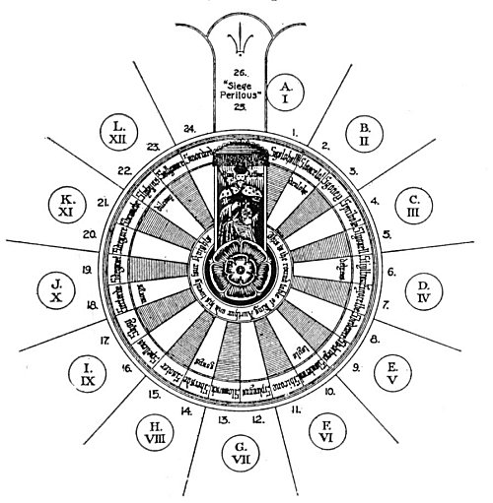
THE ROUND TABLE OF KING ARTHUR.
From Jennings' The Rosicrucians, Their Rites and Mysteries.
According to tradition, Arthur, when a boy of fifteen, was crowned King of Britain, in A.D. 516. Soon after his ascension to the throne he founded the Order of the Knights of the Round Table at Windsor. Thereafter the Knights met annually at Carleon, Winchester, or at Camelot, to celebrate Pentecost. From all parts of Europe came the brave and the bold, seeking admission into this noble order of British knighthood. Nobility, virtue, and valor were its requirements, and those possessing these qualities to a marked degree were welcomed to King Arthur's court at Camelot. Having gathered the bravest and noblest Knights of Europe about him, King Arthur chose twenty-four who excelled all the others in daring and integrity and formed of them his Circle of the Round Table. According to legend, each of these Knights was so great in dignity and power that none could occupy a more exalted seat than another, so when they gathered at the table to celebrate the anniversary of their foundation it was necessary to use a round table that all might occupy chairs of equal importance.
While it is probable that the Order of the Round Table had its distinctive rituals and symbols, the knowledge of them has not survived the ages. Elias Ashmole, in his volume on the Order of the Garter, inserted a double-page plate showing the insignia of all the orders of knighthood, the block set aside for the symbol of the Round Table being left blank. The chief reason for the loss of the symbolism of the Round Table was the untimely death of King Arthur upon the field of Kamblan (A.D. 542) in the forty-first year of his life. While he destroyed his bitter enemy, Mordred, in this famous battle, it cast him not only his own life but the lives of nearly all his Knights of the Round Table, who died defending their commander.

Within the last century several books have been published to supplement the meager descriptions in the Gospels of Jesus and His ministry. In some instances these narratives claim to be founded upon early manuscripts recently discovered; in others, upon direct spiritual revelation. Some of these writings are highly plausible, while others are incredible. There are persistent rumors that Jesus visited and studied in both Greece and India, and that a coin struck in His honor in India during the first century has been discovered. Early Christian records are known to exist in Tibet, and the monks of a Buddhist monastery in Ceylon still preserve a record which indicates that Jesus sojourned with them and became conversant with their philosophy.
Although early Christianity shows every evidence of Oriental influence, this is a subject the modern church declines to discuss. If it is ever established beyond question that Jesus was an initiate of the pagan Greek or Asiatic Mysteries, the effect upon the more conservative members of the Christian faith is likely to be cataclysmic. If Jesus was God incarnate, as the solemn councils of the church discovered, why is He referred to in the New Testament as "called of God an high prim after the order of Melchizedek"? The words "after the order" make Jesus one of a line or order of which there must have been others of equal or even superior dignity. If the "Melchizedeks" were the divine or priestly rulers of the nations of the earth before the inauguration of the system of temporal rulers, then the statements attributed to St. Paul would indicate that Jesus either was one of these "philosophic elect" or was attempting to reestablish their system of government. It will be remembered that Melchizedek also performed the same ceremony of the drinking of wine and the breaking of bread as did Jesus at the Last Supper.
George Faber declares the original name of Jesus was Jescua Hammassiah. Godfrey Higgins has discovered two references, one in the Midrashjoholeth and the other in the Abodazara (early Jewish commentaries on the Scriptures), to the effect that the surname of Joseph's family was Panther, for in both of these works it is stated that a man was healed "in the name of Jesus ben Panther." The name Panther establishes a direct connection between Jesus and Bacchus--who was nursed by panthers and is sometimes depicted riding either on one of these animals or in a chariot drawn by them. The skin of the panther was also sacred in certain of the Egyptian initiatory ceremonials. The monogram IHS, now interpreted to mean Iesus Hominum Salvator (Jesus Savior of Men), is another direct link between the Christian and the Bacchic rites. IHS is derived from the Greek ΥΗΣ, which, as its numerical value (608) signifies, is emblematic of the sun and constituted the sacred and concealed name of Bacchus. (See The Celtic Druids by Godfrey Higgins.) The question arises, Was early Roman Christianity confused with the worship of Bacchus because of the numerous parallelisms in the two faiths? If the affirmative can be proved, many hitherto incomprehensible enigmas of the New Testament will be solved.
It is by no means improbable that Jesus Himself originally propounded as allegories the cosmic activities which were later con fused with His own life. That the Χριστός, Christos, represents the solar power reverenced by every nation of antiquity cannot be controverted. If Jesus revealed the nature and purpose of this solar power under the name and personality of Christos, thereby giving to this abstract power the attributes of a god-man, He but followed a precedent set by all previous World-Teachers. This god-man, thus endowed with all the qualities of Deity, signifies the latent divinity in every man. Mortal man achieves deification only through at-one-ment with this divine Self. Union with the immortal Self constitutes immortality, and he who finds his true Self is therefore "saved." This Christos, or divine man in man, is man's real hope of salvation--the living Mediator between abstract Deity and mortal humankind. As Atys, Adonis, Bacchus, and Orpheus in all likelihood were originally illumined men who later were confused with the symbolic personages whom they created as personifications of this divine power, so Jesus has been confused with the Christos, or god-man, whose wonders He preached. Since the Christos was the god-man imprisoned in every creature, it was the first duty of the initiate to liberate, or "resurrect, " this Eternal One within himself. He who attained reunion with his Christos was consequently termed a Christian, or Christened, man.
One of the most profound doctrines of the pagan philosophers concerned the Universal Savior-God who lifted the souls of regenerated men to heaven through His own nature. This concept was unquestionably the inspiration for the words attributed to Jesus: "I am the way, the truth, and the life: no man cometh unto the Father but by me." In an effort to make a single person out of Jesus and His Christos, Christian writers have patched together a doctrine which must be resolved back into its original constituents if the true meaning of Christianity is to be rediscovered. In the Gospel narratives the Christos represents the perfect man who, having passed through the various stages of the "World Mystery" symbolized by the thirty-three years, ascends to the heaven sphere where he is reunited with his Eternal Father. The story of Jesus as now preserved is--like the Masonic story of Hiram Abiff--part of a secret initiatory ritualism belonging to the early Christian and pagan Mysteries.
During the centuries just prior to the Christian Era, the secrets of the pagan Mysteries had gradually fallen into the hands of the profane. To the student of comparative religion it is evident that these secrets, gathered by a small group of faithful philosophers and mystics, were reclothed in new symbolical garments and thus preserved for several centuries under the name of Mystic Christianity. It is generally supposed that the Essenes were the custodians of this knowledge and also the initiators and educators of Jesus. If so, Jesus was undoubtedly initiated in the same temple of Melchizedek where Pythagoras had studied six centuries before.
The Essenes--the most prominent of the early Syrian sects--were an order of pious men and women who lived lives of asceticism, spending their days in simple labor and their evenings in prayer. Josephus, the great Jewish historian, speaks of them in the highest terms. "They teach the immortality of the soul," he says, "and esteem that the rewards of righteousness are to be earnestly striven for." In another place he adds, "Yet is their course of life better than that of other men and they entirely addict themselves to husbandry. " The name Essenes is supposed to be derived from an ancient Syrian word meaning "physician," and these kindly folk are believed to have held as their purpose of existence the healing of the sick in mind, soul, and body. According to Edouard Schuré, they had two principal communities, or centers, one in Egypt on the banks of Lake Maoris, the other in Palestine at Engaddi, near the Dead Sea. Some authorities trace the Essenes back to the schools of Samuel the Prophet, but most agree on either an Egyptian or Oriental origin. Their methods of prayer, meditation, and fasting were not unlike those of the holy men of the Far East. Membership in the Essene Order was possible only after a year of probation. This Mystery school, like so many others, had three degrees, and only a few candidates passed successfully through all. The Essenes were divided into two distinct communities, one consisting of celibates and the other of members who were married.
The Essenes never became merchants or entered into the commercial life of cities, but maintained themselves by agriculture and the raising of sheep for wool; also by such crafts as pottery and carpentry. In the Gospels and Apocrypha, Joseph, the father of Jesus, is referred to as both a carpenter and a potter. In the Apocryphal Gospel of Thomas and also that of Pseudo-Matthew, the child Jesus is described as making sparrows out of clay which came to life and flew away when he clapped his hands. The Essenes were regarded as among the better educated class of Jews and there are accounts of their having been chosen as tutors for the children of Roman officers stationed in Syria. The fact that so many artificers were listed among their number is responsible for the order's being considered as a progenitor of modern Freemasonry. The symbols of the Essenes include a number of builders' tools, and they were secretly engaged in the erection of a spiritual and philosophical temple to serve as a dwelling place for the living God.

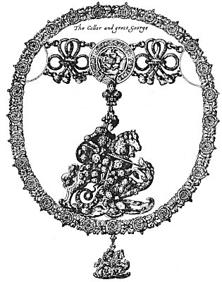
THE GREAT GEORGE AND COLLAR OF THE GARTER.
From Ashmole's Order of the Garter.
The Order of the Garter was probably formed by Edward III in imitation of King Arthur's Knights of the Round Table, which institution was hopelessly scattered after the battle of Kamblan. The popular story to the effect that the Countess of Salisbury's garter was the original inspiration for the foundation of the order is untenable. The motto of the Order of the Carter is "Honi soit qui mal y pense" (Shamed be he who thinks evil of it). St. George is looked upon as the Patron of the order, for he typifies the higher nature of man overcoming the dragon of his own lower nature. While St. George is supposed to have lived during the third century, it is probable that he was a mythological personage borrowed from pagan mythology.

Like the Gnostics, the Essenes were emanationists. One of their chief objects was the reinterpretation of the Mosaic Law according to certain secret spiritual keys preserved by them from the time of the founding of their order. It would thus follow that the Essenes were Qabbalists and, like several other contemporary sects flourishing in Syria, were awaiting the advent of the Messiah promised in the early Biblical writings. Joseph and Mary, the parents of Jesus, are believed to have been members of the Essene Order. Joseph was many years the senior of Mary. According to The Protevangelium, he was a widower with grown sons, and in the Gospel of Pseudo-Matthew he refers to Mary as a little child less in age than his own grandchildren. In her infancy Mary was dedicated to the Lord, and the Apocryphal writings contain many accounts of miracles associated with her early childhood. When she was twelve years old, the priests held counsel as to the future of this child who had dedicated herself to the Lord, and the Jewish high priest, bearing the breastplate, entered into the Holy of Holies, where an angel appeared to him, saying, "Zacharias, go forth and summon the widowers of the people and let them take a rod apiece and she shall be the wife of him to whom the Lord shall show a sign." Going forth to meet the priests at the head of the widowers, Joseph collected the rods of all the other men and gave them into the keeping of the priests. Now Joseph's rod was but half as long as the others, and the priests on returning the rods to the widowers paid no attention to Joseph's but left it behind in the Holy of Holies. When all the other widowers had received back their wands, the priests awaited a sign from heaven, but none came. Joseph, because of his advanced age, did not: ask for the return of his rod, for to him it was inconceivable that he should be chosen. But an angel appeared to the high priest, ordering him to give back the short rod which lay unnoticed in the Holy of Holies. As the high priest handed the rod to Joseph, a white dove flew from the end of it and rested upon the head of the aged carpenter, and to him was given the child.
The editor of The Sacred Books and Early Literature of the East calls attention to the peculiar spirit with which the childhood of Jesus is treated in most of the Apocryphal books of the New Testament, particularly in one work attributed to the doubting Thomas, the earliest known Greek version of which dates from about A.D. 200: "The child Christ is represented almost as an imp, cursing and destroying those who annoy him." This Apocryphal work, calculated to inspire its readers with fear and trembling, was popular during the Middle Ages because it was in full accord with the cruel and persecuting spirit of mediæval Christianity. Like many other early sacred books, the book of Thomas was fabricated for two closely allied purposes: first, to outshine the pagans in miracle working; second, to inspire all unbelievers with the "fear of the Lord." Apocryphal writings of this sort have no possible basis in fact. At one time an asset, the "miracles" of Christianity have become its greatest liability. Supernatural phenomena, in a credulous age interpolated to impress the ignorant, in this century have only achieved the alienation of the intelligent.
In The Greek Gospel of Nicodemus it is declared that when Jesus was brought into the presence of Pilate the standards borne by the Roman guards bowed their tops in homage to him in spite of every effort made by the soldiers to prevent it. In The Letters of Pilate the statement also appears that Cæsar, being wroth at Pilate for executing a just man, ordered him to be decapitated. Praying for forgiveness, Pilate was visited by an angel of the Lord, who reassured the Roman governor by promising him that all Christendom should remember his name and that when Christ came the second time to judge His people he (Pilate) should come before Him as His witness.
Stories like the foregoing represent the incrustations that have attached themselves to the body of Christianity during the centuries. The popular mind itself has been the self-appointed guardian and perpetuator of these legends, bitterly opposing every effort to divest the faith of these questionable accumulations. While popular tradition often contains certain basic elements of truth, these elements are usually distorted out of all proportion. Thus, while the generalities of the story may be fundamentally true, the details are hopelessly erroneous. Of truth as of beauty it may be said that it is most adorned when unadorned. Through the mist of fantastic accounts which obscure the true foundation of the Christian faith is faintly visible to the discerning few a great and noble doctrine communicated to the world by a great and noble soul. Joseph and Mary, two devout and holy-minded souls, consecrated to the service of God and dreaming of the coming of a Messiah to serve Israel, obeyed the injunctions of the high priest of the Essenes to prepare a body for the coming of a great soul. Thus of an immaculate conception Jesus was born. By immaculate is meant clean, rather than supernatural.
Jesus was reared and educated by the Essenes and later initiated into the most profound of their Mysteries. Like all great initiates, He must travel in an easterly direction, and the silent years of His life no doubt were spent in familiarizing Himself with that secret teaching later to be communicated by Him to the world. Having consummated the ascetic practices of His order, He attained to the Christening. Having thus reunited Himself with His own spiritual source, He then went forth in the name of the One who has been crucified since before the worlds were and, gathering about Him disciples and apostles, He instructed them in that secret teaching which had been lost--in part, at least--from the doctrines of Israel. His fate is unknown, but in all probability He suffered that persecution which is the lot of those who seek to reconstruct the ethical, philosophical, or religious systems of their day.
To the multitudes Jesus spoke in parables; to His disciples He also spoke in parables, though of a more exalted and philosophic nature. Voltaire said that Plato should have been canonized by the Christian Church, for, being the first propounder of the Christos mystery, he contributed more to its fundamental doctrines than any other single individual. Jesus disclosed to His disciples that the lower world is under the control of a great spiritual being which had fashioned it according to the will of the Eternal Father. The mind of this great angel was both the mind of the world and also the worldly mind. So that men should not die of worldliness the Eternal Father sent unto creation the eldest and most exalted of His powers--the Divine Mind. This Divine Mind offered Itself as a living sacrifice and was broken up and eaten by the world. Having given Its spirit and Its body at a secret and sacred supper to the twelve manners of rational creatures, this Divine Mind became a part of every living thing. Man was thereby enabled to use this power as a bridge across which he might pass and attain immortality. He who lifted up his soul to this Divine Mind and served It was righteous and, having attained righteousness, liberated this Divine Mind, which thereupon returned again in glory to Its own divine source. And because He had brought to them this knowledge, the disciples said one to another: "Lo, He is Himself this Mind personified!"

THE ARTHURIAN CYCLE AND LEGEND OF THE HOLY GRAIL
According to legend, the body of the Christos (the Spiritual Law) was given into the keeping of two men, of whom the Gospels make but brief mention. These were Nicodemus and Joseph of Arimathea, both devout men who, though not listed among the disciples or apostles of the Christos, were of all men chosen to be custodians of His sacred remains. Joseph of Arimathea was one of the initiated brethren and is called by A. E. Waite, in his A New Encyclopædia of Freemasonry, "the first bishop of Christendom." just as the temporal (or visible) power of the Holy See was established by St. Peter(?), so the spiritual (or invisible) body of the faith was entrusted to the "Secret Church of the Holy Grail" through apostolic succession from Joseph of Arimathea, into whose keeping had been given the perpetual symbols of the covenant--the ever-flowing cup and the bleeding spear.

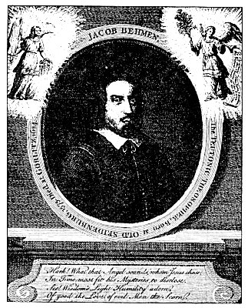
JAKOB BÖHME, THE TEUTONIC THEOSOPHER.
From William Law's Translation of The Works of Jakob Böhme.

Jakob Böhme was born in the year 1575 in a village near Gorlitz, and died in Silesia in 1624. He had but little schooling and was apprenticed at an early age to a shoemaker. He later became a journeyman shoemaker, married and had four children One day while tending his master's shoe shop, a mysterious stranger entered who while he seemed to possess but little of this world's goods, appeared to be most wise and noble in spiritual attainment. The stranger asked the price of a pair of shoes, but young Böhme did not dare to name a figure, for fear that he would displease his master. The stranger insisted and Böhme finally placed a valuation which he was all that his master possibly could hope to secure for the shoes. The stranger immediately bought them and departed. A short distance down the street the mysterious stranger stopped and cried out in a loud voice, "Jakob, Jakob come forth." In amazement and fright, Böhme ran out of the house. The strange man fixed his yes upon the youth--great eyes which sparkled and seemed filled with divine light. He took the boy's right hand and addressed him as follows--"Jakob, thou art little, but shalt be great, and become another Man, such a one as at whom the World shall wonder. Therefore be pious, fear God, and reverence His Word. Read diligently the Holy Scriptures, wherein you have Comfort and Instruction. For thou ust endure much Misery and Poverty, and suffer Persecution, but be courageous and persevere, far God loves, and is gracious to thee." Deeply impressed by the prediction, Böhme became ever more intense in his search for truth. At last his labors were reworded. For seven days he remained in a mysterious condition during which time the mysteries of the invisible world were revealed to him. It has been said of Jakob Böhme that he revealed to all mankind the deepest secrets of alchemy. He died surrounded by his family, his last words being "Now I go hence into Paradise."

Presumably obeying instructions of St. Philip, Joseph of Arimathea, carrying the sacred relics, reached Britain after passing through many and varied hardships. Here a site was allotted to him for the erection of a church, and in this manner Glastonbury Abbey was founded. Joseph planted his staff in the earth and it took root, becoming a miraculous thorn bush which blossomed twice a year and which is now called the Glastonbury thorn. The end of the life of Joseph of Arimathea is unknown. By some it is believed that, like Enoch, he was translated; by others, that he was buried in Glastonbury Abbey. Repeated attempts have been made to find the Holy Grail, which many believe to have been hidden in a crypt beneath the ancient abbey. The Glastonbury chalice recently discovered and by the devout supposed to be the original Sangreal can scarcely be accepted as genuine by the critical investigator. Beyond its inherent interest as a relic, like the famous Antioch chalice it actually proves nothing when it is realized that practically little more was known about the Christian Mysteries eighteen centuries ago than can be discovered today.
The origin of the Grail myth, as of nearly every other element in the great drama, is curiously elusive. Sufficient foundation for it may be found in the folklore of the British Isles, which contains many accounts of magic cauldrons, kettles, cups, and drinking horns. The earliest Grail legends describe the cup as a veritable horn of plenty. Its contents were inexhaustible and those who served it never hungered or thirsted. One account states that no matter how desperately ill a person might be he could not die within eight days of beholding the cup. Some authorities believe the Holy Grail to be the perpetuation of the holy cup used in the rites of Adonis and Atys. A communion cup or chalice was used in several of the ancient Mysteries, and the god Bacchus is frequently symbolized in the form of a vase, cup, or urn. In Nature worship the ever-flowing Grail signifies the bounty of the harvest by which the life of man is sustained; like Mercury's bottomless pitcher, it is the inexhaustible fountain of natural re source. From the evidence at hand it would indeed be erroneous to ascribe a purely Christian origin to the Grail symbolism.
In the Arthurian Cycle appears a strange and mysterious figure--Merlin, the magician. In one of the legends concerning him it is declared that when Jesus was sent to liberate the world from the bondage of evil, the Adversary determined to send an Antichrist to undo His labors. The Devil therefore in the form of a horrible dragon overshadowed a young woman who had taken refuge in sanctuary to escape the evil which had dcstroyed her family. When Merlin, her child, was born he partook of the characteristics of his human mother and demon father. Merlin, however, did not serve the powers of darkness but, being converted to the true light, retained only two of the supernatural powers inherited from his father: prophecy and miracle working. The story of Merlin's infernal father must really be considered as an allegorical allusion to the fact that he was a "philosophical son" of the serpent or dragon, a title applied to all initiates of the Mysteries, who thus acknowledge Nature as their mortal mother and wisdom in the form of the serpent or dragon as their immortal Father. Confusion of the dragon and serpent with the powers of evil has resulted as an inevitable consequence from misinterpretation of the early chapters of Genesis.
Arthur while an infant was given into the keeping of Merlin, the Mage, and in his youth instructed by him in the secret doctrine and probably initiated into the deepest secrets of natural magic. With Merlin's assistance, Arthur became the leading general of Britain, a degree of dignity which has been confused with kingship. After Arthur had drawn the sword of Branstock from the anvil and thus established his divine right to leadership, Merlin further assisted him to secure from the Lady of the Lake the sacred sword Excalibur. After the establishment of the Round Table, having fulfilled his duty, Merlin disappeared, according to one account vanishing into the air, where he still exists as a shadow communicating at will with mortals; according to another, retiring of his own accord into a great stone vault which he sealed from within.
It is reasonably certain that many legends regarding Charlemagne were later associated with Arthur, who is most famous for establishing the Order of the Round Table at Winchester. Reliable information is not to be had concerning the ceremonies and initiatory rituals of the "Table Round." In one story the Table was endowed with the powers of expansion and contraction so that fifteen or fifteen hundred could be seated around it, according to whatever need might arise. The most common accounts fix the number of knights who could be seated at one time at the Round Table at either twelve or twenty-four. The twelve signified the signs of the zodiac and also the apostles of Jesus. The knights' names and also their heraldic arms were emblazoned upon their chairs. When twenty-four are shown seated at the Table, each of the twelve signs of the zodiac is divided into two parts--a light and a dark half--to signify the nocturnal and diurnal phases of each sign. As each sign of the zodiac is ascending for two hours every day, so the twenty-four knights represent the hours, the twenty-four elders before the throne in Revelation, and twenty-four Persian deities who represent the spirits of the divisions of the day. In the center of the Table was the symbolic rose of the Passion of Our Lord Jesus Christ, the symbol of resurrection in that He "rose" from the dead. There was also a mysterious empty seat called the Siege Perilous in which none might sit except he who was successful in his quest for the Holy Grad.
In the personality of Arthur is to be found a new form of the ever-recurrent cosmic myth. The prince of Britain is the sun, his knights are the zodiac, and his flashing sword may be the sun's ray with which he fights and vanquishes the dragons of darkness or it may represent the earth's axis. Arthur's Round Table is the universe; the Siege Perilous the throne of the perfect man. In its terrestrial sense, Arthur was the Grand Master of a secret Christian-Masonic brotherhood of philosophic mystics who termed themselves Knights. Arthur received the exalted position of Grand Master of these Knights because he had faithfully accomplished the withdrawal of the sword (spirit) from the anvil of the base metals (his lower nature). As invariably happens, the historical Arthur soon was confused with the allegories and myths of his order until now the two are inseparable. After Arthur's death on the field of Kamblan his Mysteries ceased, and esoterically he was borne away on a black barge, as is so beautifully described by Tennyson in his Morte d'Arthur. The great sword Excalibur was also cast back into the waters of eternity--all of which is a vivid portrayal of the descent of cosmic night at the end of the Day of Universal Manifestation. The body of the historical Arthur was probably interred at Glastonbury Abbey, a building closely identified with the mystic rites of both the Grail and the Arthurian Cycle.
The mediæval Rosicrucians were undoubtedly in possession of the true secret of the Arthurian Cycle and the Grail legend, much of their symbolism having been incorporated into that order. Though the most obvious of all keys to the Christos mystery, the Grail legend has received the least consideration.
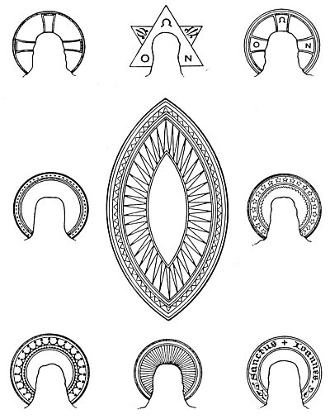
THE NIMBUS AND AUREOLE IN SYMBOLISM.
From Audsley's Handbook of Christian Symbolism.
The golden halos around the heads of pagan gods and Christian saints refer both to their being bathed in the glory of the sun and also to the fact that a spiritual sun within their own natures is radiating its glow-ray and surrounding them with celestial splendor. Whenever the nimbus is composed of straight radiant lines, it is solar in significance; whenever curved lines are used for beams, it partakes lunar nature; whenever they are united, it symbolizes a, harmonious blending of both principles. The circular nimbus is solar and masculine, while the lozenge-shaped nimbus, or vesica piscis, is lunar and feminine. The same symbolism is preserved in the circular and lozenge-shaped windows of cathedrals. There is a complete science contained in the shape, color, and adornments of the halos of saints and martyrs. A plain golden ring usually surrounds the head of a canonized saint, while God the Father and God the Son have a far more ornate aureole, usually adorned with a St. George Cross, a flowered cross, or a lilied cross, with only three of the arms visible.

===================================================================================================================================================
END

