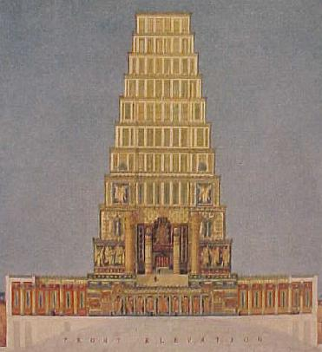
Biblical History of King Solomon’s Temple
www.phoenixmasonry.org/historypage.htm

The Origin of the Phoenix as a symbol in Phoenixmasonry
The old mythological legend of the Phoenix is a familiar one. The bird was described as of the size of an eagle, with a head finely crested, a body covered with beautiful plumage, and eyes sparkling like stars. She was said to live six hundred years in the wilderness, when she built for herself a funeral pile of aromatic woods, which she ignited with the fanning of her wings, and emerged from the flames with a new life. Hence the phoenix has been adopted universally as a symbol of immortality. Higgins (Anacalypsis, ii., 441) says that the phoenix is the symbol of an ever-revolving solar cycle of six hundred and eight years, and refers to the Phoenician word phen, which signifies a cycle. Aumont, the first Grand Master of the Templars after the martyrdom of DeMolay, and called the "Restorer of the Order," took, it is said, for his seal, a phoenix brooding on the flames, with the motto, "Ardet ut vivat" - She burns that she may live. The phoenix was adopted at a very early period as a Christian symbol, and several representations of it have been found in the catacombs. Its ancient legend, doubtless, caused it to be accepted as a symbol of Jesus Christ's resurrection and immortality.
Here at Phoenixmasonry, we believe that each of us has had the feeling of being consumed by fire. That the problems of our lives have left us in the pit of despair, the ashes of destruction, although it may not have been the fire that creates those ashes. Adversity and the overcoming of it makes us stronger. Just as the beautiful Temple of King Solomon rose from the rubbish and ashes of barbarous forces to become an even more magnificent and resplendent structure, our belief and faith that Jesus died for our sins allows us to rise up from the ashes to become stronger and better Phoenixmasons.
The Meaning of Masonry
In all the rich symbolism of Ancient Craft Masonry two symbols, or symbolic themes, predominate. One is the "Search for Light"; the other is the "Labor of Building". The source of light is the Holy Bible, and the grand representation of the builder's art is King Solomon's Temple. Searching persistently and building carefully, the candidate travels slowly towards the East. As he pursues his quest for light and more light and still further light in Masonry, he learns by the way to use the working tools of the stone craftsman, until at last he finds himself portraying the character of the greatest of all legendary builders, the master architect of King Solomon's Temple Hiram Abiff. Searching and building, light and the Temple, - the two dominant Masonic themes are distinct but not separate, complementary rather than supplementary.
And the search and the labor are not completed by the candidate within the Lodge. Light is revealed, and the sacred source of all light is clearly indicated, but the search for complete illumination must be eternal. The Temple in the Masonic ritual is almost but not quite completed; the allegory rises from a physical to a spiritual Temple; "a house, not made with hands, eternal in the heavens." Regardless of symbolic revelations in Masonic degrees apart from the Lodge, the unending search and that labor toward perfection, begun in the Lodge, must continue with the initiated Mason throughout his life.
The Tradition of Solomon
It was natural that imaginative stone Mason's, long before the development of anything like our modern fraternity, should have felt a kinship with the great builders of all ages. It was natural also that they should have acknowledged a peculiar attraction for the most famous and glorious of all building enterprises, King Solomon's Temple and Citadel. Interest and attraction for the wonderful structure on Mt. Moriah have increased rather than diminished during the six hundred and more years of recorded Masonic history, until today the Temple of Solomon is the spiritual home of Freemasonry. What do we know about the Temple, its form, its beauties, its historical and religious background?
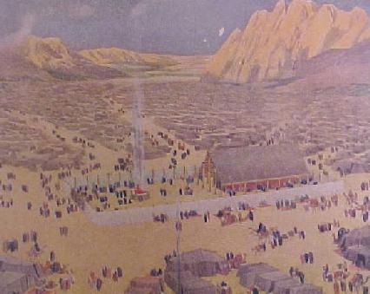
The Tabernacle in the Wilderness
A thorough understanding of the details of the primitive Tabernacle of Israel is essential to grasp fully the fundamental principles involved in the construction of King Solomon's Temple. An intimate knowledge of the Tabernacle's contents and their relation to one another is necessary to comprehend the ritualistic system developed by Solomon and his priests. A study of the ceremonies, the sacrificial offerings, and the priestly ministrations of the Tabernacle will reveal the great spiritual mystery of the Indwelling God, as made manifest by Moses during the sojourn in the wilderness.
Master Builders
Moses, during his prolonged stay of forty days and forty nights on Mt. Sinai, appears to have visualized the form which the Tabernacle should take. The subsequent building of the Tabernacle, the system of worship adopted, and the structure of government developed by Moses under divine guidance, have inspired his race and impressed the whole of mankind. Moses chose as his chief architect, Bezaleel, a direct descendant of Terah, one of the master builders of Ur of the Chaldeans, and as chief assistant, Aholiab, also a direct descendent of Terah and by marriage of the line of Tubal-cain, traditionally the first instructor of artificers in brass and other metals. Bezaleel was unusually endowed with the Spirit of God in wisdom, understanding and knowledge. These three outstanding geniuses gave to the world the most beautiful and magnificent religious structure ever conceived and erected for a nomadic people. Exodus 24-31; Genesis 4:22.
Materials for the Tabernacle
Gold, silver, brass, and iron; silks, fine linen and a fabric of goats' hair; rams' skins, and badgers' skins; shittum wood or acacia timber; onyx stone, sardius, topaz, carbuncle, emerald, sapphire, diamond, ligure, agate, amethyst, beryl and jasper; also blue, purple and scarlet dyes; all of these went into the construction of the Tabernacle. Exodus 25:3; 35: 5-10.
How the Materials were Acquired
The Israelites, a nomadic tribe roaming about through Chaldea, Assyria, and Caanan. and finally locating in the land of Goshen in Egypt, naturally accumulated wealth by trading with the natives through whose countries they passed. They increased their flocks through attention and by seeking the well-watered localities for pasture. They industriously converted the wool from the sheep, and the hair from the goats and camels, into cloth, and wove grass fibers into fabrics, from all of which they made tents, rugs, clothing, and other useful articles. But, possibly, their greatest wealth was acquired just before they left Egypt, when we are told that they "spoiled the Egyptians" Exodus 11: 2, 12: 35-36.
Now, when the Lord spoke through Moses, requesting an offering from
every man who would give with his heart and in accordance with his means for the building of the Tabernacle, the people responded with gold, silver, brass, blue, purple, and scarlet, and fine linen; goats' hair, rams' skins, shittim wood, oil, spices, sweet incense and precious stones. In addition, every wise hearted among them gave personal services as needed. So great was their response that Moses finally gave commandment, saying: "Let neither man nor woman make any more work for the offering of the Sanctuary." So the people were restrained from bringing more wealth.
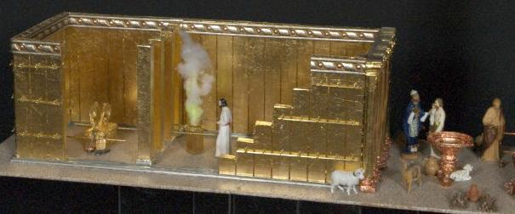
The Architecture of the Tabernacle
The Tabernacle, Tent, or Portable Temple, being so constructed that it
could be readily taken down, moved from place to place, and erected at will, was especially adapted to the needs of a nomadic people. Being constructed on geometrical and scientific principles, it readily lent itself to a practical system of removal and erection which was essential in the case of so large and costly a structure. The Tabernacle consisted of an oblong or rectangle, called the Court, in the rear half of which was the tent or covering of the Sanctuary. Under this Tent, the Holy and Most Holy Places were defined by partitions of boards and pillars, securely joined by means of rods, rings, etc. A careful study of the entire structure reveals an architectural gem, servicably conceived, beautifully designed, mystically embellished, celestially canopied, and inspiring the beholder with profound reverence and peaceful security in the thought of an ever present and Indwelling God, and typifying the encampment of the Angels of the Lord around about them that fear Him.
The Court of the Tabernacle
The Court, the walled curtain of which surrounded the enclosure
containing the Holy and Most Holy Places, with their furnishings - the Tent, Laver, Altar of Sacrifice, bowls and other sacrificial utensils - was oblong in shape; "100 cubits long and 50 cubits wide" (200 feet by 100 feet - A cubit was a Standard of measurement adopted by ancient builders, the distance from the elbow to the end of the middle finger.) Exodus 27: 9-19; 38: 9.
This court was enclosed by a wall "5 cubits high" (10 feet), composed of linen and canvas, supported by pillars of brass, which rested in sockets of brass. The pillars were ornamented at the top with capitals of silver, to which were attached hooks of silver to hold in place the rods. The rods kept the pillars an equal distance apart and supported the canvas or linen wall. This wall was further supported by guy ropes attached to pins driven into the ground on both sides. This enclosure, composed of 60 pillars of brass, filleted with silver, with their 60 capitals of silver, 60 sockets of brass, and 120 hooks of silver, was only broken on the eastern side by the entrance, which was "20 cubits wide" (40 feet). This entrance, or gate curtain, was of fine twined linen, wrought with needle work in the most gorgeous shades of blue, purple, and scarlet. One can visualize its appearance and effect as it stood in the midst of the encampment of Israel.
The Altar of Burnt-Offering
The Altar stood in the midst of the eastern half of the oblong Court enclosure, the sacrificial tables and utensils being upon the left of the main entrance within the Court. The Altar of Burnt-offering was the instrument used for the purpose of reconciling man with his Maker. The Altar was 5 cubits long, 5 cubits broad and 3 cubits high (10 feet by 10 by 6). It was a large hollow case, made of shittim wood, overlaid with brass, and ornamented with huge wooden horns overlaid with brass, one for each of the four corners.
A grating or network of brass, having a ring at each of its four corners, was hung in the middle of the top of the Altar, and on it was laid the wood for the fire which consumed the sacrifice. On two sides of the Altar were rings of brass, through which were laid staves of shittim wood overlaid with brass, to carry it from place to place. The pots, shovels, basins, flesh-hooks and fire pans, as well as all other vessels or utensils necessary to the service of the Altar, were made of brass. Exodus 27: 1-8; 38: 1-7.
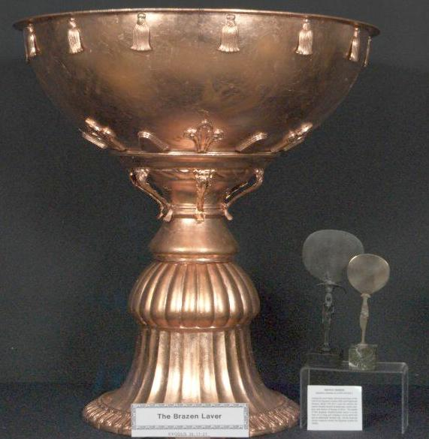
The Brazen Laver
The Laver consisted of a large bowl or fountain, which held fresh water used by the priests in the services. It stood in a fount, or pool, as a base to catch the waste water. Here the sacrifices were washed and the priests cleansed before entering the Tabernacle. From the mention of the "Laver and its Foot" one gets the idea of two containers, like a cup and saucer. Exodus 30: 1-8; 38: 1-7.
The Biblical statement that the Laver was made of the looking glasses of the women of the congregation which assembled at the door of the Tabernacle, reveals the deep religious emotion which prevailed.
The Sanctuary in the Tabernacle
The Sanctuary was erected in the center of the western half of the oblong Court enclosure, and consisted of two chambers, the Holy Place and the Most Holy Place. The tent, or covering, protected and formed a cover round about the Sanctuary, and was used by the priests and attendants as chambers or rest rooms.
The western end and the two sides of the Sanctuary were enclosed by boards made of shittim wood overlaid with gold. The length of one board was10 cubits (20 feet), and the breadth was 1 1/2 cubits (3 feet). Each board had two tenons at the base equally distant one from the other, with two sockets of silver for each board to fit the tenons and form the foundation. On the outside of each board were rings to receive the bars to join one board to the other. There were 20 boards for the north side and 20 boards for the south side, held in place by five bars for each side. Four bars joined in the center of the wall and one bar passed through all the rings of the 20 boards, on each side. For the western end of the Sanctuary there were six boards and twelve tenons, with two corner boards and four tenons. They were so cut and coupled together as to form a perfect right angle for each corner, coupled at top and bottom. All the boards stood upright, edge to edge.
The Most Holy Place was divided from the Holy Place by four pillars of shittim wood overlaid with gold, resting upon sockets of silver. These pillars supported a hanging of most sumptuous tapestry of fine twined linen, a splendid fabric in blue, purple, and scarlet, beautifully embroidered with cherubim in gold.
A most beautiful covering of splendid linen fabrics in blue, purple, and scarlet, embroidered with figures of cherubim in gold formed the canopy for the two sacred rooms. This, together with the two hangings previously described and the boards of gold, produced an enchanting effect in gorgeous colorings, dazzling beyond description. The covering was composed of ten curtains of fine linen all in blue, purple and scarlet. Each curtain was 28 cubits (56 feet) long and the breadth of 4 cubits (8 feet). The ten curtains were joined permanently into two great curtains of five each by means of couplings. On one edge of one of the great curtains were loops of blue, 50 in number; on the edge of the other great curtain were taches of gold, 50 in number. The loops and taches coupled the curtains together into a one-piece covering. This splendid fabric of blue, purple, and scarlet colored linen, magnificently embroidered with figures of cherubim, formed the ceiling of both the Holy and Most Holy Places. It was drawn down on the outside of the golden boards and fastened to the center rod upon all sides except the eastern entrance.
To protect this beautiful and delicately wrought covering, eleven curtains of goats' hair were provided, each 30 cubits (60 feet) long and 4 cubits (8 feet) wide. Five of these curtains were permanently united into one great curtain and six into another. These in turn were provided with 50 loops on the edge of one curtain and 50 taches opposite the loops. The two composite curtains were joined to make one great covering carefully drawn over the entire Sanctuary and securely fastened on all sides except the eastern entrance. To complete the protection against inclement weather, a tent, oblong in shape, was also provided, consisting of two coverings, an inner one of rams' skin, dyed red, and an outer of badgers' skins. The tent had a ridge over which the coverings were drawn and then fastened by means of guy ropes to pins driven into the ground at regular intervals upon all sides.
The Holy Place
This was an oblong room 20 cubits in length, 10 cubits in width and 10 cubits in height (40 feet by 20 by 20). The entrance gate consisted of a beautiful tapestry of blue, purple, and scarlet fabric, gorgeously embroidered with cherubim in pure gold. The tapestry was hung upon five pillars of wood overlaid with gold, having beautiful capitals of silver and sockets of brass. The pillars, which were arranged in regular interval across the east entrance of the room, had hooks at the very top of the
capitals to receive the loops at the top edge of the curtain or veil of the Tabernacle, which was thus suspended across the entire front at the west so as to separate the Holy from the Most Holy Place. Above, and forming the ceiling, was the brilliant colored linen covering, and on the north and south sides were the highly polished golden walls reflecting in radiant splendor the varied colored drappings and richly rugged floor.
The Holy Place contained three articles of furniture, the Altar of Incense, which stood in the center, the Golden Candlestick with all its vessels, which stood on the left side center, and the Table of Shewbread with its dishes, spoons, covers, and bowls, which stood on the right side center. The priests entered the Holy Place each day to offer incense, and to renew the lights in the Golden Candlestick.
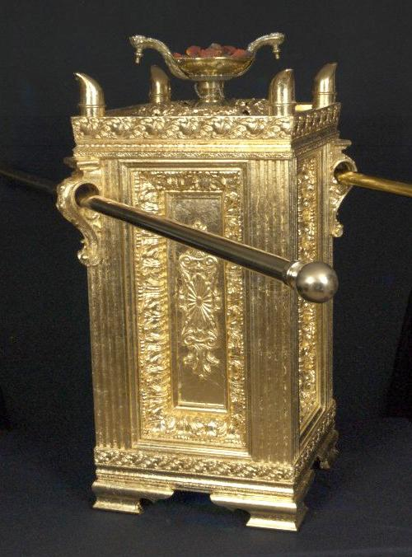
The Altar of Incense
The Golden Altar or Altar of Incense was made of shittim wood overlaid with pure gold. In form, it was two cubits high and one cubit broad (four-square, 4 feet by 2) on each of the four sides. Upon the top edge round about, it was ornamented with a crown of gold of unique design. On the four corners were horns made of shittim wood overlaid with pure gold, in shape like unto rams' horns. Under the crown, on each of two sides, were four rings of gold, two on each side, through which the staves, made of shittim wood overlaid with gold, were passed. These staves were for carrying it. Exodus 39: 38. The Censer was placed on the top center of the Golden Altar, and in it sweet incense was burned every morning. Exodus 30: 1-10.
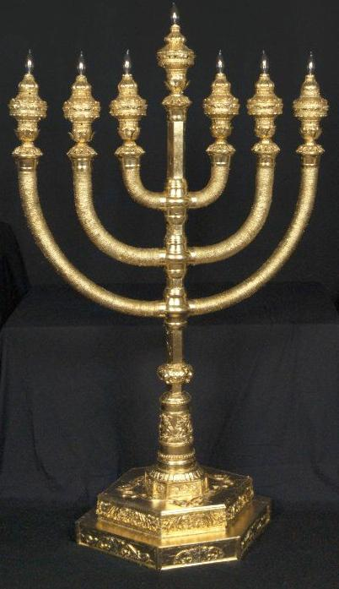
The Golden Candlestick
The Golden Candlestick was made of pure gold of "beaten work" with a central shaft ornamented with knobs, flowers, and bowls. There were six branches going out of its sides, three branches out from one side and three out from the other. All the branches, like the shaft, were ornamented with knobs, flowers, and bowls. The bowls were made after the fashion of almonds. On the top of the shaft, and on each one of the six branches, were lamps large enough to hold sufficient oil and cotton to burn all night. Exodus 26: 31-39; 37: 17-24.
The Biblical text does not define the height or breadth of the candelabrum. However, proportionate harmony with the rest of the furniture would suggest a height of 3 cubits (6 feet) and a breadth of 2 1/2 cubits (5 feet).
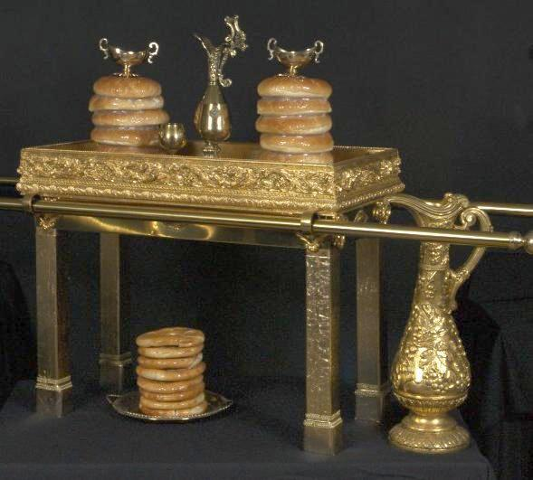
The Table of Shewbread
The table was made of shittim wood overlaid with pure gold 2 cubits long, 1 cubit broad and 1 1/2 cubits high (4 feet by 2 by 3) and finished, like the Altar, with a crown or rim of gold round about at the top edge, and four rings and two staves with which to carry it. It was furnished with dishes, spoons, bowls, and covers, all of pure gold. Exodus 35: 23-30; 37: 1-16.
Upon this table were placed twelve cakes of fine flour, in two rows, six in a row, called "Shewbread." "And thou shall set upon the table Shewbread before me alway." Exodus 25: 30.
The Most Holy Place
The second or inner chamber, called the Most Holy Place, was 10 cubits (20 feet) on each side and consequently a perfect cube. It contained the Ark of the Covenant, in which were the two Tables of Stone. This place, the Holy of Holies, the most sacred portion of the divinely appointed structure, was surrounded on three sides by highly polished walls of pure gold. The "Veil" of fine twined linen in blue, purple, and scarlet, richly embroidered and ornamented with figures of cherubim in gold, hanging from the tops of four pillars of shittim wood overlaid with pure gold, and resting in sockets of silver, defined the eastern and only entrance. Over all this magnificent, foursquare, resplendent place hung the blue, purple, and scarlet curtain, richly embroidered with golden cherubim. The reflection of these brilliant hues, and of the Cherubim, upon the walls of polished gold, must a produced have weird, startling, awe-inspiring and overpowering effect upon all those who were ordained to enter this most sacred place. Within this enclosure there was but one article of furniture and its contents, that is, the Ark of the Covenant containing the Testimony.
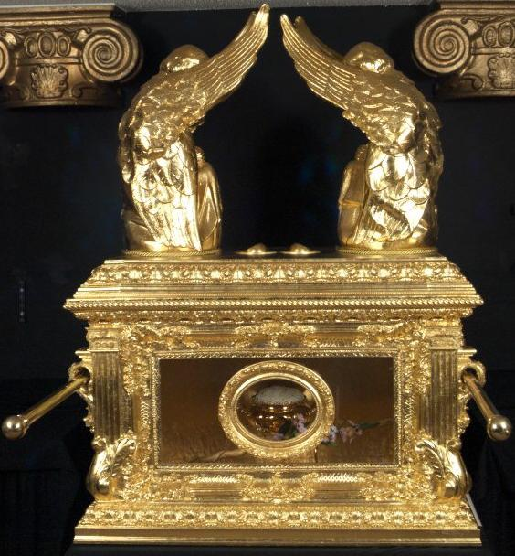
The Ark of the Covenant
The Ark of the Covenant was an ark or chest of shittum wood two and
one-half cubits long, and one and one-half cubits high (5 feet by 3 by 3)
overlaid with gold, and embellished with a crown of gold extending around the chest upon the top edge. Four rings of pure gold were set in the four corners, two on one side and two on the other, through which were passed the wooden staves overlaid with gold used in carrying the sacred chest. Exodus 25: 10; 37: 1-10.
The lid, or covering was the Mercy Seat, and was one piece of of pure gold, two and one-half cubits long and one and one-half cubits broad (5 feet by 3). Upon each end of this Mercy Seat were Cherubim, made of pure "beaten" gold. These cherubim stretched forth their wings on high, so as to cover the Mercy Seat, their faces being inward toward the Mercy Seat. In this Ark, or Chest, and directly under the Mercy Seat, were the most sacred religious items of Judaism which included the Testimony or Ten Commandments upon two tables of stone, Manna from Heaven and Arron's Rod.
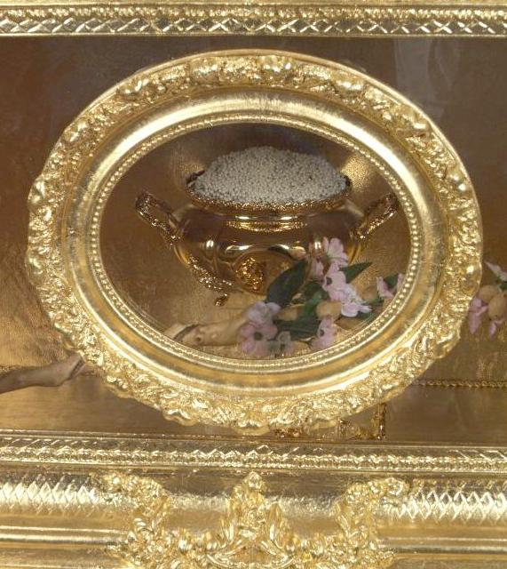
The Ark of the Covenant, thus fittingly enshrined, was the only piece
of furniture in the Most Holy Place. It was visited but once each year by
the High Priest, on the Day of Atonement, to make "atonement for the sins of the people." This was the most solemn ceremony of the Hebrew worship.
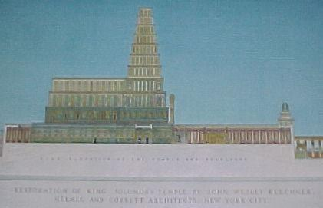
King Solomon's Temple and Citadel
The comprehensiveness of the Tabernacle, its hidden grandeur, and its
mysterious splendor, appealed to David to such an extent that he longed to build, with the Tabernacle as a model, a permanent Temple dedicated to the worship of the true God. David loved the Tabernacle as the house of the Lord. He desired to dwell in its courts forever, that he might behold the glory of God, make manifest His eternal presence, and sing His praise. David had the Tabernacle ever in mind when he prepared plans and patterns for the Temple to be erected upon Mount Moriah, the most sacred spot on Earth. He bequeathed the plans to Solomon, who with the Tabernacle as a guide, erected a Temple the grandeur of which has so impressed the world that men, never tiring in its praise, have placed it foremost in legend, romance, history, and religion.
The Tabernacle was the pattern which guided the master builders in the construction of King Solomon's Temple, as well as the priests in its ritualistic services. The physical Temple was completed about 1005 B.C. according to the received chronology. 1 Chron. 28:11-21.
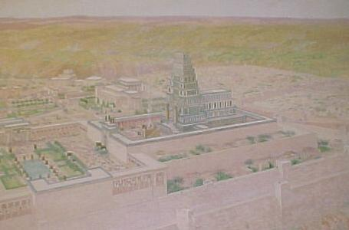
Location of the Temple
Mount Moriah, in the days of Abraham, was one of the hills in the vicinity of Salem, the one chosen by Abraham upon which to sacrifice his only son Isaac "as a burnt offering" unto the Lord. In later years it came under the control of the Amorites, whose principal city, Jebus, occupied a hill westward from Moriah. Genesis 22: 2.
In the days of King David, who subdued the Jebusites, it became a part of the city named Jerusalem. It is 14 1/2 miles from Jordan, 15 miles from Salt Sea, and 41 miles from the Mediterranean. The location was not the most desirable one on which to erect the Temple, but was chosen by Solomon because of its sacred associations. It was fitting that the great Temple to be dedicated to the God of his fathers should be erected upon the very spot where Abraham made manifest that faith in Him which was accepted ever after by the children of Israel and the world. On this spot also, where Abraham offered Isaac, David made an acceptable offering unto the Lord, and by faith saved Jerusalem from destruction. David no doubt realized the significance of the name given to the Mount by Abraham, "Jehovah Sees," and ever after the children of Abraham found consolation in the thought, "In the Mount of Jehovah He will be seen." Solomon, in deciding to erect the Temple upon this sacred spot, fulfilled the wishes of his father, King David, and of all in whose breasts these sentiments were cherished. "Beautiful for Situation, the Joy of the whole Earth."
Materials for the Temple
"Gold for things to be made of gold; silver for things of silver; brass for things of brass; iron for things of iron; wood for things of wood; onyx stones and stones to be set, glistening stones of diverse colors, and all manner of precious stones, and marble stones in abundance." Nails of gold were used, and nails of brass and iron; chains of gold; ivory from Ophir; hewn stones, stones sawed with saws, great stones (granite), costly stones (marble of various colorings); cedar wood from Mt. Lebanon, algum wood from Mt. Lebanon and from Ophir, fir wood, sycamore, shittim wood or acacia, olive wood and palm, juniper, balsam and mulberry wood. 1 Chron.29:2.
Leather came from ox skins and chamois; fur from goats and badgers;
wool from sheep. Fine (white) twined linen was used, and goats' and camels' hair made textile fabrics of purple, crimson, and blue. Varicolored dyes were produced from clays, stones, fish, and vegetation. For the services were furnished oils, spices, incense, myrtle, fitches, myrrh, sweet cinnamon, calamus, cassia, stacte, onycha, galbanum and frankincense, - Nature's contributions to the handiwork of Man.
How the Temple Materials were Acquired
King David, one of the world's greatest generals and statesmen, founded an imperial dominion which theretofore had not been realized, though it had been promised to Abraham. David became King on the scale of the great sovereigns, demanding and receiving tribute, and forming alliances which enabled him to control the great trade route of which Jerusalem was the center. Yet, during the turmoil and struggles attending his rise to supremacy, he never ceased to make preparation for carrying out his one ambition, that of erecting a Temple to the worship of God. "Behold in my trouble I have prepared for the house of the Lord an hundred thousand talants of gold, and a thousand thousand talents of silver; and of brass without weight, for it is in abundance; timber also and stone I have prepared," declared David. Again he repeats, "I have prepared with all my might for the house of my God the gold for things to be made of gold; and the silver for things of silver; and the brass for things of brass; the iron for things of iron; and wood for things of wood; onyx stones and stones to be set, glistening stones, and of diverse colors, and all manner of precious stones and marble stones in abundance." In addition to the sums he "prepared" he donated from his own private purse, "three thousand talents of gold, seven thousand talents of silver," all of which he carefully tabulated and dedicated to the Lord, in the presence of the fathers and princes of the tribes of Israel, who stood in awed silence before their venerable and God-fearing sovereign. Genesis 15: 18-21.
In his final and supreme effort to arouse his hearers to respond with contributions of their own, David shouted: "Who then is willing to consecrate his service this day unto the Lord?" "Then the chief of the fathers and princes of the tribes of Israel, and the captains of thousands and of hundreds, with the rulers of the king's work, offered willingly of gold, five thousand talents and ten thousand drams, and of silver ten
thousand talents, and of brass eighteen thousand talents, and one hundred thousand talents of iron. And they with whom precious stones were found gave them to the treasure of the house of the Lord." 1 Chron. 29.
Hiram, King of Tyre, the friend of David, gave Solomon cedar, algum and fir trees according to all Solomon's needs, also great stones (granite), costly stones (marbles), and hewed stones, shaped for pillars and squared by stone squarers.during the course of the construction of the Temple, King Hiram and King Solomon caused periodical trips to be made to Ophir for gold, algum trees, and precious stones to add to the apparently inexhaustible store. "King David rejoiced with great joy." Hiram, King of Tyre, "blessed the Lord God of Israel, that made heaven and earth, who hath given to David the King a wise son, endowed with prudence and understanding, that might build an house for the Lord."
Co-operation of Allied Nations
King David was thirty years old when the elders of Judah called him to the City of Hebron, gave him their allegiance, and publicly anointed him King. Seven years later, he received the allegiance of the entire nation. He then began to build the empire of his dreams, as promised to Abraham, which was to be the glory of Israel and the world. His first act was to set up the Tabernacle in the New City, restored, embellished, and unequalled for permanence and beauty. All his thoughts were for the religious interests of the people. Although he was recognized as "a man after God's own heart," he was not perfect. He was a man of great stature, a physical giant, a mighty warrior, and a great general, "every inch a King," a shrewd politician and sagacious statesman. His outstanding political act was the seizure of the city of Jebus, the key to control of the great trade route between the East and West, which he called Jerusalem. This also gave him possession of the most sacred spot on earth, Mount Moriah.
The commanding position of his capitol brought the Phoenicians into an
alliance, and "Hiram, King of Tyre, sent messengers, and cedar trees, and carpenters, and masons, and built David an house (palace)." Realizing his strength, David fought and conquered the Philistines, thus making a trade alliance with Egypt possible. Having made these alliances, he was free to turn his victorious armies eastward. There he conquered the Moabites, who "became David's servants and brought gifts." He next conquered the Zobahites, which brought him into battle with the Syrians, whom he utterly routed and thus gained control of Damascus and part of Syria. The spoils of these wars were great; he received much gold, silver and brass, besides placing the Syrians under allegiance, so that they too "became servants to David, and brought gifts." Having conquered the Syrians, Moabites, Ammonites, Philistines, Amalekites, Rehobites and Hittites with his thirteen hundred thousand fighting men, he forced tribute, withstood all enemies, and raised his kingdom to superior strength, opulence, and splendor. Having built an empire unequalled in his time and established peace with the world, he bequeathed to his son, Solomon, untold wealth, a commanding army, a multiple allegiance, a vast empire, and sympathetic international accord.
Through his energy, shrewdness, skill, unusual fairness, generosity, and
devotion, he also left to his heir an affectionate people. "Now the days of David drew nigh that he should die, and he charged Solomon his son." This dying charge, a magnificent state paper and one of the most remarkable readings in the Bible, related principally to the building of the Temple, whose erection David had not undertaken because of wars. "So David slept with his fathers and was buried in the City of David." 1 Kings 2; 1 Chron. 28, 29.
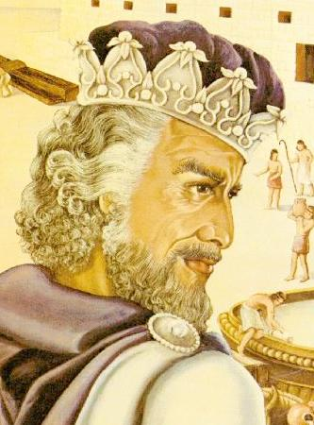
Solomon, King of Israel
Solomon was the son of Bath-sheba, a direct descendant of Ishmael,
whom Hagar bore unto Abraham. David, through the house of Judah, was a direct descendant of Issac. Thus, the two great families founded by Abraham were united in Solomon. He was about 14 years old when he was anointed King of Israel in Gihon, and about 21 at the death of David, so that when he was fully established on the throne, he was familiar with the elaborate designs and abundant preparations of his father for the building of the Temple. Solomon, having been carefully nutured by his God-fearing queen mother, had grown into a young man of great mental vigor. Having been schooled under the greatest masters of the times, reared in one of the richest and most brilliant courts of the then known world, he was preeminently gifted for the stupendous task before him, and undertook with enthusiasm to carry it on. The secret of Solomon's success is faithfully portrayed in his request at the time the Lord appeared to him in a dream, and asked what he (the Lord) should give him. Solomon's request was "for an understanding heart" that he might "discern between good and evil," that he might know how to walk before his people. This submission to God, this desire to have God make manifest through him the righteousness of God, was the first indication of his future greatness. He gathered about him the wonders of Nature, both of animal and vegetable life, drew from them the secrets of their existence, and learned that God was made manifest in the heavens above and in the earth beneath, and that God was all and in all. He soon set about to fulfill the wishes of his father and to glorify the God of his dream by creating a Temple, monumental in design, exceedingly magnificent, and peculiarly fitted to amplify the mysteries of Godliness. He took counsel with his wise men, held conference with his allies, and sought out master builders from all great nations. Thus equipped, he laid the foundation and carried to completion the Temple, not only as a place for worship, but as a structure of dazzling architectural glory.
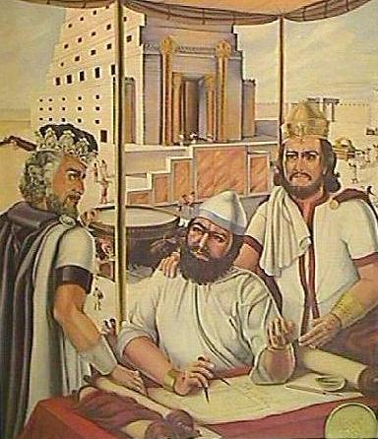
Workmen at the Temple
Hiram of Tyre, the principal architect and engineer, was of mixed race. "He was a widow's son of the tribe of Naphtali, and his father was a man of Tyre." He was "skilled to work in gold and in silver, in brass, in iron, in stone, and in timber, in purple, in blue, and in fine linen, and in crimson; also to grave any manner of graving, and to find out every device which shall be put to him. Cunning, a man richly endowed by Nature in wisdom and knowledge, he was preeminently fitted for this almost supernatural task. With him were associated the trained and "cunning" men of David, who had "trained workmen in abundance, hewers and workers of stone and timber." 1 Kings 7: 13-14.
"Solomon numbered the strangers that were in the land of Israel, and they were found an hundred and fifty thousand and three thousand and six hundred." He set three score and ten thousand of them to be bearers of burdens, and four score thousand to be hewers in the mountain. In addition, Solomon raised a levy out of all Israel of thirty thousand men, which he sent to Lebanon. Over this great army of workers, in order to obtain the greatest efficiency and results, he set three thousand six hundred overseers, besides the chief of his officers, which were over all the work. 2 Chron. 2: 17-18.
Solomon having married a daughter of Egypt's king, and thus cemented his alliance with that powerful monarch, and having, at the same time, a workable trade pact with the Phoenicians, drew from these nations skilled workmen to assist his already well-trained and formidable force. In addition, nearly all the neighboring nations as well as those of more distant realms were drawn upon for builders and artisans skilled in wood, metal, and stonework. 1 Kings 5: 18.
Architecture of the Temple
The assemblage of the world's architectural genius at Jerusalem, and the amassed store of materials of gold, silver, brass, iron, granite, and marble, together with the precious stones and costly woods and fabrics brought from foreign shores, resulted in a structure distinctive in design, gigantic in proportions, and glorious in embellishments, the like of which Israel and the people of that day had never before seen, and which will never again be equaled, much less excelled. The Temple and the Palace together, as a unit, consisted of a series of terraces round about Mount Moriah, the highest point of which was crowned by the Great Porch, with the Holy and the Most Holy Place.
The second highest terrace, surrounding the Mount, was an oblong or
rectangle, 1,600 feet long and 800 feet wide, having a retaining wall rising from the base of the Mount to a height of from 80 to 240 feet as conditions required for support, for defense, and to produce a uniform raised level about the Mount. Within this first enclosure the architects provided homes for the porters and singers, as well as havens for the worshipers. The upper terrace was 800 feet long and 400 feet wide, surrounded by a retaining wall of great stone. The eastern half of this second enclosed terrace or court was embellished by three rows of hewed stones or pillars, round about, forming a colonnade and supporting an entablature of cedar beams and costly stones. The Covert for the King was located on the north side and was of solid brass. In the western half of this oblong enclosure, and on the north side, was the Court for the women, surrounded by high walls and enclosing a series of chambers suitably arranged. To the south was the Court of the Priests, containing the chambers for those who were actively engaged in the Temple services. In the center of the western half of the great court was the inner court, 400 feet by 200 feet in size, in the form of a rectangle, surrounded by a cloistered colonnade of three rows of pillars supporting a beautiful entablature of cedar beams and costly stones. The only entrance to the inner court was through the Great Gate on the eastern side. In the center of the eastern half of the inner court stood the Great Altar of Burnt-offering. In the southeast corner was the Molten Sea, and on the north and south sides, five on each side, were the Lavers. The western square of the inner court contained the House, or Holy and Most Holy Places, surrounded by a series of chambers. The approach to these sacred precincts was through the Great Porch, rising to a height of 240 feet.
These crowning terraces which supported the Temple and King Solomon's Palace or Citadel, including his house, the House of the Forest of Lebanon, the Queen's Palace, the Porch of Pillars, and kindred structures, were surrounded for the sake of security by a wall which began at the bottom of the Mount. Some of the sides of this wall were reared 280 feet in height before they attained the desired level, and these massive and curious bases, together with the super-structure, formed an impressive prospect, which was the marvel of all beholders. 2 Chron. 3: 4.
Approaching the Temple terraces from the southwest was a road leading through a gate into the great citadel, within the walls of which were the numerous buildings. The citadel was on an elevation just below that of the Temple, and visitors to the latter had to pass through the former. Here were the King's Palace, the House of the Forest of Lebanon, the Porch of Pillars, the Queen's Palace, the Tower of David, the Palace of the Captain of the Host, the Palace of the High Priest, and the Judgment Seat or Throne. Within this same enclosure were to be found the homes of the Royal Harem, and of the immediate official family and attendants. Here also were the Royal Gardens in which were to be found a great variety of trees and beautiful shrubbery, and enclosures for wild and domestic animals and birds.
The King's Palace, the House of the Forest of Lebanon, and the other
royal buildings were of a size and magnificence such as Israel had never seen before, and were prized because they reflected the high political rank of the nation, as the Temple reflected the glory of its religious institutions. The road from the southwest gate ran diagonally northeastward to a central square which was dominated by the Tower of David. At the south of the square was the Court of Guards, at the west of the Queen's Palace, and at the east the Palace of King Solomon.
The Banquet Hall in the Palace
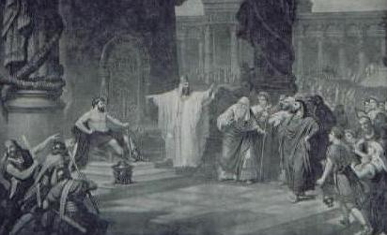
A banquet in King Solomon's Palace presented a scene of unparalleled magnificence. Here royal visitors, including the Queen of Sheba, were given sumptuous entertainment. Here also, according to tradition, the humble iron worker assumed the place of honor at a banquet celebrating the completion of the Temple, - to the consternation of the other guests but with the approval of the wise King.
The Palace of the Queen
It is stated that he built her "an house"; by that we understand that he meant it was a palace, in style Egyptian, where she could enjoy the music from her native land, isolated, as it were from Israel. Above all the women that surrounded Solomon, it is said that the only one that he really loved was his wife, the Queen; and so ardent was his love that she was able to draw him from the worship of his God and the God of his fathers.
The Porch of Pillars
North of the Queen's Palace was the famous Porch of the Pillars. This monumental structure was erected in honor of the Princes of Milo and was considered the most beautiful entrance to the Citadel of King Solomon. A famous picture portrays a Prince from Milo being received at this great portal. Important visitors such as Kings, Governors, Potentates and others of national and international standing, whom the King delighted to honor, were received at this Gate. The Porch of Pillars consisted of thirty-two pillars, beautifully entabulatured, resting upon a foundation or platform one hundred feet long and sixty feet wide. 1
Kings 7: 6.
The Porch of Judgment
Directly to the east, across an open space, was the Great Porch of Judgment. The Bible portrays a momentous event. Solomon is on his throne; at his right is his life-long friend, Zabod, and on his left, a scribe; immediately in front of the scribe is the High Priest; on the steps an orator, presenting the complaints of the Princes of the Tribes of Israel. On the right, in front of the throne, a Prophet of the Desert, dressed in
leopard skin and carrying a sheppard's crook. So important was this meeting, that Solomon called out his personal bodyguard. "He is being condemned by this Prophet as having wandered away from the faith of the true God; he is being condemned by the Princes as having squandered money in riotous living, over-taxing the people, causing universal complaint, and threats of secession from the House of Judah." 1 Kings 7: 10, 18, 19, 20.
The House of the Forest of Lebanon
Northward, extending almost to the wall of the Temple terrace, was the
monumental House of the Forest of Lebanon. In the foreground were the elaborate and beautiful sunken gardens. Upon the right and left of this building, enclosed by entablatured walls, were the international bazaars and shops.
The Inner Court of the Temple
The avenue from the southwest gate of the citadel, having passed the Palaces, the Porches, and the House of the Forest of Lebanon, proceeded again northeastward to an open space before the House of the High Priest, where there was a gate leading upward to the Forecourt of the Temple. This outer court occupied the whole of the eastern half of the Temple terrace, and on its northern side was the great brass Covert for the King. At the western side of the Forecourt was the gate to the Inner Court, whence rose the facade of the Temple itself.
The Altar of Burnt-Offering
In the center of the eastern half of the inner court stood the most indispensable part of the apparatus of worship, the Altar of Burnt-offering, made of brass, "twenty cubits in length, twenty in breadth and ten cubits in height" (40 feet long, 40 broad, and 20 high). 2 Chron. 4: 1.
The Molten Sea
The inner court, the southeast corner, stood the most striking of the creations of Solomon's Phoenician artist, Hiram of Tyre. This was the Molten Sea. It was a large circular tank of bronze, "thirty cubits in circumference, ten cubits in diameter and five cubits in height" (60 feet around, 20 feet across, and 10 feet high), with a brim the thickness of a handbreadth. These measurements show that Hiram understood the principles of circular form and construction. This great sea rested on the backs of twelve bronze bulls which, in groups of three, faced the four cardinal points. 1 Kings 7: 23-27; 2 Chron. 4: 2-5.
The Lavers
There were ten Lavers of brass raised on bases resting upon wheels. They were used for washing the animals to be sacrificed in the burnt-offering and in the general cleansing of the court after the services. Each one was "four cubits long, four cubits wide and three cubits high" (8 feet by 8 by 6). The Lavers, bases, and wheels were highly ornamented, and symbolically embellished with lions, oxen, cherubim and palm trees. Five of the Lavers stood on the north side of the inner court and five on the south side. 1 Kings 7: 27-39.
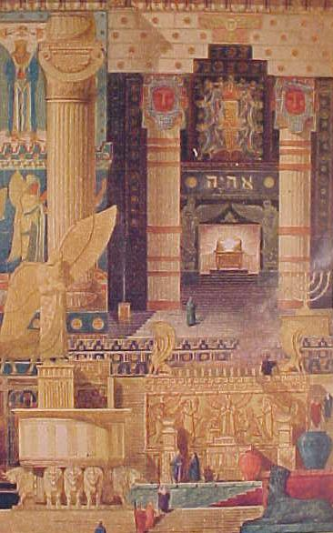
The Great Porch
The Great Porch was a monumental structure "one hundred and twenty cubits high" (240 feet), built over the entrance to the Sanctuary. This entrance or vestibule was "twenty cubits long and ten cubits broad" (40 feet by 20). Through this porch the priests were admitted to the Sanctuary. 2 Chron. 3: 4; 1 Kings 6: 3.
The Two Pillars of Brass
These two great bronze shafts, standing in relief, formed an important feature in the architecture of the Temple. Each one was "thirty-five cubits high and twelve cubits in circumference" (70 feet high and 24 feet in circumference). They were highly ornamented by a network of brass, overhung with wreaths of bronze pomegranates, each row containing one hundred. Upon the pillars and the top of the chapiters were pommels (great bowls or vessels for oil) over which were hung, festoon-wise, wreaths of pomegranates, interspersed here and there with lily work. They bore the names of Jachin and Boaz and were placed in front of the porch leading to the Sanctuary. 2 Chron. 3:15; 1 Kings 7: 15-22; 2 Chron. 4: 12-13.
The Treasure Room
This room occupied the space above the Holy and Most Holy Places, extending the entire length of the House. It was "sixty cubits long, twenty cubits wide and ten cubits high" (120 feet by 40 by 20). Here were stored the many things King David had dedicated to the Lord. Here also were the silver and gold vessels and instruments, and all the dedicated things such as gifts from allied kings, princes, potentates, and all other important personages. It was also the royal treasury where Solomon deposited and from whence he disbursed all things of value. 1 Kings 6: 2.
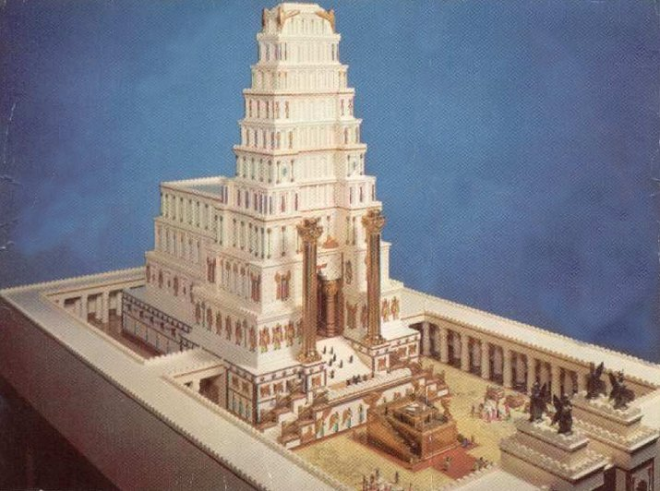
The Chambers Round About the Temple
A series of chambers surround the house on three sides, the north, west, and south, all three stories high. The uppermost chamber was "five cubits," 10 feet broad, the middle one was "six cubits" (12 feet) and the third or lower chamber was "seven cubits" (14 feet). Access to these chambers was by means of a peculiar and secret winding stairway on the south side of the house from the lower into the middle and from thence to the upper chambers. These chambers were all finished in fine wool and overlaid with pure gold, affording quiet and secluded spots for secret communion with God and for the preparation and proper clothing of the priests, as well as storage room for the vessels and instruments used every day in the ritualistic services. 1 Kings 6: 5, 6, 8, 10.
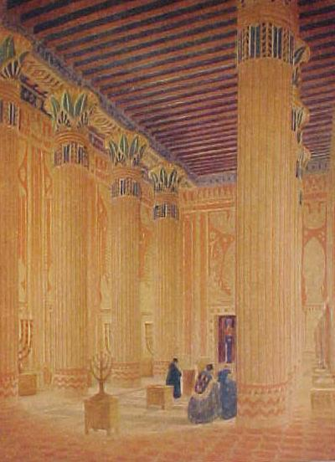
The Holy Place
The Holy Place, or Greater House, was a double cube "forty cubits long, twenty cubits wide, and twenty cubits high" (80 feet long, 40 wide, and 40 high), "ceiled with fir tree," overlaid with fine gold and settings of palm trees and chains, with engraved cherubim on the walls. The entire house was garnished with precious stones for beauty. The entrance to the house was by a large double door, two leaves to the one door and two leaves to the other, of olive wood, carved with cherubim, palm trees, and open flowers, all overlaid with pure gold.
The furniture of the Holy Place consisted of ten candlesticks of pure gold, five on the right side and five on the left, together with their lamps and snuffers; also ten tables with pure gold, five on the right side and five on the left, together with their bowls, basins, spoons, and covers. To these must be added the golden altar of incense and its censer, the table of shewbread, and the golden candlestick of the Tabernacle, all harmoniously arranged within the walls, ceilings, and floors of gold set with precious stones. 1 Kings 7: 49; 2 Chron. 4: 8.
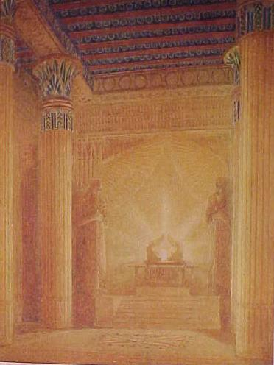
The Most Holy Place
The Holy of Holies was a perfect 40 foot cube "twenty cubits broad, twenty cubits long, and twenty cubits high." All the walls round about were carved with figures of cherubim, palm trees, and open flowers, all overlaid with pure gold; even the floor was overlaid with gold, and all was garnished with precious stones for beauty. The two doors leading to this Most Holy Place were of olive wood, cunningly carved with cherubim, palm trees and open flowers, and overlaid with pure gold. Each door had two leaves which folded. Over this entrance hung the veil of blue, purple, and crimson of the finest fabric, cunningly wrought with cherubim, palm trees, and open flowers. This beautiful tapestry defined the entrance to the Oracle. The only piece of furniture in the Most Holy Place was the Sacred Ark of the Covenant of the Lord, containing the testimony. This was the place within the oracles shadowed by the wings of two gigantic cherubim of olive wood, overlaid with pure gold. Each cherubim was "ten cubits high" (20 feet) with an outspread of wings of "twenty cubits) (40 feet). 1 Kings 6:23.
The Temple and Early Masonry
History is an afterthought, written only when greatness has already been achieved. There was no Hebrew history before David, who united the tribes and conquered their enemies. Nor was there any Masonic history, as we know it, until the operative stone masons of England had established their craft by building some of those marvelous monuments to Christian civilization, the Gothic cathedrals. But there were Masons and there were Hebrews long before their were books about either. In the widely separated beginnings of both Hebrew and Masonic history we find references to the building of a Temple. We have seen that King Solomon's Temple was not built in a day, or without the accumulation and expenditure of a vast treasure in materials, craftsmanship, and human organization. We have seen that a generation of intensive preparation (David concentrating the energies of a kingdom on a project he was never able to behold) preceded the actual building, and that long ages of venerating the simpler Tabernacle in the Wilderness came before that.
The Masonic fraternity started simply, too, and the magnificent brotherly structure of the past two hundred years was many centuries in the making. Unlike the Temple, the fraternity in its formative years had no powerful king to protect and support it, and its growth was far less spectacular than that of the great monument on Mount Moriah.
The Temple and Eternity
King Solomon's Temple was the perfect architectural expression of the religious faith of a people. As such, it has never been equaled in the history of the world, much less excelled. Its actual life was short, but is influence has been incalculable. Built to endure for centuries, only a few years elapsed before it was desecrated and then completely destroyed by invading armies. Yet its fame did not die. The children of Israel, with fervid determination, rebuilt it twice, and twice more it was destroyed. The descendents of its builders were scattered far and wide over the face of the earth, but the traditions of their labor and their unity and their accomplishment have remained to inspire all subsequent ages, and the magnificence of the Temple they built is still acknowledged as the epitome of gorgeous architecture. To arrive at recorded Masonic history, we must leave the age of King Solomon and the builders of the temples at Jerusalem far behind, coming up to the British Isles during the Christian Middle Ages.
Medieval History and Legend
The legends of Masonry are very old, and they tell of times far older then themselves. The earliest legendary Masonic writing which has survived in manuscript is a little book consisting of 33 leaves of parchment, written in English, probably before 1390 A.D. "Here begin the constitutions of the art of Geometry according to Euclid," are the opening lines, in Latin. Then the manuscript proceeds, in old English doggerel, to tell how "that worthy clerk, Euclid," taught the useful art of geometry to unemployed sons of the Egyptian nobility, how the knowledge which he taught spread to France and England, and how he admonished his pupils, in fifteen articles and fifteen points, to be good men and worthy exponents of the art of geometry. By geometry he meant Masonry. This medieval stone masons' organization, forerunner of modern Masonry, was already of respectable age when the book of "Euclid's constitutions" was written. It was old enough so that its living members saw nothing ridiculous in tracing their history back to Lamech, the grandson of Adam, and through him to Pythagoras of Greece and Hiram, King of Tyre, and King Charles Martel of France and Athelstane, King of England, even though these celebrities were separated from each other by centuries rather than by years. It was old enough so that not only stone masons but gentlemen and dignitaries of the Church were interested in its legends, and impressed with its supposed continuity since Biblical times. The next oldest Masonic manuscript, written only a few years later, tells substantially the same story in a somewhat different manner, and also includes a reference to King Solomon's Temple. Solomon is represented as having confirmed Euclid's articles and points for the government of Masons. These two Masonic manuscripts are the oldest of a long series known to have been written over a period of more than 300 years, between the end of the 14th century and the beginning of the 18th. They are sometimes called the Old Charges of Masonry, and sometimes the Manuscript Constitutions of the Craft. Because they link modern Freemasonry with an immemorial past, they are also called "the title deeds of the Fraternity." In all of them is an account of the Temple of Solomon, or "Templum Dei," or "Temple of Jerusalem," or "Templum Domini," and an attempt at the establishment of a kinship between the builders of this Temple and the English stone masons for whom the manuscripts were written. King Solomon and Hiram, King of Tyre, are always in the story, and usually a third builder who is represented as Aynon, a son of Hiram. Thus the dominant theme of the builder's art appears in the very earliest history of the Craft.
The Bible and Early Masonry
In the oldest Masonic legends the building of King Solomon's Temple was not the only, or even the principal event commemorated. Nor is the Bible mentioned in these early times as the central light of the Lodge. But the Masonic organizations in which these legends were cherished, like Masonic Lodges today, were religious bodies. Masons working on the abbey at Hirsau in southern Germany, 300 years before our first manuscripts were written in England, were actually organized as Lay Brothers under the Benedictine rule. Almost as early, there were Cistercian Lay Brothers working on a church in Yorkshire. Their motto was "Ora et Labore," "pray and work." Practically every one of the old manuscripts containing Masonic legends begins with an invocation to deity: "In the name of the Father, the Son, and the Holy Ghost, Amen." Practically every one closes with an oath, or a reference to an oath, "So help you God, and by the contents of this book," and often with the further admonition, "It is a great peril for a man to forswear himself upon a book." In many manuscripts an actual ceremony is described, practically always in Latin: "One of the Eldest taking the Book shall hold it forth that he or they which are to be made Masons may impose and lay their right hand upon it and the Charge shall be read."
The Church and the Bible
The repeated references to the "book" in these old manuscripts almost certainly mean the Bible. And as far as recognition of the Bible by early Masons is concerned, this is quite as much as could be expected in an age before printing had been invented, when every book in the world had to be laboriously copied by hand, and when the Bible, moreover, was written only in Latin. Few people could read the Bible, and fewer still could own a copy. It was a book to be venerated, but not read. The religious instruction and inspiration which the Bible supplies nowadays was then derived from three sources: (1) ecclesiastical symbolism and ceremony; (2) mystery plays or Biblical entertainments; and (3) architecture. Masons may have participated in the second; they were of primary importance in the third. When people could not read books, the lessons of religion had to be taught in other ways. They were taught by sermons of the priests and by the ritual of the sacraments. They were also taught dramatically through mystery plays, performed often by the craft guilds. The Masons may possibly have used a mystery play whose story survives in the third degree. Above all, the lessons of religion were taught during the Middle Ages through architecture and sculpture. Every village church was a message from God, and the cathedral was an entire Bible. The general plan of the church, the choir, the chapels, the carved figures of saints, the painted windows, - all told the story of God's fatherhood as clearly to the people of that day as our Bible tells it to us. The Masons' part in telling this story was a most important one, and this as well as other circumstances set the Masons apart from other crafts.
The Letter and the Word
This medieval period, which saw such a growth of Masonry, was essentially an age of symbolism. Everything in architecture, in ceremonial, in heraldry, in religion, had its symbolical meaning. Interpretation of the symbolism was left almost entirely to one division of the community, the Church, and to a few thinking people it must have seemed that as time went on the symbols grew in importance and the meaning faded. The letter became dominant, and the Word was lost. Toward the end of the medieval period, at just about the time the Masonic Old Charges were being written, the first complete English translation of the Bible was compiled by William Wycliffe. Here was the word itself, and those who had an opportunity to read it could go beyond the symbolism of architecture and heraldry and ceremonial to the religious reality on which it was based. A new authority was challenging the supremacy of the Church. That new authority was the Bible. The progress of the challenge was called the Reformation.
The invention of printing made possible the rapid dissemination of the new religious literature, especially the Bible. The Church ceased to be the unquestioned interpreter of religious truth; its place was gradually taken in Protestant countries by the Bible. The importance of religious architecture as a teacher of the people decreased rapidly, and with it diminished the importance of the operative stone mason's craft.
Operative to Speculative
Membership in medieval craft guilds, including whatever type of organization the Masons had at that time, was not strictly confined to the workers of one particular craft. Other workers, and sometimes gentlemen and noblemen, occasionally sought and gained admission. This must have been especially true in the Mason's organizations. The writer of the earliest Masonic manuscript was almost certainly a priest, and no doubt many churchmen held a kind of Masonic membership. Later, after church building had practically ceased, and the nature of the Masonic organization changed with the new conditions, members from outside the craft continued to be accepted. These "accepted" members, or "speculative masons" as they were later called, were no doubt few in number at the time of the Reformation. Their presence, however, and the legendary background which attracted them, must have encouraged the survival of a craft whose operative reason for existence was rapidly disappearing. Even with economic ruin which the Reformation brought to the stone masons' industry, it was a long time before the "accepted" masons reached the majority and took possession of the organization.
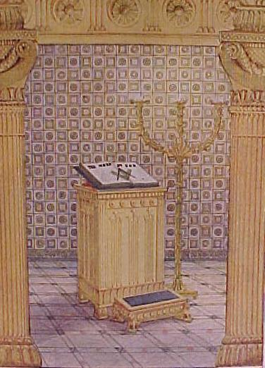
The Bible and the Temple
The Bible is many centuries old, but as a literal force in the life of western Christianity it began to grow only with the invention of printing and the success of the Reformation. Its growth as the Great Light in Masonic Lodges paralleled its growth in the churches and in the homes of pious men. Masons, like other people, took up the reading of the Bible as soon as it was translated out of the Latin and printed in sufficient quantities to bring it within reach. Always present in the Lodge for the swearing of candidates, it became increasingly important in the minds and lives of its readers. Masons became aware of the Biblical source of many of their Legends, and perhaps became inclined to attribute Biblical significance to legends which originally had none. At any rate they could see that the fundamental precepts of Masonic morality were actually to be found in the Volume of Sacred Law. They saw also that King Solomon's Temple occupied a prominent place in divine as it did in Masonic history. The growth of popular interest in the Temple paralleled very closely the growth of Bible reading. Perhaps Masonic interest also increased from a more or less incidental notice of the Temple to a final preoccupation with it as a symbol of spiritual man. The Bible hardly came into its own as a widely read book until after the publication of the King James version in 1611. The Temple began to appear prominently in religious literature at about the same time. Hugh Broughton, who died in 1612, left some writings on the Temple, as did John Selden (1584-1654). Nicholas Fuller referred to it in a book published at Heidelberg in 1612 and at Oxford in 1616. Christopher Cartwright (1602-1658) had a good deal to say about the Temple in his writings on the Talmud. Samuel Lee, in 1659, published a very suggestive work: Orbis Miraculum, or the Temple of Solomon, Portrayed by Scripture-light . . .
Models of the Temple
Late in the 17th century there were several attempts to create models
of King Solomon's Temple. Some of them attracted wide notice in England at just the time the operative Masonic craft was being gradually transformed into what we know as speculative Freemasonry. Gottfried Hensel, rector of Hirschberg in Germany, made a model. Rabbi Jacob Jehuda Leon was displaying one in England in 1675. A little later, Gerhard Schott was building his in Hamburg. This one was still being shown in London in 1725, eight years after the first Grand Lodge was organized.
Solomon's Temple Spiritualized
Even before the Apostle Paul, in his first letter to the Corinthians,
spoke of man as "the Temple of God," the idea of a spiritual temple in the human soul has had religious currency. It was natural that Solomon's great building should come to be regarded as the ideal prototype of such a temple. It was natural, also, that this idea should be an integral part of the first essay in which the word "Freemason" ever appeared in print. In The Pilgrimage of Perfection, by William Boude (1526), the following appeared: "We were but as apprentices bound to learn the craft of the exercise of virtues; and now this day we shall be masters of the craft. Example. The free mason setteth his apprentice first a long time to learn to hew stones, and when he can do that perfectly, he admitteth him to be a free mason and chooseth him as a cunning man to be master of the craft, and maketh him a setter or orderer of the same stone . . . And so to build to Almighty God a glorious and pleasant temple in our souls, we as the workmen, and He as the principal author and master of the work. Now in diverse degrees, according to their exercise in grace, every person buildeth in his soul a temple to God, some more some less, as the clearness of their consciences requireth . . ." The next section of the book drew lessons from the Tabernacle and Temple.
Antiquarians and Freemasons
Many non-operative members of Masonic lodges, the "speculative" or "accepted" Freemasons, must have been interested in the Temple, as well as in the cathedrals, now old, which the operative Masons had built. In the century following the Reformation, the craft attracted philosophers, scientists, and antiquaries, as well as gentlemen and soldiers. Elias Ashmole and Randle Holme were two distinguished examples, and there is no doubt that several of the original members of the Royal Society were Masons.
To these men, if not to the operative Masons generally, the place of
King Solomon's Temple in Masonic legend and symbolism must have become increasingly important. They were interested in the Temple as Solomon actually constructed it, and they were almost certainly interested in it also as a symbol of man's struggle for perfection. Francis Bacon, who may or may not have had direct connection with then existing Masonic organizations, wrote a few years before 1626 a fable called The New Atlantis, an important feature of which was a marvelous society known as "Solomon's House." This had nothing directly to do with King Solomon's Temple, but it showed the disposition of learned men of the 17th century to associate any organized search for wisdom and truth with the symbolism of the Temple which Solomon built in Jerusalem.
Grand Lodge Masonry
The exact position of the Temple and the Bible in operative and early
speculative Masonry is still in question. Enough has been shown to indicate that both must have been of considerable importance. It is especially evident that King Solomon's Temple, since it was attracting so much attention in the world at large and among the class of men who became speculative Masons, must in the 17th century have been one of the outstanding legends of the Craft.
Early in the 18th century (1717), four old Lodges in London met
together to form the first Grand Lodge, and Freemasonry was well on its way toward becoming the organized fraternity which we know today. Probably as early as 1720 or 1730, George Payne, John T. Desaguliers, and their associates had developed a ritual of three degrees, with the legend of King Solomon's Temple holding the central position. This legend, of which there were possible suggestions in the earliest manuscripts, had grown to be one of the dominant themes in Masonry.
Concerning God and Religion
Probably we should never know just how different or how similar Grand
Lodge Masonry may be to the operative and speculative Masonry that came before it, but of one important change there is no doubt. The operative Masonry of the Middle Ages, and also the increasingly speculative Craft of the 17th century, were Christian and Trinitarian. In contrast, the first Charge in the Grand Lodge Book of Constitutions, 1723, was as follows: "A Mason is obliged by his Tenure, to obey the moral Law; and if he rightly understands the Art, he will never be a stupid Atheist, nor an irreligious Libertine. But though in ancient time Masons were charged in every Country to be of the Religion of that Country or Nation, whatever it was, yet 'tis now thought more expedient only to oblige them to that Religion in which all men agree, leaving their particular opinions to themselves; that is, to be good Men and true, or men of Honor and Honesty, by whatever Denominations or Persuasions they may be distinguished; whereby Masonry becomes the center of Union, and the means of conciliating true Friendship among Persons that must else have remained at a perpetual distance." Still deeply religious, Masonry had become universal.
Important as the Bible undoubtedly was in early speculative Masonry, its dominant position became more rather than less pronounced after the organization of Grand Lodges in the 18th century. Although this first charge Concerning God and Religion in the Grand Lodge Book of Constitutions does not specifically mention the Bible, the implication is that its immemorial status as an essential part of the Lodge was well understood, and was to remain unchanged. A little later, when printed references to Masonry became more plentiful, the Bible appeared prominently in them. As early as 1730, the Bible, Square, and Compasses were mentioned in London as "furniture of the Lodge." According to The Boston Evening Post, June 20, 1743, reporting an incident in Vienna, a Lodge there had "a Bible on the table, open at the first chapter of Genesis." In Helston, Cornwall, April 21, 1752, a Brother Issac Head delivered a Charge: ". . . Let our whole deportment testify for us that we have formed our lives upon the perfect model of God's revealed will, exhibited to us in the Holy Bible; that this Book is the basis of all our Craft, and that it is by this piece of Divine furniture, so essential to our society, we are taught wisdom, to contrive in all our doings. . ." The Bible is now so closely identified with the Lodge that, for Christian countries, it is one of the very few undisputed Landmarks of Freemasonry. Another is belief in God. These two essentials, belief in a Supreme Being and reverence for His Word, establish beyond question the character of the Fraternity.
How the Pictures were Obtained
It is known to every reader of the Bible and student of Solomon's days,
that an amazingly detailed description of the Temple and its associated
structures has been carried down from the mists of antiquity by the
Scriptures. Lineal measurements, materials employed, and ornamental detail are so graphically presented that restoration of the Temple, at any time within a score of centuries past, awaited only the coming of a man with the vision to recognize its historic value, and the imagination to undertake the task. Notwithstanding the universal interest in King Solomon's Temple, -- a fascination which has created innumerable legends and romances during the intervening centuries -- the incredible fact remains that no scientific effort to restore the Temple was made until John Wesley Kelchner, Archaeologist, Bible Student and Lecturer began eighty years ago to make real his vision of the Scriptural description. His personal fortune went freely into the world-wide search for archaeological data and period decorative technique, from which to render accurately, down to the minutest detail, the ornamental scheme revealed by the Biblical story. Other noted archaeologists collaborated with Dr. Kelchner, and at length the work was completed. In 1923 Dr. Kelchner had assembled all that was needed to erect an exact replica of a Temple which had vanished 3,000 years ago.
The next step was to display the entire conception, from the foundation
up, in graphic sketches, paintings, working drawings and plans. In his New York studio, he surrounded himself with expert draftsmen and capable artists, laying before them the models, plans and designs of this, his life work. As Moses after receiving the Designs of the Tabernacle of Israel called to his aid the "cunning" master mechanic, Bezaleel, who was "filled with the spirit of God in wisdom, in understanding and in knowledge, and in all manner of workmanship," and as Solomon "sent and fetched Hiram out of Tyre," filled with wisdom and understanding, and a cunning skilled workman, so did John Wesley Kelchner labor with these experts. Together they dropped out of the Twentieth Century, back into the years 1011-1004 Before Christ. The difference was only thirty centuries between; the creative objective the same; and the results identical.
Now the art of our period is enriched by a set of paintings and drawings of unparalleled historical value. Nothing so marvelous of its kind has ever been achieved for the illustration of any subject. The paintings and drawings were prepared by the ablest artists of their field in America and Europe. They translate to the layman's vision the architect's technical plans as worked out in modern builders' specifications.
A special "Thanks" to Artist and Lecturer - Rev. David Hamilton of Mishkan Ministries for allowing us to photograph and display his beautiful Ark and other Temple furniture in our museum. David has a website of his own where you can see other reproductions of Temple artifacts like the Golden Candlestick, Table of Shewbread and Altar of Incence. David travels the United States giving lectures on these sacred objects. You can visit his website by clicking on the link below:
http://www.mishkanministries.org

