A BRIEF HISTORY OF NEW THOUGHT
by Roger and Lydia Weiss
http://website.lineone.net/~cornerstone/nthistory.htm

Michael Servetus was burned at the stake in Geneva, Switzerland in 1553 for a theology akin to New Thought, and Emanuel Swedenborg, a scholar & master of many fields, in the 1700's, secretly wrote of New Thought. It was Phineas P. Quimby in the 1800's, a master New England clockmaker, who gave up his trade to heal & was the first to proclaim a system of healing based entirely upon spiritual and mental processes. Quimby is considered the founder of New Thought.
Dr. Phineas Parkhurst Quimby's Principles:
God is invisible Wisdom which fills all space, and whose attributes are all light, all wisdom, all goodness and love.
90% of all beliefs are erroneous
God is Principle, without form or sex.
God is the only reality - everlasting essence, existing in all matter.
Indicted the clergy of his day as filling the world with sickness & disease
All subversions of Christ's doctrine which now pass as religion must one day give way to Truth. The true God is Benevolent, and could never have created disease.
Quimby understood Jesus to be opposed to all forms and ceremonies, having no "religious" opinions as such, and curing simply by changing the minds of those afflicted with maladies correcting errors in thought.
False ideas and mental imagery cause disease.
Sickness comes from beliefs and fears. Faith heals.
He had supreme contempt for misuse of authority.
God lets people work out their own salvation, and people are sanctioned according to their own belief.
Quimby transmitted his views to patients of his Warren Felt Evans, Julius and Annetta Dresser, and Mary Baker Eddy, who founded Christian Science. A former Eddy associate, Emma Curtis Hopkins was know as the teacher of teachers, as she taught the founders of Unity Church (Charles and Myrtle Fillmore), Religious Science (Ernest Holmes) and Divine Science (Nona Brooks and Malinda Cramer). Fenwich Holmes, brother of Religious Science founder Emest Holmes, partly influenced Masaharu Taniguchi to found Seicho-No-le, the Japanese New Thought Group with the largest following worldwide. A mystical outgrowth of Christian Science is Joel Goldsmith's Infinite Way. A recent addition to New Thought is A Course in Miracles.
The New Thought founders, e.g. Quimby, Holmes and the Fillmores originally did not intend to start churches but bring New Thought principles into other religions and groups.
In 1915, New Thought groups met and formed the Interrnational New Thought Alliance (INTA). INTA is a free and open alliance of truth motivated individuals and organizations who desire to unfold and practice a positive life-style of spiritual maturity. It's purpose: to teach people to come into a conscious realization of the divinity within, and the unity of God and man, so that out of the sublimity of our souls we can say, "I and the Father are one". Annual Tranformational-Expo's, regional and international meetings are held.

NEW THOUGHT: what it is and how it can help YOU!
(The following is exerpted from a pamphlet put out by Calgary New Thought Centre.)

New Thought churches are variously called Unity, Science of Mind, Churches of Religious Science, Divine Science, Churches of The Truth; and there are a myriad other independent churches, centres, and study-groups espousing the same "New Thought" philosophy. All of these groups would fit into the terms of reference of the philosopher, William James, in his book, The Varieties of Religious Experiences, as "the religion of healthy-mindedness." Many of these societies are loosely associated under the umbrella organization of The International New Thought Alliance. One of the main functions of the I.N.T.A. is the presenting of an annual congress bringing these groups together as a unit. These are held in different cities throughout North America.
WHAT ARE NEW THOUGHT "ROOTS" ?
New Thought roots date back to the antiquity of man, but there are two tap-roots that initially fed the growth of New Thought in America and the world. Phineas P. Quimby is regarded as the founding father of New Thought in America. He was a New England clock-maker who became interested in Mesmerism, a forerunner of hypnotism as we know it today, a new phenomena introduced from France in 1838. This technique appeared to effect cures to seriously-ill patients that seemed beyond the help of medicine. Through study of this phenomena, use of his scientific mind, and a personal "miraculous" healing, Quimby realized that Mesmerism was not necessarily needed to effect a cure. Quimby would sit with a patient, and through his personal insight intuitively determined the nature of the problem. He would then explain the situation to the patient and recovery was realized. This discovery or method of healing he termed the "Science of Christ," or "Christ Science," assuming that he had rediscovered the method Jesus used in his healings. Quimby was instrumental in healing thousands, many of whom were regarded as incurable by medical science of the time, through this mental healing process. One of Quimby's patients who became very well-known was Mary Baker Eddy. She was cured through Quimby's method and using the same concepts founded the Christian Science Church, which is not associated with New Thought. Quimby did not see the need of a church organization; Mary Baker Eddy did. It is concluded that if it were not for Phineas P. Quimby we would not have known of Mary Baker Eddy; and without Mary Baker Eddy we may not have known of Phineas P. Quimby. Another strong-willed woman of genius, Emma Curtis Hopkins, worked with Mrs. Eddy, but, because she endorsed truths found in other religions and philosophies outside the teachings of Mrs. Eddy, was obliged to leave the Christian Science organization. Emma Curtis Hopkins became known as a "teacher of teachers" for her influence in teaching and inspiring many founders of New Thought churches. Two of the better-known students of Hopkins were Charles and Myrtle Fillmore who studied with her and subsequently founded Unity School of Christianity, the largest denomination having members in the New Thought movement. A Mrs. Frank Bingham, grievously ill, was put in touch with Emma Curtis Hopkins. After just three weeks of study and treatment, she was able to return to Pueblo, Colorado, in radiant health. She gave informal classes, using Hopkins material, to a group which included the sisters Miss Nona Brooks, Mrs. Fannie james, and Mrs. Alethea Small. These three women, with Mrs. Malinda Cramer, founded the Divine Science Churches. Ernest Holmes studied with Hopkins in her later years after he had drawn much inspiration from Ralph Waldo Emerson and Judge Thomas Troward and Christian D. Larson. He went on to found the School of Religious Science. Thomas Troward was the other tap-root of New Thought. As a member of the British Civil Service he served as a Divisional Judge in the Punjab for twentv-five years. A devout churchman, and a student of all religions, he formulated a philosophy that explained a creative mental process. This. he concluded, was used by all persons in mentally creating their world. He lectured on this "Mental Science" to use his term, and presented a concept that was later described by the American philosopher, William James, as, "far and away the ablest statement of the philosophy I have met, beautiful in its sustained clearness of thought and style." Troward's idea and philosophy was brought to America, initially, by Dr. Harry Gaze, and later his friend, Emmet Fox. As many as six thousand would flock to hear Fox's bi-weekly services in New York. His books are still widely distributed and read by many denominations within and without the "New Thought" umbrella. These two, Phineas P. Quimby and Judge Thomas Troward, are the tap-roots of New Thought; and Emerson provided the climate for growth. Emerson was a Transcendentalist Unitarian Minister, widely known and idealized for his writings of literary excellence. The literary content of his writings was well received although his ideas were not universally accepted in the religious climate of that period. They did, however, open people's minds to new ideas. Albert Grier, a former Universalist minister, having received healing from reading and assimilating New Thought philosophy through literature, was instrumental in founding the Churches of The Truth, espousing this "Truth that sets men free." It was from the mid-1800's, then, that this school of thought and religion has spread throughout the modern world. The philosophy has been helped to cross denominational barriers by such leaders as Norman Vincent Peale and Robert Schuller and their concepts of the "Power of Positive Thinking.'' The New Thought message, then, being presented today is a composite message, based on Bible truths, complemented by the laws of science, the opinions of philosophy, and the wisdom found in all living religions, providing you with an understanding of your place in the cosmic scheme of things in this universe.
DOCTRINE
New Thought has no doctrine or dogma as presented by other churches. New Thought teachings do not assume that there is any finality in the discovery of Truth, It is an eternal, ongoing process in every individual. It teaches; and expects continuous revelation for all of humanity. Our purpose is not to point the way for you to go, but rather to walk with you on the path of discovery of yourself, and discovery of your relationship to God. We may appear somewhat dogmatic, in some basic concepts such as: (a) There is One Presence, One Power, One Intelligence, One Mind, One Love: throughout the Universe. (b) The first of all commandments is: Hear, 0 Israel, the Lord our God is one; And you must love the Lord your God with all your heart, and with all your soul and with all your mind and with all your might. And the second is like to it: You must love your neighbor as yourself. (c) All men/women are born of God, hence the inherent divinity of all humanity.
BELIEFS
-- ABOUT GOD God is all there is, Omnipresent, Omnipotent, Omniscient, First Cause, Divine Mind, Divine Intelligence, Pure Spirit, Limitless Being everywhere present, absolute, changeless. eternal, everywhere and forever manifesting as Creative Intelligence; Everything both visible and invisible. God is an intelligence and a presence: not a person, but a principle. In the Beginning, God...In the smallest particle of one atom there is controlled activity and space relationship. Multiply this by the atoms in the ocean, the sands of the desert and in all living things and you then have some idea of the infinite law and order in the universe maintained and controlled by this infinite intelligence that we call God.
-- ABOUT OUR RELATIONSHIP TO THE CREATOR We are made in God's image and likeness. God, being all there is, can only create of Him/Herself; therefore, we are made in His/Her image, likeness, and nature. We are like the drops of water to the ocean; it is ocean, but it is not the ocean, yet it contains all the elements of the ocean. We are as the ray is to the sun; it is sun, but not the sun. We are in the finite what God is in the infinite.
-- ABOUT RACE, CREED OR COLOR We are all created by the One Creator. "Behold, God saw all that He had made, and it was very good." There is unity in all humanity and in all life; therefore, all are the expressions of the One God. God did not choose any particular race, creed or color: we choose God. We choose God in our thoughts for there can be no separation from God except in our own thinking.
-- ABOUT JESUS Man is the highest expression of God, and Jesus (amongst others) was an example of this expression. Jesus, having manifested the Christ of His Being, or His "Christ Consciousness" earned the title of Christ. His mission was one of love and to establish our personal relationship to the Creator. He was the example, and not the exception. This is the universal God Presence saying, "Lo, I am with you always."
-- ABOUT THE BIBLE We realize that the Bible is a record of the emancipation of humanity. Every Bible should have stamped on its cover, "This is me," for there we are portrayed in every person, in every state of consciousness, and in all the evolutionary concepts of God. Our nature is presented there. It is stated that the Bible is the divinely inspired word of God, and this is true; however, Divine inspiration did not cease thousands of years ago. Divine inspiration and revelation is an ongoing thing. The bible has survived the centuries and has provided a catalyst for western religious thought (as many other works by the wisdom traditions of humanity have done for other parts of our world). It does present a literal meaning, a moral meaning, and a spiritual meaning. It is the spiritual meaning that has given it timelessness. The esoteric or spiritual meaning is what we try to discover and employ in our teaching and our daily living.
- ABOUT THE CREATIVE MENTAL PROCESS We, having been made in the nature, image and likeness of God, are then co-creators with God. This does not mean to say that we create something out of nothing, but by means of this creative mental process used by God in His creation, and we, in our thought patterns, give form to that which already is, in the unformed state. Everything begins with an idea. Divine mind, working through the subconscious phase of mind, produces the effect. This is the trinity manifesting through all that is created. There are analogies that perhaps illustrate this: spirit, mind, and body; idea, cause and effect; seed, garden and produce; computer input, data process, and print out. It is self-evident in our lives that that on which we focus all our thoughts or attention comes into being. If we maintain a positive approach to life, then positive things happen in turn. Conversely, if we dwell on the negative, the universe produces that in our experience. We, by our conscious thought, produce the molds for the substance of the universe to take shape. That which we totally accept in our thinking materializes in life. This is a further realization that "it is done unto you as you have believed." God is Mind or Intelligence. This Mind or Intelligence is behind all creation. This Mind works through thought, and thought expresses as word, and the word becomes flesh (substance). It can be seen, then, that this creative law of cause and effect produces in experience man's mental states. To put it another way, that which we mentally conceive, believe in, and confidently expect, must become our experience. We believe in, teach, and encourage, practice of Spiritual Mind Treatment, This is what is termed scientific prayer, as opposed to the idea of prayer of supplication, a begging or beseeching some Divine entity outside of ourselves. We feel that we are uniting with, and complying with, the laws of the universe when we "treat"; that is, visualize, mentally accept and positively anticipate desired results. We believe it is self-evident that that on which we focus our attention comes into our experience in life. Much of our potential is self-limited by our own thought processes through low self-esteem, lack of confidence, and a resignation to negative experiences in life. As a result of our thought processes, we are responsible for many of our conditions in life concerning health, finances and general well-being. We accept that there is a Universal Creative Power and Intelligence that created us and the universe around us, and that this Power and Intelligence is eternally available to us. Spiritual Mind Treatment, then, is a recognition of this Creative Power working and expressing through us to bring about a sound mind, a sound body, and a happy and prosperous life. It is not prayer of supplication; it is prayer with a knowing, positive mental attitude buttressed by visualizing the positive end result and affirming the positive right outcome. We recognize illness, but we focus our attention on, visualize and affirm health. We recognize limitation, but we focus our attention on potential through visualization and suggestion, to stretch the mind and the mental acceptance of these possibilities. It is faith, coupled with our works, that bring desired results. It is recognizing that the strength and power of God, working through us can make many more things possible. With an understanding of New Thought, this provides spiritual help; therefore, one does not need an intermediator to find help from God. With this understanding, through Spiritual Mind Treatment, we find an answer to every prayer, a solution to every problem through the power of God expressing as us and through us. "Behold, the Kingdom of God is within."
SUMMARY
To summarize, New Thought teaches us to recognize that we are triune beings; that is, Spiritual, Mental and Physical. An acceptable teaching or philosophy must, of necessity, satisfy all aspects of our being.
As spiritual beings, we want something that satisfies our cosmic senses; we want to know where we fit in the spiritual scheme of things. We need to feel that we are part of the sustaining, maintaining, universal creator of all that exists.
As mental beings, also, our answers, ideas and philosophy must be mentally acceptable. It must not be an affront to the intellect; it should make sense. It should be scientifically verifiable.
As physical, emotional beings, we have to experience something that is emotionally satisfying; something that we can feel; something that is, can and does permeate our entire being.
New Thought does all this, in a rational, plausible, and acceptable way.
We, therefore, invite you to join us in this journey of self-discovery to the point of Awareness of Oneness with all that is.

New Thought History Chart
The material reproduced here was distributed, on two sides of folded pieces of yellow 8.5 X 11 in. paper, by the INTA/SSMR Addington Archives Committee at the 2000 INTA Congress.
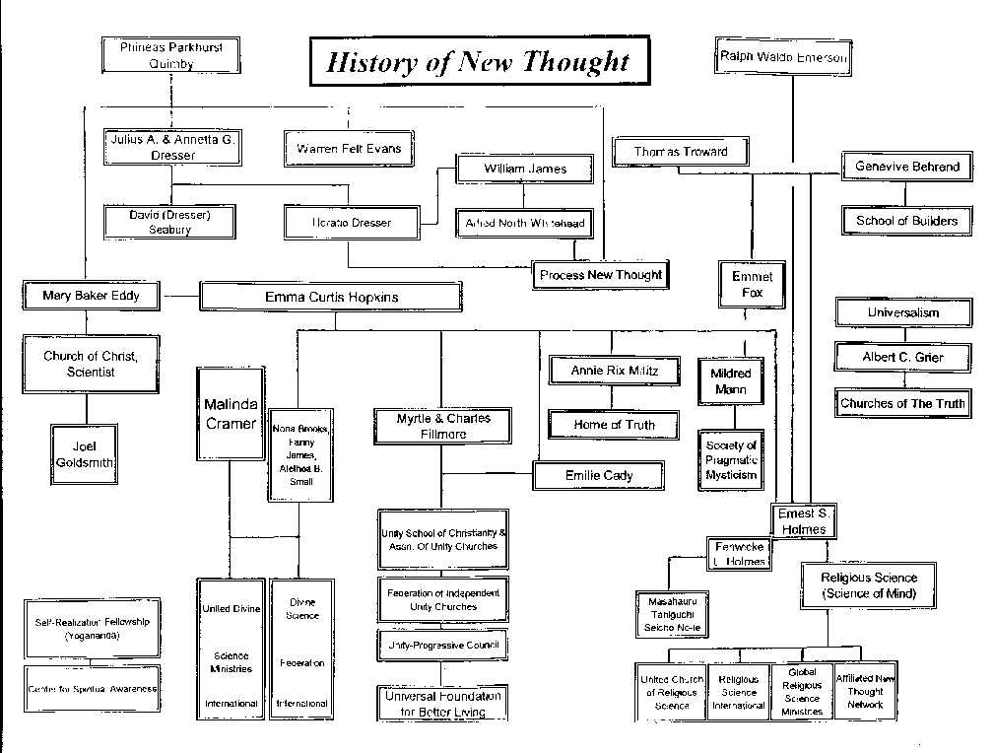
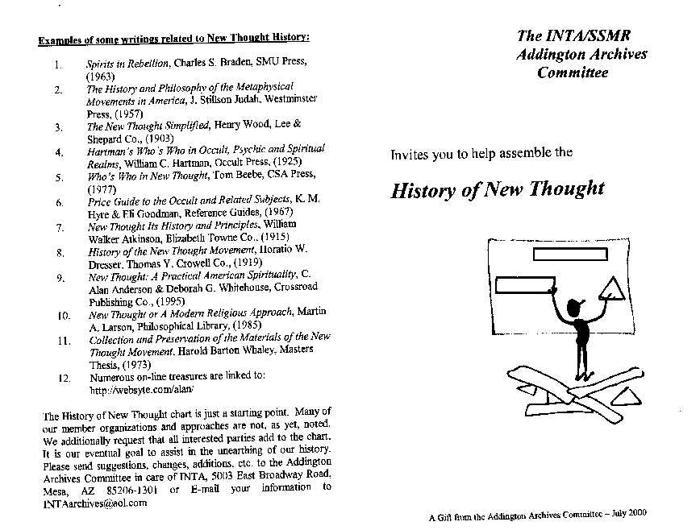

New Age and the New Thought Movement
Excerpts from Chapter 5, "New Thought and New Age," of C. Alan Anderson and Deborah G. Whitehouse, New Thought: A Practical American Spirituality
Similarities Between New Age and New Thought
New Thought and New Age both believe in a direct relationship with the Ultimate, however conceived. Neither movement favors hierarchical organizations, and both groups treat women and men as partners, with many women in leadership roles. Many people in both groups believe in reincarnation, because they feel that we can't learn all we need to learn in one lifetime.
New Age, like New Thought, is strongly optimistic, largely because most people in both groups believe in a good God, and that all people are part of God or have at least a spark of the divine. New Agers are full of hope for the transformation of society and the planet. New Thought accepts, as does New Age, the old Hermetic teaching, "As above, so below," which appears in an early version of the Lord's Prayer as "As in heaven, so on earth" (Luke 11:2). Heaven, in a New Thought interpretation, alludes to one's state of mind, and earth is the manifestation of that state. As in mind, so in manifestation. Symbolically interpreted, Heaven is the uplifted state of consciousness, the wonderful, peaceful sense of universal oneness that the mystic seeks. Charles Fillmore defines it as "a state of consciousness in which the soul and the body are in harmony with Divine Mind." All of Jesus' metaphors about heaven are attempts to explain the necessity for disciplining our thoughts, weeding out the negative ones and treasuring the positive ones; e.g., the pearl of great price, tares growing with the wheat, seeds falling in various places with various results. New Age shares New Thought's interest in metaphor, and the late Joseph Campbell, the preeminent authority on myth and metaphor, is a popular New Age author.
In large part borrowing from or paralleling New Thought, New Agers generally believe that there is only one Presence and Power in the universe and that that Power is good (although there may be a small segment who believe in Satan). Many see that Power as both immanent and transcendent. Both movements have a growing interest in panentheism (not to be confused with the old heresy, pantheism, which holds that God and the universe are one), expounded on at length by one of us (Alan) in New Thought and with perhaps a somewhat different understanding by former Roman Catholic and now Episcopal priest Matthew Fox, in New Age. . . .
Like New Thought, New Age also emphasizes the value of meditation. Much of this interest springs from the influence of Eastern religions on both movements, as well as the importance given to the power of the mind and the necessity for disciplining or training the mind.
New Thought and New Age both frequently seek alternatives to orthodox medicine, especially in overlooked natural and scientific discoveries for healing that lack the huge profit potential of drugs or surgery. Members of both groups use orthodox medicine when it is appropriate, but seek better choices where it falls short or fails altogether. They particularly seek to learn to harness the power of the mind to heal, and increasing amounts of scientific research have supported this approach. New Age physician Larry Dossey in his most recent book, Healing Words, has listed over 100 studies on the power of prayer to heal, over half showing that prayer brings about "significant changes." The result of one randomized, double-blind study by a cardiologist was so significant that Dossey states, "If the technique studied had been a new drug or a surgical procedure instead of prayer, it would almost certainly have been heralded as some sort of 'breakthrough'." Dossey also describes three eras in medicine: Era I, physicalistic medicine, dominant from the 1860s to 1950 and "still influential"; Era II, mind-body medicine, arising in the 1950s and still developing; and Era III, nonlocal science and medicine, "just being recognized."
In this, New Age is clearly building on New Thought, which began with Quimby's use of the power of the mind to heal, frequently with absent healing. Most New Age groupsþand indeed, individualsþwelcome New Thought teachings on healing and general prosperity, along with its views on God, once they become aware of New Thought's existence.
New Age is fascinated with the new physics, and New Thought shares this interest. Both movements are philosophically idealistic, and the findings of the new physics support idealism. Marilyn Ferguson observes, "the new science goes beyond cool, clinical observations to a realm of shimmering paradox, where our very reason seems endangered." Physicists are starting to sound like metaphysicians. Research moves so fast that results are obsolete before they can appear in print. Scientists have repeatedly demonstrated the mind's ability to affect the body, beginning with biofeedback and extending into studies showing that white blood cell count varied according to whether subjects thought happy or unhappy thoughts. Bell's Theorem led to experiments showing that paired particles remain mysteriously connected even after they fly apart, another example of the nonlocality that Dossey mentions in connection with Era III medicine. Neuroscientist Karl Pribram's research on holograms suggests that the universe may be a giant hologramþin other words, we are all one. As he puts it, "The brain we know now allows for the experiences reported from spiritual disciplines."
And Differences
But New Thought and New Age do differ, whether or not both are viewed as religions. One big difference is interest in the occult. Crystals, pyramids, and other occult trappings belong to New Age, not New Thought. Unity founders Charles and Myrtle Fillmore investigated various occult practices such as channeling early in their ministry and rejected them as largely ineffective and possibly even dangerous for dabblers. Still, New Thought does remain open to truth from whatever unlikely source it may spring. It may discourage interest in the occult, but it does not invariably condemn it.
In the early years of current New Age thinking, John Charles Cooper, in his Religion in the Age of Aquarius, characterized New Age interest in the occult as a wholesale rejection of a society founded on materialistic positivism (not to be confused with positive thinking). He found that this interest originated in people's frustration with social conditions that they believed that they could not control. If this is so, New Age and New Thought have different psychological origins; New Thought never has suffered from a feeling of inability to deal adequately with a world held to be essentially mental and subject to mental control.
The supposedly channeled New Age work, A Course in Miracles, purportedly coming from Jesus, remains popular among Unity churches despite efforts to discourage its use. Many people undoubtedly have been helped by the Course, especially by its emphasis on forgiveness and its discussion groups in which people share their problems, but it remains quintessentially New Age, not New Thought. New Agers Gerald Jampolsky and Marianne Williamson have mined the valuable nuggets of the Course and set them down admirably in their own writings. . . .
New Thought more nearly relies exclusively on spiritual healing than does New Age. New Thought allows and sometimes even encourages use of both conventional medicine and alternative healing methods, but recognizes them as outside New Thought. In contrast, most if not all of the alternative forms of healing are within the broad boundaries of New Age. . . .
Summary
New Thought concentrates on the power of the mind to heal and to prosper in a world in which all is mind. New Age especially extends this healing, prospering transformation to the entire planet, and with the inquisitiveness of youth, pokes its nose into numerous interesting corners, some clearly valuable, some questionable, in the process. It is possible to share in many of these interests, beliefs, and practices, yet continue to belong to mainstream Christianity or other religions.
The success of both New Thought and New Age can be measured to a considerable extent by the degree to which their interests and teaching have seeped into cultures that neither know nor care about either group by name. By this measure, both are successful, and probably will become increasingly so. It seems almost certain that New Thought will continue in largely its current organizational ways. Many New Agers will find their way to New Thought organizations, but probably most will remain outside any organized religion, or even organized spirituality. However, the world is far too complex and the changes that are occurring are far too profound to make predictions worth much. What seems clear is that with or without capital letters, we have entered a promising new age, and New Thought will remain an important and distinguishable part of it.
To New Thought Movement Home Page http://websyte.com/alan/index.htm

Created November 10, 1995
by Alan Anderson
caa@gis.net or aanderso@curry.edu
URL of this page: http://websyte.com/alan/newage.htm
Latest update June 21, 1997

END

