Henry Drummond 1851-1897
http://en.wikipedia.org/wiki/Henry_Drummond
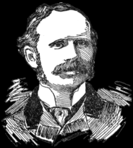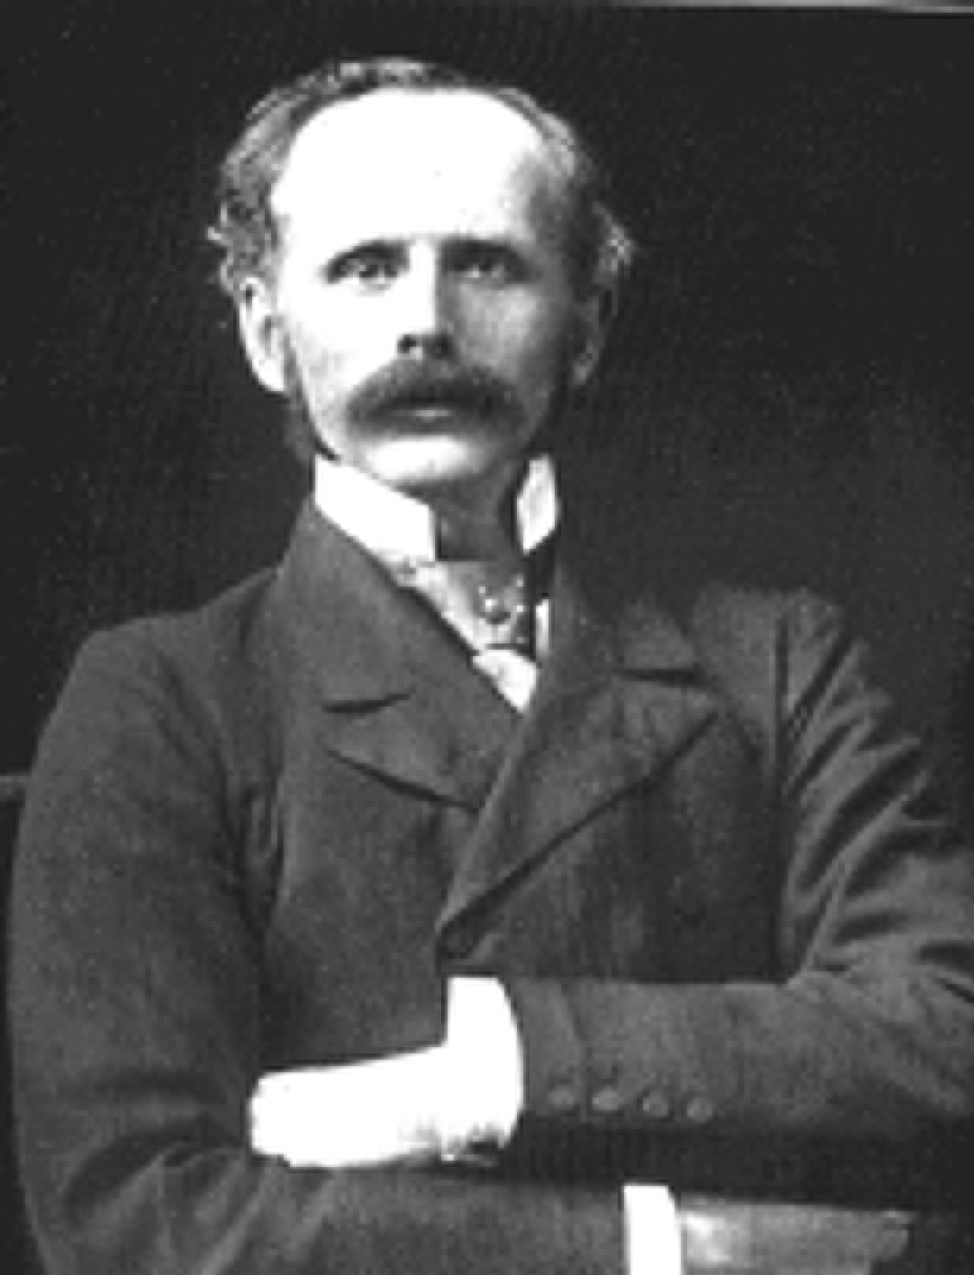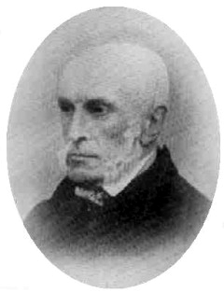

Henry Drummond (August 17, 1851 - March 11, 1897), Scottish evangelical writer and lecturer, was born in Stirling.
He was educated at Edinburgh University, where he displayed a strong inclination for physical and mathematical science. The religious element was an even more powerful factor in his nature, and disposed him to enter the Free Church of Scotland. While preparing for the ministry, he became for a time deeply interested in the evangelizing mission of Moody and Sankey, in which he actively co-operated for two years.
In 1877 he became lecturer on natural science in the Free Church College, which enabled him to combine all the pursuits for which he felt a vocation. His studies resulted in his writing Natural Law in the Spiritual World, the argument of which was that the scientific principle of continuity extended from the physical world to the spiritual. Before the book issued from the press (1883), a sudden invitation from the African Lakes Company drew Drummond away to Central Africa.
Upon his return in the following year he found himself famous. Large bodies of serious readers, alike among the religious and the scientific classes, discovered in Natural Law the common standing-ground which they needed; and the universality of the demand proved, if nothing more, the seasonableness of its publication. Drummond continued to be actively interested in missionary and other movements among the Free Church students.
In 1888 he published Tropical Africa, a valuable digest of information. In 1890 he travelled in Australia, and in 1893 delivered the Lowell Lectures at Boston. It had been his intention to reserve them for mature revision, but an attempted piracy compelled him to hasten their publication, and they appeared in 1894 under the title of The Ascent of Man. Their object was to vindicate for altruism, or the disinterested care and compassion of animals for each other, an important part in effecting the survival of the fittest, a thesis previously maintained by Professor John Fiske.
Drummond's health failed shortly afterwards, and he died on the 11th of March 1897. His character was full of charm. His writings were too nicely adapted to the needs of his own day to justify the expectation that they would long survive it, but few men exercised more religious influence in their own generation, especially on young men.

References
- This article incorporates text from the Encyclopædia Britannica Eleventh Edition, a publication now in the public domain.

External link
- Works by Henry Drummond at Project Gutenberg
==============================================================================================================================
END

