ANTON LAVEY'S FIRST CHURCH OF SATAN

www.unexplainedstuff.com/Religious-Phenomena

On Walpurgisnacht, April 30, 1966, Anton Szandor LaVey (1930–1997) of San Francisco shaved his head, donned clerical clothing, complete with white collar, and proclaimed himself Satan's high priest. Concurrently, LaVey announced the establishment of the First Church of Satan in America. A short time later, LaVey published The Satanic Bible (1969), affirming in bold language the teachings of the Church of Satan and proclaiming that Satan ruled the earth. This was the dawn of the Age of Satan, he announced—the morning of magic and undefiled wisdom.
Worship of the Prince of Darkness is at least as old as the Judeo-Christian tradition, and there was nothing new about a belief in magical powers. What was new was LaVey's use of the term "church" as part of his organization's title. While some accused him of blasphemy, he pointed out that the word itself came from the Greek and applied to any group that feels it has been "called out" of society's rank-and-file for a special purpose. And there seemed little question that LaVey seriously considered his church to be quite special. In addition to ceremonies and rituals devoted to the Prince of Darkness, there were weddings, funerals, and children baptized in the name of Satan.
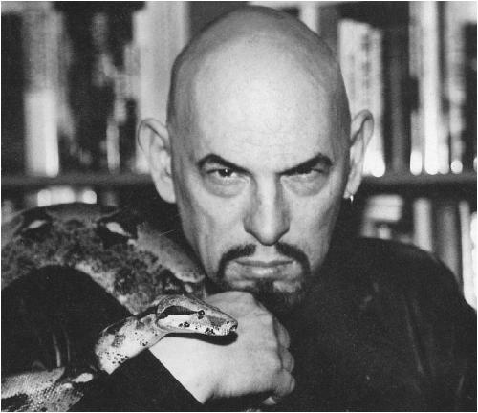
Church of Satan founder Anton Szandor La Vey (1930–1997). (
CHURCH OF SATAN ARCHIVES
)
LaVey's The Satanic Bible listed nine declarations that defined Satanism for a new age:
- indulgence, instead of abstinence;
- vital existence, instead of spiritual pipe dreams;
- undefiled wisdom, instead of hypocritical self-deceit;
- kindness to those who deserve it, instead of love wasted on ingrates;
- vengeance, instead of turning the other cheek;
- responsibility to the responsible, instead of concern for psychic vampires;
- man as just another animal…more often worse than those that walk on all fours, who because of his divine spiritual and intellectual development, has become the most vicious animal of all;
- all of the so-called sins, as they lead to physical, mental, or emotional gratification;
- Satan is the best friend the Church has ever had, as he has kept it in business all these years.
In The Satanic Bible, LaVey revealed and explained the credos of Satanism as proclaimed by the Church of Satan. In his introduction to the work, he described Satanism as being "dedicated to the dark, hidden force in nature responsible for the workings of earthly affairs for which science and religion had no explanation." He explained that he was moved to establish the Church of Satan when he saw the need for a church that would "recapture man's body and carnal desires as objects of celebration." The Church of Satan preaches a religious system that endeavors to overcome the repressions and inhibitions of human instinctual behavior it believes has been fostered by the Judeo-Christian tradition.
The First Church of Satan does not recognize the existence of Satan as an actual being, but as a symbol representing materialism. The church emphasizes that the figure of Satan stands for an inner attitude, and it is never to be regarded as an object onto which human powers are projected in order to worship what is only human in an externalized form. In The Satanic Bible, Satanists are charged to Asay unto thine own heart, 'I am my own redeemer.'" (Book IV, line 3.)
The Satanic Bible is divided into four sections, or books, each corresponding to one of the four hermetic elements of fire, air, earth, and water. The first section is entitled The Book of Satan, and its introduction advises the reader that the "ponderous rule books of hypocrisy are no longer needed," it is time to relearn the Law of the Jungle. The second section, The Book of Lucifer, explains how the Roman god Lucifer, the light bearer, the spirit of enlightenment, was made synonymous with evil through Christian teachings. The Book of Belial, the third section, is a basic text on materialistic magic, a book of ritual and ceremonial magic expressed in satanic terms. The fourth section, The Book of Leviathan, stresses the importance to successful magic of the spoken word.
The Satanist doctrine celebrates man the animal. It exalts sexual lust above spiritual love, claiming that the latter is but a sham and a cover-up. Satanism declares that violence must be met with violence and that to love one's neighbor is a utopian unreality. "Hate your enemies with a whole heart," The Satanic Bible advises. "And if a man smite you on one cheek, smash him on the other! Smite him hip and thigh, for self-preservation is the highest law!" (Section III, paragraph 7).
Satanists condemn prayer and confession as vain, futile gestures, believing that the way to achieve what one wants is through magic and aggressive effort—and that the best method of ridding oneself of guilt is not to assume it in the first place. If Satanists make a mistake, they recognize sincerely that to err is human; and instead of involving themselves in efforts to cleanse themselves, they examine the situation in order to determine exactly what happened and how to prevent its happening again.
Satanists regard the Christian preoccupations with otherworldliness as subterfuge, with self-denial as depravity, and with piety as a sign of weakness. To Satanists, the Christian way of life is a colorless, odorless, and tasteless encounter with stagnation and boredom. Worshippers of Satan believe that the way to greater levels of personal perfection and an exploration of the deeper mysteries of life is through study and the performance of rituals emphasizing the sensual nature of humankind and directing this power toward the release of psychic or emotional energy.
Because Christian churches, especially the Roman Catholic, are considered anathema to the Prince of Darkness, Satanists use parodied versions of their rituals and symbols in their ceremonies. The cross is used, but it is worn or displayed with the long beam pointing downward. Satanists may on occasion use the pentagram or five-pointed star, traditionally used by the practitioners of Wicca or witchcraft, but as with the cross, it is inverted, resting upon a single point, rather than two. Satanists insist that their parodying and inversion of other religions' rites and symbols are not done strictly for purposes of blasphemy. It is their belief, they maintain, that such use appropriates the power inherent in the rite or symbol and inverts it for Satan's purposes.
Satanists believe their doctrine and belief system is of the here and now. Acting on that premise, they look for their rewards in their
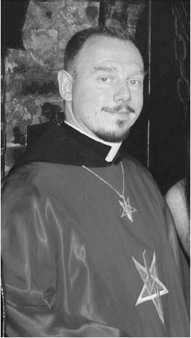
Since Anton La Vey's death in 1997, Peter H. Gilmore is currently the Church of Satan's High Priest. (
CHURCH OF SATAN ARCHIVES
)
present life and in this world. "Life is the great indulgence—death the great abstinence. Therefore, make the most of life here and now!" (Book IV, line 1.)
As a supplement to The Satanic Bible, LaVey published The Satanic Rituals (1972), in which he explained the Church of Satan's rituals and ceremonies in greater detail. Rituals includes the actual text of the Black Mass and the ritual for the satanic baptism of adults and children.
Anton LaVey, the founder of the First Church of Satan in San Francisco, ran away from home at the age of 17 to work as a cage boy for the circus lion tamer Clyde Beatty. Later, LaVey became a carnival mentalist and hypnotist, then an organ player for the dancers and strippers in the sideshows. On Sunday mornings he had an extra job playing the organ for an evangelist who conducted revival meetings in a large tent on the neighboring lot.
In the 1950s, LaVey became a San Francisco Police Department crime scene photographer, but he maintained the same fascination for magic that had driven him to perform as a stage mentalist, hypnotist, and magician in the carnivals and circuses of his youth, and he soon included a widening circle of devotees in his Magic Circle discussion group. In the late 1960s, when he founded the First Church of Satan, LaVey became immediately popular in the media, often allowing reporters to attend certain rituals that he conducted over the living altar of a woman's naked body in his church, the famous "Black House," said to have been a brothel. Then in a sudden rush came the books, the attention from movie stars, the position as technical advisor to such motion pictures as Rosemary's Baby, (1968), and the hostility of millions of devout Christians, who saw LaVey as a kind of antichrist. By the 1970s, the death threats and the harassment had become oppressive, and LaVey went underground, ceased all public ceremonies, and recast his church as a secret society.
In February 23, 1986, The Washington Post Magazine carried Walt Harrington's account of a visit with LaVey in which the journalist noted that the satanic high priest, like anyone else, loved his friends, wife, and children, but there was a venom that went beyond his claim that Satanism was a parody of Christianity: "Anton LaVey is not a cartoon Satan," Harrington wrote. "He's far less frightening than you would imagine, because he is admittedly a carnival hustler. Yet he is still terrifying, because he touches, if not the mystical darkness, then the psychological darkness—the hate and fear—in us all."
In 1991, LaVey lost ownership of the "Black House" when a judge ordered him to sell the satanic temple, along with such mementos as a shrunken head and a stuffed wolf, and split the proceeds with his estranged wife, Diane Hagerty.
Anton Szandor LaVey died on October 30, 1997, the day before Halloween, and soon after his death, what remained of his estate became the object of a legal struggle between his oldest daughter Karla and Blanche Barton, his longtime consort and the mother of his son Xerxes. At the same time, LaVey's younger daughter Zeena, who renounced the Church of Satan in 1990 and became a priest in the Temple of Set, began proclaiming what she claimed was the truth about the Church of Satan, listing, among other charges, that it had never been intended to be a spiritual movement, but was created solely as a money-making venture. Such denouncements are unlikely to damage severely the reputation of the First Church of Satan, which continues today under the direction of the High Priestess Blanche Barton and the Magister Peter H. Gilmore.

DELVING DEEPER
Church of Satan web page. [Online] http://www.churchofsatan.org/main.html. 26 January 2002.
Freedland, Nat. The Occult Explosion. New York: Berkley, 1972.
Harrington, Walt. "The Devil in Anton LaVey," The Washington Post Magazine, February 23, 1986.
[Online] http://www.churchofsatan.com/Pages/WaPost/html. 26 January 2002.
LaVey, Anton Szandor. The Satanic Bible. New York: Avon, 1969.
——. The Satanic Rituals. New York: Avon, 1972.

