Temple of Set

http://en.wikipedia.org/wiki/Temple_of_Set

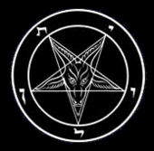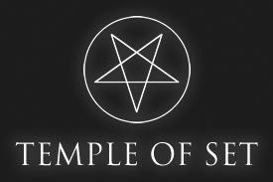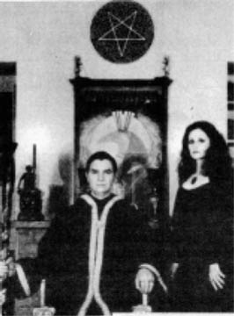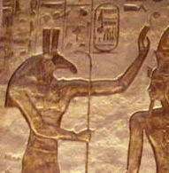
Satanism
Associated Organizations
Church of Satan
First Satanic Church
Prominent Figures
Anton LaVey | Blanche Barton | Peter H. Gilmore | Peggy Nadramia | Karla LaVey
Associated Concepts
Left-Hand Path | Moral Majority | Pentagonal Revisionism | Suitheism | Survival of the fittest | Objectivism | Might is Right
Books and Publications
The Satanic Bible | The Satanic Rituals | The Satanic Witch | The Devil's Notebook | Satan Speaks! | The Black Flame | The Church of Satan | The Secret Life of a Satanist
In Popular Culture
Allegations of Satanism | Satanic artists | Satanic ritual abuse
The Temple of Set is an initiatory occult society that claims to be the world's leading Left-Hand Path religious organization. It professes Setian philosophy and magical practice.

Contents
- 1 History
- 2 Organization
- 3 Philosophy
- 4 References
- 5 External links

History
The Temple of Set was established in 1975 by Michael Aquino and certain members of the priesthood of the Church of Satan, who left because of administrative and philosophical disagreements with its founder, and, as Aquino claims, because he was disgusted at the corruption within the Church of Satan. The Temple was incorporated in California that same year as a nonprofit church.
While Aquino remains an active member of the Temple of Set, he no longer holds any office within the organization. The office of High Priest is currently held by Magistra Patricia Hardy, who succeeded Aquino in 2004.

Organization
The Temple of Set is an occult initiatory school in which varying degrees of expertise, experience, and apprehension of metaphysics are recognized among members.
The Temple of Set holds an annual conclave where members of the Temple can come together to meet and exchange ideas. Workshops are held in which members discuss a wide variety of topics and activities. The conclave usually lasts about a week and is held in various global locations, though usually takes place within the USA. There are also occasional regional gatherings, organized and attended by interested Setians, at their own initiative.
In addition to the international organization, the Temple sponsors initiatory Orders and local groups called Pylons. Pylons generally explore a wide range of metaphysical topics and exercises, since their members are determined largely by the accident of residence. Order members share specific interests, and Order activities therefore focus more deeply on these selected interests.
The Temple also makes available to members a variety of informational resources for individual reference as desired.
The Temple has never stated nor confirmed its membership count. The Temple adheres to selective membership policies; fewer than half of all applicants are accepted for membership with the two year recognition period. The Temple's membership does have a fairly large turnover rate; most members leave eventually for a wide variety of reasons. Only a minority of members remain with the Temple more than a decade. Members pay a membership fee of about $80.00 (USD) a year. The Temple does admit to membership on all continents except Antarctica, though is largely an American based organisation.
All officers and workers within the Temple of Set are volunteers. Some receive reimbursement for expenses incurred for the Temple; none receive a salary. All officers are selected from within the Priesthood.

Philosophy
The Temple of Set's philosophy may be summed up as "enlightened individualism", i.e. enhancement and improvement of oneself by personal education, experiment, and initiation. This process, necessarily different and distinctive for each individual, is referred to within the Temple by the Egyptian hieroglyphic term Kheper, or "Xeper" (a phonetic of _Xpr_) as the Temple of Set prefers to write it. Xeper is symbolized by the scarab beetle, significant of personal rebirth and immortality within the Temple of Set. The term is deemed central to Setian philosophy and practice, having been introduced at the founding of the Temple of Set in 1975, when Aquino made the claim that the Egyptian god Set 'communicated' the word Xeper to him during the "North Solstice X Working" (PDF).
Setians recognize several levels or degrees of initiation, and identify their members by their degree. These degrees are:
- Setian ( First Degree )
- Adept ( Second Degree )
- Priest / Priestess ( Third Degree )
- Magister / Magistra Templi ( Fourth Degree )
- Magus / Maga ( Fifth Degree )
- Ipsissimus / Ipsissima ( Sixth Degree )
The Priesthood of the Temple of Set is restricted to members holding the Third Degree or higher. Full membership comes about on recognition to the second degree, which has a time frame of around two years. Recognition is performed by members of the priesthood, though it is up to the individual to find a priest to work with towards this end. However, there is no set criteria for recognition and no obligation for the priesthood to work with new initiates towards recognition.

References
- Lords of the Left Hand Path: A History of Spiritual Dissent © 1997 by Stephen Edred Flowers, Ph.D., Runa Raven Press, ISBN 1-885972-08-3
- The Seven Faces of Darkness: Practical Typhonian Magic © 1996 by Don Webb, Runa Raven Press, ISBN 1-885972-07-5
- Uncle Setnakt's Essential Guide to the Left Hand Path © 1999 by Don Webb, Runa Raven Press, ISBN 1-885972-10-5
- Mysteries of the Temple of Set: Inner Teachings of the Left Hand Path © 2004 by Don Webb, Runa Raven Press ISBN 1-885972-27-X
- "Temple of Set" in Religious Requirements and Practices of Certain Selected Groups: A Handbook for Chaplains © 2002 by U.S. Department of the Army (ed.), University Press of the Pacific. ISBN 0-89875-607-3

External links
- Official Web Site
- Temple of Set information page at the Religious Movements Homepage
==============================================================================================

