Anton Szandor LaVey 1930-1997
http://en.wikipedia.org/wiki/Anton_LaVey
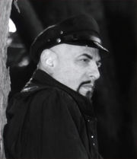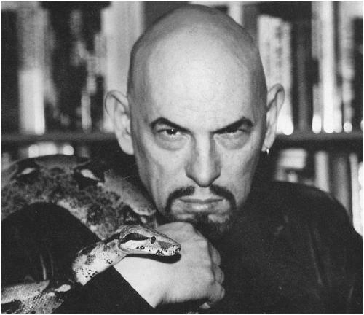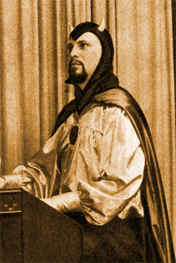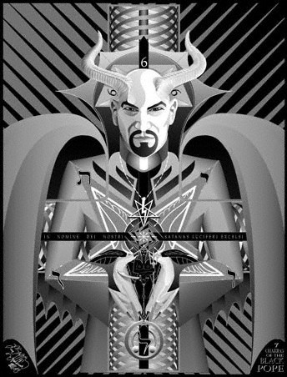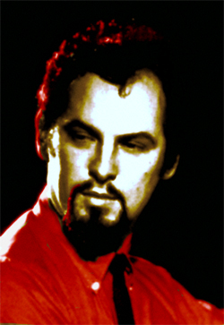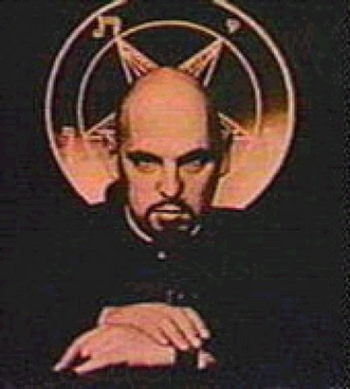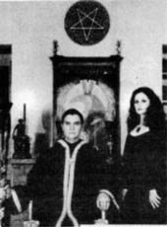
Anton Szandor LaVey 11 April 1930 – 29 October 1997) was the founder and High Priest of the Church of Satan as well as a writer, occultist, musician, and actor. He is the author of The Satanic Bible and the founder of Satanism, a synthesized system of his understanding of human nature and the insights of philosophers who advocated materialism and individualism, for which he claimed no "supernatural inspiration”. LaVey viewed "Satan" not as a literal deity or entity, but as an historic and literary figure symbolic of Earthly values.

Contents
- 1 Biography
- 2 Trivia
- 3 LaVey related books
  - 3.1 Books by LaVey
  - 3.2 Books featuring writings by LaVey
  - 3.3 Books about LaVey
- 4 Filmography
- 5 Recordings of Anton LaVey
- 6 References
- 7 External links
  - 7.1 Writings by LaVey
  - 7.2 Interviews with LaVey
  - 7.3 About LaVey

Biography
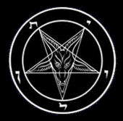
Satanism
Associated Organizations
Church of Satan
First Satanic Church
Prominent Figures
Anton LaVey | Blanche Barton | Peter H. Gilmore | Peggy Nadramia | Karla LaVey
Associated Concepts
Left-Hand Path | Moral Majority | Pentagonal Revisionism | Suitheism | Survival of the fittest | Objectivism | Might is Right
Books and Publications
The Satanic Bible | The Satanic Rituals | The Satanic Witch | The Devil's Notebook | Satan Speaks! | The Black Flame | The Church of Satan | The Secret Life of a Satanist
In Popular Culture
Allegations of Satanism | Satanic artists | Satanic ritual abuse
LaVey was born in Chicago, Illinois to a liquor distributor. His family soon relocated to California where he spent most of his life in the San Francisco Bay Area. According to his biography, his ancestry can be traced to French, Alsatian, German, Russian, and Romanian stock^{[1]}. His parents supported the development of his musical abilities as he tried his hand at various instruments, his favorite being keyboards like the pipe organ and the calliope.
LaVey's biography tells of his dropping out of high school to join the circus and carnivals, first as a roustabout and cage boy in an act with the big cats, later as a musician playing the calliope. LaVey later noted that seeing many of the same men attending both the bawdy Saturday nights shows as well as the tent revival meetings on Sunday mornings supported his increasingly cynical view of religion. He later had many stints as an organist in bars, lounges, and nightclubs. While playing organ in Los Angeles burlesque houses, he reportedly had a brief affair with the still-unknown Marilyn Monroe, a claim that was later challenged by some.
According to his biography, LaVey moved back to San Francisco where he worked for a while as a photographer for the Police Department. He also dabbled as a psychic investigator, looking into "800 calls" referred to him by the police department. Later biographers have questioned whether LaVey ever worked with the police, as there are no records substantiating the claim. LaVey met and married Carole Lansing, who bore him his first daughter, Karla LaVey, in 1952. They divorced in 1960 after LaVey became entranced by Diane Hegarty. Hegarty and LaVey never married, but she was his companion for many years, and bore his second daughter, Zeena Galatea LaVey in 1964.
Becoming a local celebrity through his paranormal research and live performances as an organist (including playing the Wurlitzer at the Lost Weekend cocktail lounge), he would attract many San Francisco notables to his parties. Guests included Carin de Plessin, Michael Harner, Chester A. Arthur III, Forrest J. Ackerman, Fritz Leiber, Dr. Cecil E. Nixon, and Kenneth Anger.
LaVey began presenting Friday night lectures on the occult to what he called a "Magic Circle" of associates who shared his interests. A member of this circle suggested that he had the basis for a new religion. On Walpurgisnacht, 30 April 1966, he ritualistically shaved his head, declared the founding of the Church of Satan and proclaimed 1966 as "the year One", Anno Satanas—the first year of the Age of Satan. Media attention followed the subsequent Satanic wedding ceremony of Radical journalist John Raymond to New York socialite Judith Case on February 1st, 1967 (photographed by Joe Rosenthal). The Los Angeles Times and San Francisco Chronicle were among the newspapers that printed articles dubbing him "The Black Pope". LaVey performed Satanic baptisms (including one for Zeena), Satanic funerals (including one for naval officer Edward Olsen, complete with a chrome-helmeted honor guard) and released a record album entitled The Satanic Mass.
In the late 1960s and early 1970s LaVey melded ideological influences from Ayn Rand^{[2]}, Friedrich Nietzsche, Aleister Crowley, Mencken, and Jack London with the ideology and ritual practices of the Church of Satan into essays introduced with reworked excerpts from Ragnar Redbeard’s Might is Right and concluded it with “Satanized” versions of John Dee’s Enochian Keys to create books such as The Satanic Bible, The Compleat Witch, (rereleased in 1989 as The Satanic Witch), and The Satanic Rituals.
Due to his increasing visibility through his books, LaVey was the subject of numerous articles in the news media throughout the world, including popular magazines such as Look, McCall's, Newsweek, and TIME, and men’s magazines. He also appeared on talk shows such as Joe Pyne, Phil Donahue, and Johnny Carson, and in a feature length documentary called Satanis: The Devil's Mass in 1969.
Hegarty and LaVey separated in the mid-1980s, and she sued for palimony. The claim was settled out of court. LaVey’s next and final companion was Blanche Barton, who bore him his only son, Satan Xerxes Carnacki LaVey on November 1, 1993. She succeeded him as the head of the Church after his death.
Anton LaVey died on October 29, 1997, in St. Mary's Hospital, San Francisco of pulmonary edema. He was taken to St. Mary's, a Catholic hospital, because it was the closest available. The time of his death was listed as the morning of Halloween, which has since, for reasons open to speculation, been determined to be off by two days. A secret Satanic funeral for LaVey, by invitation only, was held in Colma, and his body was cremated. His ashes were not buried, but were eventually divided amongst his heirs as part of a settlement, on the assumption that they possess occult potency, and can be used for acts of Satanic ritual magic.
Preceded by:  Church established | High Priest of the Church of Satan  1966-1997 | Succeeded by:  Peter H. Gilmore after vacancy

Trivia
- LaVey regarded his development as being heavily influenced by dark literature and legends, horror and science fiction pulp magazines, the works of Jack London, film noir, German Expressionism, and historical figures such as Cagliostro, Rasputin and Basil Zaharoff. He cited his eastern European grandmother's stories and folktales as influential.
- An eclectic individual, LaVey was fond of music, painting, antique automobiles, firearms, and animals. His pets included a Nubian Lion (Togare) and a Doberman Pinscher (Loki). He was an accomplished musician and made recordings of traditional music on which he played all the instruments on his keyboard synthesizers. LaVey also painted as a hobby throughout his life.
- Over the years, LaVey attracted a number of notable allies and associates, including celebrities such as Jayne Mansfield, Sammy Davis Jr., King Diamond, Robert Fuest, Jacques Vallee, Marc Almond, Aime Michel, Boyd Rice, and Marilyn Manson.
- LaVey was known by many as "doctor" (sometimes spelled "doktor"). While possessing no formal doctorate, he was considered a doctor of Satanic theology and philosophy. Church of Satan representatives say that the Church's fifth degree, Magus, merits the title of doctor and that LaVey was awarded it from the Church's ruling body, the Council of Nine. When asked for a dissertation, The Satanic Witch is quoted as being the equivalent, due to the extensive research done and references given.^{[3]}
- LaVey did not play the role of Satan during the rape scene of Rosemary's Baby (in fact it was actor Clay Tanner) and no technical advisor was used^{[4][5][6][7][8]}, the rumor also went unmentioned by Blanche Barton in "The Georges Montalba Mystery"

LaVey related books

Books by LaVey
- The Satanic Bible (Avon, 1969, ISBN 0-380-01539-0)
- The Compleat Witch, or, What to do When Virtue Fails (Dodd, Mead, 1971, ISBN 0-396-06266-0); republished as The Satanic Witch (Feral House, 1989, ISBN 0-922915-00-8); re-released with an introduction by Peggy Nadramia, and an afterword by Blanche Barton (2003, ISBN 0-922915-84-9).
- The Satanic Rituals (Avon, 1972, ISBN 0-380-01392-4)
- The Devil's Notebook (Feral House, 1992, ISBN 0-922915-11-3)
- Satan Speaks!, introduction by Blanche Barton, foreword by Marilyn Manson (Feral House, 1998, ISBN 0-922915-66-0)

Books featuring writings by LaVey
- "Misanthropia," Rants and Incendiary Tracts: Voices of Desperate Illuminations 1558-Present, ed by Bob Black and Adam Parfrey (Amok Press and Loompanics Unlimited, 1989, ISBN 0-941693-03-1)
- "The Invisible War," Apocalypse Culture: Expanded & revised ion, ed by Adam Parfrey (Amok Press, 1990, ISBN 0-922915-05-9)
- "Foreward," Might is Right, or The Survival of the Fittest by Ragnar Redbeard, LL.D., ed by Katja Lane (M.H.P. & Co., Ltd, 1996, ISBN 0-915179-12-1)

Books about LaVey
- The Devil's Avenger: A Biography of Anton Szandor LaVey by Burton H. Wolfe (Pyramid Books, 1974, ISBN 0-515-03471-1, Out of print)
- The Secret Life Of A Satanist: The Authorized Biography of Anton LaVey by Blanche Barton (Feral House, 1990, ISBN 0-922915-12-1)
- Popular Witchcraft: Straight from the Witch's Mouth by Jack Fritscher ; featuring Anton LaVey (University of Wisconsin Press : Popular Press, 2004, ISBN 0-299-20300-X, hardcover, ISBN 0-299-20304-2, paperback)

Filmography
- Invocation of my Demon Brother (short, uncred role as Satan, 1969)
- Satanis: The Devil's Mass (featured, 1970; released on DVD by Something Weird Video, 2003)
- The Devil's Rain (technical advisor, role as High Priest, 1975)
- The Car (creative consultant, 1977)
- Doctor Dracula, aka Svengali (technical advisor, 1981)
- Charles Manson Superstar (research consultant, 1989)
- Death Scenes (narrator/host, 1989)
- Speak of the Devil (featured, 1995)

Recordings of Anton LaVey
- The Satanic Mass, LP (Murgenstrumm Records, 1968; re-released on CD with one bonus track, "Hymn of the Satanic Empire, or The Battle Hymn of the Apocalypse," by Amarillo Records, 1994; Mephisto Media, 2001)
- Answer Me/Honolulu Baby, 7" single (Amarillo Records, 1993)
- Strange Music, 10" EP (Amarillo Records, 1994; now available through Reptilian Records)
- Satan Takes A Holiday, CD (Amarillo Records, 1995; now available through Reptilian Records)

References
- ^ Barton, Blanche The Secret Life of a Satanist
- ^ Lewis, James R. "Who Serves Satan? A Demographic and Ideological Profile". Marburg Journal of Religion. June 2001.
- ^ "Explanation of "Doctor" Anton LaVey"
- ^ "Imdb Entry Clay Tanner"
- ^ "The Church of Satan by Micheal Aquino p. 17"
- ^ "Imdb entry for Anton Lavey"
- ^ "Imdb Entry "Rosemary's Baby" ".
- ^ Castle, William "Step Right Up! I'm Gonna Scare the Pants off America"

External links
Wikiquote has a collection of quotations related to:
Anton LaVey

Writings by LaVey
- The Nine Satanic Statements
- The Eleven Satanic Rules of the Earth
- The Nine Satanic Sins
- Pentagonal Revisionism: A Five-Point Program, 1988
- The World’s Most Powerful Religion
- Enochian Pronunciation Guide
- Letters From The Devil from The National Insider, Vol. 14, No. 17, April 27, 1969.
- On Occultism of the Past from The Cloven Hoof, September, 1971 c.e., Volume Three, Number Nine.

Interviews with LaVey
- Section concerning Anton LaVey in Chapter XII (Satan in the Suburbs) of "Occult America" by John Godwin (Doubleday & Company, Inc., 1972)
- Section concerning Anton LaVey in "Everything You Ever Wanted to Know About Sorcery, But Were Afraid to Ask" by Arlene J. Fitzgerald (Manor Books, 1973)
- “Anton LaVey: America’s Satanic Master of Devils, Magic, Music, and Madness” by Walt Harrington in "The Washington Post Magazine", February 23, 1986.
- “Anton LaVey / The Church of Satan Interview” by Eugene Robinson in "The Birth of Tragedy", No. 4 “The God Issue”, November 1986 - January 1987
- "Dinner with the Devil: An evening with Anton Szandor LaVey, the High Priest of the Church of Satan" by Reverend Bob Johnson in "High Society", August, 1994.
- "The Doctor is in......" by Shane & Amy Bugbee in "MF Magazine" #3, Summer 1997.
- Interview with Anton LaVey by Michelle Carr and Elvia Lahman, originally published in the September 11, 1997 Velvet Hammer souvenir programme.

About LaVey
- Anton Szandor LaVey: A Biographical Sketch by Magus Peter H. Gilmore, on the Church of Satan's official website.
- Anton Lavey by Alex Burns at disinformation.
- Anton Szandor Lavey: In memorium
- Anton Szandor LaVey tribute
- Anton LaVey at the Internet Movie Database
- Find A Grave Entry
- People of Significance entry for LaVey
- Ding Dong.. The Witch is Dead ~ A Tribute to the Late, Great Anton Szandar LaVey
- Anton LaVey entry on NNDB
- Short biographical sketch with particular focus on his influence on Marilyn Manson, taken from "Spin magazine" (Feb. 1998, pg. 64).
- "Has the Church of Satan Gone to Hell?" by Jack Boulware "SF Weekly", Jun 17, 1998
- http://www.unimarburg.de/religionswissenschaft/journal/mjr/lewis3.html Lewis, James. R., "Diabolical Authority: Anton LaVey, the Satanic Bible and the Satanist Tradition," in "The Marburg Journal of Religion", v.7 no.1 (Sept 2002)
- Introduction to "The Satanic Rituals", by Burton H. Wolfe, 1976
- In Memory of LaVey (Russian web-page)
========================================================================================================

