LIST OF KNOWN NAMES CONNECTED TO SATANIC CULTS / PEDOPHILIA / CHILD-TRAFFICKING IN AMERICA:

● Hillary Clinton
● Bill Clinton
● George Nader (Businessman)
● Huma Aberdin
● Laura Silsby
● Rachel Chandler
● Jeffrey Epstein
● Ghislaine Maxwell
● John Podesta
● Michael Podesta
● James Alefantis
● Anthony Wiener
● Leslie Wexner (Limited Inc Chairman)
● Herbert Strauss
● Isidor Strauss
● Martin A. Nowak
● Steven Spielberg
● Edgar Bronfman Sr. (Seagram Chairman)
● Charles Bronfman (Seagram Co)
● Michael Steinhardt (former hedge-fund manager)
● Sara Bronfman
● Clare Bronfman
● Niles Lehman (Professor at Portland State University)
● Seth Roger
● Ruth Ginsberg
● Alison Mack
● Rachel Chandler
● Robert Maxwell
● Wendi Murdoch
● Jonathan Cheban
● Naomi Campbell
● Maximiliam Chow
● Val Kilmer
● Marina Abramovic

LIST OF HOLLYWOOD PEDO-NAMES:

● Steven Spielberg
● Michael Jackson
● Kevin Spacey
● Alison Mac
● Marc Collins-Rector (Founder of Den)
● Chad Shackley
● Brock Pierce
● David Geffen
● Tom Hanks
● Dustin Hoffman
● Andrew Kreisberg (American television writer, producer)
● Bryan Singer
● Harvey Weinstein
● Bob Weinstein
● Roman Polanski
● Ruma Hazard
● Charlie Sheen
● Madonna
● Kate Perry
● Miley Cyrus
● Errol Flynn
● Billy Graham
● Walt Disney
● Michael Laney (Former Walt Disney vice president)
● James Gunn (Disney)

LIST OF NAMES OF CELEBS CONNECTED TO THE DEEPSTATE, CIA & MOSSAD:

● Heidi Fleiss
● Jeffrey Epstein

LIST OF NAMES CONNECTED TO SATANIC CULTS:

● Alison Mack
● Stormy Daniels
● Rachel Chandler
● Ghislaine Maxwell

LIST OF NAMES OF VISITORS ON EPSTEIN ISLAND:

● Ghislaine Maxwell
● Chris Tucker
● Larry Summers
● Lisa Summers
● Bill Murray
● Bill Hammond
● Ehud Barak
● Andrés Pastrana (Former President of Colombia 1998-2002)
● Jean Luc Brunel
● Doug Band
● Ron Burkle
● Woody Allen
● Sarah Kellen
● Ray Barzanna
● Sandy Burger
● Andrea Mitrovitch
● Peter Marino
● Shelley Lewis
● Paul Hala(t) (d) a
● Richardo Legoretta
● Tom Pritzker
● Kelly Spamm
● Tiffany Gramza
● Claire Hazel
● Paula Epstein
● Mark Epstein
● Ralph Elison
● Sophie Biddle
● Audrey Raimbault
● Shelley Harrison
● Melinda Luntz
● Gwendolyn Beck
● Albert Pinto
● Linda Pinto
● Gary Roxburgh
● Mandy Elison
● Jean Michelle Gathy
● Virginia Roberts
● Kristy Rodgers (Kristina Real Rodgers)
● Greg Holbert
● Alyssa Rodgers
● Juliette Bryant
● Heather Mann
● Ed Tuttle
● Glen Dubin
● Ellen Spencer
● Chris Wagner
● Casey Wasserman
● Laura Wasserman
● Paul Mellon
● Oliver Sachs
● Henry Rosovsky
● Lynn Forester (de Rothschild)
● Joe Pagano
● Naomi Campbell
● Nicole Junkermann
● Rodney Slater
● Magali Blachon (Deperrier)
● Svetlana Griaznova
● Emmy Tayler
● Larry Visoski
● Teala Davies
● Juan (Pablo) Molyneux
● Freya Willemoes) Wissing
● Adam Perry Lang
● Fleur Perry Lang
● Caren Casey
● Hank Coller
● Cindy Lopez
● Mark Lloyd
● Alan Dershowitz
● Seth Green
● James Gunn
● Steven Spielberg
● Tom Hanks
● Steven Colbert
● Jimmy Kimmel
● Barack Obama
● Kevin Spacey
● Kathy Griffin
● Oprah Winfrey
● Shawn Carter
● Beyoncé Knowles
● Anthony Kiedis
● John Legend
● Chrissy Tiegen
● Jim Carrey
● Steven Tyler
● Ben Affleck
● Stephen Collins
● Will Ferrell
● Aliaune Damala Badara Thiam (Akon)
● Marshall Matters
● Jeffrey Jones
● Victor Salva
● Mark Collins Rector
● Charlie Sheen
● Tyler Grasham
● Madonna Ciccone
● Katheryn Hudson
● Gwen Stefani
● Stefani Germanotta
● James Franco
● Will Smith
● Justin Roland
● John Cusack
● Anderson Cooper
● Demi Moore
● Brian Affleck
● Meryl Streep
● Wanda Sykes
● Chelsea Handler
● Michelle Wolf
● David Yarovesky
● Pharrell Williams
● Quentin Tarantino
● Courtney Love
● Alec Baldwin
● Robert Downey Jr.
● Disney Corporation (Offering kids “scuba-diving” trips, to the Epstein Island)

Link: the Epstein flight log documents

LIST OF NAMES CONNECTED TO THE STANDARD HOTELS

● Andre Balazs (Owner of the Standard Hotels and connected to the Rockefellers)
● Jay Z
● Beyoncé Knowles
● John Belushi
● Britney Spears
● Errol Flynn
● Dennis Hopper
● Helmut Newton
● Jim Morrison
● James Dean
● Billy Idol
● Victoria Beckham
● Heath Ledger
● Sienna Miller
● Balthazar Getty
● Scarlet Johansen

MORE NAMES TO ADD TO THE LIST-
INDIVIDUALS THAT’S DIRECTLY CONNECTED TO JEFFREY EPSTEIN & THE EPSTEIN ISLAND:

● Elon Musk
● Mark Zuckerberg
● Lawrence M. Krauss
● Steven Pinker
● Mick Jagger
● Courtney Love
● Joan Rivers (deceased)
● Kevin Spacey
● Chris Rock
● Eli Weisel (Nobel Prize winning Holocaust profiteer)
● Lauren Hutton (Top fashion model)
● Duke & Duchess of York
● Earl Spencer (Late Diana’s brother)
● Richard Bronson (English businessman)
● Tony Blair (Former UK prime minister)
● David Koch (1/2 of a brother team)
● David Rockefeller
● Evelyn de Rothschild
● Eduouard de Rothschild
JOURNALISTS THAT’S DIRECTLY CONNECTED TO JAMES ALEFANTIS, COMET PING PONG & BUCKS FISHING, WASHINGTON DC:
● Jake Tapper (CNN)
● Jennifer Tapper (wife of Jake Tapper)
● Maple Inc
● Me Over Seas

JOURNALISTS THAT’S DIRECTLY CONNECTED TO JEFFREY EPSTEIN & THE EPSTEIN ISLAND:
● Barbara Walters
● Mort Zuckerman
● Eric Margolis
● Rupert Murdock
● Conrad & Barbara Black; Baron Black of Crossharbour

POLITICS THAT’S DIRECTLY CONNECTED TO JEFFREY EPSTEIN & THE EPSTEIN ISLAND:

● Bill Clinton (Former president of America)
● Jon & Mary Kaye Huntsman
● Governor Charles Turnbull (US Virgin Islands)
● Henry Kissinger
● Ethel Kennedy
● Bobby & Mary Kennedy
● Senator Edward Kennedy (deceased)
● Ted Kennedy Jr.
● Andrew & Kerry Kennedy Cuomo
● Maria Shriver (Kennedy relative/Schwarznegger’s ex)

THE DTLA STANDARD HOTEL CONNECTIONS:
(Vacant 1992-2002)

● Keck Family (Standard Oil / Founders of The Standard Hotel)
● Perry Mason
● Bank of California
● JP Morgan – Standard Oil
● Jeffrey Epstein
● Bear Stearns Group
● Standard Holdings
● Colombia Development

_note:_
(It appears to be an obvious connection between the; STANDARD HOTEL DTLA and the underground military base at the CHINA LAKE NAVAL MILITARY TEST-BASE.)
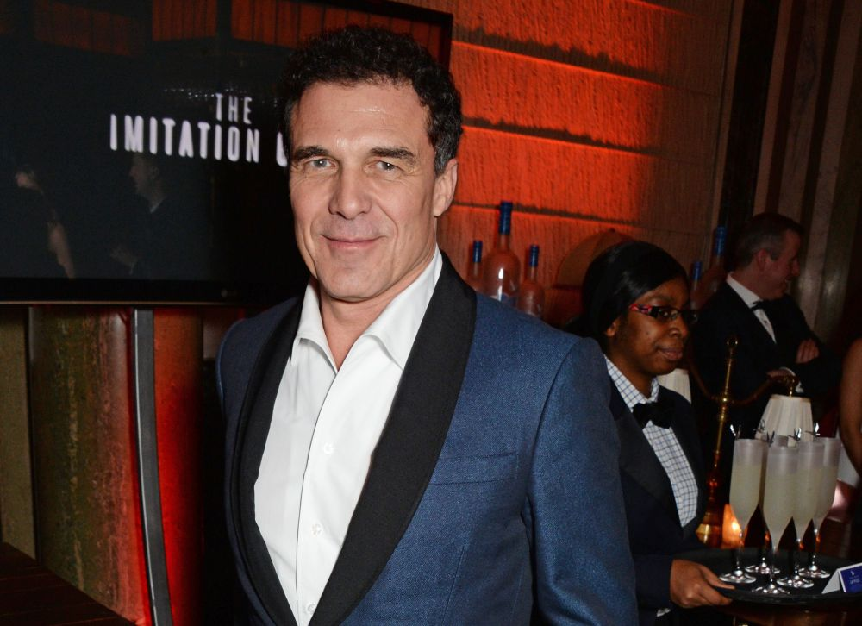

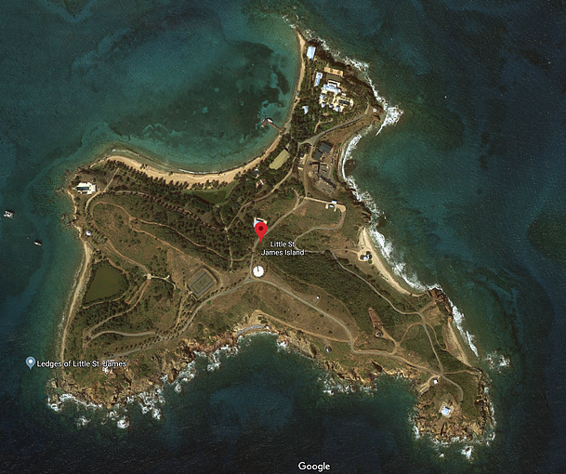
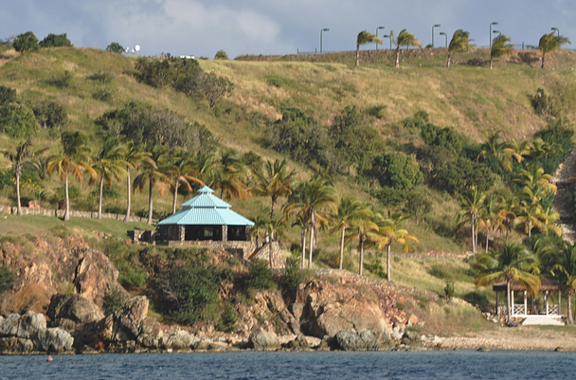
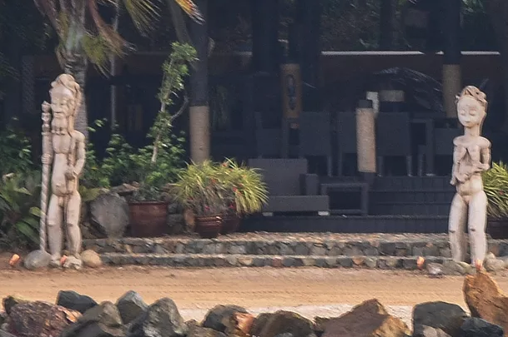
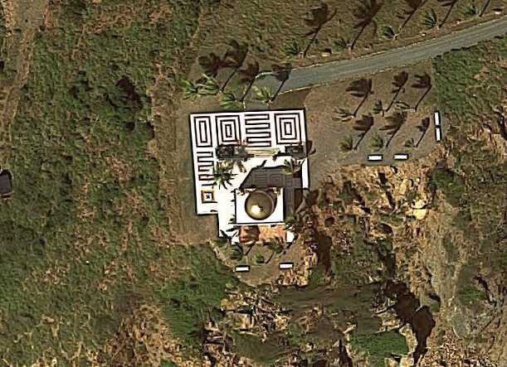
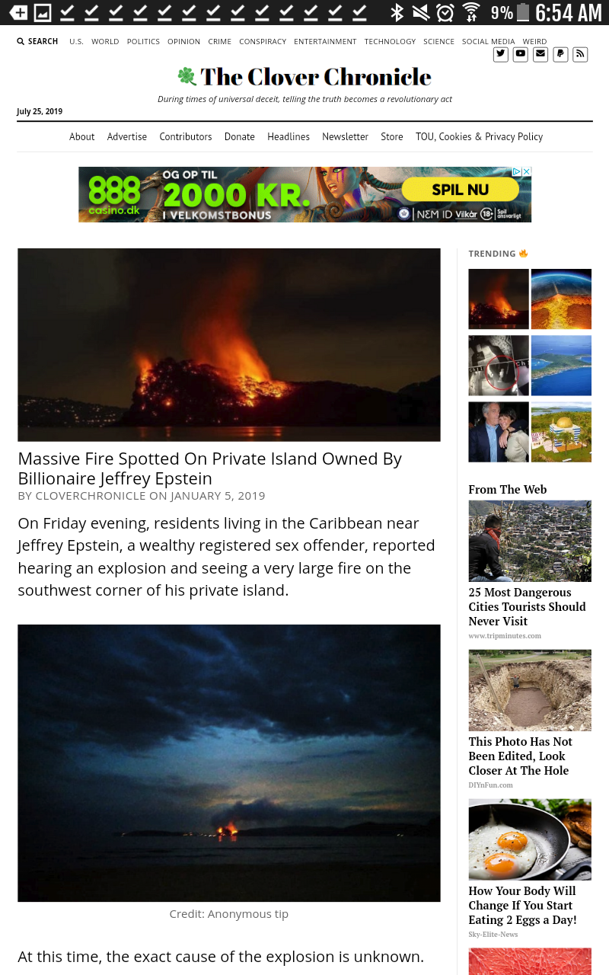
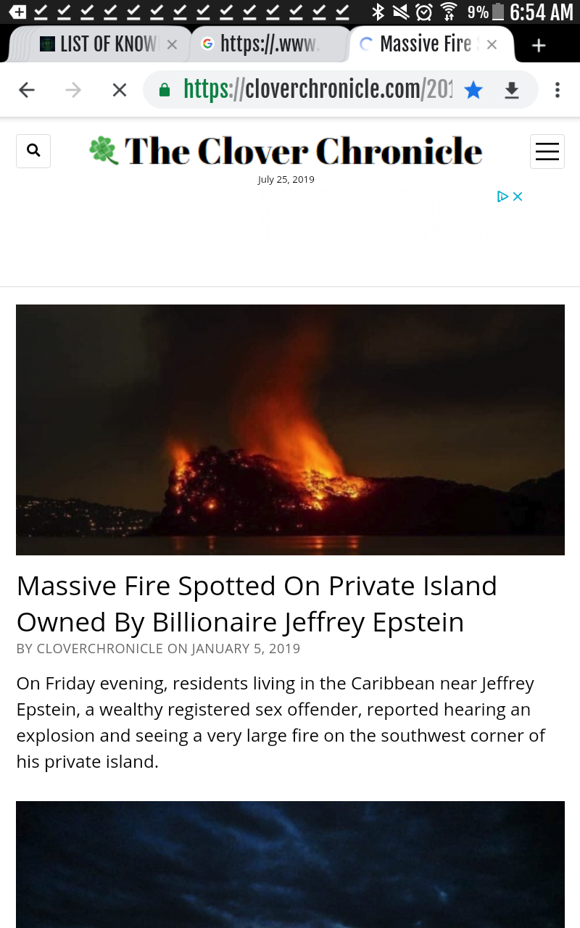
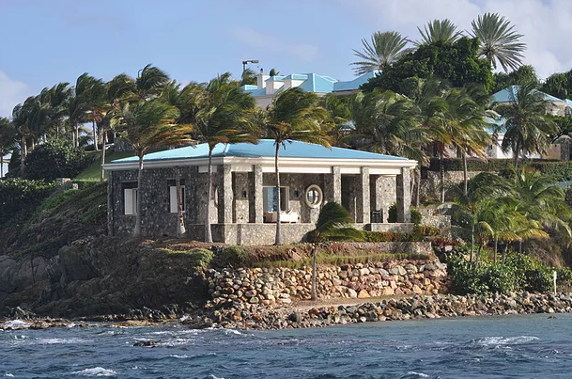
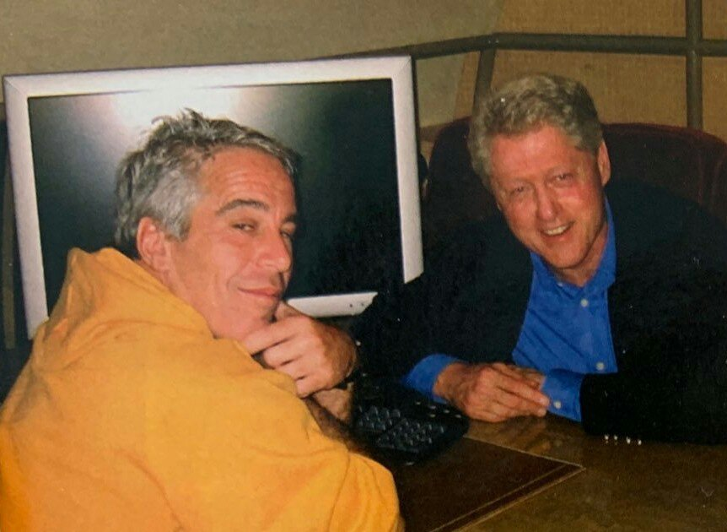
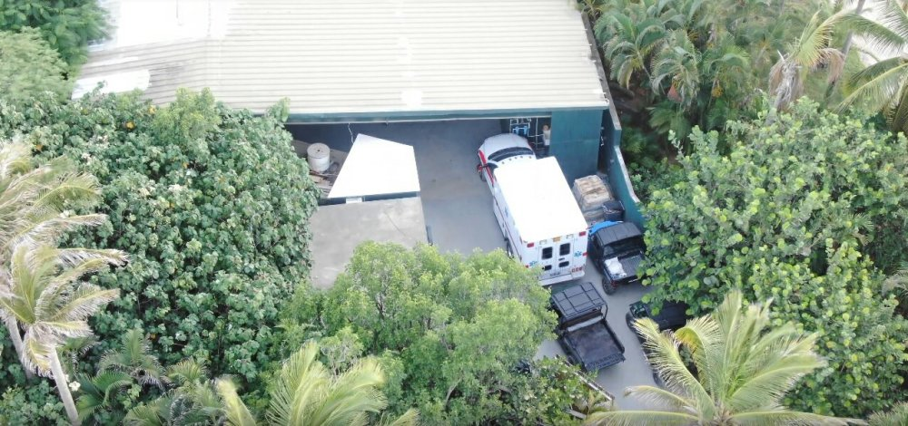
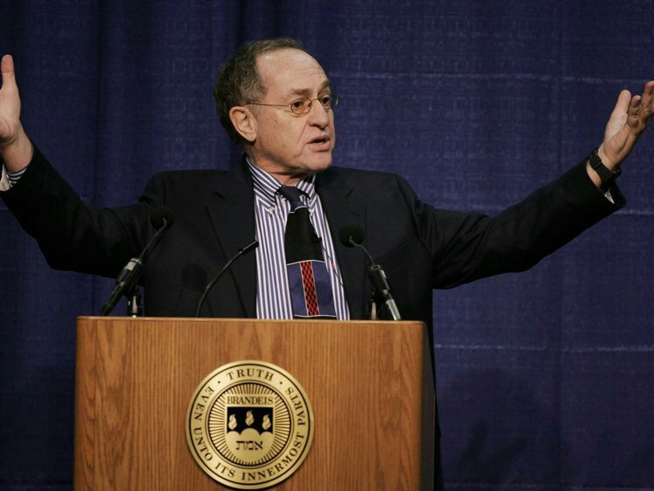

Share this Article:
- Share

