In Search of Black Assassins

UPDATE, CYBELE, SATANISTS, BLOOD-EATERS & THE ORLANDO HOMOSEXUAL FALSE FLAG CLUB MASSACRE
4072016
“THE LIES GROW BIGGER AND BIGGER”
Within conservative corporate mass media circles, Judge Andrew P. Napolitano is a well respected Fox News Senior Judicial Analyst. He is no lover of the people. On the Orlando False Flag Massacre, the mouthpieces for the ILLUMINATI are getting their signals crossed. On Fox, he said that nobody was killed at the Pulse night club until about 5:13 am when the SWAT team moved in. He said it came from a summary of a FBI transcript of the events at the Pulse Night Club that included a timeline. So far, it doesn’t seem as if anyone including the has challenged Judge Napolitiano’s timeline. There is not even direct evidence to challenge what he said. The FBI issued gag orders on the Pulse Club Massacre to hush-up local police, fire, emergency medical personnel, and hospital doctors and staff.
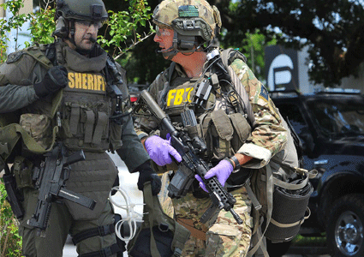
County, City and FBI Swat Teams were at Pulse Club False Flag Massacre
In particular, Pulse Club Massacre mass media darling survivors, Patience Carter and Tiara Parker, have committed themselves to a story line that Omar Mateen shot and killed people in the bathroom hours before the Swat team moved in. But, which Swat team, FBI, County or Orlando PD? The Orlando Pulse Night Club Massacre official story line is a very big problem that is growing bigger and bigger by the days.
“SCARE THEM, YOU CAN HERD THEM”
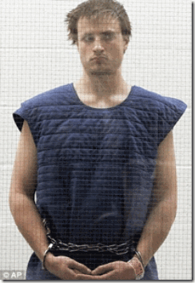
In Santa Monica, CA, the following morning after Saturday’s June 12, 2016 2 a.m. Pulse Club Massacre, James Wesley Howell, 20 years old, of Jeffersonville, IN called police for protection. He said that the CIA was out to kill him.[1] He said that he had been part of a secret 5 (five) member domestic terrorist team that was sent in on a mission by the CIAto assault Sunday’s Los Angeles Gay Pride Festival and Parade. Their mission had been coordinated with Saturday night’s Orlando Pulse Club terrorist attack. When Howelldiscovered the South’s team leader, Omar Mateen, was assassinated in performance of the mission in Orlando by a SWAT Team, he feared the CIA would also betray and assassinate him as a PASTY.[2] Local police found in Howell’s car, a loaded assault rifle with magazines rigged to allow 60 shots to be fired in quick succession and 15 pounds of chemicals mixed and ready to explode. He also had two other loaded rifles, ammunition, a stun gun, a buck knife and a security badge.[3]
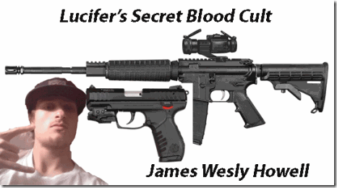
Lucifer’s CIA Pasty
Actually, he had twenty-five (25) pounds of Shoc-Shot, an explosive used for blowing up targets by high velocity bullets most likely to cause a crowd widespread panic, and a possible escape by assailants in smoke and mass confusion. The two components needed to make the Shoc-Shot explosive had been mixed. Howell had an AndersonManufacturing AM-115 .223– high velocity round caliber rifle. The rifle had a round in its chamber and additional rounds in a 30-round magazine attached to it. Another 30-round magazine was taped to the rifle. He had a .30-06 bolt-action rifle with a round in its chamber, and a high velocity .22-caliber Ruger semi-automatic pistol. He had a mass murdering commando assassin’s arsenal.[4]

Omar Mateen- Multi-generational MK ULTRA Manchurian Candidate
Actor, hermaphrodite/homosexual or a radical Islamist, they could turn Omar on a dime. The weapon used by a gunmen in Saturday night’s deadly attack at the Pulse gay nightclub in Orlando was not an AR-15 assault-style rifle as previously widely reported, according to the Washington Post. The Post, citing Orlando Police officials that the weapons used were a SIG Saucer MCX (high velocity sub-machine gun pistol), and a 9 mm Glock.[5]

Black Blood Cult Cybeleans- Patience Carter and Tiara Parker
Tiara Parker claimed that she had been shot in the stomach with a high velocity bulletthat went in the front right stomach area and exited downward out of bottom right side. I think she spent no more than a night of the shooting in the hospital before coming one of corporate mass media Pulse Club Massacre darling witnesses. Both Carter and Parkerwere treated at Orlando Regional Medical Center for alleged gunshot wounds. It is widely reported that the hospital’s Emergency Room staff were coerced by federal agentsinto signing a Non-Disclosure Agreement for all aspects of the Pulse Nightclub Shooting incident. Anyone that refused was allegedly walked right out the door byfederal agents. So, if they actually suffered gunshot wounds, the type of injuries they suffered and weapons used that caused their injuries are now state secrets. Nevertheless, being shot with a high velocity projectile is not a matter of as I understand it, oh well, it went in here and came out there; then out and dancing through the tulips the next couple of days. “As a missile passes through tissue, it decelerates, dissipating and transferring kinetic energy to the tissues; this is what causes the injury. The velocity of the projectile is a more important factor than its mass in determining how much damage is done; kinetic energy increases with the square of the velocity. In addition to injury caused directly by the object that enters the body, penetrating injuries may be associated with secondary injuries, due for example to a blast injury.”[6]
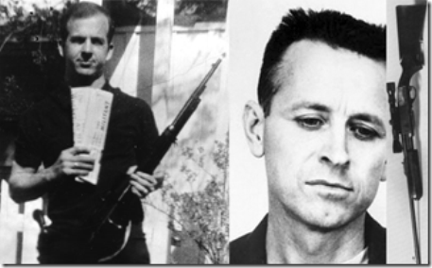
Omar’s corporate mass media damning public purchase of an AR-15 was a deliberate false trail to set him up for a sensational frame like legendary government intelligence pasties, Lee Harvey Oswald and James Earl Ray. So, where did the sub-machine gun pistol come from?[7] Howell described to local police details of his recruitment and training by the CIA. Howell additionally stated that, “everything has gone south. Dan was gone when I got here. They killed the leader of the Florida attack this morning. They are going to kill me. I need protection.”[8] Howell indicated to officers who first made contact with him that he was one of five people involved in a planned Sunday attack on both the east and west coasts. Howell stated that he was suppose to “hook up” late Saturday night with his contact in LA who was suppose to have more weapons and chemicals to mix with the Tannerite he was in possession of. Finding his contact missing when he got to LA and having heard that Omar Mateen had been killed by a FBI SWATteam in Orlando, Howell determined he had been double crossed by the CIA and feared for his own life.[9]
Like Omar Mateen, Howell worked as an armed security guard for a multi-national security firm, United Security Services, Inc.[10] United is an annual $2.5 Billion vast security industry that specializes in all aspects, stages, and sizes of commercial and residential construction and projects from cabins to castles, from small local businesses to federal facilities.[11] Both Howell and Mateen‘s security badges and weapons’ permitswere cleared under cover of national security firms. According to sources within the Santa Monica Police Department, he told them that “We were all familiar with each other through an online fundamental Islamic knowledge seminary course- we were recruited through the course and trained together at a camp in VIRGINIA – we were taught how to shoot and make bombs – everyone knew their part – something went wrong….”[12]
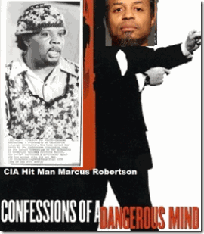
Howell’s fundamental Islamic knowledge seminary course connect he and Omar to a government 5 member CIA domestic “hit squad” not at all dissimilar from Marcus Wayne Chenault’s 5 member CIA domestic “hit squad,” the Troop. Also, not dissimilar from the SLA– the CIA, the SLA was led and trained by black U.S. military counterintelligence/CIAassassination specialist, Colston Westbrook. Howell and Omar’s “hit squad” was led and trained by a black U.S. Marine/CIA counterintelligence specialist, and ex-felon pseudo Muslim, Marcus Dewayne Robertson.
Pulse Club Massacre & The Blood Eaters
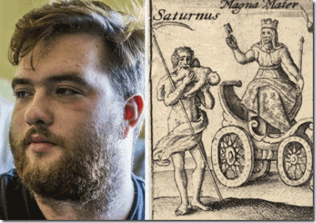
Satanic Blood Eater, Joseph Greeson
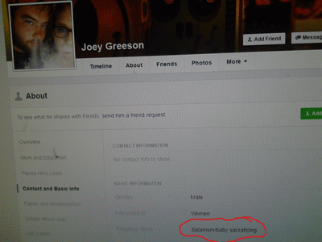
Some allege that Howell is gay. Joseph Greeson of Clarksville, TN surfaced in corporate mass media as Howell’s fake Hermaphrodite boyfriend. Greeson’s hometown just happens to be Orlando, FL. Greeson doesn’t seem to work anywhere. His religious views: SATANISM/BABY SACRAFICING [Greeson’s Spelling].[13]
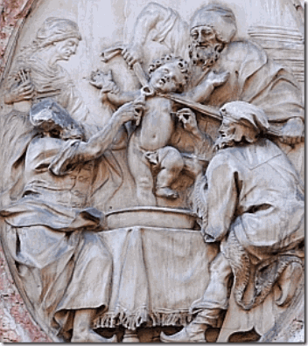
Ancient Blood Cult- Baby Blood Eater Sacrifice
He confessed in corporate mass media that he was a homosexual. He said that he was interested in these ghoulish things not me. Undoubtedly, Greeson is a Satanist that has a Blood Oath with the DEVIL with very extreme and serious implications. Human sacrifice, flesh and blood eating has existed in secrecy for ages. For some people, it constitutes a shadow spiritual religion. These people at this level of the game of secret shadow government false flag operations are well organized to back up a mass Orlando false flag psychological warfare operation.
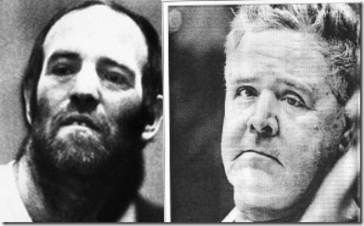
The infamous Hermaphrodite/Homosexual Blood Eaters and Satanic Killers, Ottis Tooleand Henry Lee Lucas, above, claimed that they were trained by a nationwide satanic cultin a mobile paramilitary training camp in the Florida Everglades. They admitted to being part of a secret organization called “The Hand of Death,” which was a satanic “BLOOD” cult that cannibalized and killed.[14]
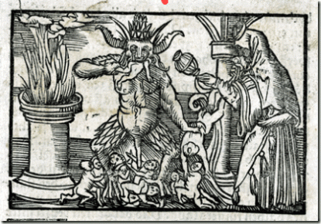
From Max Call’s book, Hand of Death,
“In the book Henry tells of his indoctrination into a nationwide Satanic cult, and says that he was trained by the cult in a mobile paramilitary camp in the Florida Everglades in the fine art of killing. Other training involved abduction and arson techniques. The first task he was given was the murder of one of the “students,” a young black homosexual who had betrayed his oath to the Devil. He slit the man’s throat and later that same evening, a Satanic ritual was performed in which the dead man’s heart was cut out, his blood drained, and his body dismembered. All of the initiated members of the Hand drank the dead man’s blood and ate pieces of his flesh. The remains of the body were then burned at an altar.”[15]
They are self regulating. Satanist play actor Greeson says that he had been with Howellsince June 1, 2016, “I never really got, like, any bad signals,” said Greeson, 18. “Just that it was strange and kind of weird. He was an only child and just kind of lonerish. I don’t know. It’s hard to explain.”[16]
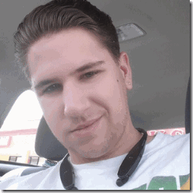
AlliedBarton Officer, Michael Shantey?
Greeson’s Facebook Friend just happens to be Michael Shantey.[17],[18] Shantey has the entire Orlando Pulse Club logo on his Facebook Page. Shantey is a security officer for AlliedBarton Security Services. [19] Established in 1957 by the ancient noble Iron CraftFrench Satanic Jewish Wendel (House) Group with close historical ties to the Rothschilds, AlliedBarton is the largest American-owned security officer services company in the United States. AlliedBarton has more than 38,000 employees in 60 offices serving more than 2,000 customers coast to coast, including more than 100 Fortune 500 companies.[20] AlliedBarton was named to the “G.I. Jobs Top 100 Military Employers List“. These security firms are nothing less than the ILLUMINATI’s private paramilitary police and ARMIES.[21]
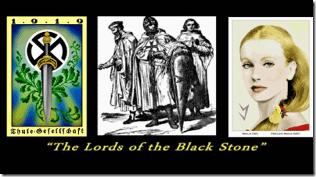
At sometime, AlliedBarton was acquired by the Zionist (Raymond, Ronald) Perelman Family than they sold it to the scary global Lords of the Black Stone, the Blackstone Group. The Blackstone Group helped Larry Silverstein mortgage 9-11’s World Trade Center, Building 7. [Henry] Kissinger McLarty Associates has a “strategic alliance” with the Blackstone Group.[22] So, it isn’t surprising that Jewish Mysticism and the Blood Sacrifice secretly lies at the spiritual foundation of these companies.[23]
In 2010, the International Association of Jewish Vocational Services (IAJVS) and AlliedBarton formed a national strategic partnership that promises to promote and enhance training and employment opportunities for workers in the communities they jointly serve.[24] With their eyes clearly on the future, they say the Mission of IAJVS owes its vision to the words of the 12th century Master of Kabbalah (Jewish Mysticism) Maimonides, which they say are as relevant today as they were more than 800 years ago.[25] If they owe their future vision to the Sephardic Jewish Philosopher and AstronomerMaimonides (1135- 1204) than it also secretly includes the “Blood Sacrifice.”
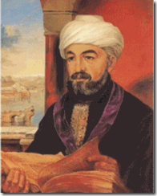
Maimonides states (“Guide for the Perplexed“, Book III, chapter XLVI, pg. 362 Dover ed.) that certain cultures who would either eat blood or sit around a pot of blood, as they felt they would be favored by “spirits“. After Maimonides explained the origin of the Torah prohibition against eating blood, he connects this prohibition to the a somewhat qualified prohibition to serve Molech- Moloch, a fire G-d.[26]
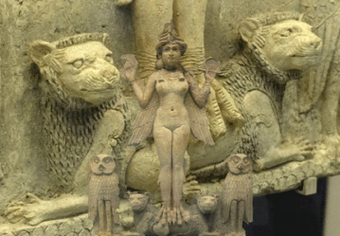
Babylonian Goddess Ishtar and Cybele’s Twin Lions
And Solomon did evil in the sight of the Lord, and went not fully after the Lord, as did David his father. Then did Solomon build an high place for CHEMOSH, the abomination of Moab, in the hill that is before Jerusalem, and for MOLECH (Moloch), the abomination of the children of Ammon. (1 Kings 11: 6-7) Who was CHEMOSH? CHEMOSH was a god associated with the Mother-Goddess Ishtar– CYBELE and the BLOOD SCARIFICE.
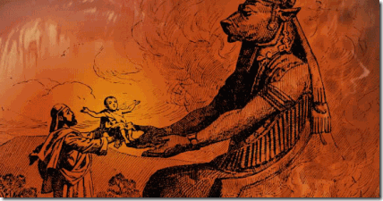
Baby Passed Over the Fire to Lion Headed Molech- Moloch
In 2012, Universal Security Services acquired United Security.[27] In May 2016, AlliedBarton acquired Universal Security Services.[28] That means that Greeson’s friend, Michael Shantey, worked for the same company as James Wesley Howell. Omar Mateenworked for G4S–Wackenhut Corporation, a Department of Homeland Security (DHS) contractor.[29],[30] Rob Ryan, Universal Security Services, President, Southeast Division (Florida), before joining Universal Protection Service, he served as the Northeast Region Vice President for G4S–Wackenhut Corporation.[31]
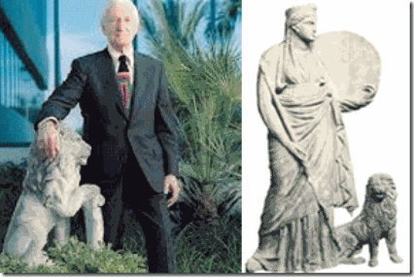
George Wackenhut, Lion & Cybele
Founded in 1954 by an extreme right wing former FBI agent, George Russell Wackenhut, the security company has to be one of the most dangerous and clandestine CIA- ILLUMINATI paramilitary/counterintelligence private police forces in America. All of the below extremely dangerous shadow government conspirators are known to have been attached to Wackenhut.
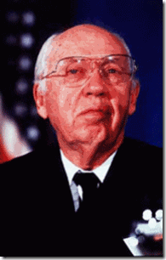
William Casey: OSS (Operation PAPERCLIP) agent, CIA director. Member of Le Cercle; Knight of Malta; Co-founded the Jamestown Organization, along with Zbigniew Brzezinski, Dick Cheney, and Frank Carlucci (Carlyle Group, Wackenhut). Used P2(Propaganda Due Masonic Lodge) to fund the Solidarists in Poland; Friend of Roy Cohn, who has been connected to the Mafia, JFK assassination and Donald Drumpf (Trump); helped fund the Mujahedin (Osama Bin Laden) with the help of the CIA- BCCI bank.[32]
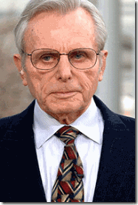
Frank Carlucci: Knight of Malta, member of the Carlyle Group, CFR, and Wackenhut. He is suspected of being a 9/11 Inside Job criminal.[33]
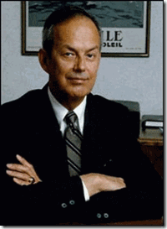
Bobby Ray Inman: Director of Office of Naval Intelligence (ONI), DIA, NSA, and FBI; Knight of Malta, Director of Wackenhut, Director of the Trilateral Commission; Member CFR; Head of the Jet Propulsion Lab Oversight Committee at Cal Tech.[34]
Wackenhut is a creature of the FBI, CIA, U.S. Military Intelligence, and the Knights of Malta. The Sovereign Military Order of Malta (SMOM) is directly allied with international Freemasonry, from where they recruit their new elite brethren. Hence, the Knights of Malta and the Knights Templar are the Rosicrucian upper-degrees of Freemasonry. During the 15th Century in France, Baron Gilles de Rais’ was publicly tried, convicted and executed for practicing the secret “Old Religion” of the Knights Templar– Satanism, Baby Sacrifice and Human Fleshand Blood Eating.
Seizure of Satanist James Wesley Howell & the Patriot Act
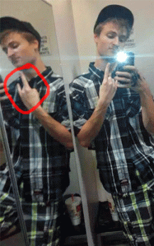
DEVIL HORNS- James Wesley Howell- Satanist?
he Federal authorities stepped in and assumed immediate control of James W. Howellfrom the San Monica Police Department under the Patriot Act and National Securitybecause they operationally classified the Orlando Pulse Club Massacre as a terror incident, even though they did not say so publicly. In Orlando, the FBI swept in and took over the entire crime scene.[35] When the FBI entered and seized Howell’s investigative case, slapped the local police with a gag order, the storyline suddenly changed. The FBIclaimed that the local police were mistaken, Howell did not intend to harm anyone at the L.A. Gay Pride Parade and Festival to take the CIA off the hook. Howell was slapped with a Clark County, IN child molestation case that allegedly occurred on May 31, 2016 to keep him isolated in jail until the CIA’s post-hypnotic suggestion specialists do their work, or they just terminate him.
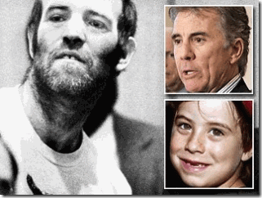
James W. Howell, Omar Mateen, Joseph Greeson, and Michael Shantey all appear to be have been part of a national ultra secret subservient but powerful interrelated ILLUMINATI Luciferic “Blood Cult” that even Adam Walsh of America’s Most Wantedwas/is too afraid to breach even for the heinous slaughter and beheading of his son.[36]
Mateen, Howell, Pseudo Muslims, U.S. Marines & the CIA
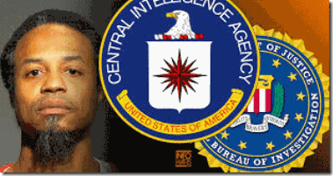
CIA/FBI Pseudo Muslim, Marcus Dewayne Robertson
Like Little Markie, Marcus Robertson was from a multi-generationalgovernment/military intelligence family. According to public record, U.S. District Court, Middle District of Florida, Orlando Div., U.S.A v. Robertson, Case NOS, 6:11-cr- 277- Orl- 3GJK; 6:12-cr- 63-Orl-36JK (4/24/15); “ROBERTSON was born in the late 1960’s to Clarence and Mable Robertson. Both … holding positions in government their entire careers. His father is retired from the Brooklyn, New York District Attorney’s Office. He recently (April 18, 2015) was honored with the Outstanding Citizen Award by Brooklyn’s Medgar Evers College where he had previously served as Vice-President… ROBERTSON, and all three of his siblings have served in the Armed Forces. His oldest brother, Alonzo, served in Army intelligence, the CIA, and then spent fifteen (15) years in the NSA. His brother, Malcolm, and his spouse both served in Iraq. Finally his youngest brother, Martin, was in the military police with the Army.”[37]
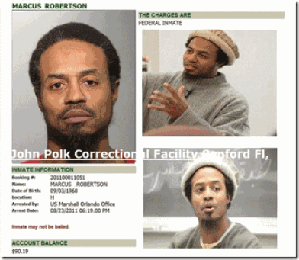
“ROBERTSON served in the United States Marine Corps from 1989 until his honorable discharge in 1994. While in the Marines, Mr. ROBERTSON was part of an elite counter-terrorism operations group of Marines known as the Second Force Reconnaissance Company… The Government acknowledges that ROBERTSON has provided extensive assistance to the authorities. Although it denies or cannot confirm that ROBERTSONundertook certain activities on its behalf, it acknowledges the following and ROBERTSONwill testify concerning his other activities in camera at the sentencing proceedings:
1) ROBERTSON testified for the Government at a federal trial in 1999; 2) From 2004-2007, under the express authority of the FBI Joint Terrorist Task Force (“JTTF”), ROBERTSON performed these inherently dangerous activities: a) He was an extraterritorial confidential source that was sent to Mauritania performing a role that can only be defined as “espionage.” See 18 U.S.C § 793; b) He served as a confidential source in domestic terrorism investigations from Atlanta to Los Angeles, wherein he was provided with actual authority to, inter alia: possess firearms in order to maintain his cover and fulfill the objectives set for him by the JTTF.
Although ROBERTSON is not interested in exposing classified activities, he would like the Court to have a true picture of his service to his country. Therefore, he is reluctantly prepared to testify concerning the activities in which he engaged on behalf of the United States that the Government contends did not occur or cannot be documented.”[38]
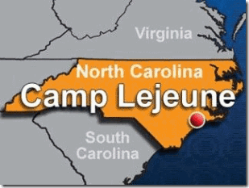
Robertson’s U.S. Marine Second Force Reconnaissance Company is stationed at Camp Lejeune, North Carolina. Marine Corps Base Camp Lejeune is a 246-square-mile U.S. military training facility in Jacksonville, NC . The base’s 14 miles of beaches make it a major area for amphibious assault training, and its location between two deep-water ports (Wilmington and Morehead City) allows for fast deployments. The main base is supplemented by six satellite facilities:Marine Corps Air Station New River, Camp Geiger, Stone Bay, Courthouse Bay, Camp Johnson, and the latest addition to the facility, the Greater Sandy Run Training Area. Camp Lejeune, just below Virginia, is part of America’s ultra secret U.S. Military Homosexual/Hermaphrodite Complex, and Nato’s Secret Army- Operation Gladio that had been primary setup by SS-Obersturmbannführer Otto Skorzeny and his Junkerschule Commandos- Knights of t he Black Sun.[39],[40]
The U.S. Navy (Marines) & Gladio’s NATO Secret Army and the Sodomite BROTHERHOOD
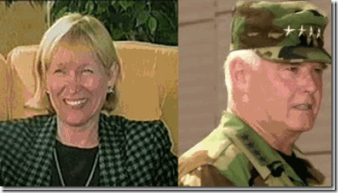
Katherine Griggs of Virginia Beach, VA was the wife of 11 years to alcoholic ColonelGeorge Raymond Griggs, USMC, Intelligence Operations, head of special (psychological) operations under Admiral Celso at NATO. Roanoke is approximately 500 miles outside of Virginia Beach. Kay Griggs was a member of the board in NATO’s wives club, and assistant director of the Virginia Center for World Trade in Norfolk, VA. Marine Col. Griggs’ background includes NATO’s college at Rome, and then Princeton. His intelligence spy career began in Vietnam.[41] She maintains her former husband, Marine Col. Griggs, ran a military intelligence Murder, Inc. of trained assassins that he called the “firm” or “The BROTHERHOOD” that were “sexually perverted” (Hermaphrodites). Kay Griggs said that the BROTHERHOOD had its origins in the secret German illness, the Pink Triangle–Sodomite SS and Nazis out of Operation PAPERCLIP. [42] South Carolinaaround Columbia, Fort Jackson, and the Fort Bragg, NC backwoods veils the BROTHERHOOD’s ultra secret U.S. military grounds, camps and fields for home-grown trained pseudo false flag 9-11 Muslims and domestic terrorists.
Chris Sean Harper, Fort Jackson & the BROTHERHOOD
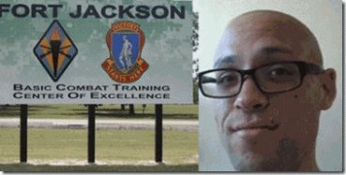
Chris Sean Harper, 26 years old, the alleged October 1, 2015 Umpgua Campus, Oregon Mass Murderer, that killed 9 people and left 7-10 injured, had been taken from Switzer Learning Center, a special needs school for emotionally disturbed students, in Torrance, CA straight to Fort Jackson, SC for military training in the country’s backwoods.[43],[44]

Chris Harper was a severely disturbed “head banger.” He was a seriously mentally and developmentally disabled individual that required a daily regiment of psychotic drugsincluding LITHIUM to control his behavior and Multiple Personality Disorder (MPD). Poor Chris couldn’t function without them.[45]
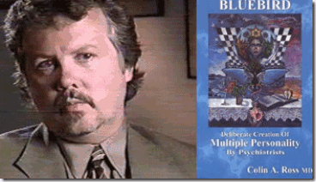
Chris Harper had been managed mentally and medically hands off exclusively by Dr.Colin A. Ross’ Institute for Psychological Trauma, Del Amo Behavior Health System of Southern CA in Torrance, CA.[46] Yes, that is Colin A. Ross, M.D., author of Bluebird: Deliberate Creation of Multiple Personality by Psychiatrists: The CIA Doctors, Human Rights Violations by American Psychiatrists.[47] He remains silent about Chris. If he didn’t have anything to do with Chris, he should say something. His silence remains a very serious and big problem!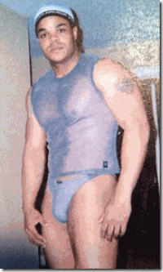 Chris never had a girlfriend. In his prepared CIA HollyWeird scripted manifesto, he idolized the late Black Manchurian Candidate and Pasty Virginia Hermaphrodite/Homosexual, Vester Lee Flanagan. On August 31, 2015, he allegedly wrote a blog centered on a post-script psychoanalysis of Vester Lee Flanagan of Roanoke, VA, ” … I read some excerpts of his manifesto the media was releasing. And I have to say, anyone who knew him could have seen this coming. People like him have nothing left to live for, and the only thing left to do is lash out at a society that has abandoned them. His family described him as alone, no partner/love. A victim not only of his own perception but also of our social media soaked environment.”[48]
Yes. According to Chris’ “lone nut” psychological profile of Flanagan, the signs were present that he would become a serial killer. Chris didn’t write that script. “In his [Flanagan] profile, he had a lot of dollar signs, and that was a sign to the people he was chatting with that he was willing to hook up for money,” says the family member. “He kept it a secret from his parents, but he did tell a few other family members in his generation who he thought might accept it. I won’t say he was proud of it, but he wasn’t ashamed, either.”[49]
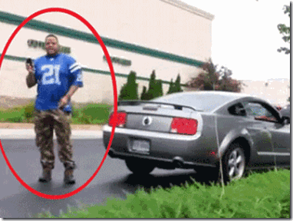 In a raid on Flanagan’s apartment in Roanoke, police reportedly confiscated a gay pride flag. They also found “many” Sex Magick Tools, which had fresh “human genetic material” on them.[50] Sex toys and chat lines, Flanagan was far from a lonely abandoned society outcast. He was still a very busy veteran male prostitute.
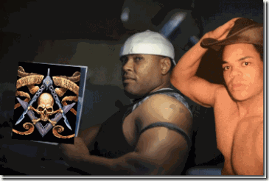
Frenchy, Freemasonry & Flanagan
Flanagan had friends in his closed trade and circle like Frenchy, Robert Lee Avent, but nobody except me seems willing to discuss any of that. He also had his Sex Magickhomosexual/hermaphrodite “clientele” that paid his rent and taste for high end sport cars. I suspect Flanagan had a secret classified “clientele” that were top level U.S. military personnel sodomites of the BROTHERHOOD. Virginia has from 22 to 27 military bases. It has about 13 (thirteen) Naval and Marine bases. Roanoke is a military housing zone.[51]Flanagan’s computer hard drive, phones and telephone records were taken, and have not resurfaced as a record of seized evidence.
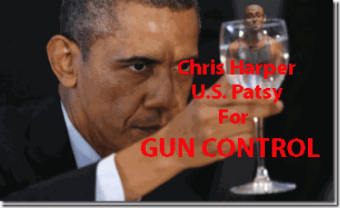
Poor Chris was a virtual throw-away child. What was the U.S. government training him to be- a Manchurian Candidate Sleeper, FALSE FLAG PASTY. There still remains no video surveillance evidence to show that Chris ever sat foot on Umpgua College on October 1. Where is his autopsy? We have just forgotten about Chris Sean Harper when there is far more to learn about the case that may help prevent another U.S. military government mass murder false flag domestic terrorist operation.
Back to Marcus Wayne Chenault for a moment. Little Markie’s five (5) member team of programmed assassins were called, The Troop. The Troop assassination team targeting national black religious leaders was verified in The Journal Herald, Dayton, Ohio by Reporter Arlene Gordon in a copyrighted story, July 2, 1974. The team was also identified as the “Greyhound Pastors.” The assassins traveled by greyhound from city to city receiving money and assignments along the routes. Little Markie had traveled from Dayton, OH to Atlanta by Greyhound Bus to try to kill Dr. King, Sr. Markie said that he had once traveled to Chicago by Greyhound Bus to attempt to kill Jesse Jackson, but the mission was aborted at the last minute. Markie’s hit team was led by Walter E. Brooks, Jr.. The Troop was ran out of the ultra top secret Building 18, Area B, Wright Patterson Air Force Base, Dayton, OH.
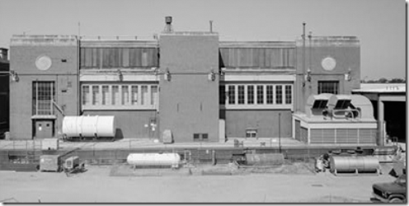
EXTERIOR WEST VIEW, BUILDING 18B (LABORATORY OFFICE) (1991). – Wright-Patterson Air Force Base, Area B, Building 18, Power Plant Laboratory Complex, Northeast corner of C & Fifth Streets, Dayton, Montgomery County, OH
At the time of the Assassination of Mrs. King, Brooks had been the maintenance man for the “Blue Room” and Building 18, Area B containing the Roswell Flying Disk under control of Operation PAPERCLIP Nazis, SS Werhner von Braun, Dr. Alexander Lippischand the Blood Covenant SS in the Interest of U.S. National Security.[52] According to FBIdocuments, at some point, Brooks was wanted for questioning in the assassination of two Midwest black preachers.
Little Professor & Fort Jackson, SC
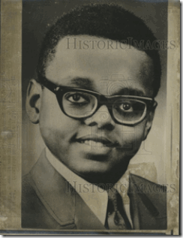
The “Little Professor” as he was at time called at Ohio University, with a large head, thick coke bottle glass lenses, and standing no more than 5 feet tall among a group of men would be an unforgettable and odd sight. It would be quite notable if he was seen moving into Fort Jackson, SC.
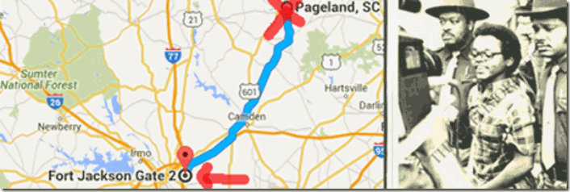
Well, that is what actually happened. The Columbia, SC FBI office reported that an eyewitness reported to them on July 2, 1974 that he saw an individual that looked very similar to Little Markie among men in three or four caravans of cars that had stopped several times at his store on U.S. Route 9 to buy food and drinks. He said that he hadn’t seen them for the past 2 years. He said that they moved south on U.S. Route 9. They had to have moved into the Fort Jackson Gate.[53] Fort Jackson (U.S. Army Training Center) encompasses more than 52,000 acres of land, including 100 ranges and field training sites and more than 1,000 buildings. Fort Jackson was incorporated into the city of Columbia in October 1968.[54] From witnesses in South Carolina along the route to Fort Jackson, Little Markie received secret U.S. Army basic military field training on several occasions. Markie’s secret military training was most likely the same as Chris Harper, Howell, and Omar Matteen.
From U.S. v. Robertson in regards to Howell and Mateen, we learn that shadow government counterintelligence agent provocateurs, assassins and Manchurian Candidates received clandestine weapons handling, sharp shooting, and explosives training from undercover CIA/FBI agents, and the U.S. Army, Navy or the Marines.
Expeditionary Warfare Acronym: SMEAC
They also received intense psychological military conditioning or layering. In U.S. v. Robertson, in the field (streets), undercover CIA/FBI/Military Intelligence agents indoctrinate their pasties with SMEAC (Five Paragraph Field Order). The military believe that they indoctrinate almost anyone in most mental conditions and simple mindlessness, even Chris out of a special educational needs school, with SMEAC. It is a standardized military method to tell people/soldiers what they want and expect them to accomplish.
The five paragraph order or five paragraph field order is a style of organizing information about a military situation for a unit in the field. It is an element of U.S. Army, U.S. Marines and U.S. Navy Seabees of small unit tactics, and similar order styles are used by military groups around the world. An order specifies the instruction to a unit in a structured format that makes it easy to find each specific requirement. The five paragraphs can be remembered with the acronym SMEAC: “S” Situation, “M” Mission, “E” Execution, “A” Administration/Logistics, “C” Command/Signal.[1]
I often wondered the mechanics involved in conditioning a person under mind control to violate his or her, society’s moral code and the law to slay your brother. You wrap it up, layer it, and feed it to an alter in the form of a military mission order (SMEAC). I remember when we took down a Black Manchurian Candidate during the late 1960s at Merritt Jr. College in Oakland, there were at least 10 men wrestling with him to get a out of a leather shoulder hostler, and take him down. There was so many brothers wrestling with him, I couldn’t break the circle. I had studied wrestling in high school. I knew take-down techniques, but there were so many brothers in the flay. I didn’t get the chance to feel that extraordinary strength of a Manchurian Candidate on a blind mission to kill. We were able to remove the gun from him only after his eyes began to slowly lap to the back of his head. Foaming at the ends of his mouth, he lapsed into a state of unconsciousness. He weighted no more than 150 pounds, and stood no more than 5′ 6-7″.
I talked to and questioned him, extensively. I couldn’t figure it out. He appeared to a be a normal medium light skinned middle class/clean cut intelligent young man. He was far out of place at a Black Nationalist gathering in Oakland. Why he was there was a big BLANK. He didn’t know why he was there with a loaded gun. I didn’t get anything out of him. He seemed spirituality devoid. It was as if he had been cloned a week ago. The only papers I found on him was a California I.D. or Drivers’ License with a name and address, but I can’t remember the name. I sent two brothers to the address listed on the California document with a set of keys we took from him. It was 43 or 44nd Street above Telegraph Ave. in Oakland. My introductions, bring me back something, telephone, gas and electric bill, pictures- anything from that address. Bring me something. They brought me nothing from the address. One of the brothers turned out to be a state police infiltrator. The other brother died mysteriously within a couple of years. I guess if they did bring back something, my faith also would have been sealed. I later discovered that the address and apartment in North Oakland was a CIA safe house that harbored Indiana State Police on special assignment, Bill and Emily Harris of the SLA, and Patty Hearst Kidnapping.
The young man had been armed with a snub nose 38 Smith & Wesson filed with outlawed exploding “dum-dum” bullets. He had been sent in on a SMEAC to kill somebody. His most likely target for assassination was H. Rap Brown, who was scheduled to show up on campus within hours. The shadow government wanted H. Rap DEAD very-very badly. When we took the Black Manchurian Candidate down, I was afraid of a back-up plan in case he failed. That’s another reason, I had him held until the nation’s most feared nationalist brothers, H. Rap and Stokely Carmichael, left the college campus and California.
I traveled to the King Family’s Ebenezer Baptist Church in Atlanta . For a moment, I sat in a place that I thought Little Markie may have sat on that day of tragedy for a weary family and people. Within the long traditional love, spirit and sacredness of the Black Church, there is no way in my mind, heart, body and soul that I could even for a moment rationalize or even envision anyone pulling a gun and striking down our beloved and most humble elders praying in that most sacred and holy place to our people. It only brought tears to my eyes as it does even today.
Little Markie didn’t get his mission’s target, Dr. Marin Luther King, Sr., but what he did sent shock waves through out Black communities across the nation, resist and die. They will kill your mothers, fathers and elders. The people that programmed Marcus Wayne Chenault, and gave him the mission (SMEAC) to attack our beloved elders are still out there. His operational programming began inside Wright Patterson Air Force Basewith Reichsfuhrer Heinrich Himmler’ SS Peenemunde Rocket Team.
Early in the murder investigation, the FBI switched its focus entirely from The Troop and Nazis at top secret Building 18 B (Operation PAPERCLIP) at Wright Patterson to a sect of hapless and powerless U.S. Black Israelites.
From July 9, 1973 – February 15, 1978, the FBI Director was Clarence M. Kelley. After the FBI, Kelleyopened up an investigative and security firm as a subsidiary of the Wackenhut Corporation known as the Kansas City Division. President Richard M. Nixon nominated Kelley, a career Southerner FBI agent, to replace Edgar J. Hoover after he suddenly came up (assassinated) dead. He wasn’t an open high ranking Freemason like Hoover. Kelley belonged to the underground confederate fraternal brotherhood, Sigma Nu (Secret Legion of Honor). Sigma Nu was founded by James Frank Hopkins at Virginia Military Institute (VMI) in Lexington, Virginia in 1869. In Hopkins‘ third year at VMI, he joined the Masonic Lodge, No. 25 in Lexington. It was the Masons that inspired or instructed him to create a similar Masonic organization at VMI. Sigma Nu’s rituals and initiation rites are Masonic rites. Sigma Nu is a “kindred kind” to Free and Accepted Masons.
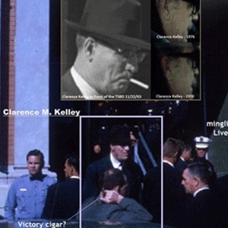
Clarence M. Kelley in Dallas at the Texas Book Depository- Lee Harvey Oswald
Nixon’s running dog, Kelley, had a clear FBI “hands off” policy on NASA, Operation PAPERCLIP Nazis, and Sturmführer SS Wernher von Braun. He certainty appears to have been with the Brotherhood in Dallas when they ritually killed President John F. Kennedy.
Chenault & Jacob
“Chenault advised he did the shooting at the church because the GOD OF JACOB told him to ….” FBI Subject: CHENAULT, MARCUS WAYNE, FOIP No. 0965824-000
After the murder of Mrs. Martin Luther King, Sr., Chenault called himself, Jacob Israel. It was far from a random multiple personality disorder (MPD) personality implantation. Jacob (2000 BC- ?), Son of Abraham, Brother of Joseph and Isaac, is a biblical enigma warped inside a puzzle. Until going to college, Chenault had been raised in the Baptist Church since childhood. His killer alter personalities were designed carefully not to conflict with or substitute his religion with something alien, but supplement it with far deeper theological secrets, forbidden mysterious exoteric and esoteric knowledge of Christianity.
Genesis 28: 17-19

17 ” …. this is none other but the house of God, and this is the gate of heaven.” 18 And Jacob rose up early in the morning, and took the stone that he had put for his pillows, and set it up for a pillar, and poured oil upon the top of it. 19 And he called the name of that place Bethel. In the Book of Genesis, Jacob took his family to Egypt, and offered a sacrifice to God, for a blessing, guidance, and to seek God’s will. Abrahamand Isaac also honored God with sacrifice in Beer-Sheba. It honored the covenant. Jacob had not had a vision from God in a long time. God called him by name, and Jacob answered. God identified himself as God of Isaac. It is important to note the God of both Abraham and Isaac involve issues of Human Sacrifice. The sacrificial slaying of Isaac had been the ultimate test of Abraham’s faith. So, Jacob’s Godwas isolated from the broad conception of GOD, and uniquely named in the sense of a God that called for Human Sacrifice (human slaughter) as a test of faith.
Jacob’s Dream that is recorded in Genesis is also incredibly significant and important. The site of Jacob’s Dream is a Canaanite city named Beth-El (House of (God) EL). It seems almost certain that the God of the Jews evolved gradually from the Canaanite El, who was in all likelihood the ‘God of Abraham’… If Elwas the high God of Abraham—Elohim, the prototype of Yahveh— ASHERAH was his wife, and there are archaeological indications that she was perceived as such before she was in effect ‘divorced’ in the context of emerging Judaism of the 7th century BCE. (See 2 Kings 23:15)
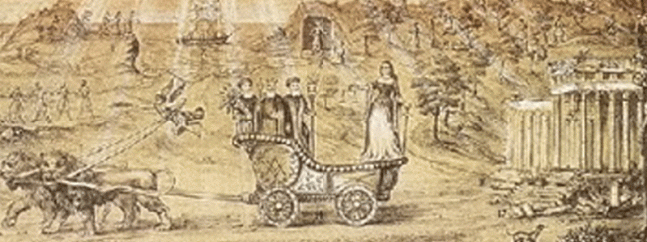
Asherah- CYBELE and the Three Founding Father of French Freemasonry
According to Freemasonry, Asherah is CYBELE.
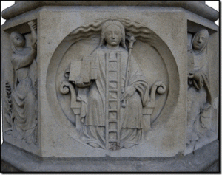
Above is a 12-13th Century relief called “Cybele, philosophy” which is on the West portal of Notre-Dame of Paris. This Lady Wisdom, Cybele, has her feet on the EARTH and her head in the CLOUDS. She holds two books, one open and one closed, symbols for exoteric and esoteric knowledge, or wisdom gained from books and from interior prayer or meditation. Leaning on her is “JACOB’S LADDER”, which represents the gradual way of knowledge of God leading to her scepter of wisdom, divine union. The stones that Jacob put for his pillows, and set up for a pillar in Bethel was/is believed to be METEORIC. Cybele is worshipped in form of a BLACK METEORITE.
Thank God that James Wesley Howell didn’t follow through with his SMEAC, but it does seem to appear that he didn’t abort his mission for any type of love and respect for mankind. He aborted his mission, because he figured that the CIA betrayed him.
Too Close for Comfort, the Columbia (Cybelean), South Carolina Incident
On Monday, October 26, 2015, Columbia had been the site of that infamous student cell phone video that went viral that recorded a deeply horrifying and disturbing incident at Spring Valley High School. It graphically showed 6′ 3″ power weight lifter and football physical strength coach Richland County Deputy Sheriff Ben Fields attack a small defenseless 16 (sixteen) year old black female student named Shakara.
In Part II, Black Manchurian Candidate Chris Mercer Harper, Columbia, SC …, I said that the case had to disappear quietly. The situation in Columbia/Fort Jackson veiled something far more deeper, greater and dangerous than you ever can imagine, and U.S. Military Intelligence PSYOPS and or the U.S. Army Special Forces Psychological Warfare Operations had been on top of this case since it first went viral globally on the internet- to spin, re-write and re-image everything your lying eyes witnessed, and much more.
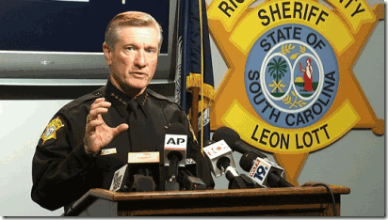
Columbia’s Chief Law Enforcement Officer, Richland County Sheriff Leon Lott is a Luciferian 33rd degree Freemason, York Rite Master Mason, Scottish Rite Knights Templar and a PAGAN.[55],[56] He was out of the town when the cell phone video brutal attack on Shakara went viral. Sheriff Lott had to take the first thing smoking back to Columbia to put all the ducks in order to quash and cover-up the incident as quickly as possible. And in fact, Shakara has disappeared from the public record. Sheriff Lott is the SC State Guard Brigadier General and Deputy Commander of Special Operations Command. He is an Honorary Green Beret, Special Forces Association (S.C. chapter); Retired Military Police Association; SC Combat Veterans Group, Special Forces Association. Special Forces in American culture is tantamount to Himmler’s Elite Waffen SS Officers, and “SS Otto Skorzeny’s Secret Global Terrorism Groups.”[57]

Christopher Columbus used to sign his name, Colon. The name Columbus was invented as yet more BROTHERHOOD symbolism. The Romans used to worship a deity they called Venus Columba, Venus the Dove. Venus and dove are associated with Queen Semiramisin Babylon. The word dove in French today is still Colombre. Columba is also an “Aphrodite” goddess which symbolizes the negative, death and destruction, aspects of the female energy.[58] Semiramis is the Statue of Liberty (Libertas). Semiramis/CYBELE, is the wife of Nimrod and Queen of Babylon.[59]
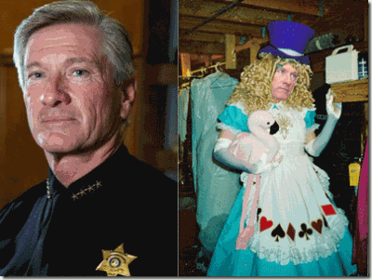
Here’s the kicker. In 1998, Sheriff Lott was the first drag queen to win the title of Columbia’s Vista Queen. In the pageant, Lott donned gay apparel and was described to have “fought it out like proper the proper bitches they are for the crown and the title of Vista Queen.” For Sheriff Lott, it was both a ritual and initiation rite to enter an extremely ultra secret and high level rank among U.S. military elites and the ILLUMINATI–
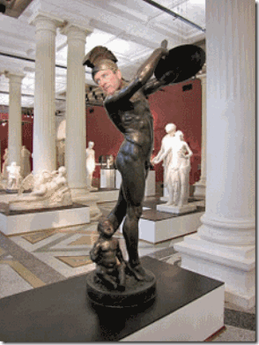
A Corybante

or GALLAE of Goddess Cybele of the Secret Sodomite Army.[60] I CAN MAKE THIS STUFF UP!

Elite Cybelean Gallae Homosexual Rite, Donald Drumpf publicly kissing Former NY Mayor, Rudolph Giuliani (Judy Ruliani), in Drag (Transvestism). At first, I didn’t what to call the elite Satanic Homosexual Rituals spreading across the nation. I suspected all along that there ancient Roman homosexual rituals, but I didn’t have a name. Transvestism, global conquest, secret blood sacrifices among an ultra powerful secret royal and imperial elite, it all fits in with CYBELE.
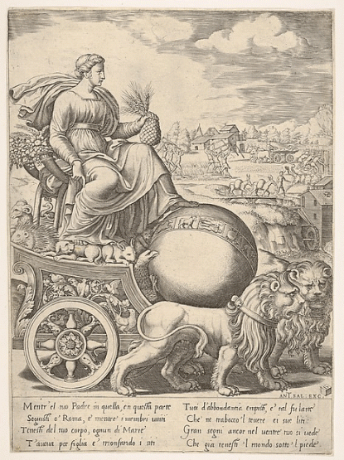
Cybele has the ages old sacred symbolic Pine Cone in her hand. The Pine Cone is considered by many to be our biological Third Eye, the “Seat of the Soul,” the “Epicenter of Enlightenment“. For generations, she has had her foot on the World for her secret elite Enlightened Worshipers.
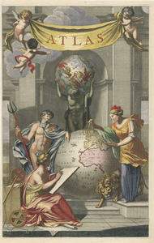
Generations ago, the Cult of CYBELE had plans for world domination of here worshipers. Cybele is an ancient BLOOD CULT from the dawn of history. She was the mother goddessof Ancient Troy, before there was a Greece. The mighty majestic and the imperial elite of Rome claimed descent from Ancient Troy and Goddess CYBELE. Her many names and worship has been preserved throughout the ages by secret fraternities, sororities, freemasonry and Satanic Cults. Her son is the DEVIL God Pan (Baphomet). She is the WHORE OF BABYLON.
Question: “What is the whore of Babylon / Mystery Babylon?” Answer: Rev. 17: 1-2 tells us, “Then one of the seven angels who had the seven bowls came and talked with me, saying to me, ‘Come, I will show you the judgment of the great harlot who sits on many waters, with whom the kings of the earth committed fornication, and the inhabitants of the earth were made drunk with the wine of her fornication.’” Rev. 17: 5 goes on to say, “And on her forehead a name was written: MYSTERY, BABYLON THE GREAT, THE MOTHER OF HARLOTS AND OF THE ABOMINATIONS OF THE EARTH.” Who is this “whore of Babylon” and what is “mystery Babylon”?
Rev. 17: 3 gives this description: “Then the angel carried me away in the Spirit into a desert. There I saw a woman sitting on a scarlet beast that was covered with blasphemous names and had seven heads and ten horns.” The beast mentioned in this verse is the same beast as in Revelation chapter 13:1, “And I saw a beast coming out of the sea. He had ten horns and seven heads, with ten crowns on his horns, and on each head a blasphemous name.” The BEAST in Revelation chapter 13 is understood to refer to the Antichrist, the man of lawlessness (2 Thessalonians 2: 3-4; Daniel 9: 27). So, the whore of Babylon, whoever it is, is closely affiliated with the ANTI-CHRIST.

[1] http://getoffthebs.com/five-suspects-involved-in-planned-attacks/
[2] Id.
[3] http://wlfi.com/2016/06/22/lawmaker-indiana-blew-it-by-not-ensuring-man-had-no-guns/
[4] http://www.indystar.com/story/news/crime/2016/06/15/james-wesley-howell-charged-child-molestation/85925896/
[5] http://www.tampabay.com/news/publicsafety/crime/washington-post-gun-used-by-omar-mateen-a-sig-sauer-mcx-not-an-ar-15/2281735
[6] https://en.wikipedia.org/wiki/Penetrating_trauma
[7] http://www.telegraph.co.uk/news/2016/06/12/orlando-shooting-gunman-omar-mateen-used-ar-15-assault-rifle-to/
[8] https://lunaticoutpost.com/thread-663148.html
[9] Id.
[10] https://erickaecourtney.wordpress.com/2016/06/13/james-wesley-howell-intended-to-attack-the-lgbt-parade/
[11] http://unitedsecurityservices.net/about/
[12] Id.
[13] https://www.facebook.com/MrGresson
[14] http://www.skyscrapercity.com/showthread.php?t=299036
[15] Id.
[16] http://www.indystar.com/story/news/crime/2016/06/13/james-wesley-howells-ex-boyfriend-didnt-surprise-me-all/85836328/
[17] https://www.facebook.com/michael.shanley.940?fref=pb&hc_location=friends_tab&pnref=friends.all
[18] https://www.facebook.com/MrGresson/friends?source_ref=pb_friends_tl
[19] https://www.facebook.com/michael.shanley.940/about?section=bio&pnref=about
[20]https://www.sec.gov/Archives/edgar/data/1301566/000095013605005733/file002.htm
[21] https://en.wikipedia.org/wiki/AlliedBarton
[22] http://elitewatch.911review.org/Blackstone_Group.html
[23] https://www.zacks.com/stock/news/180280/blackstone-pens-167b-deal-to-sell-alliedbarton-to-wendel
[24] http://finance.yahoo.com/news/International-Association-of-iw-586340475.html
[25] http://www.iajvs.org/
[26] http://www.mesora.org/molech.html
[27] http://www.prnewswire.com/news-releases/universal-protection-service-acquires-ar-security-services-inc-and-united-security-llc-168452686.html
[28] http://www.alliedbarton.com/Media-Center/Press-Releases/View-Press-Release/ArticleId/965/AlliedBarton-Security-Services-and-Universal-Services-of-America-to-Merge-to-Create-Leading-Security-Company-in-North-America
[29] http://silenceisconsent.net/revealed-dhs-contractor-employing-omar-mateen-fudged-his-psychological-evaluation/#sthash.O5Hd045A.dpbs
[30] Id.
[31] http://www.universalpro.com/execbio_ryan.html
[32] https://deeppoliticsforum.com/forums/archive/index.php/t-2902.html?s=9de2ebec73c7b897c1a325f00170019e
[33] Id.
[34] Id.
[35] http://www.veteranstoday.com/2016/06/12/mk-ultra-triple-play-in-orlando/
[36] http://forum.bodybuilding.com/showthread.php?t=112730161
[37] https://firstlook.org/wp-uploads/sites/1/2015/06/sent-memo1.pdf
[38] https://firstlook.org/wp-uploads/sites/1/2015/06/sent-memo1.pdf
[39] https://www.newspapers.com/newspage/31503416/
[40] https://www.youtube.com/watch?v=AyVbieOy7_A
[41] https://gabrielbenshalom.wordpress.com/2015/07/09/the-beirut-diary-an-interview-with-kay-griggs/
[42] http://www.redicecreations.com/specialreports/2005/07jul/kgriggs.html
[43] http://www.washingtontimes.com/news/2015/oct/2/chris-harper-mercer-was-discharged-from-army-penta/
[44] http://www.mercurynews.com/crime-courts/ci_28916437/details-oregon-shooters-troubled-childhood-southern-california
[45] http://www.oregonlive.com/pacific-northwest-news/index.ssf/2015/10/new_details_emerge_on_umpqua_c.html
[46]http://events.r20.constantcontact.com/register/event;jsessionid=E6F7C2B52EBB75CED36A6346338322DC.worker_registrant?llr=tpcdhtlab&oeidk=a07e91iubxnd40ea1ad
[47] http://www.rossinst.com/cia_doctors.html
[48] http://static.conservativetribune.com/wp-content/uploads/2015/10/Harper-post.png
[49] http://www.people.com/article/shooter-vester-lee-flanigan-once-paid-escort
[50] http://www.thegatewaypundit.com/2015/08/killer-bryce-williams-left-dirty-sex-toys-for-investigators-would-throw-cat-sht-at-neighbors-balconies/
[51] http://www.militaryauthority.com/wiki/military-bases/nationwide/virginia/
[52]http://news.google.com/newspapers?nid=1356&dat=19740704&id=m4ZPAAAAIBAJ&sjid=iwUEAAAAIBAJ&pg=7148,571358
[53] 7/12/74, FBI FB 204 (Rev 3 359) Reporting Office: Columbia, Office of Origin: Atlanta; Title of Case, MARCUS WAYNE CHENAULT, aka; Mrs. MARTIN LUTHER KING, SR. VICTIM; EDWARD BOYKINS ….
[54] https://en.wikipedia.org/wiki/Fort_Jackson_(South_Carolina)
[55] http://www.rcsd.net/bio.html
[56] http://paganroundtable.org/2011/07/
[57] http://www.rcsd.net/bio.html
[58] http://www.abovetopsecret.com/forum/thread57816/pg1
[59] http://www.whale.to/c/nimrod.html
[60] http://jaspercolumbia.net/blog/?p=1485
Comments : Leave a Comment »
Tags: 9-11 inside job, adam walsh, alliedbarton security services, baby sacrifice, ben fields, blood cults, blood eaters, blood oath secrecy, blood sacrifice, bobby ray inman, brotherhood, Building 18-b, building 7, camy lejeune, chris sean harper, christopher columbus, CIA, col. george Raymond griggs, Colombia, Colston Westbrook, corybante, cybele, del amo behavior health system, dr. colin a. ross, ebenezer baptist church, Fort Bragg, fort jackson, frank carlucci, freemasons, frenchy, gallae, gay agenda, gay parade, george wackenhut, gladio, gs4, hand of death, Henry Kissinger, henry lee lucas, hermaphrodite, homosexual, Illuminati, James Earl Ray, james wesley howell, joey greeson, joseph greeson, katherine griggs, Lee Harvey Oswald, leon lott, lords of the black stone, maimonides, manchurian candidates, marcus dewayne robertson, marcus robertson, Marcus Wayne Chenault, max call, michael shantely, molech, moloch, multiple personality disorder, NATO, omar mateen, orlando, orlando homophobic massacre, ottis toole, Otto Skorzeny, patience carter, pink triangle, pulse club, secret sodomite army, semiramis, smeac, statue of liberty, switzer learning center, The Troop, tiara parker, u.s. army, u.s. marines, umpgua college, united security services, universal security services, Vester Lee Flanagan III, vista drag queen, vril, wackenhut, william casey, Zbigniew Brzezinski
Categories : 1000 Year Reich, 9-11, albert pike, Aryan Supremacy, baby scarifrice, black children, black christianity, Black Manchurian Candidates, blood covenants, blood oaths, blood sacrifice, CIA, COINTELPRO, Crimes Against Democracy, cybele, DIA, division five, false flags, fbi, h. rap brown, Heinrich Himmler, Hip Hop, human sacifrice, illuminati, illuminati sacrifice, imperium, Knight of Malta, Knights of the Black Sun, lucifer's servants, luciferians, Marcus Wayne Chenault, maria orsic, Martin Luther King, masonic sacrifice, michael flanagan, mk ultra, cia occult bureau, temple of set, MK-ULTRA, Molech, Moloch, MOSSAD, mulitiple personality disorder, nato, Nazis, new world order, nwo, order of teutonic knights, Paperclip Project, post amnesia barriers, post hypnotic suggestions, President John F. Kennedy, psychological warfare campaign against Christianity, Reichsfurhrer SS-1 Heinrich Himmler, Ritual Satanic Abuse, ritual satanic sexual abuse, ritually abused children, Satanic Global High Cabal, Satanism, Schutzsteffel, scottsish rite, south carolina, SS, Strumbannfuhrer SS Dr. Wernher von Braun, Symbionese Liberation Army, trauma-based mind control, underground reich, underground third reich, vril, Zbigniew Brzezinski, ZIONIST

FLICKR PHOTOS
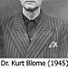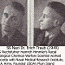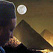
More Photos

EMAIL SUBSCRIPTION

Enter your email address to subscribe to this blog and receive notifications of new posts by email.
Join 1,583 other followers

PRINCE RAY
- PRINCERAY Y-DNA= TA- SETI LA BANTUbullockblackfamily.wordpress.com/2017/10/06/pri…https://t.co/E0sFS7B1bx6 months ago
- Where is the gun at Scott's feet?1 year ago
- #charlestongoddamn Dylann Storm [Trooper] Roof- Devil & CIA- MK ULTRA in the Details http://t.co/sNAOSUpNEe2 years ago
- #charlestowngoddam, Slavocracy Lost Cause & Secret 2nd Civil War Against Blacks, bit.ly/1GwduFt2 years ago
- The police didn't make it to Emanuel AME to save our elders in Charleston- planned diversion, Active Shooter Drillbit.ly/1e0qZqc 2 years ago

- Follow

