CHAPTER XIII
Productores de Monteverde S. A.

FIRST CHEESE MADE IN MONTEVERDE
From John Campbell’s MONTEVERDE MEMOIRS
Soon I would get out another bulletin: Making American Cheese on the Farm – after we found ourselves with extra milk. The first cow we had bought had just come fresh, while the one we had bought to fill in was still doing well so I decided to try making a hard cured cheese. One of the bulletins I had brought was how to make Cheddar cheese at home. We had some good culture, made from selected sour milk which we carried in our little kerosene operated refrigerator. We had been using this for making butter and cottage cheese. This culture together with fresh clean milk was the key to our success. We used an export style metal oatmeal can with holes punched in the bottom for a mold and candle wax paraffin as a coating. I made a press that used a pulley and weight to keep a constant pressure on the curd.

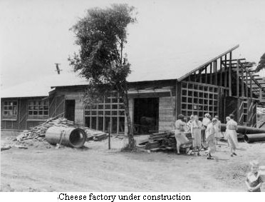
CHEESE MAKING IN COSTA MCA
At that time most of the cheese made in Costa Rica was a soft white cheese- long on salt and a lot of whey and short on flavoring and cleanliness. The one family who were making cured cheese when we came to Costa Rica had their weekly production sold out the day it came to town. It was sold at a small shop located in the Musmani building in San Jose. It was not fully cured, but if one was lucky enough to get a big chunk and didn't use it too fast it would develop a flavor before you ate the last of it. Years later we were to meet the family who made this cheese: the Eulogio Dominguez family; at that time one son had just returned from England with a Masters degree in Food Technology butter and cottage cheese.

CHEESE FACTORY IS A REALITY
It was decided to give cheese making a go and Guernsey heifers were purchased to replace the fence jumping, bucket kicking native cows - which had to be milked on a once a day share basis with their calves. You had to have the calf to stimulate the cow to let her milk down. I thought that this wasn't true so I tried milking a cow without her calf and she dried up her milk.
The first board of directors was named and the original idea was to have it be a cooperative. But after studying the laws of Costa Rica it was found that it wasn't feasible because there weren't enough original founding members. It was decided then to form a corporation. It has been run over the years very similar to a cooperative. On May 15, 1953 the documents were all signed fulfilling the legal requirements. We started with a ¢50.000 Capital and 50 stock certificates were ordered.
The 200 gallon vat had double walls to provide for the pasteurization. First steam was run in to reach the right temperature and then cold water was run in to cool the milk down to about 100 degrees. After it was cooled to this temperature the bacterial culture and the rennet were then introduced. The cheese presses were home-made wooden frames with manually operated screws and heavy springs for maintaining pressure as whey was expelled. The cheeses were initially protected by a paraffin coating. Later they were packaged in plastic bags using a vacuum cleaner to suck the air out and rubber bands to hold the bags closed. The vacuum cleaner was replaced by a milking machine vacuum pump.
A twenty horsepower wood burning boiler was put in a building to one side. Oxcarts were kept busy in the beginning to keep the firewood supplied. The wood burning boiler even though it was very challenging to maintain a good supply of dry wood for fuel was still used until 1971 when a 30 horsepower diesel burning boiler was installed. The next boiler acquired was a 60 horsepower computarized boiler that uses bunker fuel.

++++++++++++++++++++++++++++++++++++++++
- from old letters by Lucky Guindon
2-13-54 Oscar Montien's have finally gotten here in a roundabout way from Japan. They visited Germany (his native land) and the U. S. (she’s from Philadelphia) first. He is to be manager of the dairy plant. They have a little girl the same age as Berto. They adopted her while in Germany. She’s as smart as can be. Right now some of us are sending a little cream down to Puntarenas to sell. It will be a while yet before they get the vats set up and boiler room done so we can start making cheese. Still have quite a bit of work to do on the cold room and curing room of the dairy plant – including collecting enough planer shavings and sawdust to make a 12” insulation of all four walls in both rooms.
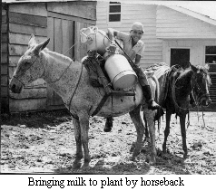
++++++++++++++++++++++++++++++++++++++++
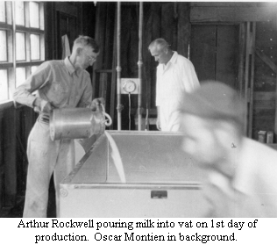
From John Campbell’s MONTEVERDE MEMOIRS
The first manager was Oscar Montien. His wife Margaret, a Quaker, had found out about Monteverde through the Friends Bulletin. They were considering coming to Monteverde. Oscar had graduated with a major in dairy industry from the University of California, he was working in Japan at the time in a creamery. He took a short course in cheese making at the University of Pennsylvania to be able to take over the position of the first manager of our Cheese Factory. Oscar and Margaret and their daughter Rene arrived in February 1954 and took up temporary residence in the small office and laboratory section while their house was being built.
April 8th 1954 the first 30 gallons of milk arrived and the first cheese was made. I assisted Oscar, a novice, in making the first batch of cheese in the nearly completed plant of Productores de Monteverde, using as molds the 2- 1/2 Ib. tin cans that tropical Quaker Oats were packed in. Most of the milk arrived by pack horse from nearby farms - with bits of floating butter that had been churned by the ride. This was a very special day with all the community attending. The school children had made banners and there were good wishes from the several visitors. This was an important day for the people of Monteverde and for their Costarrican neighbors.

The total milk received the first month was 741.5 gallons (2893 kilos) for which producers were paid ¢2.00 a gallon (¢0.5126 a kilo). That month showed 41.8 pounds of cheese sold at ¢4.00 a pound. Approximately 20 pounds (9 kilos) of cheese were produced daily in the very beginning.
The milk producers had to wait for three months to receive their first pay checks. It took this long for the first cheese to be mature enough to begin being sold.
In the first six years the Dairy Plant went from an initial capitalization of ¢50,000 to being worth ¢183,000. More then a 300% increase. No outside capital had been added either. Also interest had been paid on the original capital and dividends and bonuses had been paid out. The milk from our Costa Rican neighbors was a big influence in this rapid growth and by 1960 there was more milk being received from outside of the community than from within it. Also in Costa Rica, when the Dairy Plant first began, there was no competition in the market for cured cheeses.
++++++++++++++++++++++++++++++++++++++

-from “A Brief History of Monteverde”
by Marvin Rockwell
The first time we, as a group, considered dairying was when a letter from Oscar Montien was read at a Monteverde Town Meeting the 27th of November 1951. Oscar said in his letter that he might be interested in coming to Monteverde and starting some sort of dairy plant. At the time we were very much occupied with other things but decided to inquire more about Oscar and his suggestion. We considered what we could produce as the principal source of income for the majority in the community. Since the road was so bad it had to be something of high value for its weight and not too perishable. Three of the families had dairy farms in the United States before coming to Costa Rica. The possibility of making cheese was considered even before we came to Costa Rica and one couple visited a cheese factory in Wisconsin. We also remembered Oscar Montien’s proposal. John Campbell had been experimenting with making some cheese at home. Analyzing all these factors we decided that cheese would be the product. With that in mind we purchased 50 purebred Guernsey heifer calves from dairy herds in the Central Valley and brought them up in jeeps and trailers. These would start producing milk about October or November 1953.
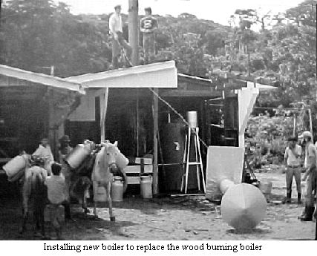
In July of 1952 the community met to discuss the founding of the entity to manufacture the cheese. Hubert Mendenhall was in correspondence with Oscar and Margaret Montien who were in Japan where he was managing a milk processing plant for an American company. They came to Costa Rica by way of the United States where he took a short course in cheese making. It was decided to form a cooperative to be called "La Cooperativa de Monteverde" and a board of directors was named. The board met a few times but in April 1953 because of a shortage of members and the laws regarding cooperatives in Costa Rica they decided to form the company as a corporation.
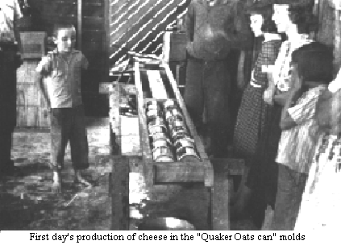
On May 15, 1953 the documents were signed to form Productores de Monteverde Sociedad Anonima with a capital of 50,000 Colones, approximately $6,000.oo. Eight persons, Hubert Mendenhall, John Campbell, Wilford Guindon, Oscar Montien, Lawrence Osborne, Arthur Rockwell, Abner Rockwell and Howard Rockwell Sr. were the founding shareholders.
++++++++++++++++++++++

THE CHEESE PLANT
-from “Monteverde” book by Mildred Mendenhall
Except for one or two, whose interests leaned towards growing sugar cane, most of us hoped to make a living milking cows. To this end a like-minded group got together to discuss the ins and outs of the dairy industry. Already the first of a total of fifty Guernsey heifer calves had been brought up the mountain for those who wished to milk anywhere from one or two, to a whole herd. Many of the calves came from one of the top herds in Costa Rica and were sold to us at low cost in the interests of herd improvement in the country.
It was now imperative that we face the problem of marketing. Considering our remote, isolated location, selling fluid milk was out of the question. Our Costa Rican neighbours were adept in the making of an uncured fresh cheese which, when sufficiently dried on the outside, would keep until it could be taken to market. In the hope that we could manufacture a more profitable product, we decided to work toward a less perishable, aged cheese such as cheddar.
By this time correspondence was underway with a couple living in Japan. Margaret Montien, a Friend originally from Ohio, and Oscar Montien, her husband, had learned of the community through the Friends Bulletin. They were interested in coming to Monteverde to live and asked if we had considered establishing a cheese plant. Oscar was a graduate of the University of California with a major in dairy industry, at the time employed in the manufacture of milk products in Japan. He and Margaret expressed a willingness to invest in the cheese plant, and if we wanted Oscar as plant manager, he would be willing to take a short course in cheese making at the University of Pennsylvania before moving to Costa Rica in about three years time. This proposal fitted their needs as well as ours. In August of 1952 those who were involved in forming a dairy co-operative elected a board of directors.
In September the following year the excavation and levelling of the site for the building was underway, greatly facilitated by the arrival of Hubert's new TD6 crawler tractor. The concrete floor was poured, and the carpenters went to work. Several of the heifers had calved and the milk began to flow. A number of local farmers had inquired about bringing their milk to the plant, fulfilling our wish to benefit them as well.
In February 1954, Oscar and Margaret arrived, and the final push was on, with a series of work bees to get the plant ready to go into production. On the morning of April 8, close to three years to the day of "the discovery" of Monteverde, milk began arriving at the plant. By noon the curd from that first fifty gallons was, appropriately enough, packed into the waiting row of scrubbed and lined Quaker Oats tins serving as the first cheese molds. That day the quesos finos (fine cheeses) de Monteverde were born, and in time they earned a reputation as some of the best in the country.
Productores de Monteverde, is today housed in a building thirteen times the size of the original. Aside from the workrooms, storage and refrigerated rooms, there is a retail sales outlet. On the upper level a reception area is embellished with finely finished woods from the forests of Costa Rica. Behind mahogany doors off a long hallway are the offices, a computer room, board room, laboratory, and a large recreation/lunch room.
Including those who work in the associated enterprises of a huge piggery and model farm, there are now one hundred employees, all Costa Ricans. Of the two hundred and twenty-six milk producers, six live in Monteverde. Of the four hundred and fifty shareholders, thirty are Monteverdians, as are two of the seven who make up the board of directors.
There is room for speculation as to whether the farmers received over the years their fair share of the revenues generated by the cheese plant, in view of the time, energy and expense incurred in establishing dairies and maintaining productive herds.
The uncertainties of weather conditions and a search for suitable grass varieties had to be dealt with as farmers confronted the rising costs of supplemental feed, supplies and labor. Along with the impressive cheese plant, today one observes restaurants and tourist hotels in great numbers. The improved road to Monteverde has become a busy thoroughfare with an increase in transportation services. Electricity, telephones and even television have become widely available in the area.
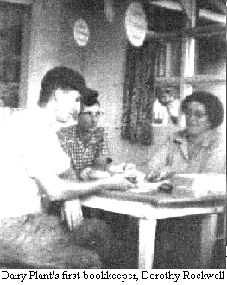
During those early years there was a sense of satisfaction in being able to help our neighbours get their products to market, in seeing them begin to put tighter, more weather resistant metal roofs on their houses, efficient little iron cook stoves in their kitchens, and piped water to their homes.
Today however, we have to question the effects of our locating in a quiet, isolated rural community. We had desired to see the local people enjoy more comfortable lives, while being reluctant ourselves to adopt their level of subsistence living. By helping to improve the local economy and living standards, had we contributed to a form of materialism we had come to Costa Rica to avoid? Has the area been well served by the relative prosperity we observe there today? Perhaps the tentacles of growing global consumerism would have reached eventually into this isolated area anyway.
++++++++++++++++++++++++++++++++++++++++
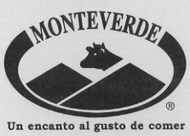

Some of my experiences as an "Inspector de higiene"
Written and illustrated by Miguel Figuerola.
Translated by Molly Figuerola
Before I started on this work, my knowledge of this part of Costa Rica was more than scant. I had been a few times along the "road that leads to San Jose", and could find my way about Monteverde, but that was practically all. I liked horses in a rather platonic way; I was used to see them grouped around the dairy-plant, looking rather sorry for themselves, and along the road, but on the whole considered them more as part of the landscape than as a thing I would one day have to sit on and make go.
As for this last point, I am thoroughly convinced now that it is possible to make this animal go, but the difficulty sometimes is to make it stop. However, this also I managed to overcome; otherwise I would not be here. A second difficulty, related with the first one, is that, whereas one can sit on a chair indefinitely without feeling discomfort, the same cannot be said about sitting on a moving horse: one has to go through an extremely "touchy" period before developing the indispensable calluses, or whatever it is, that makes you really enjoy a long trip on horseback. - Riding by night even calls for another physical feature: cat's eyes. Of course the horse has the faculty of seeing, or feeling, its way very well in the dark, and has an infallible memory for roads it has once followed. But the first time the horseman has to make it go where he wants it to, and consequently must know where he is going.
So this again leads to another problem: where does a certain producer live? For this reason I always started out by day in the beginning, arriving just "before dark, and spending the night in the hospitable homes of our Costarican neighbours, mostly together with the family, as guest rooms are not found in places where the house consists of four walls and a roof, with hardly any partitions inside. The preparations for the night are very simple: as in many houses there are no beds, you just choose a soft spot on the dirt floor, lie down on a couple of gunnysacks, cover yourself with another couple, of course without undressing, and go off to sleep - if possible! Evidently this calls for years of training, beginning in childhood, for my hosts never seemed to have any difficulties, whereas I lay listening to the more or less musical sounds produced by the sleepers.
Other beings seemed to be awake besides me: the pigs were rummaging under the house, around the house, and sometimes in the house; the chickens are stretching in their sleep, sometimes "dreaming aloud", or trying to get rid of a bothering bicho. I remember a certain place where there still seemed to be "tigres" about. In any case the family shut the door very carefully. In the dead of night an eerie, long-drawn cry rose from nearby. The poor pigs, finding them-selves on the wrong side of the door, that is to say outside, started jamming together under the house, which set the floor planks heaving up and down, like a minor earthquake.
Between four and five o'clock the family generally rises and the milking starts. There are even. producers who begin at three, due to the big number of cows that has to be milked, and the long distance from the dairy-plant. In the house of one family I saw a very original system for waking everybody at the same time. The woman's father-in-law, who, like most old people, is a very light sleeper, walks through the house with a contraption like a coffee-grinder, which produces the most awful din I have ever heard. In case anybody has managed to sleep through this, he enters into the different bedrooms (this house is big, and has real beds), and raps on the beds with his stick, shouting: "Get up, good-for-nothings, it is 3 o'clock I want my breakfast!"
The old gentleman, who, at 97, is still very alert, eyed me suspiciously the first time he saw me, and said: "And who may you be?" After I had explained to him the object of my visit, he nodded: "Very good, very good. Now, young man, you just leave things to me. I'll watch these good-for-nothings, and if they don't wash the buckets properly, I'll teach them." - Afterwards his daughter told me that he stood beside them with his stick, shouting: "You call that cleaning the udders? Do it again, I tell you, again!"
The second time I was there I happened to meet the evangelist missionary, who had come for a visit. As the master and "his house" had all been converted, the evening meal was preceded by a long prayer said by the said missionary. At each breathing-pause, the old father, who had stayed by his Catholic faith, chimed in with: "Ave María purísima!", just to remind those heathens!
Recently, the old man's eyesight seems to have become very bad. When I had to come for the third time because the milk had been below par, he no sooner heard what was the matter than he got up, caught his stick, and started beating about him, hitting whoever and where-ever he could. I realized he could not see what he was doing when he shouted: "Let Don Miguel get behind me! I do not want to hit him!" Nevertheless, I thought it better to get outside the house, as he was turning round all the time, and "behind me" was a very relative idea.
For the wives and daughters of the more isolated farmers, my coming is to be compared with that of the Yankee-peddler in colonial times. As they do not often get beyond the immediate vicinity of the house, they are eager for the latest news, and general talk. The news-items are talked over during the evening meal, or, when I come at milking-time, in the morning, as I do now, we talk at breakfast. The master of the house and I discuss "technical problems" of milking. The little ones show their few toys and their pet animals. They are charming, especially the tiny ones. At one place the sow had just had a litter, and when I prepared to start on my way home, I found they were waiting for me with two tiny chicks and a 2-day old pig, for me to take home. It was very difficult to refuse tactfully, because they had even put in a little bag of corn for the pig. But I managed to hand the little animals to the father again when they were not looking. As they were only three and four years old, they will probably not have noticed the difference in number. It is those little things that establish the human contact between people, and make them endearing to you.
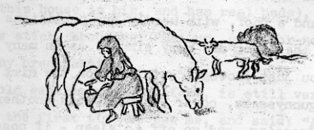
++++++++++++++++++++++++++++++++++++++

- from old letters by Lucky Guindon
Oct. 2, 1969 There was an offer to buy the Dairy Plant - Mr. Jay Teja. He's from India and (he says) worked with Ghandi.. "might have been Prime Minister if parties hadn't switched." As it is he's a political exile— stayed in U.S. for several years til they didn't allow him to stay longer. Now they have officially granted him asylum here in Costa Rica. He says he'd like to live up here but to do so would like to own the Dairy Plant and help our community by bringing more concrete funds into it. We had quite a lot of discussions over the matter and finally decided not to or at least essentially so. He says he's been trained for that sort of work and we figured he could no doubt do it more efficiently but as yet we'd rather do it ourselves.

Nov 21, 1969 We hear Hubert's are selling their farm to Jay Teja—the political refugee from India—the one "who could be ruling there now"—I don't feel this is the place for them... . Another thing about him buying up here is that he wants to buy a caterpillar tractor and trucks and go into road-building in a big way. BUT, he wants to know now much we're giving towards it too. We shy away from big operations. Does not help our relationship with our Costa Rican neighbors. We've just started working together more on repair of roads. Teja is a BlG man with money power supposedly but we haven't seen any money materialize yet! It's all politically tied up, he says. And India claims he filched their Gov' t funds. He's been acquitted, supposedly so he could go back there, some say, but for now he doesn't want to. He's one of these extremely intelligent people and makes you feel very small and insignificant! But I don't know him well and shouldn't judge. We just hope for the best.
++++++++++++++++++++++++++++++++++++++++

ANYBODY. WANT TO BUY A CHEESE PLANT?
By Wilford Guindon
From Family Album Vol. XII
Over the years, especially when returning from late night meetings, spent trying to decide plant policy or solve some pressing problem, this question would come to the surface of our thinking. However the exercise was mainly to bring some humor into the situation as who (except ourselves), would consider such a thing--our location being enough to stop any business minded person.
Thanks to our emphasis on quality and because of ourselves and sometimes in spite of ourselves, the plant continued to expand and prosper. So it came to pass that we were to be faced with the question "Does anybody want to sell a cheese plant?"
The offer to purchase Productores de Monteverde came from Jay Teja and along with it his expressed desire to come and live here in the community. He felt that operating the plant was the area where he could use some of his experience to contribute to a more financially sound and efficiently operated business.
Actually under Jay's offer we would still own our interest in the plant. Present share holders would receive preferred stock equal to what they now hold, and in addition they would receive an amount equal to 50 % more which would be paid in a bankable note and could either be held and draw 10% interest or be discounted at the bank for cash. He hoped in this way to help furnish capital to producer share holders so they could improve and expand their present dairy operations.
In return we would agree to hold the preferred stock for five years and to remain here and continue to produce milk for the plant.
Needless to say such an offer brought out some tall thinking and lots of active discussion. This included thoughts as to just what role the dairy plant does play in our community and its responsibility to Costa Rican producers. Also to question whether it would continue to be the same if it wasn't operated in the main by producer members.
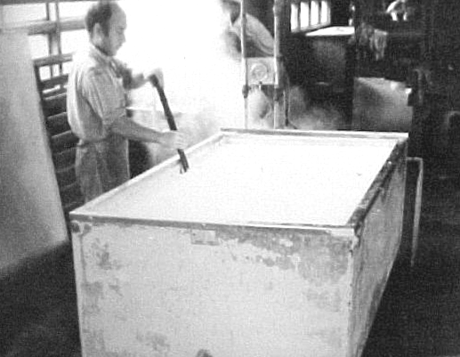
While there is no question that the plant has taken and will continue to take a real amount of time and capital it is also a fact that it has consistently paid a high return—while paying a good price for milk. It has also been the one project that the community has worked together on and the end result has been a success.
While we were not unanimous in our decision against selling, the majority were certain that they did not want to sell their shares. We were unanimous in feeling that the discussions had been valuable and that it was time for us to take a longer look at the whole operation and especially in the areas of expansion, cash reserves, and finance.
+++++++++++++++++++++++++++++++++++++

- from old letters by Lucky Guindon
Aug. 15, 1970 Jay Teja, who almost bought Hubert's and wanted to buy the Dairy Plant was arrested in England recently on false papers and I don't know what else. He's still wanted in India. We're so glad that didn't work out. There's quite a stir about it because he and Pres. Figueres were in close friendship and it was thru that that he got permission to stay here. It's all a little queer. ....... Arthur and Clara sold their house to Dan Boehm and Dan may rent it to the Smiths when they come. Floyd's may move to San Jose, and Carlos and Ruth Rojas have their place up for sale.
++++++++++++++++++++++++++++++++++++++++

Leido en occasión de la celebración del Cuadragésimo Aniversario de la fundación de la empresa,
DESARROLLO DE LA EMPRESA PRODUCTORES DE MONTEVERDE, S.A.
DESDE QUE INICIO OPERACIONES EN 1954
HASTA MAS O MENOS EL AÑO 1980
por Eston Rockwell y otros
Señores y señoras, amigos y amigas:
Es un placer estar aquí con ustedes hoy, celebrando cuarenta anos de vida de esta empresa. Productores de Monteverde, S.A. Durante esos cuarenta afios ha cambiado de una fabrica pequeña, humilde, de producción muy limitada y propiedad por completo de los colonos Quákeros. Si, ha cambiado - a una fabrica moderna, bien equipada, con una producción muy importante en la economía de esta región y todo el país, y los dueños ahora son, mayormente, los productores de leche y los empleados. No miento ni exagero al decir que la empresa, las instalaciones y los productos que salen de aquí constituyen un orgullo para todos nosotros, y un ejemplo para Costa Rica. Y me perdonan que lo digo, pero es para mí una causa especial de satisfacción porque yo siento haber tenido mucho que ver en años pasados en el desarrollo de la empresa. Estoy seguro que comparten esa satisfacción mis otros compañeros - paisanos - que también tuvieron parte en esa lucha.

Miguel Figuerola meneando con la paleta

La fábrica fue un edificio muy rudimentario, de madera con piso de cemento únicamente en la parte de producción. La caldera, que quemaba leña, fue un calvario para don Oscar Montien, el primer gerente de planta y técnico en hacer quesos, porque pocas veces pudo contar con leña seca y costó prender el fuego y calentar lo suficiente para producir bastante vapor.
En los primeros meses de operación de la fábrica, toda la leche provenía de la comunidad de Monteverde y la cantidad era tan poca que se hacía queso día por medio. Al rato, los vecinos en Cerro Plano y Santa Elena y más allá, al ver la posibilidad de tener un mercado para la leche de sus vacas y una entrada mensual fija, empezaron a solicitar que se les recibiera la leche de ellos. Fueron aceptados como productores con ciertas condiciones para mantener una calidad mínima en la leche recibida. Así, algo rápido iba aumentando la cantidad de leche recibida. Al sexto año la leche recibida de fuera de la comunidad alcanzó y sobre-pasó la producción de la comunidad. A los diez años, en el invierno, la cantidad de leche fue tanta que había que hacer tres tareas diarias por algunas semanas. (En el tanque de 200 galones.) La agitación se hacia a mano con una paleta de madera. Había que estar meneando la leche constantemente, caminando de un lado al otro del tanque durante el proceso. A los once años fue instalado un tanque de 1000 galones litros con agitador automático que fue una gran cosa para nosotros.
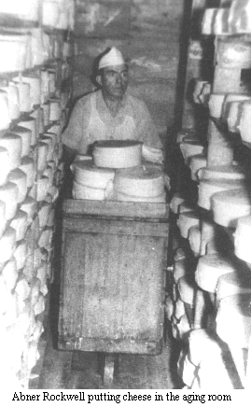
Oscar Montien, el primer jefe de planta, tuvo dos ayudantes. Pero generalmente fue él mismo quien llegaba temprano para prender el fuego de la caldera y alistarse para el recibo de la leche, la cual llegaba en bestias o al hombro. (Nada de camiones). La leche fue vertida directamente al tanque porque no había pasteurizadora hasta años más tarde. Asi que hubo que pasteurizar la leche en el mismo tanque - subir la temperatura y volver a enfriarla antes de mezclar el cultivo y el cuajo – todo el tiempo meneando con la paleta de madera. Cada rato él, o uno de los ayudantes, tenia que salir a atizar la caldera. A veces tenía que rajar leña. Él hacía las pruebas de leche en el laboratorio, hacía el queso, en fin, hacía un poco de todo.
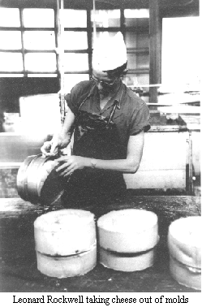
Oscar Montien tuvo una habilidad para trabajar con el mínimo de equipo y bajo condiciones difíciles. Él tuvo que hacer milagros para hacer queso de superior calidad con los medios a su disponibilidad. Él, con ayuda de otros del grupo, inventó un aparato rústico tipo baño maría, con que hacer queso procesado, cuando no pudimos comprar una olla apropiado. Con un hombre en cada lado con paleta de madera en mano, se mezclaba el queso derritido manualmente. De allí se vertía a los moldes de madera forrados con manta, formando bloques. El block era cortado en libras y envuelto en celofán. Después de ocho años, al fin, se compró e instaló la olla mezcladora con cámara de vapor, para queso procesado, que hizo posible llevar al mercado un queso procesado de mejor calidad y apariencia y de más larga duración.
Hubert Mendenhall tuvo el único generador de corriente eléctrica, que fue operada con la misma fuente de energía que movía un aserradero. Se pudo contar con electricidad únicamente por ciertas horas del día. Muchas veces no se pudo mantener una temperatura correcta en las cámaras frías por falta de electricidad más continua. A los cuatro años Reuben Rockweil y su hijo David pusieron a funcionar otra planta hidroeléctrica mas grande que dio energía eléctrica los 24 horas todos los días excepto las veces que fallaba la planta. Cuando no había electricidad, hubo que conectar, por medio de una faja, un motor de gasolina a la bomba de agua del tanque de hacer queso para circular agua caliente o fría, según el caso, para procesar la leche. Fue un ruido escandoloso dentro de la fábrica.
El acceso a este lugar por camino fue un gran reto desde el principio. La ayuda del gobierno central y la Municipalidad de Puntarenas en mantenimiento y construcción por los primeros 7 u 8 años fue nulo. Para contar con fondos para mantener el camino transitable se fijó un aporte para caminos que se rebajó del pago de la leche. Este fue un tanto por quintal de leche y efectivamente sumó a más o menos un 7% del valor de la leche. Si estuviera vigente hoy, un productor que recibe ¢50,000 pagaría ¢3,500 para el fondo de caminos. Con este fondo fue tractoreado el camino al principio de verano, se hicieron reparaciones de emergencia en invierno, y se construyeron trochas nuevas. Ese fondo de la leche no fue gastado en otros caminos - solamente en "la carretera" donde sale el queso al mercado. Nosotros, en Monteverde, tuvimos otro fondo aparte para mantenimiento y construcción de caminos dentro de la comunidad a que aportamos según el tamaño y valor de la finca.
En los años '60 fue construida la carretera actual, pero hasta principios de los años '70 fue lastreado.
Por ser tan malo el camino en los años '50 el costo del transporte era altísimo. Para darles una idea, con la equivalencia del valor del dinero de hoy, el transporte a San José en verano costaba alrededor de ¢l,800 el quintal y en invierno era de más o menos ¢2,250 el quintal. En invierno uno ponía cadenas en las cuatro ruedas. Con buenas cadenas a veces se podía subir sin usar el wincher pero muchas veces hubo que buscar un árbol macizo adelante, amarrarle el cable y halar para sacar el camión de un barreal o subir una cuesta muy empinada y llena de huecos. Uno se sentía muy satisfecho y con mucha suerte si llegaba a Monteverde con únicamente uno o dos de tales contratiempos.
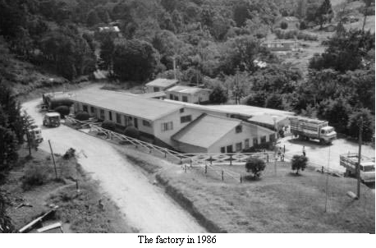
Una vez que tuvimos queso maduro para vender hubo que abrir mercado, porque aunque teníamos un producto muy bueno, no valía nada si no había un comprador. Marvin Rockwell vendía los primeros quesos. Los llevó a San José y fue de negocio en negocio hasta poder colocarlos todos. Iba desarrollando una ruta y seguía yendo más o menos una vez por mes. Después de unos meses me dieron a mi la tarea de repartir el queso y seguí haciéndolo por unos 3 o 4 anos empezando con un viaje por mes - después, cada tres semanas. Salía de aquí a las 2 o las 3 de la madrugada el lunes, llegando a San José en la tarde. Los dos días siguientes repartía queso a los expendedores y cobraba las facturas. El resto de la semana seguí cobrando y haciendo compras hasta regresar el sábado con carga a Monteverde. (Naturalmente no existían teléfonos para estarse comunicando con la fábrica o con mi esposa.) El uno y medio por ciento de las ventas de queso pagó la distribución - la mitad por mi tiempo y la mitad para pagar el camión por el reparto en San José. (El transporte de Monteverde a San José fue pagado por aparte.) Después, necesariamente, el sistema de distribución cambió con un aumento en el costo. Marvin Rockweil estableció un local en San José en el año '59 y se encargó de nuevo de la distribución. En ocho años pasó a Hubert Mendenhall y su hijo, Phillip. Después, a MADRE SELVA hasta el año '72 cuando pasó a Carlos Arias quien constituyó CAROMA, S.A. y desde luego, por espacio de 21 años, esta última empresa ha estado frente a la distribución de nuestros productos con mucho empeño.

Volviendo a Monteverde y la fábrica y los años '50

En el año '57 Oscar Montien salió y Abner Rockweil, mi papá, se puso al frente de la fabricación de queso y manejo de la fábrica, por unos 5 anos. Creo que fue durante este tiempo que fue instalado un tanque pasteurizador que facilitó mucho la pasteurización de la leche.
Cuando mi papá murió, yo tomé su lugar por tres años y medio. Fue un reto para mí porque casi de un día para otro tuve que aprender hacer todos los trabajos de la fábrica.
Kenny Wallace me reemplazó en la fábrica y continuó por 11 años - hasta el año '75. Durante eses años hubo un programa de construcción que cambió mucho el aspecto de la fábrica y le dio mucho mas espacio. También se compró maquinaria para obtener una operación mas eficiente. Y, muy importante, Kenny desarrolló el queso Monte Rico que tenía, y todavía tiene, tanto éxito en el mercado. Kenny tuvo mucho que ver con el auge de nuestra industria .
Elias Newswanger actuó de gerente de planta por un tiempo, y también Marvin Rockweil. Los dos sabían mantener el ritmo de la expansión y la fabricación de productos de alta calidad para el mercado.
Thom Dixon fue gerente por ocho anos y medio - hasta el ano '86. Naturalmente se hicieron muchos cambios durante ese lapso. Continuaron las ampliaciones en la planta física y la compra e instalación de maquinaría moderna y eficiente. Se desarrollaron otros tipos de queso y se lanzaron al mercado: el Dambo y el Provolone Ahumado.
Hubert Mendenhall merece mencionarse aqui porque fue una persona muy importante en la fundación de Monteverde. Sin él nosotros, "los gringos", no hubiéramos venido aquí. No existiría este Monteverde. El lugar sí, pero probablamente con otro nombre. Difícilmente existiría esta industria, la fábrica de queso. Todo sería muy diferente - no digo peor - pero muy diferente - en toda esta región. Hubert Mendenhall fue Presidente de la Junta Directiva por 11 anos, y todos los anos que vivió aquí con su apreciable familia, tuvo una influencia muy grande en el desarrollo de esta empresa y en todos los quehaceres en general de Monteverde, y en toda la región.
Howard Rockwell, el Presidente actual de la Junta Directiva, para mi, merece una medalla porque ha sido siempre tenaz en el cumplimiento de sus deberes en la Junta Directiva y desde principios de la empresa ha cooperado y ayudado a resolver todo problema que aparezca.
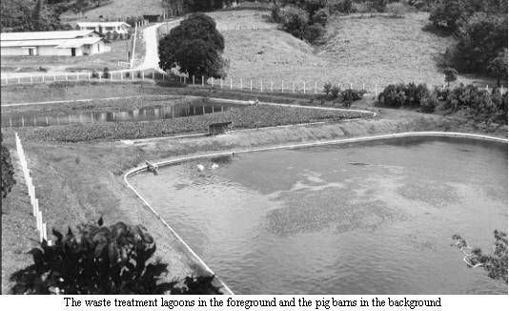
Hace falta mencionar mucha, pero mucha gente para elogiar todos los que han ayudado a traer a esta empresa al punto en que se encuentra hoy día. -- José Luís Vargas ha tenido una sensibilidad para dirigir la empresa sin olvidar o dejar de lado los principios con que nos dirigimos los Quákeros fundadores. Otros que merecen elogio son: -- Todas las personas que han participado en la administración y en la planta de proceso hoy y antes. -- Todos los productores, empezando con los del año '54 y continuando hasta la fecha de hoy. Y los lecheros - primero los muchachos que trajeron leche a caballo - y más recientemente los camioneros que traen leche de las fincas. -- Y los que ordenan las vacas y los que chapean los potreros y arreglan cercas. Las mujeres que cocinan y lavan, y ayudan a sus maridos en mil maneras. Las mujeres casadas o solteras que trabajan en oficinas o industrias o cualquier otra parte. Los comerciantes que se empeñan a traer los enseres y productos que todos necesitamos. Los veterinarios que ayudan con la salud de nuestros animales. Pues, no hay fin - todos dependemos unos de otros - todos somos hermanos y hermanas.
Gracias.
++++++++++++++++++++++++++++++++++++++++

PRODUCTORES DE MONTEVERDE, S. A.
1980 – 2000
- por José Luis Vargas L.

Aspectos Sobresalientes Del Desarrollo De
La Empresa En Este Periodo
La llegada de los cuáqueros ha marcado en forma muy importante y positiva la historia de esta región. Con la fundación de la empresa Productores de Monteverde, S. A. el día 15 de mayo de 1953, se dio quizás uno de los pasos más significativos para establecer las bases de una integración comunal más amplia, una fuente de trabajo y sustento para miles de familias y fue también el inicio de un modelo empresarial que ha sido ejemplo para Costa Rica y otros países.
Se resume seguidamente un análisis general de los últimos 20 años de actividades de la empresa.

Los Productores y La Producción de Leche
Considerando la necesidad de un mercado seguro para la leche producida en la zona y las posibilidades de ampliación de productos y mercados, la zona de recibo de leche creció gradualmente hasta el año 1988. A partir de ese año el crecimiento que ha experimentado la producción ha sido básicamente con una zona de producción estable comprendida entre Monteverde, Guacimal, San Rafael y Quebrada Grande.
El total de productores se ha mantenido estable entre 230 y 240 en los últimos 10 años, mientras que la producción promedio por día por finca ha crecido desde 50 Kg en 1980, 80 Kg en 1990 y 160 Kg en el año 2000. En 1980 se recibieron 8,400 Kg diarios de leche, en 1990: 18,400 Kg/día y en el año 2000: 37,700 Kg/día.
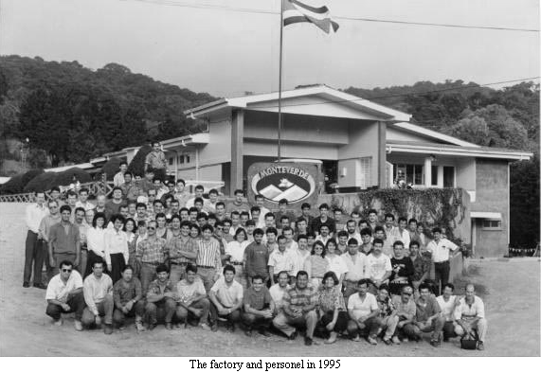
Después de que toda la leche fuera transportada a caballo en los años 60´s, hoy toda se transporta en camiones. Una hermosa excepción lo constituye la carreta de bueyes de la finca Stuckey-Nygard en la que día a día hacen llegar su leche a la fábrica, constituyéndose también en un atractivo para los turistas. Para bien y para mal, a mediados del año 2001 una parte de la leche comenzará a transportarse por medio de un tanque cisterna.
El año 1998 será histórico para el productor y para la fábrica. El huracán Mitch ocasionó enormes destrozos en un trayecto de 300 metros del camino entre la Cooperativa y la fábrica, de tal magnitud que durante cuatro días ningún camión pudo completar su ruta, haciéndose necesario un enorme esfuerzo por parte de los productores, empleados de la Fábrica y vecinos para “hombro a hombro” hacer llegar la leche a la planta y sacar el queso hacia el mercado.
La producción de leche y café sostienen la economía de la mayor parte de las familias finqueras de la zona, mientras que las zonas de mayor densidad poblacional, Santa Elena, Monteverde y Cerro Plano han pasado a depender mayormente del comercio, turismo y los empleos que generan la fábrica de quesos y las otras instituciones y comercio.

Los Productos y El Proceso Industrial
La familia de productos elaborados por la empresa ha crecido considerablemente. Se han agregado nuevos quesos como el Emmental, Baby Swiss, Parmesano, Mozzarella, BonSalut. Después de unos 40 años regresa el queso Edam a la lista y se desarrolló un Gouda Deluxe más seco y maduro que el Gouda tradicional. En el año 1995 se inició la producción de queso fresco que es un producto de muy alto consumo en Costa Rica. En recuerdo del primer jefe de planta y quesero que tuvo la empresa (Oscar Montien) se le dio a este queso el nombre de Montino.
En años recientes las ventas de subproductos lácteos han tenido un crecimiento importante. Se incluyen productos tales como la natilla, el queso crema y los helados que han tenido gran éxito y aceptación.
Debido a la urgencia de dar un adecuado manejo al suero lácteo y a las aguas residuales de la fábrica, en 1992 se construyó la Granja Porcina y el Centro de Tratamiento de Aguas Residuales en la finca de Eric Rockwell. Después de un período inicial de ajuste, el proyecto ha permitido dar un tratamiento biológico logrando una depuración total del 98% en las aguas de desecho de la fábrica y la granja.
El aprovechamiento del suero en la producción de cerdos permitió que en el año 1997 la empresa instalara una fábrica de productos cárnicos en la finca que adquirió para ese fin en Chomes de Puntarenas. (Muy cerca del Río Guacimal – Carretera Interamericana). En este momento la planta en Chomes produce 45,000 Kg mensuales de unos 25 diferentes productos cárnicos (Salchichas, jamones, mortadelas, salchichones, etc.) y se consume la totalidad de los cerdos producidos en la Granja. A la vez, las instalaciones en ese lugar funcionan como sala de ventas al público y como centro de distribución de productos lácteos y cárnicos para Guanacaste, Puntarenas y las exportaciones a Nicaragua.
Otro paso importante ha sido el desarrollo de una segunda marca para productos. Después de más de 40 años de depender exclusivamente de la marca Monteverde, a partir del año 2000 nace la marca DelGusto con líneas de producto de menor precio en lácteos y cárnicos y con el fin de desarrollarse en mercados más amplios de los que tradicionalmente se han cubierto con la marca Monteverde.

El Mercadeo de Los Productos
El principal mercado para los productos elaborados por Monteverde en ambas fábricas sigue siendo Costa Rica. Aunque se han hecho esfuerzos para ampliar mercados en el exterior, éstos no han sido muy exitosos debido al bajo nivel de precios de productos de Norteamérica y Europa, por los excedentes que han tenido esos países y los subsidios que brindan a sus exportaciones. En la actualidad Monteverde exporta aproximadamente el 5% de la producción a Nicaragua y Panamá.
La comercialización en Costa Rica se efectúa mediante unos 25 camiones refrigerados que cubren todo el país. La competencia ha crecido mucho en los últimos 20 años con el surgimiento de nuevos fabricantes de queso a nivel nacional, la modernización de plantas existentes y un crecimiento importante de las importaciones de productos competitivos. El precio se ha convertido en un factor cada vez más relevante en la decisión de compra del consumidor, por lo tanto el mercadeo y comercialización son de las actividades más complejas en las operaciones actuales de nuestra empresa.
Aun así, Monteverde ha logrado mantener su imagen de líder en la producción de quesos de alta calidad en Costa Rica y gradualmente va desarrollando esa misma imagen con los productos cárnicos. En el año 2000 las ventas totales alcanzaron ¢2,518.0 millones equivalentes a aproximadamente $8.3 millones.

La Organización Actual
Hoy día la empresa pertenece a unos 500 accionistas. Se mantiene la política de no vender acciones a personas que no residan en la región ni se permite que un mismo socio adquiera más del 5% del total de las acciones.
Actualmente la empresa pertenece en un 50% a productores de leche, 6% a empleados de la empresa y 44% a vecinos de la región y familiares de productores y empleados. Mediante un programa especial, unos 60 niños y jóvenes de la región han adquirido acciones y son parte activa del grupo de dueños de la empresa.
La empresa sigue siendo dirigida por una Junta Directiva de siete miembros, la cual se ha distinguido siempre por su estabilidad y alto grado de responsabilidad e identificación con los valores que la crearon.
En forma directa la empresa emplea 150 personas (106 en Monteverde, 36 en Chomes, 8 en Heredia).
La administración de las actividades se realiza mediante la participación del Gerente General, un Gerente Administrativo-Financiero, un Gerente Agropecuario, un Gerente Industrial y un Gerente de Mercadeo y Proveeduría, quienes velan por la operación de ambas fábricas.
Hoy acercándose a los 50 años de existencia y después de grandes transformaciones producto de la necesidad de ajustarse a los requerimientos de los socios y del mercado, la empresa sigue adelante. Ninguna época de su historia ha sido fácil pero siempre, desde su fundación, ha contado con muchas personas responsables quienes con cariño y dedicación y con la guía de Dios han sabido llevarla por buen camino. Dios quiera que a través de las próximas décadas Productores de Monteverde, S. A. siga produciendo bienestar para la región y mucha satisfacción y orgullo para sus socios y fundadores.
++++++++++++++++++++++++++++++++++++++++

The heifers came from the Irazu farm of Alfredo Volio, Costa Rica's leading Guernsey Breeder.
This was written and published in 1995.

