CHAPTER XII

Hospitality

- from Memories by Irma (Rockwell) Hampton
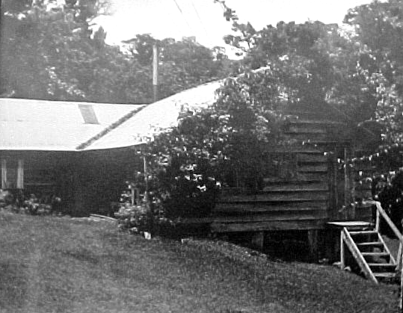
We had it in our minds to have the "guest house" for the community since no one had extra room. People seemed to be willing so when we built the rest of our house, we built a large living-dining room and three bedrooms and a room to have for a bath with a big porch across the front of the utility and kitchen, also a ladder—at first—to the upstairs. Our guests started coming Feb 7, 1954, according to the guest book I kept. I can't believe now how many we had before we ever got electricity or a bathroom! I had a wash stand with a pitcher and wash-basin in each room and a bucket for waste water. Also a kerosene lamp with a reflector in back and a slot for hanging it on the wall. It seems amazing now that there never was a broken chimney that I recall or any fire from peoples using them. I kept the chimneys shiny and the rooms clean and neat. We had a hanging Aladdin lamp over the dining table that gave a nice light.
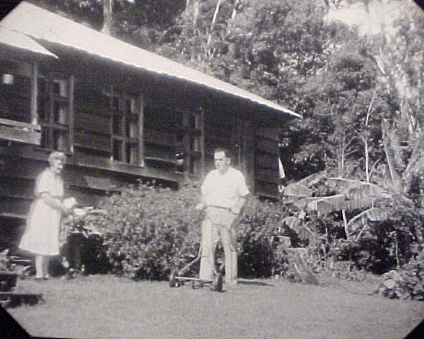
Irma and Abner in front of Green Mountain Inn
Abner read in the Bible after breakfasts as part of the routine. Sometime along beautiful new floors were installed all over the house and plywood paneling put on the ceilings and sides of each room except the living room and it was left open for awhile to the roof. But it proved too drafty and hard to heat with the fire-place at one end so several years later Glen (our son) came down and put on a ceiling like the rest which helped a lot.
Green Mountain Inn
Abner worked at the cheese plant with Oscar Montien for several years then took over the management of it himself but it proved too much for him and no replacement could be found. Then he got sick and died suddenly June 29, 1962. The community gave me a lump sum for Abner’s years of work at the cheese plant. They thought if I had to make a living having guests it would be better if I had a bathroom and offered to install one if I would furnish the materials. So I used that money for it and Howard Jr. supervised the volunteers. It was wonderful to have. Water was piped down thru the woods from Uncle Elwoods but before the pipe could all be buried someone stole a length of it one night!
For several years though there weren't enough guests so but what it was a real struggle to keep going. The roads still weren't good enough in rainy season so the Costa Ricans didn't plan their vacations at that time of year and there weren't enough others either. So I tried various other things to try to supplement. I tried selling cookies and candy to the milk-boys who brought the farmers' milk to the cheese plant but that didn't work. The farmers didn't give them "spending money" but they could buy at Cecil's store and "charge" it for a month! Finally, a group of biology researchers came for several days then two couples for a year. As the word spread from people being here, more and more came. The roads got better too so eventually a car made it all the way up! At that time there were no places to stay in Santa Elena so if someone came up on the bus they had to walk the 2 or 3 miles to my place and be willing to take whatever I had. There was no way for anyone to call for reservations so I never knew who or how many might come. (I recall when once it was a group of three teenage boys, who arrived and had to climb the ladder to sleep in the attic. One of them later became our Costa Rican President- he was then the former President's son—and some of his pals became part of the President's cabinet....LG)

BOMBA
In the early seventies, there were no tourists or hotels or reserves yet. The occasional visiting scientist or friends visiting Monteverdians could stay at the one pension in the whole zone - lrma's. One day back then, when tourism had yet to descend on Monteverde, Irma and I stood talking in front of her place, and she was a bit distressed. As I remember her expressing it: "Why, today I got a letter from some folks who want to come stay here next week, and I JUST had people here last week."

A big problem was that I needed help, but for the most part only Costa Rican girls were available and not even many good reliable ones of them. Also my Spanish was very poor but I had to have someone so we made out someway. Rene Montien came after school sometimes if people came in late on the bus. She rode her horse over and helped til bedtime and was a life-saver.
So after 3 or 4 lean years it seemed to snowball!, I liked being with the people and visiting with them but it got so there were so many that I had to spend more and more time in the kitchen which wasn't as rewarding so I began to see it was getting too much. I kept a guest book where people wrote their names, addresses and any comments. A lady came from New York and took it upon herself to count the people and the countries they came from and with the ones that came after she did there were 1000 in 10 years and from 15 countries!
About the time I was thinking of quitting, Oliver Hampton came down from Iowa to visit his brother-in-law Howard Rockwell Sr. and Dorothy. Oliver had lost his wife recently and we struck up a friendship. The following summer I left my business with a very efficient and trustworthy Costa Rican girl, Virjita Brenes and went to Iowa for 3 months where I got a job to see what it seemed like working at something else. I also got a chance to get better acquainted with Oliver and we decided to get married. In August, 1972, he came to Costa Rica, and we were married in the Meeting in Monteverde. By that spring I had definitely decided to try to sell as a business--completely furnished, if I could. At Easter all of a sudden three prospects showed up and I wondered how I would decide. There was an earthquake in the night so one prospective couple left immediately! The second ones didn't seem the right ones for the business so that just left Martha Moss who was there visiting friends and had not come with any idea of buying a Pension but decided to!
We had been sorting and packing assuming we were going to sell in time for us to get back to Iowa in time to see Olivers first grand-daughter graduate from High School! Martha had to get back to a job and to make arrangements to come hack to run a business so it was a wild scramble for all of us. We bought some land across the river and made arrangements with Bob Law to build us a house to came back to in the fall. He had rainy weather to deal with but had it practically finished and it was nice. We spent eleven happy winters there living 6 months here and 6 at his farm in Iowa.
Each later year it got harder and harder for him to make the trip so we did not return in the fall of 1983. We did not want to spend any winters in Iowa and as Phyllis—my daughter—and Kenny were in Alabama they rented us a furnished little house for the winter. We liked living in Alabama so well that we bought a mobile home in a trailer park and lived there where he died on November 14, 1985. It seemed too lonesome to go back and live in our house by myself so I never did and eventually sold it to Sybil Gilmore who is there with you now.
++++++++++++++++++++++++++++++++++++++++

HOSPITALITY IN MONTEVERDE FROM 1973
By Martha Moss
The year was 1973. Irma Rockwell had married Oliver Hampton and they were eager to get to Iowa to be with family there. This was my first visit to Monteverde. It was February and windy, misty and sunny all at once. As a Quaker I felt very much at home in the Meeting and at the community Potluck that followed. I visited Irma at the Pension (or the Green Mountain Lodge as Irma called it) and decided to try a new career as an innkeeper. It was an unexpected choice on my part, but it seemed the right thing to do at the time. So in May I made a special trip from New York to Monteverde to buy the Pensión and then returned to Rockland County N. Y. to rent my house, take leave of absence from my job, pack the things I might need (I'm still angry at the mover who talked me out of taking my second cast iron skillet!) Meanwhile, Susie Newswanger had agreed to manage the Pensión until I could return.
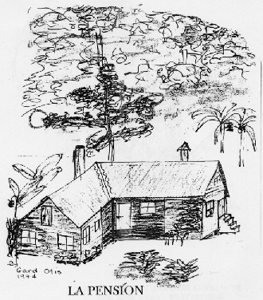
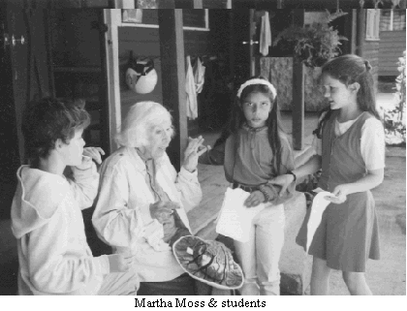
So in July of that year, myself, a widow, together with 15 year old daughter Nan and a new orange, Volkswagen Safari named "Tiger Lily" began the adventure. We drove from New York to Miami and then shipped the car to Guatemala, paying the Agencia de Aduana pirate insurance, a leftover practice from early days in the Caribbean when persons shipping goods in this area paid an additional insurance against pirates. I don't believe they are all gone, the pirates. We retrieved our car in Puerto Barrios, Guatemala and began the drive to Monteverde. After 3 days of adventures that included a night in San Salvador and the next sleeping on massage tables in the garden of a small hotel in Managua. Rooms in the city were limited due to damage by the recent earthquake and a convention being held there at the time, so the offer of the massage tables was most welcome. My lack of fluency in Spanish and the many different kinds of Central American money all added to an exciting, but fortunately uneventful trip. On the afternoon of July 25th, we started up the road to Monteverde.
I must admit that I was frightened. The weather halfway up the mountain became foggy and misty and what I most remember about the trip was watching the road in front of me and getting around rocks. Nan kept watching for holes and any unexpected traffic. There was none. We did arrive before dark and Susie had dinner ready. It was so good to be there. I heard later that our drive up the road and the fast time that we made became a record - for me, of pure fright.
It was hard to know how my past experience in a Children's Psychiatric hospital as Director of Volunteers, a year as Director of a community center for young gang members in Bronx, NY, or even my new degree of Master of Public Administration would be helpful to me in the new career. Probably the most useful was work in a variety of restaurants where I did part-time work while studying. Actually, all of it was helpful in different ways.
I don't know what I would have done without Susie to show me the ropes - how to bake bread, where to get food supplies (mostly, it was at the Pulpería Coope and choice there was limited). We made our own cereals, the granola and grape-nuts that Irma had made popular, as well as marmalades and guayaba sauce. Later in the lean times (rainy season) we sold bread and sometimes cereal to the Coope as Irma had done before. The early arrivals had several cookbooks on how to use local products like proteina from the cheese plant and chayotes, a local, ubiquitous, squash. Along with this help, Susie gave us a present of a puppy, Joshua, who for years was the Pension dog and who went faithfully to Quaker Meeting, as well as going on bird walks with Pension visitors. According to them, he was a good companion and stood quietly when a bird was sighted. He barked a lot at animals in the night however.
More and more people came to the Pensión. There were the biologists. Bill Haber arrived the day after Nan and I did and moved with hundreds of bags for leaves and butterflies into the small room off of the porch. There he stayed, a fixture, for many months. Richard Laval came for several days at a time to collect bats and would tuck them under the shingles of the house to sleep. I felt that it was a little too much
when he asked me not to turn on the outside porch light until the bats had flown away in the evening. I finally convinced him that it was not good business to tell guests that there was no light, because we were waiting for the bats to leave! Richard who was also very sensitive to the cold in the mountains would go from room to room collecting all of the quilts and blankets to stay warm.
BOMBA
The time was the first of the Latin-American OTS classes that came to MV. Ann Hayes, a gourmet cook from New York, living at "Mata's" near the Reserve would come to the Pension to cook for the group. One night she told Martha that she didn't feel so well and spent the night in the Pension loft. In the morning, she had a rosy rash and stopped to see Sylvia Smith on her way. It was measles! Most of the biologists from the Latin American countries had been exposed!! Luckily, Ann got better, and we never heard more.

Visitors came from the Audubon Societies , World Wildlife Fund and Nature Conservancy, all interested in the Monteverde Reserve , a vision of George Powell another biologist. Many people, students and their professors, museum curators and others came attracted by the natural beauty of Monteverde. They didn't seem to mind the fact that there was no telephone and reservations could not be made. There was only one bathroom, but it had a tub - one of the only ones in Monteverde. Some neighbors took weekly advantage of this and came to the Pension for a real bath. All were very good sports and seemed to enjoy the adventure even if it meant sleeping on the floor in front of the fireplace when we were really full. We had lots of books and a collection of music on records. This was before TV and people usually went to bed early after a day of hiking the trails in the Cloud Forest. The most fun was having meals together at the big table in the living-dining room. Later, the OTS classes made the Pension their headquarters while in Monteverde and the Peace Corps workers discovered us for R and R. They especially enjoyed the chance to talk English, eat fresh milk and cheese, cakes and cookies and go square dancing on Saturday nights.
In September, Nan went back to her Quaker boarding school in New Hampshire and "Tiger Lily" and I began our biweekly trips to San Jose to get provisions for the Pension. In the years that I had this guest house (We still didn't talk about "tourism") finding food was a big part of the job. This meant a trip to San Jose for things like lasagna noodles, spices, sesame seeds and any non-traditional treasure one might find like fresh mushrooms. When I ride the bus now, I think of the hundreds of trips I made driving up and down the mountain road. A pleasant part of staying in San Jose was the Tala Inn, a small Pensión on the site of what became the parking lot for the giant Seguros Building. Allen Huper and his family always found room for travelers from Monteverde. Often it was on the large porch where there were many mattresses and people could sleep if they had not been able to make reservations.
These mattresses at Tala Inn gave me an idea, and we put a floor in the unfinished loft and used foam mattresses when we had large groups of students. The single bathroom remained a problem, even with the outhouse (very reassuring when there were problems with the water line.) For one class of OTS we rigged up an outdoor shower (cold) and offered a prize to the person who took the most outdoor showers. It was a young woman biologist who won the prize and a lot of applause.
After a few years it was obvious that the Pension could not take care of the many people who now wished to come to Monteverde and a committee meeting was held to discuss "hospitality". I thought that I would like to have a small field station for biologists and others who wished to do research. Other hospitality was divided up somewhat like this: Bob Law and Susie Newswanger would build a pensión (this became "The Quetzal") Marvin and Flory Rockwell would have a "Soda" (which in time became the Pensión "Flor-Mar”) Dan and Betty Boehm built a Camparque for backpackers and young people who could not afford the pensions. There was an increasing need for a small hotel in the area that would have private baths and this would become the "Hotel de Montana" in 1978. As so many large Costa Rican families from San José were discovering Monteverde. The Pension, despite it's flexibility could not accommodate them all. I helped the Hollander's with the early planning and beginning of the Hotel de Montaña.
Meanwhile, the Tropical Science Center built their own field station at the Reserve and I was finding that my career of a small simple pension was rapidly changing. It seemed a question of enlarging or stopping. Hospitality seemed in good hands and the next 20 years was proof of this. I will let someone else write about it however.
The Old Pensión had been a special place as is the community of Monteverde with many wonderful stories about the animals and people there. For the next years I wrote and told these stories and hope to be able to tell many more.
++++++++

HOSPITALITY AND HOTELS
- by Martha Moss
From the late '70's until the present the growth of pensions, hotels, field stations in the zone has been one of the greatest changes of all. Now in 2001 according to the local "Camera de Turismo" there are more than 1,000 rooms available for guests to Monteverde. This growth alone could be a chapter.
In many ways, Monteverde has been fortunate in this growth. The combination of Quaker values of simplicity, the strong environmental focus of tourism here and the influence of the many researchers and biologists has kept the area almost a model of Ecotourism, considered by most people to be the ideal for Costa Rica.
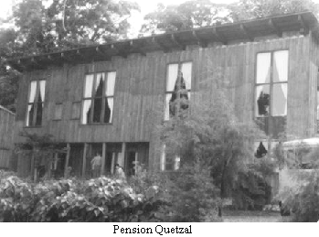
Most of the hotels and pensions are family businesses built by people already living here; many of whom have grown up in Monteverde. For the most part, the hotels are attractive and modest, and provide jobs for many locals.
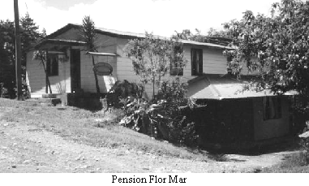
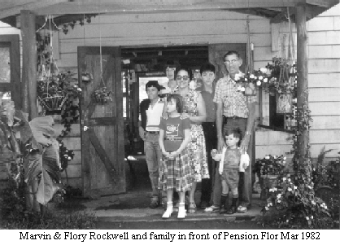
A few of these that are in Monteverde Community or in nearby Cerro Plano are: The Pension Quetzal built and managed for many years by Bob Law and Susie Newswanger (recently closed). Pension Flor Mar belonging to Marvin and Flory Rockwell - (recently sold and now called Colina Lodge). The Hotel Fonda Vela, built and managed by Paul and Steven Smith - El Bosque Hotel belonging to Marcos Vargas and Irma Arguedas family. The Sapo Dorado Hotel, owners and managers, Geovanny Arguedas and his wife, Hannah Lowther. Hotel El Establo owned and operated by Arnoldo and Ruth (Campbell) Beeche. Hotel Heliconia built by Mario and Roxana Solano and the Hotel de Montana mentioned above as the first modem (!) hotel. There is also the bed & breakfast in Monteverde, La Mariposa owned and operated by Rafael Vargas & Luz Mary (Leitón) Vargas.
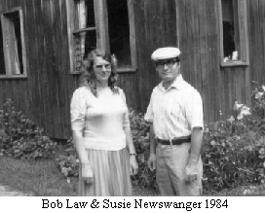
All of the above, and many more including 3 Research Stations have replaced the original Pension - the Green Mountain Inn of Monteverde History. Yes, the landscape has changed, but the guests continue to enjoy their stay in this beautiful place.
++++++++++++++++++++++++++++++

VISITORS
- from John Campbell’s Monteverde Memoirs
One of the earliest visitors could well have been from the CIA. Clean cut and imposing, he looked more like an executive than the prospective pioneer he claimed to be. Introducing himself as Henry Benjamin Quick from Minneapolis, he said that he was thinking of joining the community . The last that we ever heard from him was his parting pledge to "keep in touch."
The first group to visit were several volunteers from the Friends Work Camp in El Salvador. One of the young women from the Northeast had dated Ted Kennedy, until mama stopped the affair because she was not a Catholic - but it didn't stop the Kennedys from using the Work Camps as their model for the Peace Corps.
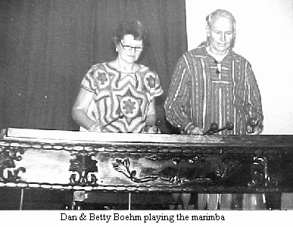
The last of these volunteers to visit was Jane Badger, an intrepid young lady who hitchhiked alone from El Salvador just after Christmas of 1958. Later three of Monteverde's young people went to the Friends Work Camps in Mexico, while two others joined the Peace Corps.
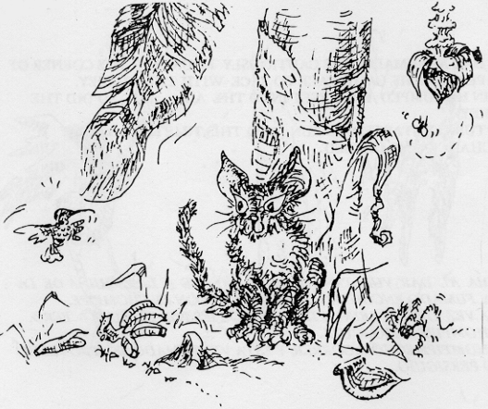
One lady arrived from the Appleton, Wisconsin bringing her daughter. Some Indian seer was predicting a World Catastrophe and she felt this would be the safest place for her daughter. She wanted to make sure her daughter would survive to carry on their family.
Clara Rockwell's mother visited in 1955 for three months, she returned home just before her 90 birthday. It was her first trip by airplane and she enjoyed it. She died at 101 years of age.
Until 1977 there wasn't a great quantity of visitors
++++++++++++++++++++++++++++++++++++++++

Visiting Advice
By John Campbell
From Family Album Vol. VIII
In the dozen years of its existence, quite a number of visitors have managed to find their way to Monteverde. The length of their visits have ranged from hours to months; but no matter how long they stay, most visitors have formed very definite impressions of our community before they head back down the mountain. Some have objected to the wind or the Isolation or that the ground was too hilly, while at least one found that bathing in the river was a little too chilly.
A number of our visitors have felt the urge to share with us their ideas on how we could improve the community: A hitching post at every front door, for the man who wanted to make his return visit aboard a mule. Or more seriously: a reliable map of the community for those who would like to get away from the guided tour – or maybe just plain don't like to get lost!
A few have felt that their visit could have been longer if we could have catered to their peculiar diets, or if our meetings for worship were not so quiet.
A milk pipeline to the highway, and airport for the skyway. Silly or sober or just plain wishful, advice we have had it by the fistfull. Regardless of the diversity of opinion of our visitors, all have been united on one "behooving" * The Road From The Highway Could Stand IMPROVING!!!
++++++++++++++++++++++++++++++++++++++++

- by Betty Boehm
On my first visit to Monteverde, Dan met my plane & after an overnight at Tala Inn we went by bus to the turnoff, then a smaller bus to Guacimal turnoff, and then in a pickup where I was honored with a seat in the cab. Amazing sights - esp. the drop-offs at the side of the road & Dan pointing out the hill which used to be winched up. End of the line in Santa Elena, and after a delicious simple meal in the dark restaurant, we started slogging through the black night, carrying my suitcase, with muddy road slurping at our boots at each slippery step! I had no idea how anyone could know where the road was. Finally arrived at Irma's pension, my home for the week! Guess what? Monteverde trotted out its usual warm welcome, wonderful, interesting people, beautiful (tho very wet) surroundings. I came back again & again!
Walking up the hill following Mary James, with Walter quite a bit farther ahead! thru the pastures, and on up thru their farm to the house. Mary grumbling a little that Walter never looked back to see if she had any misstep or whatever.
Dances at the school -from square dances called by Wolf, to line dances, mostly Israeli, to various European folk dances - big variety, some attracted many participants, others just a small group.
Dorothy's advice when we took care of Clara's laundry while Dorothy visited in the States was not to worry about doing it any particular time, but remember that "Clara doesn't think clothes wash except on Mondays".
Stretching the limits of what I thought I could do. With guidance from Sylvia Smith, helping care for Emilce (colostomy patient), and caring for sick mom, cleaning up & feeding two little ones when their mother couldn't even get off the bed (hepatitis?)
Women's group meetings, often in the Smith's 'Octagon' house.
Seeing the Puffer house become a reality, ready to welcome those who could be cared for better in a central location.
++++++++++++++++++++++++++++++++++++++++

- contributed by Lucille Guindon
I was looking through some old letters and papers and found a note which Mildred Hoge wrote to me when I was in the hospital. She had written some jokes to cheer me up. Here are a couple of them:

Joe & Sarah Stuckey had plenty of time for conversation as they walked home from Santa Elena. Sarah said, "Daddy did you know Emily Rockwell was a Quaker before she was a Seventh Day Adventist?" "Yes" Joe said. Then Sarah said, "Just like before I was a Quaker I was a Ceasarean."

Like father, like son?
“ I'm beginning to think that my father doesn't like me,” said the little boy.
"Why", asked his friend.
"Well, the other day I heard about a father-son picnic at the park. I went home and told my father about it, and he said it sounded terrific and that he was looking forward to it"
"What's the matter with that?"
"He went with my Grandfather."

Ticket Temptation
An exasperated salesman who abandoned his car in a no-parking zone left this note: "I've circled this block 20 times. I have an appointment and must keep it or I lose my job. Forgive us our trespasses."
When he returned he found a parking ticket and a note from the Meter-maid. "I've circled this block for 20 years. If I don't give you a ticket, I lose my job; Lead us not into temptation."

++++++++++++++++++++++++++++++++++++++++

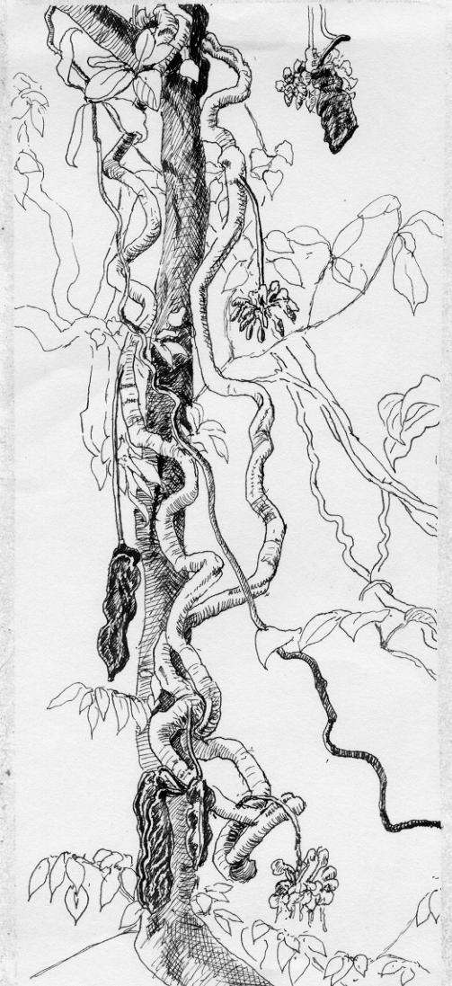
Drawing by Lucky Guindon

