CHAPTER XI

“Our Woods” and Natural Phenomena
SONNET FOR OCTOBER
-by Margaret Montien
The trees so softly outlined through the mist
Are pure enchantment on this rainy day,
Their greenness dimmed to subtle shades of gray
With overtones of palest amethyst.
Low weeds and grasses which the rain has kissed,
In gladness make extravagant display
Of jeweled leaves. Though hid the sun's bright ray,
Today earth's beauty needs no alchemist.
With boots and black umbrella, up the hill
I plod, oblivious of all, until
I pause to rest; and only then I see
The misty loveliness surrounding me.
So may I pause as up Life's hills I plod,
And through Life's mists observe the hand of God.
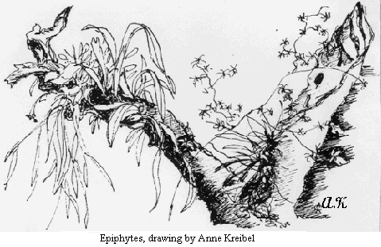

THE CLOUD FOREST ENVIRONMENT

-from “Monteverde” book by Mildred Mendenhall
Long before environmental consciousness became what it is today, there existed in Monteverde from its inception a perceptive awareness of the imperative need to protect the forestland surrounding us. Acting accordingly, we designated specific areas which were to remain wooded, made use of the large amount of timber already on the ground in the clearings and used discretion in cutting standing trees…
We had lived in Monteverde about ten years when the first biologists arrived, intent on doing an in-depth study of the army ants. The scientists have been coming in greater and greater numbers ever since, until it would seem there is no bird, bat, butterfly or bug that has anything left to hide.
What began as academic research has now evolved into biological surveys directed toward the preservation of a much larger area in the interest of protecting endangered plant and animal species.
++++++++++++++++++++++++++

The Last Sloth
- by David Rockwell
We, the Americans that had been looking for land since January 1950, found a high, cool and affordable place to call home.
Leo and I had come up the hill, making road on the way, with Cecil and Hubert (as I remember). They left us to hold down the fort and they went back down the hill for more stuff. We had food but we wanted to eat meat. It was some time in April 1950 and most of us had not had much meat. Leo and I were just meat hungry. We needed to have some meat.
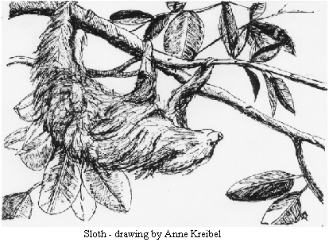
So we got our guns and walked up the hill. Not very far up the hill we see a sloth on top of a fig tree, that was meat, and 10 shots later it was on the ground. We carried the poor animal down to Don Rubén’s house and skinned him out. The thing looked like an ugly kid with long fingernails, but it was meat.
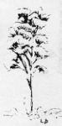
We washed some rice, cut up a tomato and put it with some of the meat and water in a pressure cooker. Then put the pot on the stove and cooked the stuff for 30 mins. at 15 lbs. Now one would think that meat would be ready to eat but let me tell you it was tough! I tried to cut off a small piece and I believe it was tougher than it was when it was raw. So, back on the stove with more water for about 25 minutes. By this time we were hungry enough to eat anything, we thought. After cooling the pot down to open the lid, I got some rice out, just like mush, and a piece of meat. Now the rice was good so I tried some meat, a small piece. After chewing for some time I took out about half and still had more than I started with. I chewed and chewed, it just got bigger. I gave up, I couldn't swallow that ball of string.
Thank goodness the rice was good. That was not the last Sloth in Monteverde, but it was the last one killed to eat!
+++++++++++++++++++++++++++++++

Hunting
- by Mildred Mendenhall
I feel uncomfortable recalling the following incidents but at the same time feel satisfaction in knowing of the tremendous progress that has been made over the last fifty years in the preservation of the fauna of the forest.
During the very earliest days in the history of Monteverde, Ted and David, camping in the Ugalde house, had a tasty looking stew prepared for Hubert and Cecil upon their arrival from San Jose. After a prolonged attempt to chew the meat therein, inquiry was made as to its identity with the expected consequences of expressions of shock and disgust when they learned it was monkey.
In September, deer were observed hanging out under the protection of a patch of tall corn in an upper clearing, enjoying the corn and beans planted there. Without success some of the fellas had been up there exercising their prowess at hunting. It was Eston who came down the hill one day with a deer slung over his shoulder, the source of some tasty meals. Sadly, it was a doe with a fawn and no way to find it afterward. In El Semanario the children waxed poetic about the episode in a parody on Hiawatha. Ted had seen a buck deer on the water-path right near their tent.
On a trip into the Peñas Blancas Valley, the hikers returned with a lapa, one of the gorgeous lowland parrots. The school children were thrilled with the brilliant yellow, blue and green feathers and fashioned them into Indian headdresses.
David shot a kinkajou, which must have been an old-timer as it, too, proved to be a tough chew. Not so the Guatusa which Howard's boys shot. It was choice eating with a good amount of meat on it.
Hubert shot a skunk we suspicioned was the culprit that had taken all but one of our little turkeys and two chicks, but then after we found fourteen of our hens and two roosters slaughtered, the track of a fairly large cat was discovered. Not long after, it was back - discovered trapped in the hen coop when the up-and-down sliding door was released. Within was a beautiful margay, trying to get out. Sadly again, it was destroyed. Then a sloth was killed and I felt it was time to have a discussion in Town Meeting concerning killing the forest creatures, realizing my grandchildren might never know of their existence.
+++++++++++++++++++++++++++++++++

EL MENSAJERO
10th Mo, 24, 1952
WOLFS TURKEYS— The fourteenth of this month was Wolf and Lucky's second wedding anniversary. It so happened, while on a hike around their farm that day, Wolf shot two wild turkeys—one for each year. If he continues to shoot as many turkeys every year as they have been married, think how many they'll have when they reach their 25th anniversary. Then the 16th of this month he shot another one. It sounds like good turkey hunting over that way.
++++++++++++++++++++++++++++++++++++++++
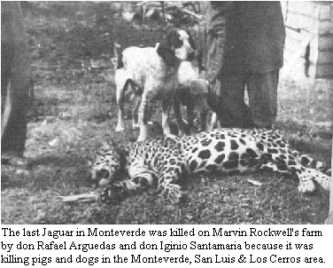
BOMBA
We had half a guatusi a couple weeks ago. Was really delicious. One of John's cows was chasing it across his pasture so he went out and shot it, But he didn't have time right then to skin it so he brought it for Wolf to skin on halves. I never realized they were so big. It's nearly all white meat and quite similar to rabbit. Wish his cows would do that more often!
+++++++++++++++++++++++++++++++++++++

BIOLOGISTS
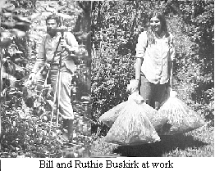
- by John Campbell
from “Family Album 1971-1991”
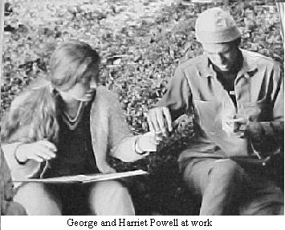
Monteverde's Renaissance began in April of 1970 with the arrival of the Buskirks and Powells, four graduate students from the University of California at Davis. They had come to begin long term research projects for their Doctorates. A few biologists had visited previously, but for only short periods. The arrival of these four almost doubled the number of environmentally concerned adults in the community.
Bill and George's study of the flocking habits of small birds was carried out in "Campbell's Woods", the only sizeable tract of virgin forest deliberately, or as some said - impractically, left uncleared.
When the two years of field work were over, the Buskirks returned to Davis to write up their Dissertations and receive their Degrees.
The Powell's departure was postponed because of their strong concern that the forest above the Community be put into a Nature Reserve. This project had the enthusiastic support of only one of the original families. The attitude of the rest was influenced by the fact that one of the arguments used to justify the high price of the land, was that each would have a proportionate share in the "Watershed Land". Few wanted to give up what they considered a potentially profitable investment. Arguments and entreaties were having little effect until it was discovered that squatters were beginning to clear patches in the forest's depths. Policing the land would cost money! If it was leased as a Reserve there was always the possibility that the government might make it into a National Park and would then pay for the land!!
Only now, when their children are beginning to benefit from EcoTourism, are some of the more "practical" Quakers beginning to realize the great debt we all owe to George and Harriet Powell.
The first Research Project was a three week study by Carl Rettenmeyer of Army Ants and their "camp followers", the minute insects that live and move with the troops.
Subsequent investigations have covered a wide range of both Flora and Fauna. Most of these projects have been relatively modest but a few have involved several researchers and their assistants. One, the radio tracking of Quetzals, involves technology which was not available until the end of the Eighties. Over 100 Biologists have now researched here.
In 1973 a group of Graduate Students slept in the loft of Abner and Irma Rockwell’s Pensión. This was the start of the OTS program's which include Monteverde as one of their stops on a nation wide field trip. This has served as an introduction for a number of our friends, who have later returned on their own. Undergraduate Student groups started coming in 1977. The first, a few hardy souls from the ACM program, camped in tents during their several weeks of study.
In 1985 Biologists played leading roles in the founding of both the Monteverde Conservation League and Institute. League efforts have greatly expanded the area of protected forests, promoted conservation consciousness in the area's schools, and is promoting and managing windbreak and reforestation projects. To this end, a large tree nursery has been set up. The League is second only to the Cheese Plant in the number of area residents it employs.
The Monteverde Institute facilitates the visits of student groups and promotes cultural and educational activities for the region.
++++++++++++++++++++++++++++++++++++++++

BOSQUE ETERNO DE LOS NIÑOS
The First International Children's Rain Forest
from “Family Album 1971-1991”

A Dream Is Born
Bosque Eterno de los Niños (Children's Eternal Forest) is a piece of virgin tropical rain forest in the Tilarán Mountains of northwest Costa Rica. What makes it unique is that it is the first rain forest in the world to be saved by and for children.
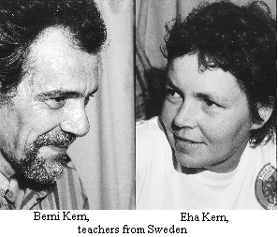
The story of Bosque Eterno began in 1987 at a small primary school in rural Sweden with the visit of a North American biologist who had lived and worked in the cloud forest at Monteverde, Costa Rica. Her words and her slides of the vibrant tropical forest and the animals who live in it moved a nine-year-old student to want to do something to keep that rain forest safe. With his teacher and classmates, the young man started a campaign to raise money to purchase threatened rain forest adjacent to the Monteverde Cloud Forest Preserve,
The seed they planted with an initial purchase of 15 acres (6 hectares) grew within two years to a forest of 18,000 acres (7,285 hectares). It grew from the efforts of students in a rural classroom in Sweden and at a private conservation group in Costa Rica, the Monteverde Conservation League, to involve children and adults from around the world.
The story is not over. There is a stretch of surviving rain forest that begs to be saved, lying between the land already purchased near Monteverde and a national forest reserve—some 43,000 acres (17,402 hectares). Joining these two protected zones is vital to some species that require large areas for survival, such as the tapir, and for birds such as the resplendent quetzal that migrate seasonally from cloud forest to lower elevations.
Springing from the children's vision, the league now has a dream of its own: an educational center in Bosque Eterno where children from around the world can join Costa Rican children in environmental workshops, outdoor leadership training, and an international theater test focusing on the environment.
++++++++++++++++++++++++++++++++++++++++

THE MONTEVERDE PRESERVE'S BEGINNING:
A COUPLE OF FREQUENTLY ASKED QUESTIONS
By George Powell - Preserve Founder
People often ask how it was that the Monteverde Preserve got started. And, why and how did a graduate student with no experience or intentions of becoming distracted from his scholarly study of understory forest birds get involved?
It was the buzz of a chain saw and the crashing of massive trees that precipitated the establishment of the Monteverde Cloud Forest Preserve. Bombarded by those sounds as I studied my birds, I could only wonder how one could study a forest that was being cut down? But what could one person do about it? When the destruction of the forest became unbearable, I set out to find out what I could do.
The history of the Monteverde Preserve is just that, an on-going, pilot study of what individuals can do. In contrast to almost every other neotropical conservation success, Monteverde has not been the protegee of an international conservation giant. The World Wildlife Fund, The Nature Conservancy, and many others have given critical assistance at one time or another, but none of these organizations saw the need to become Monteverde's benefactor. Instead, the Preserve's development has continued to be an effort of a multitude of individuals. More than 100,000 people, from all walks of life and many countries, have contributed directly to protecting the greater Monteverde forest and making it a showcase for nature education and tourism. Some contributed money, others months or years of their lives. It is a phenomenon that more people should be aware of and accept as a challenge. Everyone can make a huge difference in the race to protect biodiversity from excessive development by Homo sapiens.
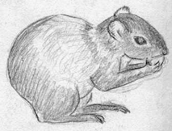
In 1972, the most one person could do was inform and motivate others, so that is what I set out to do. The uniqueness and spectacular beauty of Monteverde made it easy to captivate others (among the first to make a commitment was Dr. Joe Tosi of the Tropical Science Center who gave the fledgling reserve a legal home).
But after the motivation came the hard part - on-the- ground action. Again, I was lucky, my closest friend and local chainsaw salesman was a closet conservationist who needed little encouragement to take up the cause and co- lead the charge. It was an unlikely team, a totally naïve graduate student and a "woods-wise" hardened settler, but it worked. Together we tackled and overcame what seemed impossible. And gradually, the pieces began to come together: we purchased rights to the critical land, made nature trails, and got the word to birders and TV producers, the only active "ecotourists" at the time, that Monteverde was a naturalist's paradise. We began the process of enlightening local residents about what we were doing and why, and even eventually raised the money to repay ourselves for the land we had purchased.
The second most commonly asked question is whether we had any method in our madness as we set around purchasing farms or did we just buy whatever came along? From the beginning we had a conservation strategy. We would take advantage of the local topography with its preponderance of hilly, inaccessible habitat and restricted access points. With a relatively few strategic purchases of those accesses, we could buy time for all the forest.
At that time there were 3 major access trails punching deep into Monteverde's remaining forest. One, the Peñas Blancas trail, seemed beyond our scope; more ambitious people would have to tackle that one. The other two accesses, the Brillante and Chomogo trails, were each used by fewer than a dozen squatters. Buying them out and removing the incentive for trail maintenance and improvement would allow the saws to fall silent and the forest to begin to recuperate from its lesions. With those few hundred hectares purchased, many thousands would be protected, at least for the time being.
The plan worked well. Almost all of the landholders were happy to sell these properties and use their earnings to improve their main farms in the local communities. Only one case required serious convincing - a speculator from San Jose. In the end, we had to bring two University of Costa Rica professors all the way to the site to convince that owner to sell. Drs. Douglas Robinson and Sergio Salas, along with Chris Vaughn and Adelaida Chaverri, made the trek to that farm deep in the Brillante forest as a demonstration of the biological value of Monteverde's forests.
It would be more than a decade before the Penas Blancas campaign would eliminate that third major access that was splitting the great forest of the Tilaran mountains in half. Then there would be other access points like those into San Bosco and San Gerardo that would emerge and have to be dealt with. But the seed of a Preserve had been sown and thousands would come along to nurture it.
++++++++++++++++++++++++++++++++++++++++

EARTHQUAKE
from Clara Rockwell's Diary
April 14,1973 —
Last night or early this morning we had a real earthquake — shook books, dishes and other things off the shelves and out of cupboards as doors came open. It sure was scary. Kept on having small quakes and shakes after the first big long one.
The electric current is off indefinitely as the ditch is pretty much torn up or rocks in it, and supports gone from under the pipe. The chicken house door came open so the hens were all out this morning. Some folks lost canned fruit. There was damage to the foundation and broken glass at the house of Ron and Bill.
April 18th 1973 —
We are still having jolts or shakes from the earthquake, sometimes pretty good jolts and sometimes very light.
April 19th 1973 —
They finally got electric current on this morning. We went up to Monteverde Day picnic over at Hollander's, a very nice place, a little clearing with woods all around.
++++++++++++++++++++++++++++++++++++++++

THE EARTHQUAKE
Benito Guindon
At about 2:30 a.m., I was getting back in bed after making a trip to the bathroom when suddenly there was a small tremor. I was lying in my bed thinking about it when all of a sudden the whole house started jumping around, groaning, and creaking, and there was a great racket made by the sound of falling objects and breaking glass. In the few minutes that it lasted, I first hid under the blankets as a lamp mantle landed on my head, then I remembered that Zeb, a two year old boy, was in the bed on the other side of the room, so I crawled over to him. He was sitting up in bed with a pile of toys and books all around him, but he never made a sound. Everything was dark, as the lights had gone out. Picking up Zeb, I went into the living room, where we all huddled together and waited for it to get light. Papa got a flashlight and worked at getting the gas turned off, as it was leaking and was filling the house with fumes. Even though the house was a mess of broken glass and spilled food from the refrigerator and jars of canned foods. We were all glad to come out of it unscathed.
++++++++++++++++++++++++++++++++++++++++

WEATHER
- from John Campbell’s Monteverde Memoirs
There are three seasons in Monteverde. Rainy Season -Wet Season, May through October characterized by clear sunny mor/nings with cumulus cloud formation in the Pacific lowlands and rains in the afternoon and early evenings. Windy Season - Transitional Season, November through January with strong Northeasterly Trade Winds that often bring wind driven precipitation and mists during the day and night. Then there is Dry Season, February through April, with moderate trade winds, some stratus clouds and often clear skies. There is often mist or cloud water particularly during the night, in the upper part of Monteverde.
Our benign temperatures are the product of both our geographical location and our altitude. Costa Rica is buffered against wide swings in temperature, and low pressures, by two oceans which are less then two hundred miles apart. Our altitude gives us a built-in thermodynamic advantage of around 10C/18F over the sweltering lowlands. Another aspect of our climate with little variation is the relative humidity which averages about 80%.
The least spectacular features of our climate are the temperature and length of the day. The average daily variation in temperature 8C/14F. Our record low was 9C/14F which was recorded in 1977 and 1987. A record high of 27C/81F was reached in 1980 and 1983. When it comes to hours of daylight we have 12 hours and 42 minutes on the longest day of the year, 23rd of June and 11 hours and 32 minutes on the 22 of December. The sun is straight overhead at Monteverde on April 23rd and August 23rd, approximately and reaches a minimum of 56.6 degrees on the 22nd of December.
Our location, 10 degrees 18 degrees north of the equator places us on the edge of the Intertropical Convergence Zone, just beyond the northernmost limit reached by the thermal equator. Although the sun is north from us from April 30th until August 11th the thermal equator never quite reaches us. It is the oceans that produce the lag between the solar and thermal equator.
One of the most noticeable features of our weather are the Northeast Trade Winds which are with us in varying strengths from December through March.
Most of our average annual rainfall of 2519mm/99inches comes from the Pacific. The driest year was 1959 with 1715mm/67 1/2 inches and the wettest, so far was 1981 when 3234mm/! 27in came down. Our heaviest rainfall occurred during Hurricane Gilbert when 246mm came down in a thirty hour deluge, causing numerous landslides, one of which pushed the Guindon house off it's foundations. June, September and October usually have the most precipitation recorded.
In spring of 1956 the National Meteorological Service set up a weather station by Abner and Irma's Pension, at 1450 meters, and entrusted them with keeping a daily record of temperature and rainfall, a job Martha Moss inherited when she purchased the Pension. I agreed to take on the job of "Weather Man" in 1972, at 1520 meters, and in 1983 ICE had a recording rain gauge installed. It consists of a revolving drum with a long graph paper on it to let people know when it rained, for how long and how much. These are changed each 24 hours. There is a collector of water to be able to measure the amount of rain that fell and maximum, and minimum temperature thermometers. I enjoyed keeping the records all of those years and that data was extremely helpful to the biologists studies. Alan Pounds took the information and put it on his computer to be able to analyze the data and make better use of it.
++++++++++++++++++++++++++++++++++++++++

WEATHER REPORT
By Irma Rockwell
From Family Album Vol. XII
The "weather'' is always a good subject when a person can't think of anything else to talk about. It seems always to be "unusual" at some time of the year. The first three months of this year were quite low in rainfall compared to similar months other years so it had the farmers worried for a spell. It really wasn't until May that we got enough moisture to allay their fear's . But by August the rain was the topic of much conversation, for instead of being the usual drier month, it let loose with torrential downpours, ending with over twenty-two inches, which was an all-time high for any August since records have been kept here.
Then, as if that wasn't enough, along came October with another all-time high of thirty-one inches! Monteverde was as near the "slough of despondency" as it has ever been, with pastures and lawns supersaturated and regular streams running the water off where ordinarily there had been none. Springs opened up in old and entirely new places so truckers didn't know from one trip to the next what the road problem would be and whether they could get through. One time it got so bad in front of Irma's drive that they had to level off the old road enough to take the cheese over that route, but it was so soft that the truck had to be pulled through with Hubert's tractor.
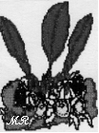
Just when it seemed like something different would have to be done, the rains suddenly let up and it started drying up quite rapidly, so Hubert could hardly believe the improvement on his next trip.
November seems to be dropping off sharply with only a bit over four inches by the 20th. Who knows, we may not yet reach last year's record high for the year of ll8.4".
+++++++++++++++++++++++++++++++++

Temporal
-from “Gleanings” by Phyllis (Rockwell)
Beginning Oct. 12, 1955 (if not before) our worst temporal of the season (& the worst in 4 yrs. according to the Costa Rican's) set in. For 3 days & nights it rained almost continually and for 2-3 more days it rained steadily all afternoon, evening & part or all of the night. Prior to all of this we'd been having the usual daily p.m. cloudbursts since the 1st of the month, so, we were feeling quite saturated & wondering if we should begin building our “Noah's Ark”.
It seemed to me this came the nearest to equaling a U.S. snowstorm of' anything we might have here: halting, demobilizing or interfering with usual functions & activities and, at times, the heavy mist or rain even resembled snow in the air. The one noticeable difference, of course, was the temperature which generally remained mild (70"F.)
The quantity of water that fell on up the mountain at the head of the Guacimal River resulted in racing torrents of the stuff down here that cascaded down over the rocks in rushing, foaming white falls, beautiful, exciting & yet rather terrifying to see. Our previously narrow, relatively shallow, peaceful stream had turned into a wider, deep, swift river taking out many bridges along its path & lower down, destroying whole fields & crops of cotton, beans, etc. The heavy rains caused great landslides in the paja (water ditch for power) & all along the roads, thus cutting off current, sawing, and any transportation even by horse.
Not only did the slides & loss of bridges make roads impassable but springs appeared suddenly every place and made roads virtually bottomless mud holes. At the bottom of one hill here in Monteverde (in front of Arthur’s) this was a. fact, as experienced by horses & humans who sank .in to stomachs & knees before realizing the danger. For a week or so the Costa Ricans were unable to get milk to the lechería (D.P.), school was. dismissed 3 days because the wind blew the rain in through the open side cracks, & supplies (including kerosene & candles) became short at the pulpería. But, except for numerous colds no one has suffered any-thing but inconvenience, and we realize how thankful we ought to be for all that we have. Many in other parts of Costa Rica have suffered great loss, & ill health; and we have learned also of the devastating hurricanes on the East Coast of the States again this year which affected large numbers.
Following this siege there were about 5 fairly decent days, though still rain almost every afternoon & sometimes eve, too. Then, as if the prior 6 days downfall hadn't been enough it started pouring again Sun., Oct. 23 for 4-5 more days, causing more landslides but with little more damage possible since there'd not been enough time in between for much repair work. except on the paja.—So, October was finally pretty monotonous & dreary weatherwise with possibly the equivalent of a week all month when there was sunshine a few hours at a time, During this time 2 trips by horse were made to Las Juntas for grocery supplies that had earlier been trucked in & stored there. These were brought up by a pack-horse train of 5 animals. Another such trip has been made at this writing (11/6) &, unless mists let up so the truck can get out, there will be others during November.
++++++++++++++++++++++++++++++++++++++++

Hurricane Gilbert, or, Little Orphan Melody
- by Lucky Guindon
(With apologies to James Whitcomb Riley)
That hurricane called "Gilbert" came to our house one
day
An' sprung the spring an' loosed the dirt—--most
washed the house away,
Scared the dog right off the porch. while Melody so
sweet
Was gettin' wood to make the fire to earn her board an'
keep.
Rodrigo was a-helpin' her an' when the chores were
done
They'd sit around the open fire, relax an' have some fun.
But that hurricane was blowin' with. such rain---
you know about!
An’ the hurricane 'll
Get you if you
Don't
Watch .
Out!

An' Ricky was a-workin’ hard, away up in the woods,
When he came home to go to bed, upon the porch he
stood
An' tho't, “There's some thin' strange ..,”Oh, Melody”
he called,
An’ when he turn't to see the steps——they were not
there at all!
He seeked his sister thru the rooms an’ cubby-hole an’
press
He seeked her up the chimbly flue an' ever’ where’s I
guess
But all he ever found were sticks of fire-wood ‘neath the
house...
An the hurricane 'll
Get you if you
Don't
Watch .
Out!

An' Melody, a big girl now—‘ud allus laugh an’ grin
An' have fun with.ever' one an' with her blood an' kin
But when the house jumped off its feet –her folks wa’nt
even there!
She did not mock she was so shocked, she just stood an’
stared….
An' this as she kicked her heels an’ turn't to run an’
hide,
The house was soon upon her—-'bout pushed her o'er
the side,
An' almost snatched her underneath 'fore she knowed
what she’s about!
An the hurricane 'll
Get you if you
Don't
Watch .
Out!

An’ now the storm is over an’ the sky’s are blue
An' Melody lives in the barn where the wind goes
woo-oo
An' thinkin’ when the crickets quit an' the moon is
gray
Of that lightenin’ catastrophe when the house ‘most
squenched away—
That she’d better mind her parents tho’ she’s a teacher
fond an’ dear
An’ churish them ‘at loves her an’ dry the children’s
tears
‘cause ‘fore you know what’s happenin’ an’ what its all
about--
An the hurricane 'll
Get you if you
Don't
Watch .
Out!
++++++++++++++++++++++++++++++++++++++++

NATURAL DISASTERS
From Lucky's Diary Pages:
1988, Sept 14. (written in New Hampshire) Beni called from Tim & Helena's (in PA). A great catastrophe has happened. With the rains and storm from Hurricane Gilbert, the bank behind our house has caved way coming down against the house up to the roof and shoved the house off its foundations several feet and near the outer bank. There's a danger that the back walls will cave in or the house is shoved over the bank, or trees fall on the house as more bank comes down. Melody and Rodrigo were on the front porch when it started and each ran a different direction. Wolf is in San Jose ready to fly. So things are a mess and Melody is quite harrassed with it all. Beni just got to Tim's—flight was delayed half a day because of the hurricane.We decided it wouldn't do much good for either of us to head back down immediately as by the time we got there the worst would have happened. And Beni's going to need all the dollars he can earn to help pay for it, he figures.
Sept 29 Finally home again—late tonight. Have seen the wreckage by flashlight. We're settled in here at the barn.
Sept 30 Today was a beautiful day—sun shining all day. Seeing the house & yard by daylight was another experience! Makes you sea-sick to walk on the floors with everything going a little off angle. Boy, it was really a close call with Melody—she was running in front of the moving house and Rodrigo watching down on the road yelling to her to jump as he could see everything coming down—he'd jumped. The firewood Melody was carrying is barely sticking out from under the house where she dropped it as she ran. The back porch is all broken up. But no windows broke! Unbelievable. The pine tree saved the house from one tree falling on it. The yard is covered with mud, trees and debris window level all the way across. I've been making our nest out here at the barn—making it more comfortable and cozier. Everything in the house is so dirty, mildewed and damp. The back door can't be closed. So the cats have the run of the place. You have to go thru the house to get to the back yard. But the house is mostly in one piece—held together amazingly. Wow! What a mess.
1998, Oct 28
It happened again! The banks came down and trees fell and we are inundated with mud. But the house hasn't moved off its foundations—yet. In the wee hours I awoke to hear the cracking of a tree coming down and I figured it would be on top of me! But it didn't. Then I awoke later to hear water gurgling under the house. So I couldn't sleep after that, and read. Then rose early, as soon as it was light and went out to see what came down. As I was watching, more trees came down before my eyes and I moved farther back in the front yard. Saw the barbeque fireplace was covered in a mud slide—then suddenly the banks caved off and I watched the wall of mud and trees come toward me into the front yard and against the house... Silently... So then I rushed to do chores and shakily get my things to take with me and went to Alberto's thru the woods—both trails were wiped out. Then to Melody's to stay with kids till Merci got there. Then up here with Steve Abbott who began helping Alberto to clean out a ditch behind the house so water could drain. Several came to help and they shoveled mud to ease it away from the house—but right now more is coming and water is pouring into the boy's room again. The wall is bashed in—we moved most of things from there to living room while Steve shoveled. I was so nervous about more trees coming down that I was very jumpy. Later Beni came to help and then Tr. Jim and 2 students, Ben and Julio and they all shoveled. Barbara came and helped a lot— I made cookies and hot soup and biscuits for a late lunch. As we were eating another tree came down where they'd been working. We're afraid more will come & more of the bank. It's filling in again what they dug out. We'll sleep at Beni's.
++++++++++++++++++++++++++++++++++++++++

Hurricane Mitch
- by Marvin Rockwell
The results of Hurricane Mitch were felt all over Central America. In Costa Rica the quantity of rain was what caused most of the problems.
In Monteverde a part of the road between The cheese factory and the Monteverde branch of the Cooperative went to mush. The milk trucks could not get to the cheese factory. They could only get as far as the curve in front of the Ortega house (built by Cecil Rockwell).
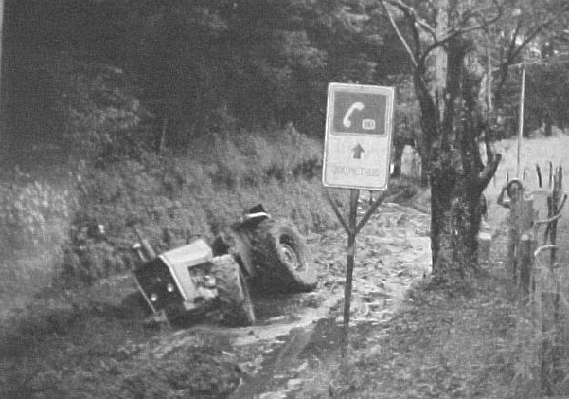
Eric’s tractor in the mush
The first few days cans had to be carried on the shoulders of helpers past the mud hole. Steve Abbott with help constructed a “cable lift” and the cans were hung on hooks below pulleys and pulled past the bad part of the road. Then they were put on my truck, Paco’s pickup or a trailer pulled by Maurico Vargas’ Cuadracycle, which took them the rest of the way to the cheese plant. The women of the Monteverde community made cookies and came to the road and served to the men who were working so hard to get their milk to the cheese factory. They were very much appreciated and strengthened the friendship with our neighbors.
Eric Rockwell tried to bring sacks of feed for his stock on his large four-wheel drive tractor. It sank so deep that after a couple of days he got help for a heavy vehicle to pull it out.
++++++++++++++++++++++++++++++++++++++++

VOLCAN IRAZU
Past, Present and Future
By Hubert Mendenhall
From Family Album Vol. VIII
In the summer of 1949 an old Pan American DC3 sat down at Sabana International Airport in San Jose, with a full load of passengers, among whom were Mildred and I. It was our first time on Costa Rican soil and not having been able to find any information of consequence previously about the country, we didn’t even know the obvious things; that the people are more friendly and seem happier than in other Central American Countries; the countryside is exceptionally lush and green, etc. etc.,
During the three days we spent in Costa Rica on that first visit two of the highlights were side trips we took, one to the Volcano Irazu, the other to the Alfredo Hernandez dairies near San Isidro de Coronado. On both trips we were greatly impressed by the fertile black volcanic soil, up to thirty feet deep, and the quantity and quality of forage and truck crops it was producing when properly worked.
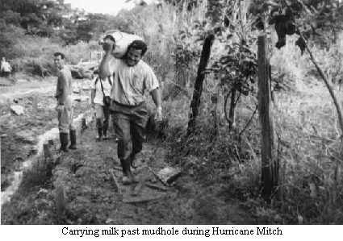
On the volcano trip, we stood on the edge of the crater and watched a few lazy puffs of steam rise from this "dead" volcano. Its work seemed finished, after all what can you do with more than thirty feet of topsoil?
Now, in 1963, Irazu has risen from the dead. The most fertile areas we visited fourteen years ago are now the sickest and most drab. Vegetation is dying and everything is the same dull grey, the color of the blanket of ash which covers everything.
The present eruptions started with an explosion in April of this year. Although there is some variation in the volume and force of the eruptions, there is no let up in the overall intensity so far. A tremendous quantity of smoke and ash boil as high as four kilometers, and it is left to the wind to ascertain who will be sifted-over with ash today. If you are lucky enough to visit the volcano on a day it is feeling real ambitious, and the wind is in the right direction, you can walk to the crater's edge and enjoy the "show" as long as your nerves will let you stay!
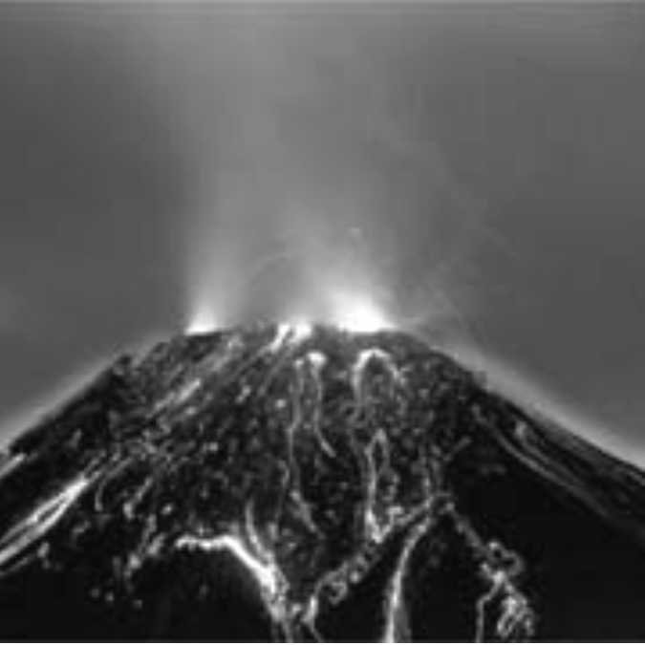
You hear a fresh eruption coming as the rocks and boulders rise nearer and nearer in a violently boiling mass, producing a most ominous sound, as they rattle and crash together. Just as your nerve is giving out, and you are sure they are about to come over the side, the force dies down and the racket with it. There is only an instant of silence after the last rock has plunked down in, until the whole ordeal begins again. What has brought on all this activity? was it really President Kennedy's arrival in the country; after all it was the same day! Maybe it is just ever - generous Mother Nature replacing the fertility which fickle man has let slip into the sea. Whatever the cause, the big question with those who are in the area of greatest damage is, "When will it stop?" if it is next week. or next month or even next year, then it is worthwhile to try to keep cattle alive, and be ready to redevelop the farms. But if it should be ten years, its better to leave and try to make a start elsewhere.
In order to predict the future of Irazu, we should study its past. The first record of activity is in a document of the Spanish Governor Don Diego de la Haya Fernandez in 1723. He refers to it as the only eruption of importance in historical times. There are unconfirmed reports of eruptions in 1726, 1821, 1842, 1844 and 1847. Then in 1882 Sr. Ballore refers to the activity of the volcano being responsible for the quakes that year, but is not sure. Four years later, some signs of activity showed on the N.E. slope, but all sign s of this disappeared the following year. An inspection of the crater in 1894 showed dense vegetation in parts of the crater.
In 1910 Cartago was destroyed by earthquake and Poas had its greatest eruption in history, but still Irazu was quiet. On September 27th, 1917 some steam and smoke were observed by an expedition to the top. This gradually increased until three months later the eruptions were similar to now.
On the afternoon of November 30th 1918 there was a tremendous eruption and the ceniza reached to the Gulf of Nicoya. Newspapers in 1919 referred to damage to pastures, dead cattle, etc. In spite of public protest, the price of milk was raised to 25 centimos a bottle. Ten bottle cows were down to two bottles daily, in 1920 one correspondent wrote;
"The column of smoke is now a permanent adornment of Irazu”....this state of affairs lasted till 1924, then gradually tapered off until 1940 by which time things were quiet.
To sum all this up it actually looks as though Irazú is becoming more active and we can probably expect to be troubled with "ceniza" in our hair, teeth and eyes for many a San José trip to come.
++++++++++++++++++++++++++++++++++++++++

Arenal Volcano
- from old letters by Lucky Guindon
July 30, 1968 Guess I'd best jot off a quickie to you so you'll know we're still here after hearing of the volcano erupting. According to our new map we're from 10 to 20 miles from the volcano. We have been hearing and watching it erupting all afternoon -- shaking the windows of the house and the rumble rumble rumble sounds like thunder. According to news locally, there have been 52 bodies found but estimated 200 people killed. Thousands have been evacuated from nearby towns. We can't see it from here but saw the mushroom arise and spread over our house. Now all light is dim and yellowish. Livestock have been killed there from thick ashes—helicopters can't fly in close because of no visibility. On the radio they said the ashes are over Lake Nicaragua. We are safe enough here but a call is on the radio every few minutes for clothes, food, medicine, and money for the needy. So I've been collecting a stack of clothing from our supplies and put in a little money out of my savings—-Wolf is in San Jose so don't suppose he has any! Our windows are still shaking —it started at 3 this afternoon (erupted yesterday too but I didn't hear it~~was in the night) and it is now 5 o'clock, so for about 2 hours steady it has been rumbling.

Aug. 10, 1968. The volcano is sill erupting but not so we can noticeably see it or to make the windows rattle. Most everyone has been evacuated from areas close. There is still danger of it exploding out a different side ~~there are cracks all around with smoke arising from them and rumor has it that another "hill" nearby is rumbling too. It has been 300 years since this one was active and trees grew down inside the rim. A family we've heard of had to leave immediately, living close by ~- with only flashlights to see (was dark from ashes) and a table held over their heads to shield from falling rocks. By that night their house was obliterated. Many were killed, or injured from falling rocks and heat waves burnt up house, trees, and some cars that came too close. Rivers were swollen from falling ashes and rocks, making it difficult for fleeing people to cross. One 13 year-old, now staying with Rocky's helped folks cross on his horse till all were across and horse too lame from volcanic rock to go much further. We are about 14 miles from the volcano, closer than the town of Arenal which had to be evacuated, and is several inches deep in ashes, There were others closer that are several feet deep. Tilarán is farther where a lot of folks were taken first. Now it's partly evacuated, Rocky drove there with Ulman who wanted to rescue his father, mother, and brothers and lived very close...he said the visibility was only a few yards ahead, and only 4-wheel drive vehicles could get in. We are over a ridge and across the continental divide and the winds carry it away from us besides the opening being on the other side.
Several families have come to this area, and. we have given freely of clothes, shoes, and work. Last count the known dead was near 100 I think. Ulman did find his family and brought them out unhurt but visibly shaken. Another family arrived in Sta. Elena. (some without clothes on their backs) across the mountains. Since then six more families arrived the same way and with 30 children altogether so we've taken jackets and clothes, right off our kids to give because we had more that size than most but they wouldn't stretch around to all the kids.
++++++++++++++++++++++++++++++++++++++++

THE. ARENAL VOLCANO
- by Benito Guindon
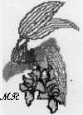
If I remember correctly, it was 1968 when the Arenal Volcano decided to erupt. I remember the eruption pretty well, as it happened during the day while I was at school. My classroom had windows all along the northeastern side, which faced the volcano. The volcano isn't visible from the school because of the Tilarán Mountain Range, even though it is only twelve or fifteen miles away, as the crow flies. Anyway, we were quite able to feel, see, and hear the eruption from the school. There were a number of loud explosions and tremors that shook the whole building, and when we looked out the window we saw huge, black clouds billowing up into the sky. Some of the kids were scared and so was I for the next few days, as the volcano continued rumbling and throwing out ashes, rock, and lava. Luckily for us, the volcano had erupted out the west side, and our area was not affected, although the sky turned black with ash which passed over us and fell on some of the towns along the coast, which were further away. Many of the people living on the west side of the mountain were killed, including one whole town that was located at the base of the mountain and was totally demolished. Our family visited the area not long afterwards, and I remember the place looked like a desert.
+++++++++++++++++++++++++++++++++++++++

Kinks in the Fabric of Paradise
By Mills Tandy, February, 2001
Many peoples’ impressions of Monteverde are of an idyllic place where peace, tolerance and environmental awareness and conservation are the rule. Most people who have come here, including those who have chosen to call it home, were attracted because of the above characteristics—which are indeed important components of the local scene.
Quaker settlers came with a vision of a peaceful community in a peaceful country far away from the involvements of the continuously militarizing United States of the early 1950s and the persecution some had suffered as conscientious objectors. Later, biologists were attracted to Monteverde primarily because of the incredible biodiversity of the region, the friendliness and tolerance of the inhabitants, and the creation and maintenance of the protected areas—first as a watershed protection strategy by the Quaker settlers, then as a refuge for many threatened organisms by some Quakers, the World Wildlife Fund, the Nature Conservancy, the Tropical Science Center, the Costa Rican Government, the Monteverde Conservation League, the Children’s Rainforest Project and the Santa Elena High School. Today many tourists visit the area seeking the same values.
But as in all places, there are kinks in the fabric of paradise. Things are not always what they seem.
Some of the early Quakers did not stay long for various reasons. There have been various disagreements among those who stayed who tell different tales of their versions of the history of the place according to their own perspectives. There were disagreements about how land was originally apportioned from the combined holding purchased by Hubert Mendenhall. There are different stories about how the idea of the cheese factory began and was pursued. Not all personal relationships, including marriages, have survived. Many children have left. Resentments remain about things that happened in the past. Some decided that the creed of the Quaker community was not fundamentally Christian enough, and thus became Seventh Day Adventists. Newer Quaker arrivals brought different perspectives of Quakerism.
The earlier biologists who came here found some residents who had an intense interest in preservation of and living with the natural world. They also found those who regarded that world primarily as something to be exploited for the short-term good of one species (man). Thus some felt that the forest was the greatest natural treasure while others considered it (and conservationists who voiced a need for protection) an obstacle to “progress”. It seems that over time, many of the “exploiters” have become “conservationists”, although for some converts this seems to have resulted primarily from a recognition of the economic advantages of exploiting ecotourism.
There have been a variety of “logistic” disputes, particularly relating to land and water use that have not all been handled in either a “tactful conflict resolution setting” nor even in a legal way.
The public institutions for which Monteverde is well known have their own differences, many of which are not settled, and some of which do not seem to make most efficient use of limited resources.
There are three private high schools and one public one in a community of permanent residents of only about 10,000. The reasons for the creation of the various schools are diverse, partly based on religious differences, partly on lack of commitment of existing institutions to respond to the needs of a changing community and partly a reflection of a general aversion to governmental institutions. In any case, scarce educational resources are spread even thinner. All of the private schools now depend on short-term volunteers and minimally paid teachers. There does not seem to be the financial will in the community to pay teachers salaries that would enable them to buy a house and become permanent residents. Thus teachers have only a short-term association with their students and the community. This problem has become more serious in recent years with the skyrocketing of land values in the area.
The major conservation organizations in the area (Bosque Eterno S. A., the Tropical Science Center, the Monteverde Conservation League and the Monteverde Institute) have their own disputes, which seem to have become more serious in recent years. Thus there are duplication of resources, lack of cooperation and even legal conflict among groups that appear to have the same goals.
The last ten years have seen a great increase in commercial interests associated with the development of Monteverde as a prime international tourist destination. This has aggravated strains that already existed and created other stresses in the community that previously were minimal (such as the wisdom of paving the roads).
So Monteverde, like other places has its special values. But there ain’t no such thing as Utopia!
++++++++++++++++++++++++++++++++++++++++

Bomba
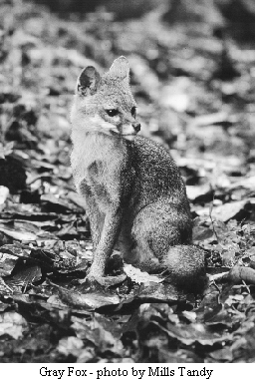
One of the Lowther girls ran into the Lawton house crying that her father, David, had been cornered in the shower by a menacing weasel. When Bob arrived at the Lowther house, he found the weasel advancing toward the bedrooms. Armed with a small bucket, a pillow case and a stick, Bob led a wild weasel chase, the children shouting behind him, and David bringing up the rear, bellowing suggestions. The weasel, no bigger than a good sized sausage, raced into David’s room, spraying stinky musk over everything. Right behind it came Bob, brandishing his bucket, pillowcase and stick. Finally, the weasel zipped onto a curtain rod, Bob swatted it with the pillow case and the weasel fell to the floor. Bob pounced, catching it in the bucket. Edging a bit of plywood under the bucket, Bob and company made for the door. Outside, biological curiosity got the best of everyone and they decided they get a good look at the weasel if they slid the plywood back just a bit. As they did so, whoof, pop went the weasel-- and was gone.

The year was 1974. - Editor
Irazú Volcano continued to erupt for a little more that a year and a half. - Editor

