CHAPTER VIII

School and Education

- from EL SEMANARIO
2nd Mo 23, 1951
School opens! Second day of this week the men of "Mountain Top Ranch" gathered at one end of the shed armed with hammers and tarpaulins. They converted part of the shed into a schoolroom. When they were finished it was 10:00, but we went to school anyway. After this school time is 8:30.

3rd Mo 9th. 1951
Eston is teaching the school Spanish. We like to have him very much. Muchas gracias!
++++++++++++++++++++++++++++++++++++++++

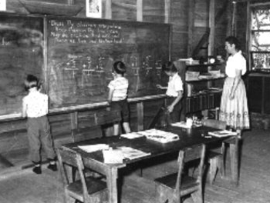
Monteverde Friends’ School in 1956

- by Mary Mendenhall
In the fall of 1950 the Friends School at Fairhope, AL, USA started as usual. But it was not a "usual" year. Several families of the Fairhope Meeting had made the decision to move to Costa Rica. Included were several of the children and the teacher. The Meeting had decided not to continue school after people left for Costa Rica, so all the children who were not leaving enrolled in other schools.
On 10-30-50 the school closed as the first of the children were leaving. Each child's text-books and supplies were packed for the trip. Fairhope Meeting gave the newer library books to the group and these books later became the beginning of the Monteverde library.
After arriving in Costa Rica, it became evident that the place we were tentatively thinking of settling was not suitable. For several months small groups, looking for just the right spot with enough room for all who wished to be neighbors, made pilgrimages around the country. Temporary living arrangements had to be found, while this search was made. Some of the families, moved to a coffee farm where they used the house, as well as the sheds and cement platforms where coffee had once been processed.
One of the smaller sections of the shed was fixed for use as a Meeting House, and on 2-19-51 the school opened there. Makeshift benches and seats were set up, books were unpacked and classes began for the seven children. As far as we know, it was the first Friend's School ever held in Costa Rica. Carol Mendenhall who was not living on the farm, stayed with her grandparents during the week in order to attend. The other school children were, Kathryn, John, and Celia Rockwell and Ellen, Jeanette and Floyd Rockwell. Two sides of the "school room" were open to the wind and the sun and the beautiful mountain view. We started the first little school paper, "El Seminario" there with each child contributing something and printing it by hand, sometimes with illustrations added. Since there was only one copy, it was delivered by hand each week and passed from family to family.
Everyone wanted to learn Spanish. Eston Rockwell, who had studied it in high school, helped the children with that. In spite of primitive accommodations, or maybe because of them, we had a good time going to school there. Finally, Monteverde was discovered and everyone in the group began to plan their move to the new location. School was discontinued again in May 1951 while everyone made the move. It was a slow process as the rainy season had begun and the last portion of the trail to Monteverde was almost impassable.
Finally when everyone was situated in some kind of temporary housing in Monteverde the largest house, where the Dairy Plant now stands, was fixed up as a meeting-schoolhouse and a community center. Partitions were removed to make one large room. The outside walls were taken off the kitchen, leaving an open-air porch with an opening into the larger room, which gave it more air and light. Elwood and Ruth Mendenhall unpacked their dining room table for a place for the older children to work. A packing box was made into a supply cupboard. The smaller children "made do" with the plank benches used for meeting. A box supper was held to get money to buy a water bucket, wash pan, blackboard paint etc. That is some indication of our primitive accommodations'
An adjoining small room, which had been used for other things, became available later when more than one teacher needed space for classes. We finally finished the year that had started in what seemed so long ago in Alabama.
Wanting to become a part of our new country as quickly as possible, it was decided to use the same schedule as the Costa Rican schools, March to November. Besides, that worked out well with vacation in the dry season when children and parents could make their annual trips to San Jose for check-ups with the doctor, for dental work, and for shopping. So the new school year started in early March 1952. It was still in "the house" but materials had been collected and the men had designed and built desks and chairs, which was a huge improvement.
It was a wonderful time to be establishing a school. Everything was new and exciting; the climate, the mountains, the culture, and the never-ending discoveries, for instance a drop of water in a tequisqui leaf would run around like mercury if tilted, or could even be funneled into ones mouth. Or seeing a buzzard circling above the hill behind the schoolhouse, the curious children ran up at recess to find only a small dead toad. Now how, from such a height, did the buzzard know it was there? The whole setting fostered one of the goals of the school: to maintain the natural eagerness to learn which is typical of small children but is often lost in school regimens.
Glen Rockwell spent some time in Monteverde that year and helped at school. His Spanish was better than ours so he could translate when on the 1st of May; the school children made a big May basket full of goodies and flowers and carried it to the nearest public school at Cerro Plano. At that time the Cerro Plano School only went through the 3rd grade and even in Santa Elena, only the first five grades were taught. Not long after our visit to their school, the teacher and children from Cerro Plano came to visit our school, bringing each of our children a small Costa Rican flag.
Watching the first section of the Dairy Plant being built just outside the door was of great interest. Everyone went outside to see the tall smoke stack hoisted in the air, using only manpower. The day the cheese plant opened, the school was there with a banner they had made. Everyone learned the process of making cheese, and Oscar allowed the older students to try packing the curds into the oatmeal cans, which were the very first cheese molds.
When we saw how mean the small boys who brought the milk in from the surrounding farms were to the pack horses that carried the milk, we decided to invite all the boys into the school where they were served refreshments, and where Molly explained to them that horses and other animals had feelings as well as people. We imagined the boys were kinder after that. At least we had tried to help the situation. One of the continuing goals of the school: to use situations, which occurred, as learning experiences.
School continued to be held in "the house" until 1957 when we moved into the new school house-Meeting House built in a spot near the center of the community. It had been built by volunteer labor provided by the Monteverde Community. Everyone met one last time at the old house, which held so many memories of the beginnings of Monteverde. Each family contributed to a farewell program, then the house was vacated.
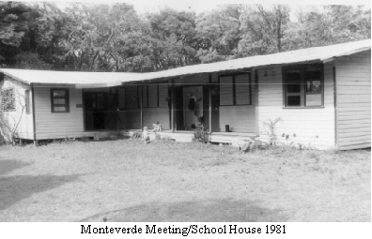
At the new location, the students and teachers reveled in the spacious new, two room building with its windows, its cupboards and its library nook. Older students had a room of their own.
The general format of the school continued in the new setting. Each day began with the entire school gathered for Bible reading, a weekly motto, announcements, and the daily news as told by the students. All ages contributed with the older one commenting on such things as current affairs while the youngest told of any interesting things they wanted to share. All were heard.
Because of several grades in the same room, class periods were held around a table, while pupils not in class, studied at their desks. The latter required real concentration. Efforts were made to meet the individual needs of each child. Older children, or any who understood a problem were allowed to help a child when needed. When a teacher was absent, if we did not have a substitute, older children who had their work done, filled in.
Reports twice a year were written out by the teachers in an effort to report each child's progress rather than comparing him with others as in letter or figure reports. As little home work as possible was assigned, as most of it could be done in the study periods and time to be a part of one's family after school seemed important.
Recess each morning was a time for everyone to participate in outdoor games when the weather cooperated. Favorites were dare - base and softball. An hour at noon gave time for eating lunches together, then having a period for play, followed by the teacher reading aloud to the group as they "cooled off".
On Fourth day (Wed) mornings the school children attended the mid-week Friends Meeting. Children from other than Quaker denominations could relate also to the quiet meeting as a time for meditations. Prior to Meeting we had a time for stories and discussion of a spiritual nature.
The students were responsible for the daily cleaning of the school and for a "big" cleaning at mid-year and at the close of school. At "the house" in the beginning there was a short floorboard, which had been left loose so that it could be lifted and the dirt swept, not under the carpet, but under the house. The new schoolhouse had no such accommodations! Big cleaning days ended with a bonfire meal. Hot dogs were not available for a long time in Monteverde, but we found a recipe for bread-twists, so who needed hot dogs? Once a year, students and teachers all went on an all day picnic.
The pupils also were responsible for putting out and taking down the plank benches for meeting.
Monteverde School was nurtured from the beginning by the genuine interest and support of all members of the community, regardless of age. The school was truly a part of the community. When there were building bees, the children were let out at noon in time to join the bee for potluck lunch and, as they grew older, to help with the work in the afternoon. Hand-made valentines, May baskets, get well cards etc were delivered to the old or the sick. Everyone came to school programs and projects.
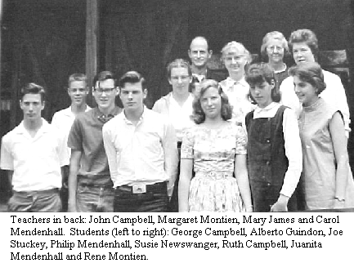
The school was most fortunate to have qualified teachers who lived in the community and became part-time teachers in their specific fields. Margaret Montien, Molly Figuerola, John Campbell, and Mary James contributed their expertise and their fun and enthusiasm for many years. Over the years many other teachers, both full and part-time brought their skills and fresh ideas to the school. Much appreciation is due each of them. Visitors who made it up the road to Monteverde found themselves sharing their experiences and sometimes pictures and slides. Biologists who began to come to the cloud forest for research were a great resource for the school and stimulated everyone's interest in nature and science. It is amazing how many children from other places attended school for various periods of time. Patty Romero from Turrialba, Chris Balderston from Pennsylvania, Osa Osborn from Iowa and Joe Stuckey from Ohio spent at least one whole school year with us. Others came for various periods of time, and stayed with Monteverde families while attending school.
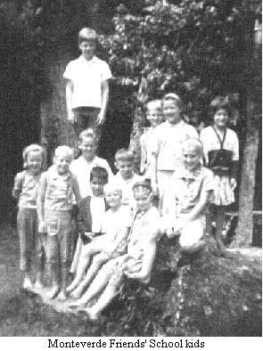
From the beginning, the school was dedicated to becoming bilingual. Molly's coming gave a great boost to this goal. Every child in the school had a Spanish class and some years, Miguel Figuerola taught some other class in Spanish also. Several Costa Rican young people wanted to study English, so a class was organized which met at the close of the school day where Molly taught English as a second language. Some of these young people entered the regular school for part or full time as they became more fluent. All this was a beginning to what I understand is now a bilingual school and a bilingual community.
There was an amazing amount of artistic talent among the students. Joan Rockwell, the first art teacher, and subsequent art teachers, shared the philosophy that everyone had talents in this direction, which only needed to be cultivated. The last afternoon of the week was always dedicated to art and sometimes crafts. Over the years they worked with paints, pens, clay, leather, wood etc. For several years, Edith Peckham taught weaving, and two of the boys even made table looms using hers as a pattern.
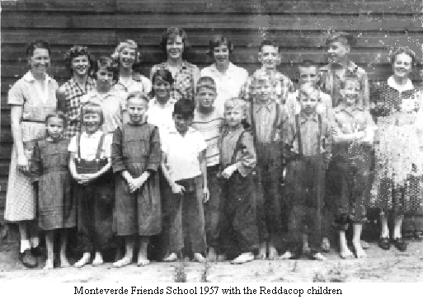
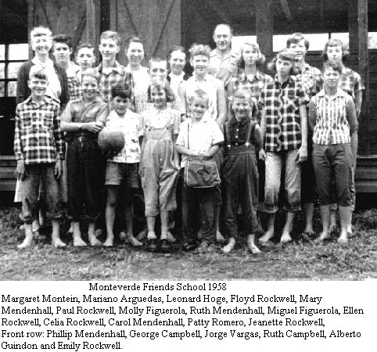
Ellen Rockwell was the first high school graduate of the school in 1958. Some students had returned to the states to graduate from Friends Boarding School. A course about all aspects of Costa Rica was required for graduation, and included making a tour of interesting places in the country. The junior and senior classes took the course and made the trip together. They decided where to go, then worked out ingenious ways of earning money to pay for the journey. That first trip, among other places, arrangements were made to visit Jose Figueres ranch and rope factory. What a surprise when the whole group was invited to have dinner with his family. It was quite a thrill, as he was the President of Costa Rica.
As with all schools there were problems and challenges to be worked out. Money was very scarce in the early years. Books had to be ordered from a second hand book company in the U.S. Making a schedule of classes for everyone with part time teachers and so many grades was a yearly puzzle. But looking back, the problems fade and I think how very fortunate I was to be a part of setting up the Monteverde School, to have had the privilege of knowing all those very special children and to have been associated with so many faculty members. It was great!
++++++++++++++++

- by Cecil Rockwell
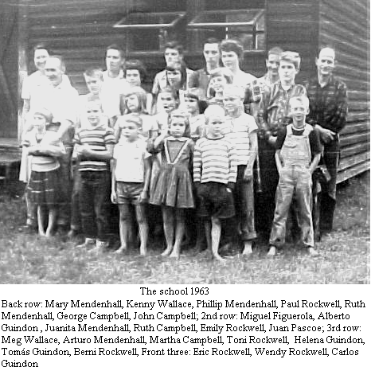
The school had been discontinued when we left Fairhope until the arrival in San Jose of the "Caravan". When everyone was settled in enough to make it possible, classes were resumed in the coffee shed on the Challe place. Six of the seven students were living on the "finca" at that time and the seventh, Carol Mendenhall, would stay with us during the school week. The school had been recessed for three months, because of the group going by land, which included three of the students. Then there was another break when everyone was moving to Monteverde. The school was started, or restarted, again on 8/27/1951, with rather primitive arrangements, soon after nearly everyone had gotten more or less settled in. Some tables and chairs or benches were loaned by various ones of the community until suitable lumber was available to make desks, chairs and tables. At that time a "bee" was held and everyone got together to construct the needed furniture. The school at this time consisted of seven pupils, three of Howard Rockwell's; Kathryn, John and Celia, one of Hubert Mendenhall's; Carol, and three of ours; Ellen, Jeanette and Floyd, with Mary Mendenhall as teacher. The school-year finally ended on December 12th, so this put our schedule in line with the system used in Costa Rica, with vacation from November to March which is considered summer or dry season and included the Christmas and New Years holidays. Paul was the first of our children to start in the First Grade in the Monteverde School, along with Ruth Mendenhall, and continue there through the full 12 grades. The other three, of course finished High School there too but had started in first grade before going to Monteverde. So the Monteverde School consisted of nine students for the first full year.
Howard's children, Kathryn and John attended Friends Boarding School in Ohio for a portion of their high-school years and graduated there. Ellen was the first Graduate of Monteverde Friends School in a class by herself in 1958. The second graduating class of 1960 consisted of our daughter, Jeanette, and Leonard Hoge, Carol Mendenhall and Mike Rockwell. By this time the school had grown and Mary Mendenhall, as head teacher, had the assistance of other qualified teachers living in the community, in some subjects, John Campbell in Sciences and Math, Mary James, Biology, Margaret Montien, English Literature Molly and Miguel Figuerola, Spanish Grammar & Spanish Literature and Joan Rockwell, Art. During these years there were students from other places, who boarded with various families in the community. These were Chris Balderston from Pennsylvania, Catherine Wise from Wisconsin, Patty Romero, whose mother worked at Turrialba, Costa Rica, Juan and Ricardo Pascoe from Mexico, Edna Glass from the Canal Zone, and Osa Osborn from Iowa. Some Costa Rican neighbor's children began attending English Classes to Molly Figuerola, and later other subjects. Floyd graduated in a class by himself in 1962 and Paul, with Ruth Mendenhall in 1963.
++++++++++++++++++++++++++++++++++++++++

from old letter by Lucky Guindon
(April 19, 1965) We celebrated Monteverde Day with a bee on the play-ground, ball-field donated or leased to the meeting for 10 years by Howard Sr. and Jr. It had been cut down a few days before and we raked and hauled off truck-loads of the hay. Very dusty work. The crawler tractor pushed out small trees and leveled over torn up ground. Now it looks like we'll really have a ball-field adjoining the school! The only draw-back is the violent wind. Howards have had trouble trying to grow anything on it because of that. In the afternoon there was a program depicting work and play and children and roads of Monteverde. Molly and I worked hard to hastily learn the alto part to Wilfned Mengel's Monteverde song. I'm glad to say it came off beautifully tho none of our practices had.
++++++++++++++++++++++++++++++++++++++++

MFS Recent History
- by Tim Curtis
In the years since Mary Mendenhall retired from teaching, the Monteverde Friends School has gone through many changes, while retaining much of it's progressive, educational philosophy. For most of the seventies, eighties and nineties, there have been few teachers who have been long-term residents of the community, so most have been recruited from other places to teach here for a year or two, occasionally three or four. Some of these teachers were experienced and others were brand new to teaching.. During the past ten to twelve years, MFS has had an increasingly well-prepared and professional group of teachers. At times the enrollment has been as low as a dozen, while during the past few years it has grown to 75 and above. For a few years, there were no students at all in the high school, but this past year we had twenty-five students from the seventh grade up.
In the early eighties, largely due to the efforts of Ann Kriebel and Elizabeth Millet who was School Director at that time, the school became more bilingual and actively encouraged more Tico students to attend. In 1993 we first hired a full-time Spanish teacher, and now we have two. - all students receive one third of their instruction in Spanish. About two-thirds of today's students come from Spanish-speaking homes. Along with these changes, there have been many challenges related to operating a school which satisfies the needs and wishes of both cultures. Nevertheless, parents of both Spanish and English speaking children in the school now value the feeling of extended family which still pervades the school community and the values of caring for each other and the environment which the school continues to provide.
Over the decades the Quaker identity of the Friends School has waned and waxed again. For a time, few or none of the school staff had Quaker background, and relations between the school and the Meeting were sometimes strained. More recently about half or more of the staff (which now numbers 15 - 20, including part-timers) has been Quaker, and both the Meeting and the school feel mutually enriched by their relationship.
For many years, the School Committee and the teachers ran the school. In the early 90’s, the growth and increased complexity of the school made it clear that it was necessary to have somebody help with administration. In 1992, Carol Evans was hired part-time as an administrative assistant, and in 1993, Tim Curtis, a former teacher was hired as part-time school coordinator, in 1995, the school hired its first full-time director, Pablo Stanfield. Jean Stuckey followed Pablo for three years and our current director is Jenny Rowe. With the support of full-time administration, teachers have been able to be more effective, and all have benefited as the result.
The school has also grown physically. A new high-school classroom and office were added in the mid-eighties and three new classrooms were built in 1994. Interested parents founded the Kinder as an independent entity on the school grounds in 1983 with Melody Guindon as teacher. The Kinder became part of MFS in 1994. As this goes to press, the 1957 school building, whose back wall has been rotting for years is being dismantled and will be replaced by a two story addition.
After many years of working toward accreditation by the Costa Rican Ministry of Education, we hope that we will finally be approved in 2001 or 2002 once the new construction satisfies the building codes for schools. While some sacrifices have to be made in the area of grading and the taking of National exams, we hope that these will be outweighed by making it possible for our graduates to attend university in Costa Rica, or to transfer to other Costa Rican schools.
After fifty years of growth and change, MFS retains it's progressive and Quaker roots . It still strives to be a school which is an integral part of both the Quaker Community and of the broader surrounding community. While we do not intend to grow any bigger, we hope to continue to grow in our ability to meet the challenges of preparing our children for life.
++++++++++++++++++++++++++++++++++++++++

Lost Treasure in Monteverde
.by Mary Rockwell
One of the incidents in our lives that helps us realize there is a power much beyond our understanding that cares and directs happened recently. It has been of great interest to many of us here, as well as to those who lived here in the early days of the community.
Just at the time the original part of the school was being torn down our 24 year old son Bryn had a free day or more from driving an auto-transport truck out of Seattle and he was catching up on his email. He went into the Internet and checked out the Costa Rica web site and found the Costa Rica Forum and checked the messages. There was a message there from a lady who was looking for Rockwells from Monteverde, saying she had lived at Abner and Irmas' when she was here back in the late '50s. He added his message back to her and told her he was Abner and Irmas' grandson and gave her his email address. Since then I have found out from her that she had pretty much given up finding anyone that way when she checked one more time and found Bryn's message!
She replied to Bryn directly and mentioned many names of people he had never known as that was well before his time, so he forwarded her message to me. I had to jog my memory to think who she was as she signed her name Pat Lawrence (Romero). It had been too long!! After repeating the name a few times it suddenly dawned on me that 'this is Patty'!! Of course I remember her and have often wondered what finally became of her!
In her letter, which Bryn forwarded to me, she mentioned that she had been going to school here when the new school was built and asked about it. I told her that part had just been torn down, to rebuild something bigger and better. So she asked if a time capsule, the students had buried under it, had been unearthed .....after getting more information of what she remembered I passed on the word to Lucky by phone and she contacted Katy, who is in charge of construction on the new school addition. Patty thought she remembered that they had put a variety of things in an aluminum box under the back left hand corner of the building. That part had not been excavated for pouring foundation yet so they held off until after a Sunday meeting when people went out and dug in that area. No box was found, but a small brown bottle did turn up, all caked with dirt. The digging continued as no-one gave the bottle much importance, but Jane Wolff took it and cleaned and washed it. It had a black plastic lid with a sort of styrofoam type liner in the lid and in spite of being on snugly it had gotten clay inside the top. In the bottle was a folded paper which created a lot of interest. Though the paper was not in top condition they were able to unfold it, but alas, no writing was visible. Nothing else had been unearthed so everyone has resigned themselves to this being the real thing.
I am not sure we should be willing to accept that without more information and I have been trying to find out from others who were in the school then whether they can remember more. Most of those I have sent to asking for help have not responded but Olivia did check with her mother, Mary Mendenhall, who was the teacher in those days. She couldn't remember such a thing at first, but finally, on thinking about it, she came up with some vague memories of the students discussing what all they should put in that would be of interest in future years. She called Carol and Floyd and Jeanette, who were some of the older students at that time, and the first two could only vaguely recall that it had been done. Jeanette was somewhat clearer and thought it had been something like a square, metal cookie can and that it had been buried in the right front corner!! And that area has already had foundation poured!! Who knows if the workers dug up anything that might have been the remains of such a thing. We all agree that probably the container has disintegrated if it truly was a lightweight metal. We would love to know what sorts of things were put in. Is there any chance we will find out more on the mystery? We may never know the answer, but I am still checking with anyone who might know.

These are the sequels in E-mail messages:

From: CECIL F ROCKWELL
To: rockwell@racsa.co.cr
Sent: Sunday, June 17, 2001 11:13 AM
Subject: capsule
Dear Mary
Elva got out Mother Mendenhall's diary and found the following entry:
Date April 19, 1956 - "The fifth anniversary of our coming here. Mary took coffee & cookies to the men working on new school house, also a bottle containing school history to put under the comer block. All the folks able were there to dinner. Thirteen men working, got foundation blocks in and sills laid for the new building. A good day."
Love, Cecil & all at Betrock.

From: The Rockwells <rockwell@racsa.co.cr>
To: CECIL F ROCKWELL <betrock@juno.com>
Sent: Sunday, June 17, 2001 7:09 PM
Subject: Thank you so much!!
Dear Cecil and Elva,
Seeing I had so much curiosity about this and made such a project of it I really appreciate you going to all the trouble of finding the answer for me. Thanks so much. I guess the case is now closed and it has been a lot of fun getting in touch with people and getting answers back. Carol and Ann did finally write and Carol thought the bottle was probably 'it'. I have forwarded your last message to everyone I was in-touch with adding a short note thanking them all.
Thanks again,
Love, Mary

From: CECIL F ROCKWELL <betrock@juno.com>
To: <rockwell@racsa.co.cr>
Sent: Monday, June 18, 2001 8:26 AM
Subject: capsule
Dear Mary:
You have spent a lot of time and work on this project. I would suggest that Mary Mendenhall write a paper of "What probably was in that paper in the bottle". Since Ruth M's diary indicated that it was a history of Monteverde School at that time, April 19, 1956, the fifth anniversary of Monteverde Day, it seems to show pretty much what it might have included. I don't know if it is too late to plant another capsule or not. Anyway, I think it has been good for all of us to feel more reacquainted and a feeling of closeness. Thanks, Mary.
Love, Cecil & Elva.
++++++++++++++++++++++++++++++++++++++

Monteverde Friends School Graduates
1958—Ellen Rockwell
1960— Carol Mendenhall, Jeanette Rockwell, Mike
Rockwell, and Leonard Hoge
1962—Floyd Rockwell
1963—Ruth Mendenhall, Paul Rockwell
1966—Phillip Mendenhall, George Campbell
1968—Susie Newswanger, Ruthie Campbell
1969—Alberto Guindon, Rene Montien
1971-—Helena Guindon, Tomas Guindon, Martha
Campbell, and Berni Rockwell
1974—Carlos Guindon, Lesli Rockwell, Lindi Maxson
1975—Ronny Maxson
1976—Benito Guindon
1977—Ivonn Rockwell, Becky Stuckey
1978—Lidieth Wallace, Julia Lowther, Ricardo
Guindon
1980—Antonio Guindon, Leyn Rockwell
1982—Arthur Rockwell
1983—Melody Guindon, Marcia Rockwell, Kimbra
Rockwell
1985—Shawna Rockwell
1995—Marlene Leiton, Juanita Leiton
1997—Federico Leiton
2001 – Veronica Rockwell
++++++++++++++++++++++++++++++++++++++++
BOMBA
The children were quoting scripture verses for school. The teacher was perplexed by one contribution – “He fixes my shoes” and then the light dawned – “He restoreth my soul”.

Adapted from a teenage diary – Monteverde
- by Carol (Mendenhall) Latter
11-4-1959, 4th Day. We teenagers did a real crazy thing. Since there was a chance Daddy might get home (from San Jose) about 2:00 or 3:00 AM we decided to wait up. It wasn’t even sure he’d come, but we had a “watch party” anyway & asked over Doris, Celia, Jeanette, Floyd, Paul & Mike. We had loads of fun. We listened to records, made taffy (which turned out real well, the 2nd time, thanks to Jeanette) and chocolate cake (!). Mike brought his guitar & we sang & sang to our hearts content. I played my accordion a little. People didn’t leave till 2:00 & of course Daddy had to get here about 3:00. But that wasn’t why we had the party anyway!

4-30-1960, 7th Day. Ruth went with Arturo and Juanita to take May baskets around in PM. I went over to help Grandmother get ready for Aunt Mary’s going-away party for Celia & Leo. It was Round Table Meeting so Aunt Mary was (at that). It rained a little, but not enough to prevent our having the camp-supper outside. There was a beautiful fire. Almost everyone came, faculty & spouses, high school students, & Doris & Leo. We had a grand supper of hamburgers cooked over the fire, buns, fixings, baked beans which Mama fixed, salad, Washington pie, & delicious refreshing chocolate milk. Then we sang around the fire. Mike played guitar, Doris harmonica & I accordion. It was a wonderful evening.

5-1-1960, 1st Day. Had discussion at Jerrys. Wrote a letter to the congressmen from our various states encouraging them to do away with the U.S. military mission in Costa Rica & to use the money for more worthwhile projects.

5-7-1960, 7th Day. Ruth & I picked berries. It was a perfectly beautiful day to be tramping through the woods & picking berries while you listened to hawks whistling and quetzals, jilguerros, & many other birds singing away. In PM Doris, Floyd & I tried to print our k(school) paper, but the old mimeograph machine didn’t work very well, so we finally gave up & left it soaking in benzine till the next try. (We should have bought a good one in the 1st place!) It seems like we’ll never get our paper out.

5-11-1960, 4th Day. Since we don’t have any English teacher (she was away at the time), we just do as we like, only we ask Aunt Mary (head teacher). This morning we read a poem by John Dryden. The book suggested you play certain pieces of music with certain parts of the poem. So, since we had some of the music, we took off on Mo, Bud, & Pat. At our place we listened to Grieg’s “Death of Ase” & Schubert’s “Serenade”. At Cecil’s we listened to Handel’s “Largo”. Then we tore back up to the schoolhouse & got back just in time to read “William Penn” before meeting.

5-12-1960, 5th Day. Today Ruth is 15. Mama baked a lovely sponge cake. We had it covered with pineapple whipped cream. Luscious! Also had pork chops, mashed potatoes, salad, & coffee ice-cream. Just wish Daddy had been here.

5-13-1960, 6th Day. We actually got our paper (From Back in the Woods) printed this morn. How happy & gay we are! The view was lovely on our walk to and from (physics & geometry class at) Johns. Nicoya very clear & some pretty cloud formations. Daddy got home in time for supper. Jeanette came over after supper to staple the pages of the paper together. We stapled, wrote over the faded parts, munched on peanut butter fudge, and listened to records. We visited, too. So our paper is now ready to hand out. We feel like we’ve really accomplished something.

5-16-1960, 2nd Day. Our science class is now back to 80%, as John would say. Poor Floyd sent a good poem about the mumps. We’ve sold 20 copies of the paper. They’re 50 centimos apiece. People seem to like “From Back in the Woods”.

5-17-1960, 3rd Day. Our class had lots of fun picking & eating berries along the road to John’s. It makes a rest for us and takes up time too.

9-5-1960, 6th Day. Today (in physics class) Len & Mike asked what we’d give if they’d shock themselves from a condenser John had. Jeanette said she’d make a pie. So they tried it, but nothing happened! I guess their resistance is too great. Jeanette said she’d make a pie anyway & we’re to have it tomorrow morning.
++++++++++++++++++++++++++++++++++++++++

EROSION IN COSTA RICA
- by Mariano Arguedas (1961)
I want to talk about erosion in my country, Costa Rica, because it seems to me it is of great importance. Although I can't say that I know all the erosion of this country, I have read some books about that subject. They have impressed me very much; for you know that when one lives in a country that is not flat, he wouldn't like to have it destroyed by erosion. Some of the places that I know have been in trouble like that are Paraiso de Cartago and Zarcero de San Carlos. These places have been in those difficulties because they are very rough and the men couldn't prevent them from being eroded.
Moreover, we can't say that this lovely Costa Rica has had erosion only in the hilly land. Costa Rica has thoughtless people that like to destroy the very good lands, cutting down trees and burning them, together with the forests. And what happens when all the logs are changed into ashes? It is very easy to answer this question. The rain will come and will take away all the very good soil into the streams and seas.
For that reason I am against all of the men who like to destroy the present and future lands. You never can imagine how I feel when I see fire and cutting down trees along the streams. When I look at those men I would like to know soil conservation enough to tell them how they're supposed to do. If I were a superintendent of soil conservation, I would tell them how to prevent the wind erosion. If the soil is dry, as in certain parts of Costa Rica, and the wind is strong, dust storms cause great losses of humus. The wind blows soil away, often carrying it hundreds of miles. The best way to combat wind erosion is to plant trees that will hold the soil with their roots or to sow a crop such as grass that will hold the soil with a sod.
Thank you very much for having read these phrases.
++++++++++++++++++++++++++++++++++++++++

- by Barbara (Imm) Berry
I arrived in Monteverde in March, 1962. I had known Jan Rockwell (Jeanette) when she worked with me in an AFSC workcamp in Mexico and she told me that there was a teacher's position open in the Monteverde School and I thought that would be interesting to do. Many people with the AFSC in Mexico had spoken in awed tones about this community in Costa Rica and I was intrigued.
I was met in San Jose by Hubert Mendenhall and his family and was transported the next day up the mountain. The trip to Puntarenas was easy but nothing had prepared me for the jolting trip up the mountain covering 35 kilometers in 7 hours. I recently read some of the letters which I sent to my Mother of my first impressions. "Green, green, green," I wrote, "everything here is green." I lived with Cecil and Elva Rockwell. They were very kind hosts-they had built their permanent home after living in a cabin for many years-and they gave me a very nice room of my own. Their sons, Floyd and Paul, were still in school-Floyd graduated that year. Elva was a great cook and Cecil always read aloud after supper which I loved. In one of the letters I wrote to my Mother I said I was going to institute that practice when I got home.
Life in Monteverde meant using an outside privy. Every so often I would go to the Hoge's for a shower. They were one of the few families that had one. Electricity was available although only by the determined will of David Rockwell who spent many hours at the electric plant fixing something or other so that we could continue to have light. The telephone system was unique. Monteverde invented the conference call- one long ring meant everyone got on the line. Announcements of events were made that way and discussions were held. It was better than e-mail.
I worked with Kenny Wallace who taught the high school. He and Stella and Meg arrived just after I did and I spent many hours at their home. I loved their humor. At one point we wrote a soap opera about a man who was being poisoned with arsenic by his wife. Don't ask me what was so funny about that but we laughed ourselves sick. One time we tried to put it on for Mildred and Arnie Hoge but we laughed so hard they couldn't understand what we were saying. Kenny was a good partner at the school and I always appreciated his help.
Teaching school was a joy. That's the way I remember it and when I reread the letters that is what comes through. Sometimes our memories deceive us and I thought what I wrote so many years ago might be different, but it wasn't. The one strong impression that I wrote about a lot was the creativity of both the children and everyone in the community. The great stories that Helena wrote; the beautiful art projects that were created, especially by Berto Guindon; the impishness and humour of Tomás and Bernie; Martha's shy sweetness; Renee's growing up pangs; Toni's dreaminess and Ruth and Emily's thoughtful commentaries on LIFE created a pattern in that year that I will always treasure. I know that the way I raised my own children was very much influenced by this experience. I loved the games, parties, charades, Lucky's creative costumes at the Halloween Party, the Christmas carol singing that began in October and Wolf's ghost stories. I still have the Christmas carol book and sang many of those songs to my children.
The flora and fauna of Monteverde were amazing. The orchids, bird of paradise and bougainvilla became familiar, but the animals never did. One letter to my Mother describes an event I don't even remember. A great snarling was heard outside Cecil's house and it was assumed to be a cat of some kind but turned out to be a very angry, large sloth hanging upside down. I guess he was annoyed at being disturbed. We left him alone. I don't think I ever saw a tepesquintle, although there was much talk of them. There was lots of talk about tapirs but the only one I saw was in the zoo in San Jose. One time, however, when I was taking care of the Campbell children for John and Doris, who had gone to San Jose, George tracked down an armadillo. It buried its snout under a log and would not be budged no matter how hard we pulled, so I only got to see the back end of it.
I also learned to weave that year. Edith taught me. I would pass her house every day on the way home from school and I would stop for my lesson. She was a wonderful teacher. I picked a most difficult pattern and she just sighed and said," All right, I reckon we'll do it." And she taught me to set up the loom and coached me in weaving a beautiful piece of cloth which I still have. I have not done it since, and when I look at that material I marvel at the fact that I did it.
I had a club after school for the older children. It was like a 4-H club. Each child had a sewing project and we planned a meal for the Mothers. The best thing we did though was to have a pajama party. One day I was telling the kids about my own childhood and they were interested in my description of a pajama party. "We must have one", said I, having no idea what I was getting into. Irma and Doris Rockwell vacated their house for the occasion, which now that I think back on it was very brave of them. We made potato chips which meant about 4 chips a piece because it was such a labor intensive process. We told ghost stories and giggled into the night. Ruth, Emily, Berto and Renee came to the party. The younger children were not allowed to come and I always felt bad about that.
My friendship with Doris Rockwell was a source of great comfort for me when I lived there. Monteverde was a very family oriented community and it was hard for a single woman to feel a part of that. But Doris was there and we bonded. We took a wonderful trip together on the train down to the Gulf coast. Later I teased Frank that it was the one train I rode that he never got to ride.
That year the Guindon house was built. A "building bee" was held and everyone helped to raise the rafters. Frank had arrived in Monteverde by that time and I was very smitten by everything about him-especially the way he hoisted those beams up and walked around with no shirt on flexing his muscles. Everyone knew it- especially the children and they loved to tease me about it. I spent a lot of time blushing and trying to be nonchalant without much success. Of course, within a year we were married. Monteverde was a wonderful place for this to begin. I can never forget that.
++++++++++++++++++++++++++++++++++++++++
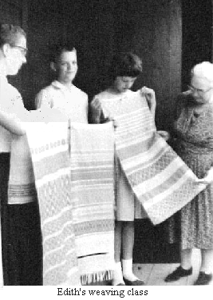

Re; the SCHOOL
By Sylvia Powers
Remember the Mother's Day Party, around Aug 15, 1975? Jean Stuckey, Emily Rockwell, Lindi (Maxson) Guindon, Bill and. 1 were teachers. The students sent out invitations, decorated the school like a. cafe, put on a concert, and served refreshments. I will never forget the other teachers singing an unexpected song in my honor since I was the only mother on staff at that time. It was a take-off on "No Man Is An Island".
I don’t know if Yvonn and William want me to tell of all the times they used the library study time to get closer to each other only to be interrupted by me!
--------------------------------------------------------------------
I remember the concerts, the pie socials, the potlucks, and the square dances. Parents were always there to support the best efforts of their children. Our girls were always included in the dances and other activities. Bigger students generally looked after younger ones also.
María remembers the time we had a. couple of plants in the window, of the classroom. We were doing an experiment to prove that plants have feelings. The students were to say and think kind thoughts to one plant but use the other to vent their negative feelings on instead of at each other. Maria felt sorry for the picked on plant and was kind to it.
And there was the time Bill took his senior class hiking to Volcán Arenal. They slept at the foot of it. Ricky kept telling Benito to be quiet only to discover later that the volcano was doing some rumbling. Two weeks later, the volcano erupted.
++++++++++++++++++++++++++++++++++++++++

WEAVING
- by Benito Guindon
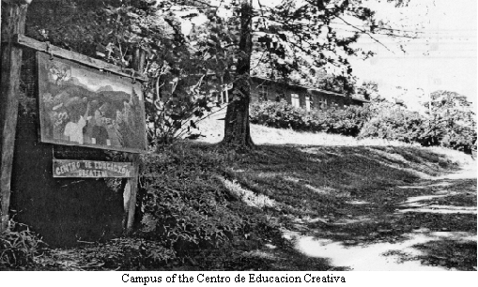
I love to do things using my hands, especially when I can use my own creativity at the same time. Some of the most enjoyable things I have done along those lines are weaving, carpentry, and various types of needle-work. There are many types of weaving of which I have only done a few. Among the first things I made were pot holders. Later, when I was in the 6th or 7th grade, I was in a basket-weaving class. The teacher was my Aunt Mary whom I always enjoyed a lot and thought highly of. Much of my interest and creativity with crafts was inspired by her. She and Uncle Walter were actually our great Aunt and Uncle. They were the only relatives near us and were like grandparents for my brothers, sisters, and me. Aunt Mary also got me started on another type of weaving which was chair caning. They had some old chairs with woven seats that came from her parents homestead in Vermont. These chairs were quite old and had been re-caned and finished by Aunt Mary when she was about twenty. That had been around sixty years earlier, and they were in need of new seats and finish. The only weaving I have done using thread or string is inkle-loom belts. I also learned this in school, but not until I was in the 9th or 10th grade. Several items can be made with these belts besides using them as belts. Some of the items I have made are doilies, hand bags, change purses, and a poncho. Another way I have used some of these weaving skills is in making floor mats. When making these mats, I mostly use a combination of weaving and macrame.
++++++++++++++++++++++++++++++++++++++++

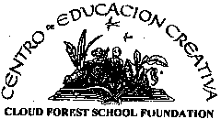
CENTRO DE EDUCACION CREATIVA
- by Jan Drake-Lowther
The final decade of the 50 years covered by this "Monteverde Jubilee Family Album" saw the remarkable grass roots establishment of an environmentally based, bilingual school for the rapidly increasing population of area children, almost all Costa Ricans and many from families coming to Monteverde in search of improved opportunity with the rapid expansion of tourism.
In 1989 when the Monteverde Friends School was unable to accept all the children graduating from a parent-run kindergarten who wished to attend first grade and the public schools continued to be increasingly overcrowded, five young parents representing both the North American and Costa Rican cultures began lengthy conversations searching for relevant and lasting answers. One had been born and raised in Monteverde, two others came to live here as young children - all three had attended MFS. The fourth was a resident biologist and the fifth a mother who was serving as the President of the MFS School Committee.
In May of 1991, with vision and conviction, these parents founded the CENTRO DE EDUCACION CREATIVA (CEC) with these guiding principles:

We have:
- a commitment and connection to environmental education that will pervade its formal as well as its informal curriculum
- a bilingual program that assures the students competency in English and Spanish with a strong emphasis on knowledge of the Costa Rican culture and its traditions
- a strong academic curriculum that helps children gain the knowledge to pursue ideas that will make the world a better place
- a child-centered school that recognizes that children learn in different ways, at different times, and are always to be loved and respected
- integrated curricula to help children understand the connections in what they are learning

That same month the first after school English classes for 24 Costa Rican children were taught by Lidieth Wallace (Guindon) in the donated original pulperia/coop building in Monteverde.
For almost five years the founding parents served as both Board of Directors and Administration for the school, meeting long and exciting hours each week - making curriculum decisions, seeking funds, space, and teachers for the fledgling school - constantly dealing with the myriad opportunities and the major and minor obstacles they continually encountered.
That group of founders were: Meg Wallace (Laval), President; Hannah Lowther (Arguedas), Vice-President; Yvonn Rockwell (Vargas), Secretary; Dr. Richard Laval, Treasurer; and Vera Zeledon (Belmar) Member at Large. Monteverde Meeting members Rebecca Cresson and Stella Wallace were particularly stalwart and encouraging supporters.
Late in 1991 the CEC built two A-frame buildings and lavatories on land loaned to the school by Yvonn and William Vargas in Cerro Plano. Kinder and Prepa classes were held there for 28 children.
Then in 1992 an ambitious step forward was taken when The Nature Conservancy of the US (TNC) leased 100 plus acres to the CEC looking toward payment of the $189,000 purchase price at 8% interest. The TNC, influenced by a justification for the biological significance of the land by Dr. George Powell, purchased this largely virgin forested land from Jovino Arguedas in order to help establish the newly-conceived "Ecological Easement" concept of private protection of property in perpetuity.
Many parents, community members, teachers and other volunteers worked feverishly for six weeks to convert a pole milking barn with no walls into what is still today the preschool building. Two lavatories were constructed, and the small house on the property converted to classrooms for the opening of school for 35 Prepa, First Grade and up children in 1992 on the beautiful new campus which lies at the top of a really, really steep hill and boasts a glorious view of the Gulf of Nicoya to the west and its acres of virgin "forest classroom" to the east. Twenty five 3-4 year old Kindergarteners were still in the A-frames below.
The pattern continued of volunteers building school spaces to keep up with the demand of parents wanting to send their children to the CEC. In 1994 David Lowther planned and oversaw the construction in six weeks' time of the mural building using all volunteer and donated labor and largely donated materials. It houses two large classrooms with the school library between them with lavatories on both ends of the building. Fourteen grandparents provided the furnishings for this building in their "Muebles por Abuelos" project. The pattern for the chairs was the same designed by Friends 3 decades earlier.
The next year Jim Standley gave the same kind of intensive volunteer time to supervise the construction of another building which provides three classrooms, which can be converted into one large meeting space for special events, and with the requisite lavatories.
The three-classroom upper school building with a covered patio area and yet more lavatories was completed in 1999 with the critical assistance of a $25,000 grant from the family of local resident and school supporter Phoebe Richards. As this book goes to press, ground has been broken for 2 additional classrooms.
From the very beginning environmentally based learning and study was going on apace inside classrooms, in the blooming and burgening organic gardens, and in the trails through the forest.
Every year has brought a remarkable group of highly dedicated and skilled teachers, most from the United States and Canada, who enthusiastically share their excitement about the goals of the school and its creative learning atmosphere.

The problems the school has faced and continues to face are legion.
It was evident that substantial outside support was needed if the CEC is to provide the quality of education it was offering local Costa Rican children, most of whom came (and still come) from families of limited means. Therefore, a 501(c)3 support organization, CLOUD FOREST SCHOOL FOUNDATION, was founded in 1993 in the United States by long time Monteverde resident Jan Drake-Lowther who served as its Chair for six years. Its Mission Statement:
"CLOUD FOREST SCHOOL FOUNDATION (CFSF) is a not-for-profit educational organization providing support to the Centro de Educación Creativa (CEC), a bilingual, environmentally focused school in Monteverde, Costa Rica.
CFSF strives to provide CEC with an international network of friends, financial support, professional development opportunities, and teacher and volunteer recruitment."
CFSF's current nine-member volunteer Board of Trustees all have lived or visited for varying periods of time in Monteverde and had significant connections with the school. The CEC and CFSF Boards have met jointly in March in Monteverde annually for the past four years. Their most recent accomplishment is the full payment for the land as part of a $400,000 Capital Campaign.
The CEC now consists of five buildings with another under construction, organic gardens and a tree nursery, 2 forest amphitheatres, carefully designed teaching trails through the mainly virgin woods which is the outside classroom for these upcoming stewards of the land. The school now serves over 180 children preschool through eighth grade. Plans call for adding a grade each year through high school with a proposed final enrollment of approximately 250 - 300.
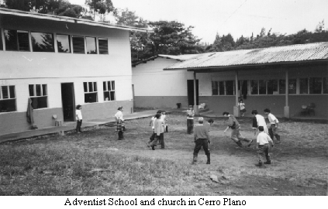
Literally hundreds of parents, teachers, volunteers, donors and angels in all kinds of disguises have created this miracle on our mountain which is making a major contribution to our area children, their families, and our forest home.
The Monteverde Community which is celebrating this 50th anniversary has from the beginning been sensitive to the needs of all the people in its adopted mountaintop home. The CEC strives to support and encourage young people as they grow to have the tools of a fine bilingual education, to nurture sound environmental conviction and behavior through understanding and to cherish and practice human values leading to happy, useful and creative lives. What a super gift to share!
++++++++++++++++++++++++++++++++++++++++

CENTRO EDUCATIVO ADVENTISTA DE MONTEVERDE
- by Emily Rockwell Villeda
director 2001 (principal)
This school began operation in 1991 even before the original building was finished. Teachers and students tell how they tried to have classes while the men were sawing and hammering! Because none of the men in the Adventist group had time to oversee the construction, Lindi Guindon did the daily supervision with the guidance of Rolando McAdam, who came up to Monteverde from San Jose every two weeks to check progress, answer questions, and give instructions for the following two weeks. When the school opened, Lindi Guindon and Sonia Montiel McAdam (Rolando's wife and an experienced teacher) were the teachers.
The reason for this project? A group of Seventh-day Adventist parents wanted to establish a school where Bible stories and teachings, as well as trust in God, would be integrated into the program.
The school began, in Cerro Plano -- between Monteverde and Santa Elena --, with 18 students in grades one through five and has gradually, over the years, grown to include kindergarten and three years of secondary (grades 7 through 9), with a total of 45 students. About half of the students are Seventh-day Adventists, and most of the other half are children from Catholic families who live in the area. Rather than the original two classrooms in one building, we now have five classrooms in two buildings.
The aim of the school is to provide a Christian education for those who seek it, teaching that high moral values and true success come from knowing God and seeking to walk in His paths. As we attempt to do this, we find that the challenges are constant, and we often fall short, but the rewards are great.
We welcome those who would like to visit. Just please let us know when you'd like to drop by.
+++++++++++++++++++++++++++++++++++++++
