CHAPTER IX

Recreation, Social Gatherings & the Arts

-from “Monteverde”, book by Mildred Mendenhall
Another first took place in this historic building when a young couple asked to be married under the care of the Friends Meeting. By coincidence don Ruben Ugalde, former owner of the house, rode up just in time to be invited in. There he witnessed what was for him an entirely new experience: a period of quiet worship prior to when the young couple stood and repeated their vows to one another without benefit of minister or priest.
++++++++++++++++++++++++++++++++++++++++

FIRST WEDDING IN MONTEVERDE
From Eston Rockwell’s letters
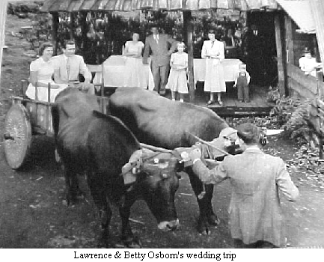
8/22/51 (About Lawrence and Betty's wedding) Spent the morning getting ready for the wedding and the afternoon getting over it.. They'd asked Mary and I if we'd be matron of honor and best man; of course we gladly accepted. The only drawback was, they made me shave off my beard that I had a month's growth on! Roy and Kathryn were bridesmaid and groomsman. Betty wore a beautiful white dress and Lawrence had a very becoming new suit, a blue-gray. He had a hand-made tie made in Italy which went with the suit. Betty gave Mary her Junior Social dress and slip which she made over and wore. It was lavendar color ..I wore my wedding suit, shoes, and tie so it was a little like getting married all over again; ....There were 50 signatures on the certificate including all the kids and 4 Costa Rican kids who were there.
+++++++++++++++++++++++

OUR WEDDING
- by Lawrence & Betty Osborne
The really big and memorable event that came about in the first year of our stay in Monteverde was my marriage to Betty Jo Starbuck. I travelled to Costa Rica in March of 1951 to get ready for my bride-to-be who would come later accompanied by her parents Jesse and Clara Starbuck. They arrived in August of 1951 and we were married the 22nd of August 1951. I asked Cecil and Elva Rockwell to be my "parents" for the occasion because my parents were not able to be there. Eston Rockwell was best man and his wife Mary was matron of honor. Roy Butgereit and Kathryn Rockwell were the other members of our wedding company. Everybody in the community contributed in one way or another to make it a very memorable and special occasion. The young unmarried fellows in the community decorated the oxcart and the oxen, and we were expected to get into the cart for a ride (we knew not what length). David Rockwell was the driver and took us only to the end of the driveway and back! It was fun and added a special memory to the others we have of the day.
As the Quaker marriage ceremony was not recognized as legal by the government of Costa Rica, Josefina Brunker (a friend of ours in San Jose) arranged for us to have a legal ceremony performed by the governor of San Jose Province. That all happened almost 50 years ago, but the memories are still good and will never be forgotten!
++++++++++++++++++++++++++++++++++++++++

FIRST QUAKER WEDDING IN COSTA RlCA.
–from El Semanario
8th Mo. 31. 1951
There was complete silence in the meeting house as the wedding company walked slowly in. First came Roy and Kathryn, then Eston and Mary. Last came Lawrence and his lovely bride Betty Jo. The first Quaker wedding was about to take place at Monteverde. The bride wore a white organdy dress, ballerina length. Mary wore a lavender organdy dress and Kathryn a dainty red and white checked rayon dress. The men were all neatly attired. After the simple yet beautiful Quaker ceremony, and as the bride and groom were receiving congratulations, a brightly painted ox-cart drove up to the house. The horns and yoke of the oxen were decorated with flowers. The bride and groom were seated in the cart and taken for a short ride. A sign pinned on the back of the cart read "Just Married". The wedding dinner was served to all of the guests. The wedding company and special guests were seated at the two attractive tables on the porch. The porch was decorated with ferns and flowers. The other guests were served cafeteria style. The three tiered wedding cake was placed, on a small table between two lighted candles. The decoration on the cake were Lilies of the Valley.
++++++++++++++++++++++++++++++++++++++++

CHRISTMAS
-from “Monteverde” book by Mildred Mendenhall
On the occasion of the first Monteverde Christmas the room was beautifully decorated with woodsy greenery, strands of bright red coffee berries. In one corner stood the Christmas tree, a variety of acacia found growing in the woods. The traditional Christmas dinner of barbecued pork served on buns along with other holiday accompaniments was started that year. Names had been drawn weeks before for the gift exchange, beautiful hand-made items unwrapped amidst a chorus of admiration for the impressive display of skill and ingenuity. Planning a Christmas program and getting together for carol singing along with the festivities of Christmas Day were always an especially warm and bonding time of togetherness in Monteverde.
++++++++++++++++++++++++++++++++++++++++

SUNSHINE FOR CHRISTMAS,
MONTEVERDE, DEC. 1951
From John Campbell’s Monteverde Memoirs
By the end of November the heavy rains had stopped and beyond the strong mist laden winds of our plateau the roads were dusty and the lowlands were starting to turn from green to brown. It is the time of year when the Trade Winds that come from the Caribbean are the strongest and the spectacular views alternate with spectacular rainbows as packets of swirling mist spill over the Continental Divide. Leaves come whirling down from the trees and often take a long time to finish their airborne dance before coming to rest. There is definitely a nip in the air as our usual minimum temperature drops several degrees as the wind brings the cold down from the North. This is the feeling of Christmas in Costa Rica.
The following excerpts were copied from a letter sent to our family back in the States that was written right after that first Christmas:
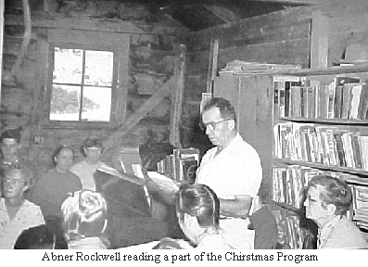
Our first Christmas in Costa Rica is just past. Our little community of 36 people and one guest from San Jose celebrated the day as a group. The ages ranged from four month old Alberto Guindon Just arrived from the states with his parents Wolf and Lucky, to 81 year old Elwood Mendenhall. The youngest member, six days old Emily, was still in San Jose with her parents' Eston and Mary.
Our annual Community Christmas Dinner and Gift exchange had its start in late fall. Names were drawn and gift making commenced, using whatever materials were available.
There were no traditional Christmas trees to be had even though nearly 400 different types of trees are to be found in Costa Rica. We didn't miss it. A beautiful tree, a variety of acacia, was substituted. Decorations for the meeting room were made by the first eight students of Mary Mendenhall, as she was starting her twenty years of service to the young minds of Monteverde. The decorations were creatively made from soup wrappers, strips from opening oatmeal cans, etc. colored ads from magazines, seed pods and berries from the woods and any material with Christmas colors. How much can be done with no expense and with a little ingenuity...!
We at the Campbell house had four people to make gifts for, so that meant the Swedish sewing machine we had purchased in San Jose as we were waiting to have our turn to move, was kept busy for a number of days. There were no stores to buy a present at, so the things were home made making for some very nice durable gifts.
Georgie, 3 1/2 years old, was a lucky boy! He received a "man-sized" oxcart, made by Marvin Rockwell, that was big enough to haul little, 1 1/2 year old Ruthie in. One of the boys about 12 years of age made a wooden truck for a little 3 year old boy. It was a very good job.
It was fun to see all the different creative gifts. Because someone had made each article received, there was more feeling of the Christmas spirit of giving.
Our Christmas dinner was a treat! Barbecued pork roasted over an open fire by some men in the group — excellent! The rest of the menu consisted of potato salad, (made from aricache), candied sweet potato (squash), cabbage salad, pickles (chayote), rolls, wild berry tapioca, lemon gelatin dessert, and cake and candy made from guava. There was more then enough to eat! Grandma Mendenhall's best linen tablecloth had been taken out of storage for this occasion.
With the cooperation of all, including the weather the day was a great success leaving a warm glow in our hearts.
Nearly nine months ago the John Harvey Campbells left Mobile by plane to come to Costa Rica. The first half of the time we lived in San Pedro, a 15 minute bus ride from San Jose, while suitable land was found. We are now located at Monteverde.
So far we haven't located on the exact land where we wish to live. The present occupant has until the latter part of April to move. But when we do move, there will be a "Million Dollar View". We are presently living in a tiny two-room "cabin" that had been built by one of the Ugalde family. Its dimensions are 9 feet by 23 feet with a 5 foot porch running the full length. The bedroom section is so small that if a click beetle comes in at night it illuminates the whole bedroom. It is near the river and about a ten minute walk from the Community Center building. I made a simple bed frame of rough 2 X 4s with the idea of stretching heavy canvas over it to serve as a temporary bed. I also bought canvas to use overhead as a ceiling for protection from the breezes and mists, which were hardly deterred by the open construction of the shingle roof. Eight families set up tents to live in.
We plan to try our hand at dairying with cheese making in mind. Our children are growing fast. Little Ruthie had her first birthday just after we came to Costa Rica. She was the youngest member of the original group. Now she is a regular mountain climber, she can talk a "blue streak", make a good attempt at singing some songs, loves to look at books, and tries to keep up with Georgie. Georgie still has an excellent memory and is a very observing lad. The memory is sometimes embarrassing to his mother since he reprimands for things he has been asked not to do. You would love to hear him read his story books to his little sister.
++++++++++++++++++++++++++++++++++++++++
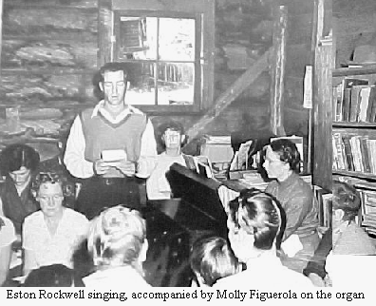

First “Monteverde Chirstmas”
- by Cecil Rockwell
On the first "Monteverde Christmas" we decided to draw names for gifts which were to be all handmade, which turned out to be a good deal of extra work for the parents of small children. A great number of different things were produced, many articles made of wood including bread-boards, end-tables and toys, also articles of clothing, shirts, aprons etc. A volunteer committee made some extra gifts if there were visitors. There was a community Christmas dinner and program with the gifts. A small pig was barbecued over an outdoor fire for the Christmas dinner. This turned into a tradition that continued through all the years since. In later years we dug a pit in the woods near the river and barbecued hams and/or shoulders and also a piece of beef for those who preferred it. The women particularly appreciated this as they had less food to prepare for the community dinner. This was done the afternoon and night before Christmas and those who cared to came to sing carols and have coffee, hot chocolate and marshmallows and broil steaks over the fire to eat at the time, sometimes staying until far into the night. The young folks would go from house to house singing Christmas Carols and were often served refreshments.
++++++++++++++++++++++++++++++++++++++++

- from old letters by Lucky Guindon
12th Mo, 28. 1953
In the gift exchange, Wolf and I got a real nice cedro little table or stand, from Mary and Elva. They did it together and really did a good job—it's what I'm typing on right now. Dave (Campbell), who was Santa Claus, was given a pair of pajamas from Janice (Harkey). Bright yellow with a contrasting print—really gay! His face got a little pink when he held them up to show. After the present passing we had our program even tho', it was rather late. Carol & Celia played some carols on their little xylophones. Don played two clarinet solos. Eston & Glen harmonized on two songs. Our quartet sang two songs—with our usual trouble of not getting started on the right key. The younger kids gave "Up on the House Top" with all the actions. Then we all went home in the mud and rain and got soaking wet.
We had the Nativity acted out in pantomime two nights before Christmas. Our Tico neighbors were invited too so there was really a big turn out. Had cookies and cookies afterwards and sang carols. We're hoping our visitors would contribute a little too but found that they don't sing their carols-until Christmas eve... For Christmas dinner we had barbecued veal (Wolf on the committee so he & Ted had to get up at 1:30 A.M. to get it done). There were lots of salads and lots of cakes.. I took candied squash. It was so much more fun this yr. as the gifts were handed out one at a time and held up for all to see.

1-11-54 The men-folks in Howard’s family made a real classy ping pong table for the community at Christmas. It is really nice and seems so big after playing on a little table for so long. They put a lot of work into it. I went down one 1st Day afternoon and joined in on a more or less tournament game.
++++++++++++++++++++++++++++++++++++++++

- from Rememberings by Lucky Guindon
Since people were so busy working that first year it seemed we lacked something to relax us—to do together. Wolf had long been an enthusiast of square dancing so we ordered some small books from the Cooperative Recreation Center in Delaware, Ohio, of play-party games, and square dance calls. Knowing that some people might be disapproving of "dancing", I took the books and visited the ones I thought might question it and talked about the history and idea of square dancing, then asked for their approval of beginning a square dance group. No objections were given so we started with a nucleus group of 4 couples with Wolf calling and music provided by my harmonica. It caught on fast and soon we had large groups—sometimes with hardly space to dance, and cookies and juice for refreshments. Ticos came from miles around to see this new phenomena. But the problem of space being important we discussed what to do; decided to leave off the refreshments a time or two and that did it. They hadn't come to dance but to eat! We still had enough Ticos and machos who were really interested to come and join in—often helping with guitar in the right rhythm for square dance calls. Others of us picked up calling also and old and young came regularly every 2 weeks for the square dance. Accordions and concertinas were added and also a record of calls was donated and still later, tapes. It had become a permanent institution— subsiding to once a month sometimes when enthusiasts .were fewer but never completely dying out.
About the same time, "Family Nights" were introduced on the same pattern as the old literary programs" of other communities. This included "hosts" planning the evening’s entertainments-, asking different ones to tell a story, sing a song, recite poetry, etc, usually on a- theme and ending with a bible reading. From this evolved the “Family Album"—a sort of summary and stories of the years' events—either imaginary or real, also planned by an editorial committee, both of these continued for many years and then bogged down. Before we had come to Monteverde the children had started "Fun nights" when all ages got together for group games, or singing—all unplanned and informal. Some old stand-bys were "ring on a string", trying to see who's got it, and "telegraph". There were also many impromptu parties for the younger married, and singles, when games were thought up on the spur of the moment, and maybe a taffy-pull or fudge making party or just story swapping. Those were fun gatherings with so many laughs we hurt. The community Halloween party was started near the beginning too with all cooperating on the refreshments generally, but usually a family to plan the games. Just as important as the work bees were these times to laugh and play together.
++++++++++++++++++++++++++++++++++++++++

- from old letters by Lucky Guindon
2-13-54
We had a "Literary" last week... Finally decided to continue once a month and call it "Family Night". There were a lot of interesting and amusing contributions. The school children did some choral reading, Elva read an original rhyme of hers— telling her grandchildren all about when we first started the community of Monteverde. Next was a letter from Wolf to Hubert telling him how to increase his dairy herd. In other words how to have heifer calves instead of bulls! (he now has eight bulls and two heifers.) --very humorous ......
3-27-55
The Family Night program was all on music, and was it ever good. Cecil’s family sang a song, Irma sang several Irish songs, Kathryn Wise played her cello, Vance R. sang a song, some Costa Ricans played two guitars and a mandolin. They were so good that they were encored back in so played another one. Margaret had an essay on music appreciation, and Oscar sang a song in German. Eston sang “old Man River” (real good), and then Lawrence & Wolf had an amusing and hilarious debate on “Singing sounds better if you carry a tune”—(Neither can). Chase, Betty and myself harmonized on “Auld Lang Syne” and Ruthie and Carol M. sang a cute song about a duck. Ruth closed with a psalm. We all wished we had something like that every time. We didn’t realize we had so much talent in the community.

8th Mo. 6, 1955
We're having a Monteverde paper which is coming out this coming Family Night. It stems from Family Night so we are calling it "Family Album". Oh, its going to have lots of things in it that ought to be good—Elva is doing a parody on "Charge of the Light Brigade" for their midnight ride up here the night Helena was born!
++++++++++++++++++++++++++++++++++++++++

SQUARE DANCES
-from “Monteverde” book by Mildred Mendenhall
Having the benefit of able "callers" within the group as well as those who could make music (mouth organ and accordion), twice monthly square dances were held, as well as "fun and games" nights, songfests and programs of a literary nature, with all ages participating.
++++++++++++++++++++++++++++++++++++++++

by Cecil Rockwell
The School House-Meeting House was also used for Square Dance every two weeks, and some of our Costa Rican neighbors began to come to this and many took part even though most could not understand English, they soon learned the routines. It turned into quite a lively time. Wilford Guindon, "Wolf", was a real good caller.
++++++++++++++++++++++++++++++++++++++++

BOMBA
Oct. 1953,.Halloween square dance -- masquerade. Wolf & I dressed as hillbilly’s and Berto was a caveman (with a gray loop rug thrown over). It's a good thing we weren't very respectably dressed since the roads were terrible. Mud knee-deep. It was very amusing to see everyone dancing (or trying to) in costumes. Marvin wore a short white tunic, and sat down in the mud going back home!

- from old letters by Lucky Guindon
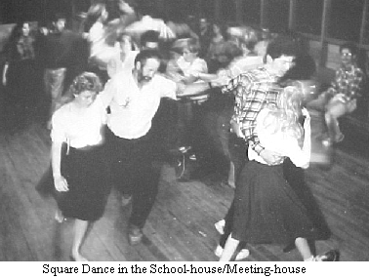
After community dinner last 1st day there was going to be a soccer game over at Rafael Arguedas’ (prominent neighbor with saw-mill and trapiche and big front lawn used as a soccer field.) The game was to be between our fellas and the Costa Ricans. But it rained so instead of soccer we had a square dance in their “large” living room. Some of the Costa Ricans played the guitar, and Wolf called and danced. All of us girls were barefoot cause it was muddy. (Betty, Looie, Kathryn & myself – Irma and Doris were there to watch). Anyway it sure was fun and everyone was in the spirit of the thing. So we got promises then of guitar players and plenty of spectators at our next square dance. Which was last night, and boy was the place crowded. It was all we could do to squeeze one square in and spectators too. We finally, after a good bit of coaxing, got some of them out to do the Virginia Reel. By the time we’d finished most of them had caught on pretty well. None had ever seen anything like square dancing before.
+++++++++++++++++++++++++++++

MONTEVERDE BEES
(tune: John Brown's Body)

That bee's not in my bonnet; no, that bee's not in my
bonnet.
It's those Monteverde people having fun as work they
do.
So that bee's not in my bonnet, no, that bee's not in my
bonnet,
But I hear it buzzing 'round me just the same.

It's a saw & hammer working and a square—don' t let it
lean,
It's a plane and sander helping and a man to hoist that
beam,
It is neighbors who're not shirking—a house will soon
be seen.
They want to help you build.

It's a tractor pushing soi1 to level up that field.
It's the trucks a-hauling rubbish as many rakes they
wield.
It's a play-ground to be leveled for the children old and
young.
The grass must grow there soon.

It's a smokestack to be lifted up to the very sky.
It's a tank that should be shifted with a heave-ho not a
sigh.
It's the lechería needing every man from far and near--
And again we find they're here.

It's a road that needs repairing on the way to Guacimal.
In a culvert holes are wearing through which a truck
may fall.
And besides the ditch you're digging you can help your
neighbors all
Up and down the line.

It's that Monteverde spirit that helps us as we strive
And besides the work accomplished, it keeps our love
alive;
And if the project's not your line—still join the happy
throng,
And bring your food along!

CHORUS :
So, that bee's not in my bonnet,
So, that bee's not in my bonnet,
So, that bee's not in my bonnet,
But I hear it buzzing 'round me just the same.
+++++++++++++++++++++++++++++++++++++++

- from Rememberings by Lucky Guindon
Ah yes, the work bees. They happened pretty often as everyone was struggling to farm and garden but to start a new home as soon as possible. Some folks were in tents which converted to roofs and wooden walls as canvas got too leaky, and some were in squatter's shacks that were already here. These varied in size and sophistication. As dairies were important to our earning income, barns were also important. So at the proper stage in development of a structure a bee was called by the owner who had to think ahead and have enough materials on hand to make it a profitable group effort. The ladies would then come forth with goodies to eat for the hard-working crew. The hosts generally provided cookies and drinks for mid-morn and mid-afternoon. And the others had to try to keep the small fry from being under foot-no simple chore! As a mother of many small children 1 learned to dread the bees on the one hand as it meant getting the meal and drink ready to carry, plus carrying a little one and no-one to help me get there—usually a long ways away, and exhaustion by the time I got there (usually late) and then I still couldn't relax as my kids would be up on the roof if I didn't watch them! (But you never send your man without taking food to contribute.) On the other hand the bees are a fun way to get things done in a hurry.
A good bee takes careful planning ahead, but mistakes inevitably happen even then.
++++++++++++++++++++++++++++++++++++++++

- from book “Monteverde” by Mildred Mendenhall
Due to the eventual deterioration of the tents caused by the wind and rain and the fact that families were outgrowing the limited space that cabins and tents afforded, we were in time confronted with the need for permanent housing. After the framework was erected and a new house had reached the stage where a crew of carpenters could work efficiently at flooring, siding or roofing, a bee was announced and men and boys arrived, hammer and saw in hand, for a day or more of work and good fellowship ending with the satisfaction of accomplishment. At noon the women and children would join the party, bringing with them a bountiful pot-luck dinner.
We followed this same procedure when a new building to house the Meeting and School was erected on an acreage set aside for the purpose.
When our house reached the ready-to-move-in stage, one elderly member of the community suggested that a House Blessing be held in the new home. The regular meeting for worship preceded a short program of word and song appropriate to the occasion, after which everyone stayed for a pot-luck dinner. This was the beginning of another Monteverde custom that was carried on throughout the ensuing years.
++++++++++++++++++++++++++++++++++++++++

- from letters by Lucky Guindon
7th Mo. 4, 1955.
Tomorrow is mtg. day and 1 have practice for singing at the house blessing for Cecil's next 1st Day. We’re having a "sextet"—there are a few strong singers or ones that have done part singing... I enjoy it immensely.. and find picking out the alto part comes easier each time... Lewis & Faye Walmsley had a house blessing at their place several weeks ago. It was a very nice occasion. They had invited all the Costa Rican neighbors around too, so their spacious house was quite crowded; I forget how many she said there were—seems like it was 130 or so. Had a good bit of Costa Rican music—mandolin and guitar and singing—recognized "Ceilito Lindo" and the Beer Barrel Polka! Also Mona Lisa. A quartet of us sang two hymns—“The Old Rugged Cross" and “Joyful Joyful We Adore Thee”—one of my favorites. It rained and rained
++++++++++++++++++++++++++++++++++++++++

Monteverde Day
- from old letters by Lucky Guindon
4-18-54 Tomorrow is MV Day so we’ll have a work project on the cemetery & Community Dinner at the spot—if it isn't raining. Has been for the last week or so, so don't know why it won't tomorrow. There is a little program planned for after dinner-reminiscences from some of the fellows that came up the first trips. Also some charades of same by the kids, such as when a chicken laid an egg in the middle of someone's bed in an adjoining room in the middle of meeting and let everyone know about it. when .the fellow with a sack of beans on his back took off into woods when the first jeep came up the mountain (thought it was an airplane). Folks wrote up .a MV song to the tune of Marianina. Mary R., Doris R. and I compiled and added the finishing touches. Later :Well MV day was sort of a flop. It rained --only put it off until we started to eat. So the food all got runny and we were all cold and dripping wet and Tomas who is usually very good natured, was yelling at the top of his lungs. So we dismissed the program until next Family Night. Seemed a shame to come that far for such a miserable dinner.
++++++++++++++++++++++++++++++++++++++++

SORE KNEES
- by Benito Guindon
It makes me laugh to remember the ways some of my brothers, my friends, and l, kept ourselves occupied when we were kids. One of my favorite occupations was pretending to be some animal, such as a dog, a horse, a cow, a pig, or a chicken. We tried imitating everything the animals did, but each animal had certain habits and/or noises that characterized it the best. If there were several of us, we would pretend to fight: for cattle we used our heads, for horses our hind feet, for chickens our beaks, for dogs our vocal cords and wrestling skills. If I was a hen, I would build nests and lay eggs, but if I was a rooster I would beat my wings, fly up onto a stump or log, and crow. When I pretended to be a cow or a horse, I would eat grass (using my hand not my mouth), and I would often tie myself up by the hind-leg; as that is how people tie up pigs. I remember having sore and green knees from spending so much time on my hands and knees; my mother didn’t like it if we used long pants for these activities.
++++++++++++++++++++++++++++++++++++++++

SCRABBLE
- by Dorothy Rockwell
- from Family Album, Vol 4, 1958
Anyone enjoying word games would likely appreciate SCRABBLE, though do not confuse it with Anagrams. This game consists of a board and 98 letters. These may be bought, if one has the opportunity, or better still find a neighbor owning a game and make one using it for a pattern. Each letter is given a numerical value from 1 to 10.
From observation it would seem people react three different ways when asked if they enjoy SCRABBLE. There are the enthusiasts, the luke-warmers, and the decidedly negatives. In the first category are those who when the word SCRABBLE is mentioned will always reply, "Did you say SCRABBLE?—and, Sure, I'll play!" Often when people first hear the game mentioned they say: "SCRABBLE? what is that? Just another word game?" After the first or second time of playing they may still be a little reticent and make the remark, "Well, maybe", but if they seem interested enough to continue they probably become enthusiastic. Therefore, the second category may enter the first; But the third are afraid to even try the game for they just might get to liking it!
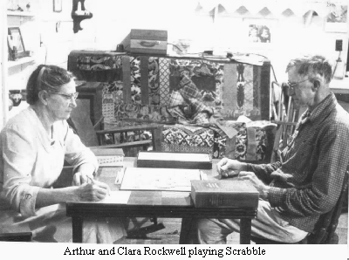
It one desires to entertain with a SCRABBLE party invite about four interested people for each game. It is necessary to have a SCRABBLE board and letters, a blank pad and pencil for score-keeping, and of course a dictionary or two, preferably two! More than just enjoying this game as such, and learning new words, it is a first-class way of having companionship with others while doing the same thing. Jokes are made and mock disgust displayed occasionally, but always pleasant conversation is mixed in.
I found one dictionary gives the definition of SCRABBLE as: "to scrabble, struggle; also to scrawl or scribble." This may or may not have had much to do with the reasons for the name when it was originally selected for this game.
My suggestion is, if you have not already tried SCRABBLE, try it the first opportunity.
++++++++++++++++++++++++++++

SCRABBLE 2001
- by Dorothy Rockwell
As of January 2001 Scrabble is still played in Monteverde every Friday afternoon beginning at 2 oclock with usually five people sitting around the table. We have made a few rules of our own which are; each player having 8 letters instead of 7 on her/his rack unless there are more playing than five, then its 7, .and a second is that if there is a blank on the board in her/his turn may replace it with the letter it had been called and use the blank for another letter in that turn. I know a few people that would rather play the official way! It is still our policy to help one another to make a higher score, though score keeping seems important! Coffee and cookies served around 3:30, but we continue playing through the refreshment time. We usually play four games in an afternoon.
++++++++++++++++++++++++++++++++++++++++

SCRABBLE BABBLE
(TO CLARA THE CHAMP)
- by Margaret Montien

Oh, when we play Scrabble
We’re not like the rabble
Who gossip and gabble—
Oh, No!

Our letters may wobble,
But we never squabble,
And we never gobble—
(Ha, ha)

And we never quibble,
‘Cause Webster’s our sible,
Our vertible bibble,
Just so.

Now where am I wending?
I need a good ending
This ditty is tending
To grow.

Glitter-fledged

And what’s the connection
Between this confection
And our predilection
Today?

Well, I’ll cease all this dabbling,
This gabbling, babbling
And quips about scrabbling
And say,
HAPPY BIRTHDAY
++++++++++++++++++++++++++++++++++++++++

A SCRABBLED ODE TO DOROTHY
May 1996
- by Lucky Guindon

Oh, the scrabbling scrabblers scrabbled
And they scrabbled while they gabbled..
There at Dorothy's house each Friday afternoon.
Yes, these cogitating scrabblers
Like to babble while they scrabble
Until dizzy in a tizzy they do swoon.

So then, Dorothy serves refreshments
She had made while wearing "vestments"
And hot coffee to revive their addled minds
Yet the scrabblers still did scrabble
Juggling coffee, cake, and babble
And forgetting where they were and what the time.

But now, Dorothy soon will leave us
'Twon't relieve us, but 'twill grieve us
And the scrabbling and the babbling will subside.
Yet again someday——(in November?)
We'll meet Fridays (and remember?)
All those words in Dor'thy's black book-it's our guide.

So here's thanks to Dorothy Rockwell
And her blackbook which is stockfull
Of those little words that save us every time.
May your trip be satisfying
But hurry back—we're up here dying
For another Scrabble party—'twill be FINE!
++++++++++++++++++++++++++++++++++++++

FOUR O'CLOCK COFFEE SESSIONS
By Dan Boehm
A pause in the day's occupation to rush over to Edith Peckham'a for a jolly gathering and a good cup of coffee. Rain or shine, all would converge at Edith's, park their boots, alforjas and umbrellas, and join the happy group inside for coffee, cake or cookies. It was the occasion to exchange greetings, news from various parts of the community, and news from San Jose via radio or truck transport. Not often, a little gossip would be whispered also. Above all was the camaraderie and boisterous laughing and joking that could only come from a gathering far from the city or maybe home country. Some, with need to do chores or return to other jobs, would slip away and leave us older or retired members and visitors, to end the session, often with an invite to supper. Yes, it was fun!!
++++++++++++++++++++++++++++++++++++++

Tuesday Morning Coffee at Dorothy’s
- by Marvin Rockwell
For many years now it has been the custom for people in the neighborhood to go to Dorothy’s house between 9 and 10:30 on Tuesday mornings to have coffee, tea or juice and cookies. It makes a chance for everyone to gather the latest news of the area. Quite often when there are visitors in the community they come to “Coffee at Dorothy’s” and have a chance to meet more persons in less time than trying to go around to the various homes.
When Roy Joe Stuckey was bringing tour groups from the U. S. he usually scheduled their time in Monteverde to include Tuesday in Monteverde and bring them to Dorothy’s house.
The one rule that Dorothy has made is “No Business”.
++++++++++++++++++++++++++++++++++++++

The Song of Monteverde
(Spring of 1954)
Where the mountain slopes are ever green,
Where the air is always fresh and clean,
Where the virgin trees grow straight and tall,
Echoing the wild bird’s call.

(Chorus)
Monteverde, cool and bright,
Glorious on a moonlit night.
Oh, Monteverde, our Monteverde,
Your sky’s so blue and grass so green all year.
Oh, Monteverde, our Monteverde,
Your lovely views make you to us more dear.

Hear the river sing its joyous song;
O’er the rocks it wends its way along.
Every winding trail we’d like to learn
With its orchid and its fern.
(Chorus)

Monteverde, with its winding streams;
Monteverde, land of all our dreams;
Mountain land where peace and beauty reign;
We would make our lives the same.
(Chorus)

The Monteverde Song
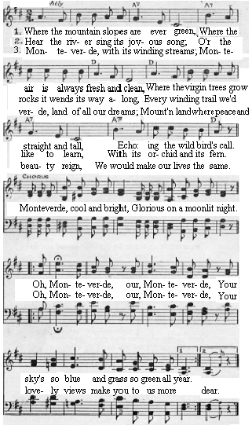
++++++++++++++++++++++++++++++++++++++

from old letter by Lucky Guindon
April 5, 1964
We went to a movie last night. Yes, up here, even at this end of the world, we have a theater with movies every Sat. & Sun. Wilfried Mengel, in Santa Elena, now has a theater, restaurant, and hotel all under one roof. The movie we saw was, "The Nun's Story". A good many from our community went along in the truck. Next week will be "The song of Bernadette"...... We have started work on the new schoolhouse addition, (new Mtg. room)
++++++++++++++++++++++++++++++++++++++++

MUSIC AND THE ARTS IN M0NTEVERDE
- by Lucille Guindon
When we came to Costa Rica and were found twiddling our thumbs while searching for land—there was plenty of time to think of fun things to do. So, at the instigation of the school children, community sings were started. We had no song books but plenty of enthusiasm so got together on the Challe Farm once a week to sing all the songs we knew. I remember "Oh Susanna" was a favorite.."0h we come from Alabama...." Later, on moving to Monteverde, sings were less frequent but still popular. When square dances were started, our Tico neighbors sometimes brought their guitars and played for the dances, relieving the harmonica players. At refreshment time, they often played and sang some of their own songs, which we enjoyed. Once, at one of our "Family Night" programs, we had a wonderful duet with guitar and mandolin, a real treat. When Molly came, she brought an accordian which Carol soon learned to play; then Ellen too got one and they both played for our bi-monthly square dances. Mary K Andrews bought a small organ which we used for Christmas Programs. When there were house-blessings or for Family Nights and Christmas programs, we got together a quartet with ones who knew how to read music and some of us who didn't. We could make the dogs howl with our close harmony! —Yes, it was the HARMONY! Molly worked hard to teach us to read parts for Christmas carols, and gradually we improved. Another musical group was our recorder trio; Molly, Betty Osborn and Margaret Montien. They performed for many occasions and even made lovely matching outfits to wear. The Walmsley's brought a piano up the mountain and we had several song-fests around it. We made a hay-ride out of it one night, singing all the way
over and back. I remember being impressed by the fact that Arthur and Clara went all the way to San Jose to hear Marian Anderson sing in the National Theater—and it was rainy season when roads were the worst! Yes, music was definitely a part of our lives—but of our own making.
Formalized art was a little slower although there were several who loved to draw which the Family Albums and school papers show. Jo Rockwell was our first artist/teacher in our school. I remember going to pose for the class while the students sculptured heads out of clay which were later cast in plaster of paris. Once, Helena, about four, asked me, "Is this the day you go to school to make faces?" Another time Jo wondered if something was troubling 'Berto as he liked to draw everything in black! (Whatever it was he must have gotten from his mother, as I like to draw in black also!) Later another artist, Graciela, Paul Rockwell's wife, came and taught art in the school. I was quite impressed with the water-colors she inspired some of the students to do. Then came the famous duo—Ron and Bill, who not only taught art in the school but started community classes, planting seeds which burst forth in all kinds of blooms. And new ones are still blooming.
Children are natural hams as has been proven by the excellent plays put on by the school every year from the early beginning. Especially for the last day of school programs.

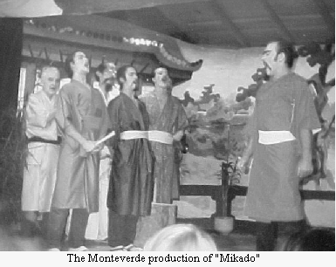
I was always impressed with their acting abilities, ingenuity, and costumes from nothing. At first these plays were directed by Mary Mendenhall.
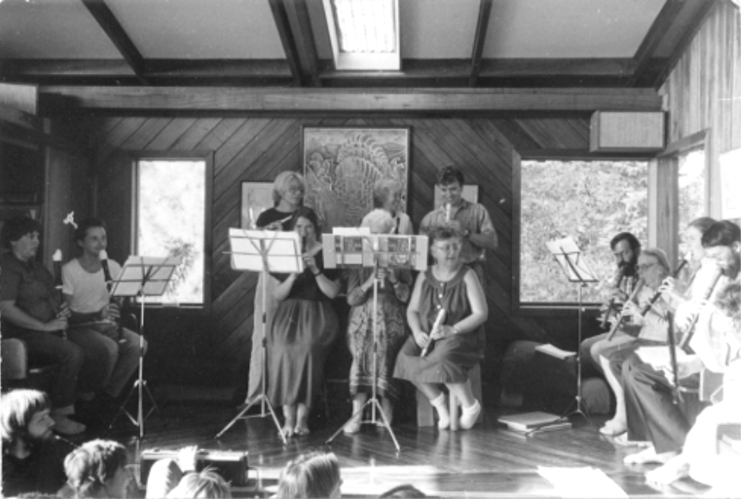
When Margaret Montien joined the staff, she not only directed the plays but often wrote them herself. One year as part of the school, the young children acted out stories after Wednesday Meeting, for whoever they had there for an audience. I'll never forget Berni Rockwell playing the part of silly Will (or some such character) trying to jump into his pants! All ages were in plays for the last day of school. Remember Gail Hoge as Christopher Robin and the other characters from Winnie the Pooh which Ann Kriebel directed? "Our Town" was professionally done with the "stage" being - among the audience. The High School had a real drama teacher that year. One year the high school really got into it and put on at least three plays, one right after another, all on their own (with the teacher's permission), just for the fun of it. Christmas programs used everybody's talents from farther afield. Remember Stella as the Grinch who stole Christmas, Monteverde fashion? Great acting. And of course there were the famous puppet shows by Ron and Bill and Sally. Never to be forgotten.
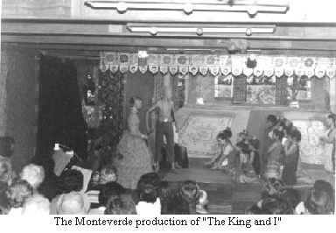
When Margaret Adelman and Barbara Haber got their heads together, even more amazing talent appeared in the form of Musicals. These really involved a wide range of community members...for the music, the acting, the costumes, the back-drops, and make-up artists. Some have been preserved on video. So it has been proven that all the world's a stage and we are all actors thereon. You never know under what guise a budding actor or actress/singer will be found. Good work, everybody!
++++++++++++++++++++++++++++++++++++++++

ART HISTORY IN MONTEVERDE
By Stella and Meg Wallace
From “Family Album 1971-1991”
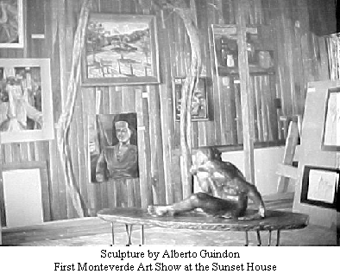
I have been asked to catch everyone up on the history of art in Monteverde over the last twenty years or so. Those of you who are past residents or friends of Monteverde will remember the enthusiasm of Jo Rockwell and Graciela Rockwell, who were involved in their own painting and classes in the school in the years before the 70's (and incidentally before my time).
So - although I do not wish to belittle the work of these and any other pioneer artists, it is usually said that art in Monteverde started with the arrival of Ron Tomlinson and Bill Kucha one rainy night in 1971. In those days the bus was a pickup truck or a jeep, and only got to Santa Elena after dark. Ron has it that they walked over holding on to the barbed wire fence along the pastures for lack of a flashlight, and, coming to an open gate asked in a loud voice was this Monteverde? A tico voice in the barn answered "este es la casa de Kenny, pase adelante" so they followed instruction',; and arrived at an old wooden house with the smell of fresh bread wafting out on the night breeze. As the door opened, a scene of indescribable chaos could be seen, and (Ron maintains to this day) two Siamese were revealed to their amazed eyes contentedly sleeping on a pile of warm bread.
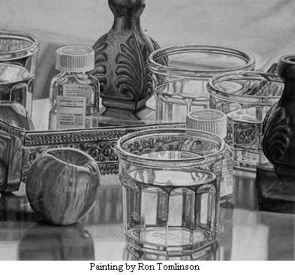
In short time they settled down in their own house and by 1972 had been persuaded to start art classes in the school, and tremendously popular adult classes after school, attended by a wide variety of people, some of whom you would never have supposed would be interested in art.
These were no ordinary classes, Ron in particular had his own special philosophy. You would be working along and would be aware that he was standing behind you. He would give you all the nice compliments he could think of, (you meanwhile although enjoying it, knowing it was a little exaggerated) and right at the end he would slip in a little constructive criticism. "The idea" he would say "is to keep people painting".
One of their best students was a member of the Guindon family (all artists in one form or another). Helena they encouraged to go off to Boston U. School of Art in 1974.
Around 1977 the sad time came when the fellows decided to go back to the States. They left a Monteverde with its inhabitants crouched over their pads, pencils scratching and brushes flowing.
Present day Monteverde has painters from this original inspiration still working. And many more people have come and gone. Some were already artists when they arrived, some were inspired to try their hand by what they saw happening.
Monteverde counts among it s resident artists: Lucky Guindon (anything she turns her hand to, at the present moment pen and ink drawings with washes), Sarah Dowell, (watercolor) - Sarah is the only painter who makes her income from art at the moment. Willow Zuchowski, (watercolors and biological illustrations), Meg Wallace, (watercolors), Stella Wallace, (oils and Gouache), Teri Matelson, (at present not doing much painting due to her job as a biologist), Daisy Youngblood, (sculpture in clay). We also have many part-timers who also join us when they stay in Monteverde.
Art shows have become frequent occasions. The first full blown art show was Ron and Bill's work, together with some Guindon sculpture, in the library in 1974. Since then there have been shows at the school, and several at the Sunset House.
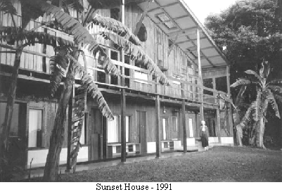
There is now a tradition of having an annual Miniature Art Show in December. This year will be the third. The first was in the Sunset House, the second at Stella's, and for the third we hope to be able to inaugurate Stella and Meg's Studio/Gallery. Sarah had a show earlier this year "Faces of Monteverde", and has had a private show at the National Theatre. She now sells her work from her studio gallery all the time. Stella has had a show at the Hotel Cariari (1989) in San Jose, and she and Meg and Lucky show their art in their homes.
+++++++++++++++++++++++++++

The Sunset House (1978-1998)
By John Trostle (and Sue)
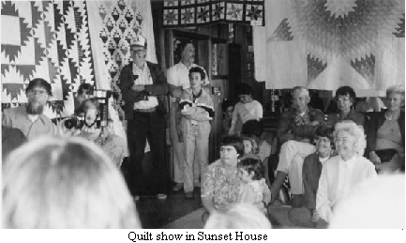
Why did I build the Sunset House? First, it was the view and second, the wood. We didn't know until we moved to Monteverde in Oct. of 1974 that there was a beautiful view of the Gulf of Nicoya and the coastal range from the west side of our finca. However we needed a 9-foot stepladder to see it! In the midst of that first discovery Sue suggested that I build a simple, rustic shelter, and maybe an outhouse, to enable us to watch the sunsets. I favored, perhaps, a 2 1/2 story open Japanese-style house, with a regular bathroom, and a place where I could do woodworking, and where we could enjoy the sunsets throughout the year. Sue deferred to my ambition very graciously, and the plan began to form in my head.
I had fallen in love with Costa Rican woods and began to collect lumber for the house. About 40% of the wood we used came from our farm, and in 1978 we poured a cement floor and foundation. I did the drawings, purchasing of materials, and transporting (with our truck, "Heffalump"). Over a two-year period, the construction was completed by Andres Rodriguez, Edwin Santamaria, and other workers. The dedication happened in 1980. Sue & I lived there for 5 months, but soon returned to our old home which was more cozy and centrally located.
The house first became our guesthouse for family and friends from abroad. Nana, Lynn & Jim used it for a quiet place to work on their respective theses, and later on, Marcy Lawton wrote there. The Sunset House rapidly developed into a supplemental community center, hosting scores of concerts, workshops, parties, art exhibits, lectures, and celebrations of many kinds during the years from 1980 to 1996, when it was rented to the Monteverde Institute for two years for offices and classrooms. We sold the house in 1998 when I began to find I was unable to maintain it properly.
What happened at the Sunset House during those first 18 years? I volunteered to write about this because the house played an important supportive role in the cultural, educational and recreational life of the community during that period of expansion and development.
Thanks to our friends Gloria Waisbluth and Bemardo Lelchuk, we were fortunate to have many distinguished musicians willing to share their talent with our community: the pianist, Boris Berman from the U.S.; and Scarlett Brebrion, a pianist who was living in Costa Rica; Guadalupe Gonzales, a Costa Rican singer, each gave memorable performances. Musicians from the National Symphony and the Youth Symphony played singly and in trios and quartets.
In 1989, after participating in "Seeking the True Meaning of Peace" conference, Paul Winter, clarinetist, gave a concert in the meeting house and a workshop at the Sunset House. There was a group from Australia who played folk music and a blue-grass festival including a band from San Jose, and Gary Diller with friends. Concerts by local musicians and singers included Paul Smith, cello; various string quartets, one including Bill & Joyce Fuller; another with Alan Masters, Jennie Rowe, Sue Trostle, and Kristie Rockwell. A recorder group had 14 participants in one presentation. Other guests played trumpet, violin, saxophone, clarinet, oboe, viola; what a rich array of instruments was presented to children as well as adults over the years.
Art shows were held in the Sunset House: drawings, paintings, miniatures, sculpture, were gathered together in various years by local artists for display and sale. One of the most memorable exhibits was that of quilts, by Dorothy Rockwell, which covered the balcony as well as the second floor rooms.
Many public lectures and slide shows were given by local biologists, and visiting guests: relief workers from the Nicaraguan war, authorities on peace and reconciliation, new developments in the sciences and education. We were privileged to hear Robert Muller, then the Ass't Sec'y. General of the United Nations; Sir George Trevellyan and Eileen Noakes, associated with the Findhorn Community in Scotland. We shared Himalayan climbing experiences with Arlene Blum. A video movie series was organized by Judith Simmons to raise money for the Ceramic Center.
The first workshop at the Sunset House was taught by Charlotte Selver and Charles Brooks, friends of ours whom we invited to inaugurate our building. They taught "Sensory Awareness" to students from the community and from San Jose. Later workshops were presented by Virginia Satir, expert in family relationships; Danaan Parry, who founded "Earthstewards"; Stephen Angel, who demonstrated an "Alternatives to Violence Project". A meditation retreat one weekend was led by Tom Sather. "Wellness Doctor", John Travis, held several weeklong workshops for physicians. The board and staff of the San Jose Peace Center as well as the San Jose Friends Meeting members came several years for joint meetings with the Monteverde Friends. They stayed and cooked at the Sunset house during those weekends.
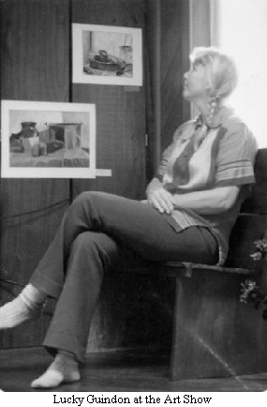
Many ad hoc and regular committee meetings met there. Women's groups, practices for various musical events; community chorus was held from year to year. During the 3 years that Sara Marriott (from Findhom) visited, a Saturday morning meditation group existed for those interested. Classes in yoga, massage, meditation, and color therapy, have been held.
Other events over the years include the Indian-style wedding of Susana and Papo, followed by a pot-luck reception and music performed by the bride and groom. We will always cherish the memory of Oliver Hampton and Walter James throwing confetti at each other. In fact, we found confetti occasionally during the next 15 years! Alan and Karen Masters also held their wedding reception at the Sunset house.
There were dinners for the lechería board members and spouses. A New Year's Eve party was held one year; a graduation banquet another; and birthday parties were frequent. Who will forget the "Messiah" tapes during the Christmas season, with enthusiastic choristers joining in from the balcony? The reading of poetry and stories by Dennis Lee and Susan Perly also will long be remembered.
We can't recall each of the wonderful evenings we shared at the Sunset House, but the above were some of the high points.
Several workshops were sponsored by MV Institute and led by Bob Shibley and Lynda Schneekloth. Students from the Sustainable Futures course presented their work on Enlace Verde, the colegio, drawings for new buildings, and other helpful ideas, to interested community audiences. The Institute held annual meetings there some years. It seemed very natural to rent the Sunset House to the Institute at the time when they needed more space.
There were unwritten rules we followed: no activities would occur at the house which would compete with the Meeting House or school use. No liquor or smoking would occur on the premises. Shoes were to be removed before entering, Japanese style, to ease the burden of cleaning. Activities and presentations would be open to all.
We rented the small apartment on the first floor to teachers, or to visiting biologists And we enjoyed having our family, guests of the community, and relatives and friends of friends stay there. We feel very privileged to have met all the people whom we otherwise might not have known, had there been no Sunset House!
++++++++++++++++++++++++++++++++++++++++
BOMBA
Tourist: “What do you do in Monteverde?"
Ron: "LOVE IT".

ART IN MONTEVERDE
By Sarah Alida Dowell Mcwilliams
In the early 1970's began a wave of art creation which has flourished to the point that nowadays Monteverde is sometimes referred to as including an "art colony". In 1972, Ron Tomlinson and Bill Kucha arrived—artists who shared their enthusiasm and skills for painting with their beloved Community Art Classes. Some who paint to this day got their beginnings in these nurturing classes: Stella, Lucky, Helena, Paul. Though definitely also inspired by Bill and Ron, I didn't attend the classes because I began to paint every day, not just at the weekly classes. Perhaps hard to imagine now is that when I opened a gallery in my home in the early 80's, "Sarah's Gallery" was the only tourist attraction in the zone besides the Monteverde Reserve.
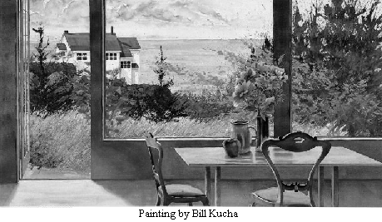
As the influx of visitors grew, so did the number of attractions, including galleries. When Patricia and Michael Fogden opened their Hummingbird Gallery some years later, they apologized to me for the competition! Then Stella and Meg opened their gallery; Paul exhibited many of his works at his sons' hotel; Helena and Lucky eventually had their gallery in Lidieth and Carlos' house; and Marco Tulio Brennes opened his "Extasis" gallery at the edge of the community.
Besides painting there has been beautiful stained glass, photography and wood work, and in the 80's Daisy Youngblood came for a time from New York City to create many orginal sculptures. Many like Bertalia and Patricia Jimenez and Martha Moss created wonderful images via the CASEM workshops. In the 1990's, potter Judith Simmons worked with the Institute to build the Ceramic Center, which has led many of all ages to create works from clay. Today the Ceramic Center is part of the Monteverde Arts Center, as the old Rockwell/Boehm House beside the Ceramic Center was converted to an imaginative locale for all local artists who wish to exhibit and offer their works for sale. Some locals have found their artistic skills have developed to unexpected levels by teaching others through Sybil Gilmore's Monteverde Studio of the Arts, which brings scores of students each year from afar. The most recent gallery to appear in Monteverde is Patricia Maynard's handsome Bromelias.
Given the beauty of the surroundings and the individualism characteristic of Monteverde, it's no wonder arts of many kinds flourish here.
+++++++++++++++++++++++++++++++++++++++

Monteverde Studios of the Arts
Sybil Terres Gilmar

In Monteverde live biologists, farmers, construction workers, Quakers, Costa Ricans, Nicaraguans, hotel owners, store owners, artists, school children and machete wielders. In short, it is a community. Visitors have come to Monteverde to identify birds, count butterflies, do field research for tropical conservation classes, hike to reach cascading cool waterfalls, and search for pizotes, quetzales monkeys, and golden toads in the dark lush green of the forest, m the process, some find they want to paint, draw, or photograph what they see to capture the beauty or affirm the sense of sight. They are the artists who muse, "I want to hold on to this space, this light, this shade of green just a little while longer." Whether its for the permanent resident or the intrepid visitor, Monteverde serves as a place of inspiration.
Before I arrived in Monteverde, Costa Rica in 1994,1 knew about its social history from Costa Rican guide books. Founded in 1951 by a group of 50 farming Quakers who left Alabama, Ohio, and Tennessee to protest the Korean War.
Monteverde, Costa Rica became home to a group of war resisters who were determined to establish a community outside the United States. They were drawn to Costa Rica because it had eliminated its standing army in 1948 and the farmers felt that they could continue with dairy production. They did and, with the help of the small Costa Rican community there established the Monteverde Cheese Factory.
When I arrived in Monteverde in 1994,1 was struck by the still rural nature of the community. Cows, goats and horses shared the unpaved road with four-wheel drives, and motorcycles. Roosters crowed in the morning; packs of dogs barked in the evenings. Electricity was not consistent and a minimum number of families had telephones. The one bank had no computers and the lines I stood on to do simple transactions seemed interminable. San José, the capital city, was a 4 1/2 hour bus ride away.
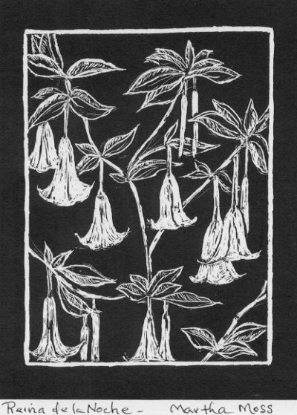
The outside appearances belied what was on the inside and probably what the two or three day tourist cannot begin to grasp. In spite of what seemed like isolation, this was and is a community that welcomes outsiders but truly nourishes strangers with ideas and talent. Artist Ron Tomlinson and Bill Kucha came to teach at the Monteverde Friends School in 1971, fell in love with the landscape and the people and stayed to 1980. According to Ron, "In those years, landscape was everything. Even a car was rarity. People would run out to the road just to see one pass by."
The Quakers' hospitality and eagerness to learn as well as their creativity so captivated Ron that he stayed for another nine years giving lessons to whoever came to the house - by horseback, or by foot. Ron remembers with fondness the campesinos who came with machetes hung at their waists with the desire to learn how to draw. "And they drew like angels," reminisces Ron.
Ron feels that the creative spirit is supported by the kind of people who came as pioneers - either Quakers or Costa Ricans - who recognize they have no more than each other. God, and the creative spirit to fill every vital need of daily live - food, shelter, clothing, and appreciation of the aesthetic.
"Everyone here seems to have the personal strength to launch something that would be off-putting to someone else. That's what the creative spirit is all about."
Ron recalled that he had not so much as built a birdhouse in his life and wound up building his own house with the support and help of the community; it was simply expected. Artists began teaching artisans; artisans taught artists until the distinction blurred. The community became and is rich with artists/teachers.
As I poked around I discovered basket weavers, painters of every specialty graphic designers, sculptors, ceramists, weavers, furniture makers, wood turners. I saw artists teaching artisans, artisans teaching artists until the distinction blurred. The community became rich with its artists/teachers. I decided to ask this community of artists to share its talents with the visitor who was willing to come and work with them in their homes and studios. With their approval, I began the Monteverde Studios of the Arts which had its first season in 1998. Since then over 200 students from 16 to 73 have enriched their artistic talent and expanded their knowledge of individuals in the community. The Monteverde Studios of the Arts has truly become the place "Where Craft and Culture Meet."

Marco Tulio Brenes - Wood Turning and Wood Relief
"The idea," says Marco, "is to have the wood sing and create poetry in your hands. Only then is it a true work of art"
In the basement of his gallery and home, Marco is surrounded by the tools of his trade- wood turning lathes as well as the special wood that he cultivates for his bowls and boxes. As you walk up the steps to his gallery/home, you realize that Marco's house is set precariously on the side of a cliff, overlooking a river and occasionally this building does sway in the wind of the mountains.
Whatever crosses one's mind about the possible lack of safety in this setting, you realize that this home/ gallery/ workshop is an artistic creation in and of itself.
Marco received the usual sixth grade education for the children of San Luis Valley where Marco was born and shared a home with his mother and father. A lack of formal education does not seem to bear a stigma in this artistic community, and Marco found his education in the shaping of wood.
In 1985, he went to San Jose, studying with Barry Biesanz and Rodolfo Morales Mano, noted wood turners and from that point Marco went forward with his own work, opened his own gallery as a home for his artistic bowls, boxes, and paintings
Marco believes that art comes from the soul and the appreciation of what life can be. "We cannot be careless about anything in life," Marco feels. " Not a piece of wood; not the ideas and feelings of people. We cannot be careless because otherwise we will stifle the creative spirit and lose the precious resources of the forest."
Sounds poetic? Marco writes poetry as well and in keeping with his creative spirit, Marco can been found at the ceramic studio in the zone shaping the clay in keeping with his artistic soul.

Meg Wallace Laval
In a gallery above her riding stable and barn, are the tools of her art work -soldering guns, designs of rainforest flora and fauna, and sheets of brightly colored glass of every color- azure blue, forest green, vibrant reds and shades of white. A half-finished multi-colored stained glass, "Noah Comes to Monteverde" is resplendent with quetzales of the rainforest instead of the doves of the Old Testament. A strangler fig dominates the center of this 1000 piece commission.
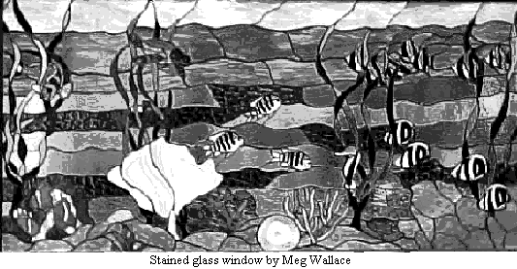
Meg can easily be called Monteverde's Renaissance woman. Born In Alabama in 1955, she now calls Monteverde home as she's been here since she was five years old when her parents Stella and Kenny Wallace came in 1960. She thoroughly assimilated the biology of the area with the help of her biologist husband, Richard Laval, Ph.D, an international expert in bats.
If you ask her what language she dreams in, she says without a moment's hesitation, "Both." Her fluent Spanish helps her work with Rigo, Lorenzo, and Abraham, the local men who help her run her horseback riding stables and tend to her organic garden richly laced with the worms that provide the energy to create the rich soil.
For Meg, the distance is short between her delight and affection for her surroundings and community and her art. The art, she feels, comes out of that passion for the forest and its creatures. Although Meg always drew, her interest in art was sparked by visiting teachers who came to Monteverde Friends School in the seventies, Ron Tomlinson and Bill Kucha. She remembers that they were always positive and helped if you asked them. She was encouraged by the splendid botanical drawings of Canadian artist, Turid Forsyth who came to Monteverde to live.
Being adventuresome and inquisitive, Meg began to explore painting on glass and that led to stained glass. She takes advantage of all the serendipitous quirks of life. She says she got started in stained glass because she bought the "for sale" tools and equipment from a "dad" who had bought them for his disabled child who eventually died. She feels that she was meant to buy those tools and go forth with her art work.
She wants to capture special moments with her art and thinks that other people want to do that as well. "It's important to me to get things down, and point things out" she says. When I take people out on horseback riding tours, I realize how important it is to stop and point out small habitats, hidden flowers to help people focus and enjoy the wonder of their vistas. I not only want to create art, but I want to make sure it captures the gorgeous moments of the forest. That's my inspiration."

Stella Wallace
Stella's ease with living a lively opinionated life is evident not only in her art but in her history. She came in 1960 to this Quaker community, from Alabama, with her husband, Kenny, when their daughter Meg was five years. That beginning started a long term relationship with the Costa Rican community and the adoption of three children, Lidieth, Toby and Marcos. The raising of her children, and caring for the animals on their farm left Stella little time for painting but she remembers liking art when she was in high school in England.
At 52, Stella felt that she had time to devote to her painting, and was encouraged by two artists who came to Monteverde to paint and teach, Ron Tomlinson and Bill Kucha, who assured her that she didn't necessarily need art classes. She just needed to paint. She paints in every spare moment and only complains about the difficulty in getting started. "All I really need is the push to begin."
Stella's creative spirit and feistiness led her to take her cooking talents and open a bakery five years ago when she was 65. The bakery now has an international reputation. People come to visit her "Panadería" not only to taste her pastries but to admire her watercolors and oils that hang on the walls.
Stella feels that there is a creative, iconoclastic spirit that abounds in Monteverde. She attributes it to the fact that the Quakers who originally came here from the United States in 1951, were definitely nonconformists and pacifists and willing to go to jail for their beliefs. She also feels that the meditative, silent aspect of Quaker prayer is similar to what she feels when she paints. "It's meditative pleasure - like a flow - once I get started. And it keeps you connected to the world. It's entirely possible to disconnect as one gets older and one thinks they've lived their lives. But this painting really keeps you connected. "

Patricia Jimenez Castillo
Patricia Jimenez Castillo, born in San Jose in 1952, has brown eyes that sparkle with the pleasure of life. They reflect optimism and a congruency of her love of womanhood and family. Her English is near perfect because of the time she spent in New York undergoing a myriad of operations because she contracted poliomyletis at 2 years of age. She has spent nearly all her life in Costa Rica and has lived in Monteverde since 1977.
In 1981, when Patricia helped to found CASEM with a group of other women in the zone - a zone that includes Monteverde, Cerro Plano, and Santa Elena. They met with the intention to provide women with the opportunity to earn money through their ability to produce sewn, embroidered, and appliquéd handicrafts and sell them to tourists that were now coming to Monteverde to partake of the beauty and knowledge of the cloud forest.
Patricia was originally inspired to paint on fabric by all the nature that surrounded her -the wonderful bright plumaged birds, and the many shades of green of the rainforest along with its sudden burst of color. She is now moving on to expand her work to the human form. Because of Patricia's ongoing commitment to the social and moral life in the community, her paintings on fabric often are commentaries on roles of women and men. She is clearly a women's advocate with strong feelings that women make the world "cozier" but that doesn't mean that Patricia wants "stay-at-home" women. She is clear. " My aim is to encourage women to grow in ways that are different from the ways men are usually taught to grow and achieve. "Women need to show men that cooperation is better than demonstration of power through competition."
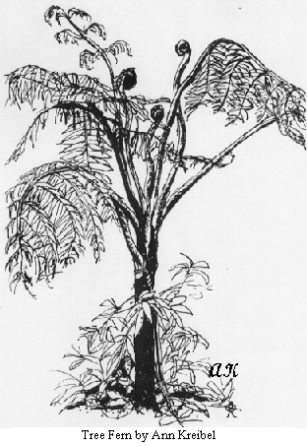
When Patricia talks about art her face glows and her passions are no less strong about her art than they are about her feelings for women and their work. Although her first reasons for doing art were economical -she now finds extraordinary pleasure in doing art. "It brings me a sense of peace and contentment that I don't find in anything else. " Patricia is comfortable with the fact that she has had no formal training. "Art is what you have inside you and I have a mucho art inside me," she says with a smile.
"I think," she muses, "there is so much art here because people did have time to express themselves. There was no electricity, or even when there was electricity, it was infrequent and sporadic and there is so much beauty here you want to find as many ways to share it as possible. Perhaps to show future generations. There are so many shapes here, such variety and such vegetation, and such textures between the ferns. I just wanted to show that to other people. For this brief period of time, it's like trying to pretend to be God."
++++++++++++++++++++++++++++++++++++++++

Snap Shots of Artists From Monteverde. Costa Rica
By Kathryn Johnson
The Evergreen State College 6-7-00
I heard someone behind me, confidently descending the steps. I pulled my eyes away from the bold, emotional landscape painting on the wall and I knew instantly this man was the artist. He was tall and slender with a dash of green paint just under his nose, his silver hair skewed to the left like the wind-shaped trees that dance on the mountainsides of Monteverde. I had to smile and introduce myself.
A musician, instrument maker and artist, Paul Smith lets genuine passion guide his life. He lived in the US as a social worker until 30 years ago, when he moved to Monteverde. He dairy farmed for his first 5 years there, but his passion for art quickly developed with the encouragement of Ron Tomlinson and Bill Kutcha, artists who came to live in the area and gave free art classes. Paul paints quickly, and freely outdoors and if all goes well, can finish a painting in one sitting. His most recent method of painting has been to paint in the same location every day for a week, creating a series of works in which each day's piece having subtle differences. Paul's work has gone through many different stages: watercolors, chalks, abstraction, oils and now acrylics. His Van Gogh-esque approach to painting makes it apparent that he puts all he has into each painting but, when it comes to how others see the work, he doesn't really care. They can look at it and take whatever they want from it.
Paul Smith is in a constant pursuit to simplify his life. He lives in a one-room home and doesn't even have a refrigerator. He's trained himself to eat raw fruits and vegetables and a little yogurt here and there so he doesn’t need all the kitchen appliances that I've always seen as necessities. He has over 150 paintings in the Hotel Fonda Vela but doesn’t really put much energy into trying to sell them. He conceives it as his own personal gallery. I will never forget what Paul said to me when I expressed my fear of becoming a starving artist. He told me, "I have found that everything works out if you follow your passion. Now, if you care about things like a big house and having cars and things, maybe you don't want to be an artist, but you really don't need hardly anything to live. For me, I am happy if I love what I'm doing."
At Quaker meeting a woman stood up to give announcements. Her eyes had a quiet peace and love that shone through, even in the most ordinary conversations. I was amazed but not surprised to find out that she is the artist Lucky Guindon.
When I told her about my artist-interviewing project, she kindly makes time to talk with me at her house, even though she is busy getting ready to go to the States to visit family and friends. Her interest in art began in Ron and Bill's classes some 26 years ago. She said she almost didn't go because she was afraid that because she couldn't just draw things from her head, she wasn't a real artist. But she went anyway, with the encouragement of her daughter, Helena, and ended up staying with the class for 10 years. They started out with charcoal on newsprint and basic seeing exercises. After a few years they began painting with acrylics and oils. But Lucky became drawn to the power and simplicity of etchings and black and white work. She discovered her love for pen and ink and has been working with it since 1984. Her work comes out of her inspiration for nature. She is especially drawn to the sculptured effect of strangler figs, which wrap and twist, creating interesting shapes. She has a little leather necklace that holds all her art tools: two waterproof pens and two paint brushes. She mixes three washes of ink as well, to put over the line work and give an extra dimension of form.
I was drawn to one of her pieces entitled, "Riverside Miracle," and I asked her about the significance of the name. She had spent days and days working on this painting, sitting on a rock in the middle of the river. This was the last day she had to work on it before the onset of the rainy season. Just as the light she needed was fading, she finished the piece. She hadn't yet capped her vial of ink wash and some little jolt caused it to spill all over the finished painting. Oh, the horror! She didn't even want to look, but she did and found a napkin to sop up the ink. Luckily (no pun intended), the ink wash had just spilled on the bottom right corner. As it turns out, that little tint was just what the piece needed and it actually looked better because of the spill. Sometimes accidents are blessings in disguise.
Lucky was 18 when she and her husband. Wolf, came to Monteverde to start a new life with the group of original Quaker settlers. All her children were born here. Lucky's advice has stayed with me and given me courage in my own art, "Don't be afraid to be bold! Those are the best."
On my first day in Monteverde, I saw the artwork of Helena Guindon in the Community Craft Center and knew that she was an artist I needed to meet. I was headed to paint one day and saw a woman whose slender figure was dwarfed by a huge green baseball cap and oversized sun glasses. I asked, "Are you Helena Guindon?" It was her! She was cutting food for her goat and I asked if I could be of any help. We talked a bit and she told me she couldn't paint that day because she had to walk up to the school to get colored pencils for her son. It just so happened that I had colored pencils in my backpack. Helena, her two sons and I ended up spending the day in the bullpen, a magical cow pasture where all the amazing old-growth trees were left standing. As we worked, we talked and I learned that she is a busy lady, with 7 and 9-year-old sons. She teaches art classes at the Friend's School as well as private lessons, and also makes time to do art of her own. She took the time to look at all my artwork and made valuable suggestions, which echoed in my head for the rest of my time in Monteverde. Each time I painted I heard her helpful words: "Look for the colors in the shadows, and look for the interesting shapes or pieces of shapes. Decide what it is that you want to focus on. Our eyes want to make everything parallel, so you have to exaggerate the slants."
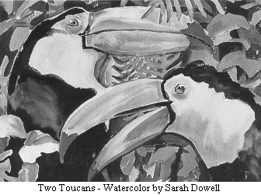
I had the pleasure of joining Helena and her family for dinner one night toward the end of my time in Monteverde. I was impressed by the simplicity of their dwelling. I have lately been trying to live my life by the phrase, "Live simply so that others may simply live." And yet what I think of as living simply would seem very extravagant when compared to their lifestyle. In Tin Box #1, their name for their modest two-room house, they used a wood burning stove, had an out house, and bathed by heating the water up on the stove and then taking it outside in order to bathe. I know that all these things make life less comfortable, and yet I would accept the extra work to live on the farm that surrounds their house, with the magical woods and the fog that rolls in on top of the view of the gulf and mountains. I long to live a more simple life in order to preserve nature, which I love and feel so much more connected to than to my washing machine or my toilet. All these comforts we in America have come to see as necessities.
After dinner, I got the rare pleasure of seeing the artwork she had stashed away on the side of her couch. There was an incredible piece portraying the forest with an interesting composition, perspective and light which filtered ever so magically through the canopy. She worked on this piece through out the course of three dry seasons. Although she usually can finish a painting within the course of a few days, neither she nor her mother is what you would call a rapid painter, yet their work is free with its movement, life and emotion. Helena captures the feeling of the light and the forest, or mountains better than any artist I've ever encountered! She told me that what looks very fast and free is often very carefully placed, sometimes worked over and over till the hue and the shapes are just right. Helena hopes that her work will help people notice what their eyes are seeing all the time. One of my favorite parts of Helena's work is that she often uses the color purple in her shadows, which give them power, color, emotion and depth. Just like her wise words that apply to art but also to life, "It is only through the contrast of the shadows that we can recognize the brightest light."
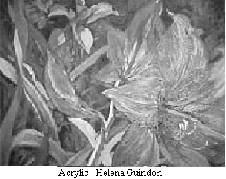
During my time in Monteverde, I concentrated on watercolor painting. It was a new medium for me and I felt very frustrated at first. When I walked into Bromelias gallery and saw the bold, expressive work of Sarah Dowell, I felt an art angel had arrived. I stayed in the gallery for hours going through the stacks of her work and trying to understand how she achieves all the different effects with her watercolors. Unfortunately, for the past four years Sarah had been living in Puerto Viejo and so I never got to meet her in person. She was very kind and responsive to my emails and we were able to talk on the phone about her work.
She came to Monteverde in 1971 and began painting three years later. She said that she always felt like she learned better out of school and never attended any art classes. Now and then she would reproduce the artwork of famous artists to aid in developing her skills. For a while, the only things for tourists visiting Monteverde to do was go to the Cloud Forest Reserve and come to her gallery, so business was really good and selling paintings was relatively easy. She started out painting with watercolors, tried oils and acrylics, but found that watercolors were her favorite medium. For years she shunned using photos and worked exclusively from life and models. Today, she uses photos as references as well as her years of life drawing experience, but she always rearranges and/or combines the photos. She usually spends over an hour drawing with pencil before she begins to paint. She paints quickly and likes to finish a painting in a 3-5 hour sitting.
Sarah's art helped me realize that even watercolor paintings can be fast, free and expressive. I doubt I would've stuck with the stiff-seeming medium if it were not for the inspiration of her artwork. She advised me to not wait for the inspiration to come, but to make art part of my life just like eating and sleeping: "Good art is 1% inspiration and 99% perspiration."
During my first week in Monteverde I saw a striking, impressive mural of a jungle scene and wrote down the artist's name, "Patricia Jimenez." Months later a friend informed me that Patricia Jimenez was speaking at a sustainable development conference. I listened in and was amazed that this incredible artist also knew so much about the ecological and social history of the area. I expressed to her my interest in her art and her other community and ecology work. She generously made time to meet with me.
She had been doing art since she was a little girl in school. Her great grandmother was an oil painter and she received a lot of encouragement from both her and her grandmother who was an art teacher. She first came to Monteverde in 1978 and sold used clothes. A few years later, around the time the reserve opened, she along with 7 other women started a women's co-operative sewing club, C.A.S.E.M., in order to give women a way to make a little money and still be able to stay at home with their family. This also fulfilled the need for souvenirs as tourism in the area grew. Some local nuns were painting on fabric and the C.A.S.E.M. women found that it was a lot quicker than sewing. With the help of the nuns, they shifted their focus, giving the other women classes on the techniques of painting on fabric. The group continued to grow by about 20 new members a year until 1990 when their membership reached 100 and they felt that any further growth would exceed the demand. In 1988, Patricia competed against a man to become the first woman president of C.A.S.E.M. and has been the president for the past three years. She helped get all their policies in order, but is now shifting her focus to environmental issues.
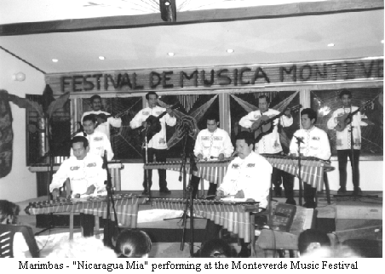
Her fabric paintings are very time consuming. She spends three to four days drafting the design on butter paper, then transfers it to the fabric and spends at least another 20 hours on the painting itself. Her art is based on nature and some pieces also tell stories of women's heritage, lives and struggles. She wants people to see how important it is that we find the balance between our lives and nature. I could've talked to Patricia for hours about her journey and realizations as an artist, but her life is dedicated to helping others and the community and she had to rush off to a meeting about the community's gray water problems. Talking to Patricia made me feel hopeful for the future of our earth. When there are people like her who work so hard for what they believe in, it inspires me to do the same in my community. Hopefully all over the world there are people like her who care about humanity and preserving nature. Each of us, in our own way, can use our strengths to get us closer to a world where humans and nature live in harmony.
Monteverde is an area full of incredible artists and my only regret is that I didn't have time to talk to more of them. My deepest thanks go out to each of the artists who so generously shared their insight, wisdom and lives with me. What I have learned from each of you I will carry with me for the rest of my life.
++++++++++++++++++++++++++++++++++++++++

The Music Festival Years
- by Sue Trostle

The Music Festival began as a collaboration between Margaret Adelman and Gloria Waissbluth Lelchuk back in 1992. Gloria engaged excellent professional musicians from Costa Rica and from abroad. Margaret owned the Villa, located at the top of a steep road, where there was an outside patio, perfect for sunset-viewing. She had bleachers built around the room facing a fireplace and stage area, large enough for her piano and for other ensembles. Thus was created an attractive and intimate setting for the series of 70 concerts of classical music, from December until April, 1993. At intermission time, the audience would watch the sunset, then return to a candle-lit environment for the second half of the concert. It was magical!
Transportation was available without cost; community residents made a suggested contribution; tourists paid to attend, and were entranced to find outstanding professional performances “up here on top of a mountain”, as one visitor expressed it. The musicians were fed and housed in the Villa. The whole community helped to entertain them during their 5-day stay.
Running a Festival was such a huge job that the next year there was none! However, Paul Smith with his sister Margaret’s help, was persuaded to manage a Music Festival in 1995, which was held at the Fonda Vela Hotel. Profits from this year were used to buy rhythm instruments for the private schools. The Festival was continued another year at the Fonda Vela, under Paul and Margaret’s direction, and there was sufficient money to pay for music teachers in two private schools. Musicians were housed and fed in a rented place, with frequent cooperation from community members by providing invitations for meals. Similar arrangements prevailed for 1996.
In addition to giving concerts, many musicians visited school classes, gave master classes, played soccer with students, and developed friendships throughout the community.
In 1997, Lindi Guindon and Lisette Barrantes managed the Festival, and it was held at the Orchideas (on the edge of Sta. Elena). The location was not satisfactory, and there were no monetary profits, despite some excellent concerts.
In 1998 and ’99, Patricia Maynard accepted the responsibility of managing the Festival, held successfully at the Monteverde Institute. The variety of concerts included classical, jazz, folk, and popular groups of singers and instrumentalists. During this period, thanks to a generous donation from the Valverde family, and profits from the Festival, the committee was able to buy a second-hand baby grand piano. Additional funds enabled music programs in the private schools.
At the close of 1998, the Monteverde Institute undertook the creation of a new Music Committee, to coordinate and manage a community-wide, year-around, music program, as well as the Music Festival.
In 2000, the Music Festival was held Thursday, Friday and Saturday of each week at the Institute’s auditorium. Room and board was subsidized almost in full by local establishments. The Music Program paid for transportation between San Jose and Monteverde, as well as for local transport. Most of the performers played free of charge as in any “benefit concert”. Other performers played at a reduced rate. Music ranged from popular music to more classical music and opera singing. The Festival culminated in an outpouring of local musicians who came together, and brought out the best in Monteverde.
The 2001 Festival, which lasted 13 weeks, was carried out in similar fashion with the musicians giving “benefit concerts”. Over 21 restaurants, hotels, and other local businesses supported the festival by donating room and board, activities, and entertainment. Schools sold refreshments and proceeds went directly to their programs.
There have been many additional benefits to the community. Profits from recent years have enabled the Music Committee to subsidize classes for students of violin and piano. When a guitar course was offered last year, 30 people of all ages signed up. Many students have appeared during the Festival concerts, playing alone or with the professional musicians. What a treat for everyone!
The Committee has purchased teaching materials, such as books, music, cassettes, instruments, and games, to be used by the music teachers in area schools. These materials have been catalogued in the Institute’s Campbell Library, and music teachers are welcome to borrow them.
To run the Music Festival and to develop a music program for the community is a huge undertaking, as the staff of the Institute, everyone who has served on the committee, or helped as a volunteer, is well aware. Gloria and Bernardo Lelchuk, Alan Masters, Alberto Guindon, Marino Serra, and Gina Russo, MVI staff member, have constituted the Music Committee in 2001. The concerts and special events have been outstanding. We owe the Institute, the music committee, the musicians, the volunteers, and all the local businesses who have given support to the Festival, a tremendous “thank you”. We will always be grateful, not only for the pleasure and privilege of attending these fine concerts for so many years, but also for the development and support of a music program which will benefit the entire zone, presently, and in the future..
++++++++++++++++++++++++++++++++++++++++

Monteverde Music Festival makes comeback
By Sarrel Downer
From Costa Rica Today - September 8, 1994

For music lovers, all roads will lead up into the cloud forest for the first six weeks of 1995 as the Monteverde Music Festival, first staged early last year, gets a new lease on life.
Once again, the hills will be alive with the sound of fine music as more than 50 of Costa Rica's best professional musicians head for the popular mountain resort to present a series of ensemble concerts at the Hotel Fonda Vela from January 2 to February 14.
The festival reappears after a two-year absence thanks to the efforts of longtime Monteverde resident Paul Smith, whose sister, Margaret Adelman, originally came up with the idea and organized the first festival.
"It was a great success," said Smith. "The festival ran for over three months and more than 7,000 people came to the concerts. Everyone agreed that it was a great idea and that it should continue. "But my sister was busy with other projects last year and no one else stepped forward. This year, I decided that I'd better take the reins or another year would go by without a music festival."
Smith and his committee enlisted the support of Jose Castella, first violin with the Costa Rican Symphony, and the festival program. The community gets a cultural shot in the arm as well as the benefit of all those extra visitors coming into the area.
"The musicians from the symphony orchestra enjoy the experience because it offers them the chance to work in small ensembles and a more intimate setting. And audiences have the opportunity to hear some of Costa Rica's finest professional players."
Proceeds from the festival will help Margaret Adelman's efforts to introduce a music education program into the Monteverde area's public and private schools.
Sunset concerts will be held every night from January 2 to February 14 at the Fonda Vela Hotel which sits at the edge of the Monteverde Cloud Forest Preserve and looks down over the Gulf of Nicoya.
There is something for everybody in the program which ranges from original Latin American compositions to the classics.
From January 2 to 5 the Quinteto Castillo, comprising violins, viola, cello and clarinet will be playing Mozart, Scott Joplin, Piazzola and Latin and Costa Rican music. From January 6 to 9, Quinteto Miravalles.(oboe, clarinet, flute, bassoon, horn) will perform works by Rosetti and Aldona Vinicio Meza.
Trio Ortiz will offer a mix of classical, jazz and Latin American music on guitar, drums and.double bass from January 10 to 13. Saxophone lovers should make a note in their diaries for January 14 to 17 when the Cuarteto de Saxofon will be performing jazz and classics. Original Latin American music is the Editus speciality and they will be at it from January 18 to 21.
El Quinteto Clasico will perform the big hits of Vivaldi, Mozart, Haydn, Bach, Beethoven and Tchaikovsky from January 22 to 25. Works by Mozart, Vivaldi, Corelli, Elgar and Costa Rican composers will be performed on the six violins, two violas, two cellos, double bass and harpsichord of Camerata Latinoamericana from January 26 to 29.
Costa Rica Today will be in the front row for the performances by Costa Rican Woodwinds (oboe, flute, horns, clarinets, bassoon) from January 30 to February 2. Their repertoire includes pieces by Debussy, Bizet, Strauss and Offenbach. The Costa Rican Brass Quintet (tuba, trombone, horn and trumpets) takes the stage next (January 3 to 6) with music from the renaissance to the present day, including jazz and ragtime.
Singers are accompanied by violins and cello in the Probus Ensemble’s performances of original works …
++++++++++++++++++++++++++++++++++++++++

En el bosque llueve música
January 8, 1999
Por sexto año consecutivo, el Festival de Música de Monteverde ofrecerá 50 conciertos para satisfacer todos los gustos musicales
Doriam Díaz
Redactora de La Nación
A las 5 p. m., cuando el atardecer se empieza a apoderar del ambiente, las chicharras chillan más duro y las ranas le croan una triste tonada a la noche, la música impone su melodía en el bosque nuboso de Monteverde.
Jazz, new age, música latina, afrocaribeña, folclórica y clásica son algunos de los ritmos que se alternan todos los días en el auditorio del Instituto Monteverde, como parte de la sexta edición del Festival de Música de Monteverde.
Allí, en esa comunidad fundada por cuáqueros de Iowa y Alabama (Estados Unidos) en 1952, agrupaciones y solistas nacionales y extranjeros ofrecerán 50 conciertos en un festival que, año con año, atrae a más invitados y adquiere más prestigio.
Los conciertos de la actividad, que empezaron el pasado sábado 2, se realizan todos los días, a las 5 p. m., hasta el 20 de febrero, según dijo Patricia Mynard (organizadora).
Trombones de Costa Rica, Manuel Obregón, Son Sax, Cantares, Cantoamérica, Acustic Ensamble, Zamira Barquero, Éditus y Luis Ángel Castro serán algunos de los 18 solistas y agrupaciones que participarán en este festival.
El auditorio donde se efectuarán los recitales está ubicado contiguo a la fábrica de queso Monteverde. La entrada a la actividad cuesta $12 (¢3.252) para extranjeros y $6 (¢1.626) para estudiantes y turistas nacionales.
En esta edición, dos grupos extranjeros visitarán el país. Uno es el Peterson Ensamble, un grupo de música clásica que utiliza el violín, la trompeta, cello y el piano, y el otro es el Coro de la Escuela Mount Holyoke, un conjunto compuesto de 40 jóvenes.
Además, Trombonilla ofrecerá un concierto llamado "Jazz de las Américas" para cerrar el festival. Trombonilla es Luis Bonilla, un trombonista costarricense que radica en Estados Unidos y ha tocado con el reconocido cantante Rubén Blades.

Tradición musical
El Festival de Música de Monteverde surgió del interés de Paul Smith y Margaret Adelman (estadounidenses) en la música clásica. Estos extranjeros contrataban cellos y violas de las Orquesta Sinfónica Nacional (OSN) para que dieran conciertos clásicos en una casa.
Después, la serie de conciertos creció y esta actividad formó parte del Programa de Música del Instituto de Monteverde. Actualmente, este festival financia la compra de instrumentos de ese programa, nacido de la comunidad, y ayuda a pagar los sueldos de los profesores provenientes de la Universidad de Costa Rica y de la OSN.
Con los fondos que se recaudaron el año pasado, el Programa de Música compró un piano de cola y pagó la planilla de profesores.
En esta sexta edición se presentará un compacto con piezas de los conjuntos y solistas participantes, al igual que el año pasado. Este disco saldrá a la venta en Monteverde el 17 de enero.
Para llegar a Monteverde se sigue por la carretera Interamericana, al norte de San José, y antes de cruzar el puente sobre el río Lagarto se vira hacia la derecha. La ruta, a partir de ahí, es de 43 kilómetros.
++++++++++++++++++++++++++++++++++++++++

Gloria no está aquí, anda en...
Gloria Waissbluth ahora vive en Monteverde, en medio del bosque húmedo, pero no ha dejado de hacer lo de siempre: enseñar música
Gina Polini
gpolini@nacion.co.cr
Hace 25 años abrazó ese sueño y hace poco menos de dos años lo hizo realidad.
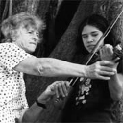
Gloria Waissbluth dejó la dirección de la Orquesta Sinfónica Nacional que había ocupado casi por ocho años, en un final rodeado de polémica. Pero, ahora cree que eso fue algo que Dios puso en su camino para empujarla a cuajar su gran sueño.
Ya todo aquello es parte del pasado. Gloria tomó sus maletas y tiliches más queridos y se fue con su esposo, Bernardo Lelchuk, a vivir a Monteverde.
Allá está hace ya casi dos años y su vida ha cambiado de forma radical, pero lo que no ha abandonado es aquello que ha sido su vocación desde que era una joven estudiante: dar clases de violín.
Allá tiene dos alumnos, niños a quienes les hace sacar dulces y hermosas notas de su instrumento, que se mezclan con los sonidos del bosque.
Además gasta mucho de su tiempo en otras tareas ligadas al mundo de la música –que al fin y al cabo es su mundo– y en labores de apoyo a la comunidad.
Viven ellos solos en una acogedora casa rodeada de infinidad de verdes. Entre los dos se reparten las tareas hogareñas.
Lo único que realmente extrañan de San José son sus hijos y ante todo sus nietos. Pero aseguran que cuando se están muriendo de ganas de verlos se montan en el carro y se trasladan a la capital.
Aparte de eso tienen Internet y teléfono lo que les permite estar en contacto directo y permanente, con ellos y con sus amigos.
Además allá en su casa casi nunca faltan las visitas por que ellos han sabido abrirla de par en par a la gente que aprecian.
Es posible que ahora Gloria tenga unas cuantas canas más que antes de marcharse y quizá también más arrugas en su rostro, pero...su espíritu está radiante y la paz se le escapa por los poros.
Nació en Chile y desde siempre se inclinó por el violín. A los 17 años su maestro la puso a darle clases a varios niños y hace 26 años se vino para Costa Rica con su marido y sus tres hijos, precisamente para integrarse a la Orquesta Sinfónica Nacional.
Fue profesora fundadora de la Orquesta Sinfónica Juvenil y gran parte de los violinistas activos aprendieron bajo su tutela.
–¿Por qué está Gloria en Monteverde?
– Hace 25 años vivimos por primera vez y desde ese momento abrazamos el sueño de venir a retirarnos aquí. Necesitábamos antes casar a los hijos y acomodar la finanzas.
"Mi salida de la dirección de la Sinfónica a mediados del 98 se unió al hecho de que las condiciones familiares que necesitábamos se habían cumplido y entonces nos vinimos".
–¿Costó adaptarse?
– Durante esos 25 años que lo estuvimos planeando visitamos Monteverde con muchísima frecuencia y casi inmediatamente de que salí de la Orquesta, Bernardo y yo nos vinimos a vivir aquí por cuatro meses para probar si era eso lo que queríamos. Hasta después de esta prueba tomamos la decisión final y aquí estamos.
"Pero no vinimos a un lugar de personas desconocidas. Desde hace ocho años cuando se inició el Festival de Música de Monteverde mi esposo y yo estamos muy ligados a esta actividad y a la gente de acá.
"Ahora esta es nuestra comunidad, nuestro hogar y nuestro lugar de trabajo".
–Ha sido un cambio grande...
–Sí muy grande, pero yo no he cambiado mi oficio solo que allá trataba de producir el mayor número de músicos dentro de la música clásica. Aquí, en este medio rural, las necesidades son otras y yo preparo músicos para que toquen desde música clásica, hasta country y música costarricense.
–¿Cómo concibe usted la enseñanza de la música a niños?
–Siempre he pensado que el objetivo de la música debe ser contribuir a la formación de los niños y no ser un recurso para poner virtuosos en el mercado. Me siento muy satisfecha de poder enseñar a tantos y tantos niños y de saber que he contribuído a su desarrollo como seres humanos.
"Por supuesto que los que triunfan y han pasado por mis manos me han dado también una satisfacción. Pero, nunca he tenido como meta crear niños fenómenos, sino más bien crear un espacio donde niños y jóvenes sientan que están dotados de algo que les causa placer, les da valor frente a sus semejantes y les genera la admiración de los mayores, los mismos que con frecuencia les hacemos creer que tienen más defectos que virtudes."
–¿Qué hace ahora en ese campo?
–Tengo dos alumnos de violín y pertenezco al Comité del Instituto de Música de Monteverde que lleva adelante el Festival de Música y maneja un programa de música que tiene 30 estudiantes de guitarra y estamos por empezar con percusión. Trabajo también con un coro comunitario.
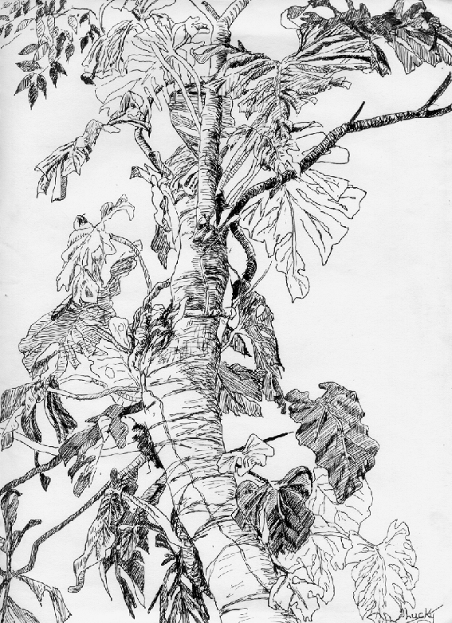
"Además, estoy dedicando mucho tiempo a crear un programa de educación musical con el que busco acercarme lo más posible a la forma en que los niños están expuestos a los medios audiovisuales para hacerlo parecido y que los niños entonces tengan interés de aprender.
–¿Qué le hace falta de la ciudad?
–Solo los nietos.
++++++++++++++++++++++++++++++++++++++++

