Gerald Massey 1828-1907
http://en.wikipedia.org/wiki/Gerald_Massey
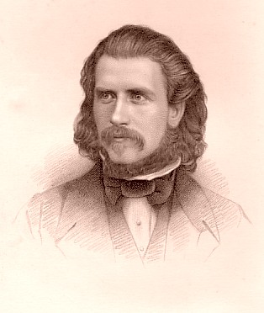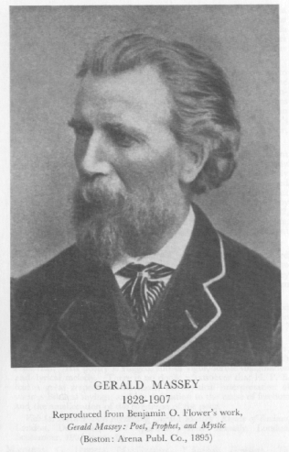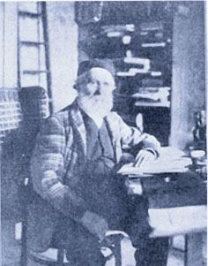

Gerald Massey (May 29, 1828 - October 29, 1907), English Egyptologist and poet, was born near Tring, Hertfordshire.
His parents were in humble circumstances, and Massey was little more than a child when he was set to hard work in a silk factory, which he afterwards deserted for the equally laborious occupation of strawplaiting. These early years were rendered gloomy by much distress and deprivation, against which the young man strove with increasing spirit and virility, educating himself in his spare time, and gradually cultivating his innate taste for literary work.
He was attracted by the movement known as Christian Socialism, into which he threw himself with whole-hearted vigour, and so became associated with Maurice and Kingsley. His first public appearance as a writer was in connection with a journal called the Spirit of Freedom, of which he became editor, and he was only twenty-two when he published his first volume of poems, Voices of Freedom and Lyrics of Love. These he followed in rapid succession by The Ballad of Babe Christabel (1854), War Waits (1855), Havelock's March (1860), and A Tale of Eternity (1869).
Many years afterwards in 1889, he collected the best of the contents of these volumes, with additions, into a two-volume edition of his poems called My Lyrical Life. He also published works dealing with spiritualism, the study of Shakespeare's sonnets (1872 and 1890), and theological speculation. It is generally understood that he was the original of George Eliot's Felix Holt.
Massey's poetry has a certain rough and vigorous element of sincerity and strength which easily accounts for its popularity at the time of its production. He treated the theme of Sir Richard Grenville before Tennyson thought of using it, with much force and vitality. Indeed, Tennyson's own praise of Massey's work is still its best eulogy, for the Laureate found in him a poet of fine lyrical impulse, and of a rich half-Oriental imagination.
The inspiration of his poetry is essentially British; he was a patriot to the core. It is, however, as an Egyptologist that Gerald Massey is best known in the world of letters. He first published The Book of the Beginnings, followed by The Natural Genesis; but by far his most important work is Ancient Egypt: The Light of the World, published shortly before his death.
See an article by John Churton Collins in the Contemporary Review (May 1904).

References
- This article incorporates text from the Encyclopædia Britannica Eleventh Edition, a publication now in the public domain.
Retrieved from "http://en.wikipedia.org/wiki/Gerald_Massey"
Categories: Wikipedia articles incorporating text from the 1911 Encyclopædia Britannica |
===================================================================================================================================
END

