Austin Osman Spare 1886-1956
http://en.wikipedia.org/wiki/Austin_Osman_Spare
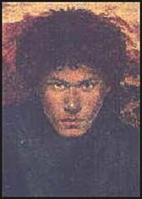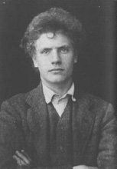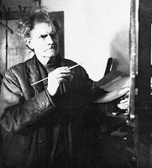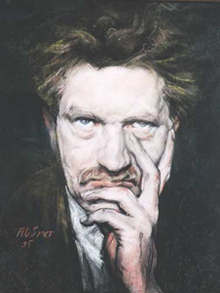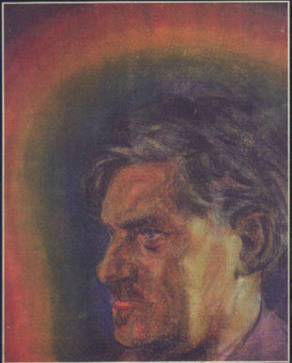
Austin Osman Spare
--------------------------------------------------------------------------------------------------------------------------------------------------------------------------------------------------------------------------------------------
Austin Osman Spare (December 30, 1886 - May 15, 1956) was an English artist and magician.

Contents
- 1 History
- 2 Publications
- 3 Quotes
- 4 See also
- 5 External links

History
He was the son of a London policeman. As a child, he showed an affinity for art, and he briefly attended evening classes at Lambeth Art School. At the age of 13, he left school to become an apprentice to a stained glass maker, Powell's of Whitefriars Street. During his teen years, his fascination for the occult grew apace, heavily influencing the work he produced. In May 1904 one of his drawings was exhibited at the annual Royal Academy exhibition in London, generating a storm of publicity for the young artist.
In October 1907 Spare exhibited his drawings at the Bruton Gallery in London. Critics likened his work to that of Aubrey Beardsley, but Spare's images were full of grotesque, sexualized human figures and magical symbols. These elements appealed to avant-garde London intellectuals, and brought him to the attention of Aleister Crowley. He became a Probationer of Crowley's order Argenteum Astrum ("Of the Silver Star") in July 1909, but was not initiated as a member, although he contributed four small drawings to Crowley's publication The Equinox. Crowley later characterized Spare as a "Black Brother", meaning that he did not approve of the goals of Spare's magical philosophy. His magical motto was Yihoveaum^{[1]}.
His iconoclasm, distate for the props and symbolism of ceremonial magic and his aversion to moralism as well as his innovative use of sigilization served to distinguish his personal style of magic which his friend and associate Kenneth Grant called Zos Kia Cultus. Spare would later say that he learned much from a Mrs. Paterson, an elderly descendant of witches from Salem Village. His work text The Focus of Life includes a pencil drawing of her. He also spoke of and drew portraits of a spirit guide named Black Eagle who often appeared in the form of an Amerindian man.
In 1917, during World War I, Spare was conscripted into the British army, serving as a medical orderly of the Royal Army Medical Corps in London hospitals. He did not see active service, and was commissioned as an official War Artist in 1919. He visited the battlefields of France to record the work of the RAMC. Several of his works presently hang in the Imperial War Museum.
Although regarded as an artist of considerable talent and good prospects, Spare lived a rather secluded life from the mid 1920s onwards, falling out of step with changing trends and influences in the broader art scene. He sold his unique work for low prices at irregular exhibitions held in his home studio and in South London pubs. Spare expressed contempt at the idea of selling his works at higher prices - an option he could easily have had available to him. He worked very quickly and often finished drawings in minutes.
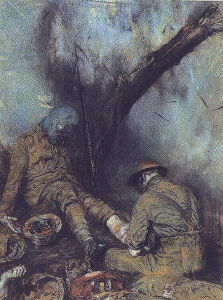
"Dressing the Wounded During a Gas Attack", one of Spare's images done while serving as a war artist.

Publications
Spare published several books privately during his life time: [[Earth Inferno] (February 1905), A Book of Satyrs (1907, reissued by John Lane 1909), The Book of Pleasure (Autumn 1913), and Anathema of Zos (1927). The Focus of Life (1921) was issued by the Morland Press. Manuscripts for Logomachy of Zos and the Zoetic Grimoire of Zos remained uncompleted at the time of Spare's death. Posthumously, the Zoetic Grimoire was published in Zos Speaks!, a part memoir (by Grant), part collection of correspondence and part anthology of art and writing by Spare edited by Steffi and Kenneth Grant and published by Fulgur Press in 1998.

Quotes
- "At no time in my life have I been a person to hold myself polluted by the touch, habits or approach of any creature other than those who were human shape." Austin Osman Spare, c.1945

See also
- Chaos magic

External links
- Fulgur Limited: Publishers of Austin Osman Spare
- An introductory essay by Kenneth Grant
- Spare's illustrations for The Starlit Mire by James Bertram and F. Russell
===================================================================================================================================
END

