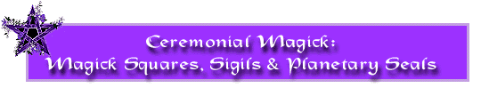

by Triplemoon and Michael Pendragon

http://www.triplemoon.com/sigils.html

These pages detail an ancient form of magick that have been updated for modern practitioners. It incorporates the use of magick squares and sigils for a more focused intent in spellwork. Magick squares are used to draw in the influences of their corresponding planet. Bear in mind that with any work of magick the inclusion of universal forces should be in harmony with your intent.
Magick Squares
Each Magick Square represents a matrix of planetary energy. Magick squares are based on the original work done by ancient mathematicians in their description of numbers. Magickal practitioners expanded on this to carry over the correlation between a number and its corresponding planet, therefore representing planetary energy in a mathematical format.
Each magick square is made up using three key numbers. The first is the planetary number itself. The second is the square of the planetary number (or the planetary number multiplied by itself). The third is the sum of the square (or all the incremental numbers starting at 1 that it takes to fill the boxes in the square added together and then divided by the planetarty number).
Obviously the best way to understand this concept is by example so for the purposes of illustration we'll use the planet saturn.
- Saturn is represented by the number 3.
- We start drawing our magick square with 3 boxes horizontally and vertically for a total of 9 squares (the square of 3 being 9).
- The sum of the square in this case are 1+2+3+4+5+6+7+8+9. This equals 45. 45 divided by saturn's planetary number of 3 equals 15.
- Each row of numbers in our magick square both horizontally and vertically need to equal 15 (which is the sum of the square of the planetary number of 3).
Arent you glad the ancient mathematicians did all the hard work for you!!!
When drawing the magick square all of the numbers should be placed in the square in sequence beginning with then number 1. Below is the magick square representing saturn. Notice, as mentioned above, that our square is 3 by 3 and that all the rows equal 15.
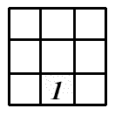

Sigils
A sigil is a signature, if you will. It can be seen a symbol of our intent. Sigils incorporated with other influences can add great direction and focus to spellwork. Sigils can be traced in air, carved on candles, drawn on paper and burned etc. Sigils can be drawn and formed using the magick squares that have been described above. We'll continue with the Saturn example started above.
Saturn is the planet that rules institutions such as banks, real estate transactions, investments, educational institutions etc. Lets say our intent was for successful investing. We want a sigil to represent ourselves at being successful in our investment endeavors. So we pick the word investor which will be our sigil, the visualization of self as a smart investor, surrounded by favorable aspects and clear choices to make our money grow.
Now...how do you determine how to draw your sigil. Using the Western system of numerology, each letter has a numerical equivilant that is detailed in the chart below.
1 | 2 | 3 | 4 | 5 | 6 | 7 | 8 | 9
A | B | C | D | E | F | G | H | I
J | K | L | M | N | O | P | Q | R
S | T | U | V | W | X | Y | Z
Referring back to our work with Saturn for a favorable investment strategy, select a word of phrase that you want drawn into a sigil. We take our key word of investor and map it to the chart shown above.
I | N | V | E | S | T | O | R
9 | 5 | 4 | 5 | 1 | 2 | 6 | 9

Then by starting with our first corresponding number and continuing through each in order, we draw out our sigil.
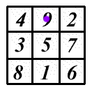
So we're left with the following sigil representing our intention of investor
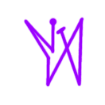
Using some of the other correspondences for Saturn, we could carve this sigil into a black candle annointed with bergamont or cypress. We can also surround the candle with onyx and place it on top of the world card from a tarot deck. As we light the candle and focus our intent, not only have, we drawn in many aspects of saturn with crystals, oils and tarot, and we've personalized our intent with our sigil.
Planetary Seals
Just as each magick square brings in planetary energy, each planet has a sigil or seal that is designed to block that planet's energy. Imagine the magick square as the accelerator and the planetary seal as the brakes. Blocking a planet's energy can be useful in times of retrograde, or when your desired intent is to block the negative effects of a planet. Lets look at Mercury for this example. Many people are effected dramatically when mercury goes retrograde. One of the most common things most often adversely impacted Mercury retrograde is communication. If for example you had a meeting that was important to your career during a Mercury retrograde, you could block the mercury energy by placing the planetary seal over the magick square of Mercury, thus eliminating the effects of Mercury retrograde for you. Bear in mind that when you block a planet you are blocking ALL of the effects of a planet, so this could work against you. Although sometimes blocking a planet temporarily may be appropriate usually a sigil designed to filter the negative effect may be a better way to handle a situation.

The Sun
Magick Square | Planetary Seal
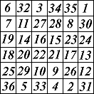 | 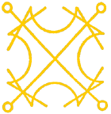

Correspondences
Rules | Health, Vitality, Ego, Heart, Creativity, Superiors, Power, Success, Advancement, Leadership, Friendship, Growth, Light
Detriment | Pride, Arrogance, Bigotry
Element | Fire
Day of the Week | Sunday
Astrological Sign | Leo
Color | Gold, Yellow
Metal | Gold
Crystals | Tiger's Eye, Citrine, Topaz, Carnelian, Amber, Orange Calcite
Herbs & Oils | Frankincense, Clove, Chamomile, Bay, Angelica, Cinnamon, Eyebright, Galangal, Juniper, Life Everlasting, Mistletoe, Rosemary, St. John's Wort. Marigold, Heliotrop, Cedar
Tarot | The Sun
Musical tone | C sharp

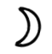The Moon
Magick Square | Planetary Seal
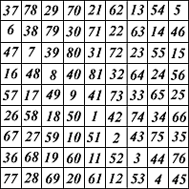 | 

Correspondences
Rules | Clairvoyance, Sleep, Psychic dreams, Reveals Secrets, emotions, Influence over general public, Astral travel, Imagination, Women's mysteries, Birth, Fertility Reincarnation
Detriment | Delusion
Element | Water
Day of the Week | Monday
Astrological Sign | Cancer
Color | Silver, White, Light Purple
Metal | Silver
Crystals | Moonstone, Pearl, Abalone, Aquamarine
Herbs & Oils | Jasmine, Lotus, Camphor, Frangipani, Orris root, Motherwort, Birch, Vervain, White Rose, Ginseng, Sandalwood, Wintergreen, Anise, Seasalt, Star Anise
Tarot | High Priestess
Musical tone | G sharp

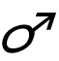Mars
Magick Square | Planetary Seal
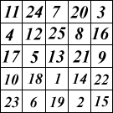 | 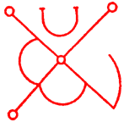

Correspondences
Rules | Male Sexuality, Strength, Lust, Anger, Destruction, Medical Issues, Surgery, Competition, Conflict, Sports
Detriment | Violence, Anger
Element | Fire
Day of the Week | Tuesday
Astrological Sign | Aries, Scorpio
Color | Red
Metal | Iron, Steel
Crystals | Ruby, Garnet, Bloodstone
Herbs & Oils | Pine, Wormwood, Tobacco, Heal All, Ginger, Blessed Thistle, Cayenne, Garlic, Pepper
Tarot | The Tower
Musical tone | D

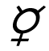Mercury
Magick Square | Planetary Seal
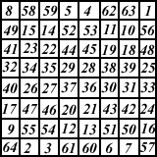 | 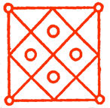

Correspondences
Rules | Communication, Intellect, Business, Writing, Contracts, Buying and selling, Information of all kinds, Wisdom, Cleverness, Creativity, Science, Memory
Detriment | Dishonesty, Deception
Element | Air
Day of the Week | Wednesday
Astrological Sign | Virgo, Gemini
Color | Orange, The Whole Rainbow
Metal | Mercury
Crystals | Opal, Moss Agate, Aventurine, Sodalite, Flourite
Herbs & Oils | Rosemary, Amber, Lilac, Lemon Peel, Agrimony, Anise, Betony, Dandelion, Hyssop, Juniper Berries, Mistletoe, Nutmeg, Sage, Lavender, Cherry, Periwinkle
Tarot | The Magician
Musical tone | D

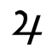Jupiter
Magick Square | Planetary Seal
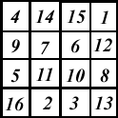 | 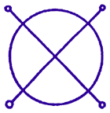

Correspondences
Rules | Success, Abundance, Money, Growth, Parties, Visions, Gambling
Detriment | Greed, Wastefullness
Element | Water, Fire
Day of the Week | Thursday
Astrological Sign | Sagittarius
Color | Blue, Purple
Metal | Tin
Crystals | Lapis Lazuli, Amethyst, Turquoise, Sugilite, Saphire, Sodalite, Azurite
Herbs & Oils | Aloe, Nutmeg, Sage, Melissa, Cedar, Cinamon, Agrimony, Anise, Betony, Dandelion, Hyssop, Juniper Berries, Linden, Mint, Mistletoe
Tarot | The Wheel of Fortune
Musical tone | F sharp

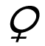Venus
Magick Square | Planetary Seal
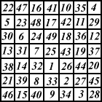 | 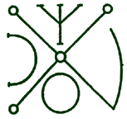

Correspondences
Rules | Love, Pleasure, Female Sexuality, The Arts, Music, Beauty, Luxury, Scent, Social Affairs
Detriment | Lechery, Coldness, Isolation
Element | Earth, Water
Day of the Week | Friday
Astrological Sign | Taurus, Libra
Color | Green, Indigo, Rose
Metal | Copper
Crystals | Emerald, Rose Quartz (venus rules the acquisition of all gems)
Herbs & Oils | Rose, Sandalwood, Ylang Ylang, Vanilla, Cardamon, Benzoin, Bergamot, Boneset, Catnip, Dittany, Gardenia, Heather, Hibiscus, Kava-Kava, Motherwort, Rose- Geranium, Yarrow, Almond Oil, Aloes, Apple, Birch, Elderberry, Feverfew, Geranium, Mint, Mugwort, Pennyroyal, Plantain, Raspberry, Strawberry, Tansy, Verbena, Vervain, Violet, Dragons Blood, Basil, Damiana, Passion Flower
Tarot | The Empress
Musical tone | A

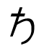Saturn
Magick Square | Planetary Seal
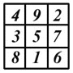 | 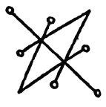

Correspondences
Rules | Gaining the Astral Plane, Real Estate, Banks, Debts, Institutions, Obstacles, Limitations, Binding, Knowledge, Death, Buildings, Time, Structures, Discipline
Detriment | Oppression, Pain
Element | Earth
Day of the Week | Saturday
Astrological Sign | Capricorn
Color | Black, Grey, Blue
Metal | Lead
Crystals | Onyx, Black Tourmaline, Apache Tears, Obsidian
Herbs & Oils | Mandrake, Patchouli, Thyme, Comfrey, Cypress, Hemlock, Moss, Mullein, Musk, Scullcap, Witch Hazel
Tarot | The World
Musical tone | D

END

