Dion Fortune 1890 - 1946

http://en.wikipedia.org/wiki/Dion_Fortune

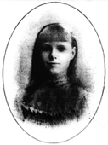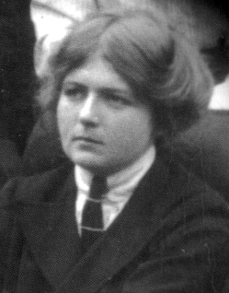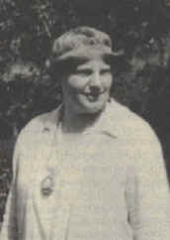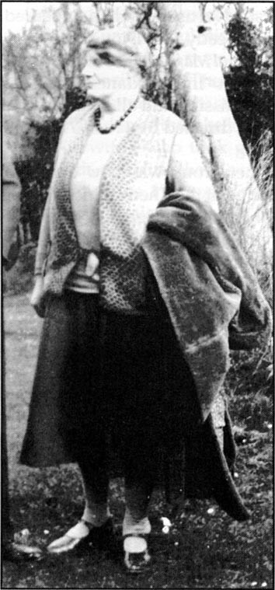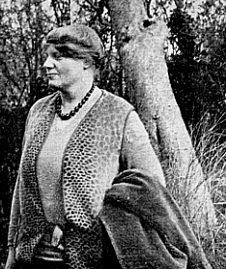

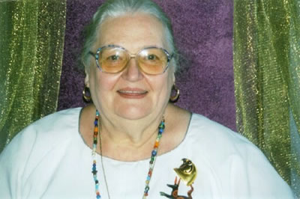

Violet Mary Firth Evans, born Violet Mary Firth (December 6, 1890^{[1]} - 1946) and better known as Dion Fortune, was a British occultist and author^{[2]}. Her pseudonym was inspired by her family motto "Deo, non fortuna" (Latin for "God, not fate")^{[3]}.

Contents
- 1 Early life
- 2 Writing
- 3 Later magical career
- 4 Quotes
- 5 References
- 6 External links

Early life
She was born at Bryn-y-Bia in Llandudno, Wales, and grew up in a household where Christian Science was rigorously practiced^{[4]}. She reported visions of Atlantis at age four^{[5]} and the developing of psychic abilities during her twentieth year^{[6]}, at which time she suffered a nervous breakdown; after her recovery she found herself drawn to the occult^{[4]}. She joined the Theosophical Society^{[4]} and attended courses in psychology and psychoanalysis at the University of London^{[7]}, and became a lay psychotherapist at the Medico-Psychological Clinic in Brunswick Square^{[8]}.
Her first magical mentor was the Irish occultist and Freemason Theodore Moriarty^{[9]}. In 1919 she was initiated into the London Temple of the Alpha et Omega^{[10]} before transferring to the Stella Matutina order^{[11]}.

Writing
From 1919^{[4]} she began writing a number of novels and short stories that explored various aspects of magic and mysticism, including The Demon Lover, The Winged Bull, The Goat-Foot God, and The Secrets of Dr. Taverner. This latter is a collection of short stories based on her experiences with Theodore Moriarty. Two of her novels, The Sea Priestess and Moon Magic, became influential within the religion of Witchcraft, especially upon Doreen Valiente^{[12]}.
Of her non-fiction works on magical subjects, the best remembered of her books are; The Cosmic Doctrine^{[13]}, meant to be a summation of her basic teachings on mysticism, The Mystical Qabalah^{[14]}, an introduction to Hermetic Qabalah, and Psychic Self Defence^{[15]}, a manual on how to protect oneself from psychic attacks. Though some of her writings may seem dated to contemporary readers, they have the virtue of lucidity^{[16]} and avoid the deliberate obscurity that characterised many of her forerunners and contemporaries^{[17]}.

Later magical career
Fortune fell out with Moina Mathers, head of the Alpha et Omega, and claimed she was coming under magical attack^{[4][18]}. In 1922, with Moina's consent, Dion Fortune left the Alpha et Omega and with her husband, Penry Evans^{[4]} formed the Fraternity of the Inner Light as an offshoot of the Alpha et Omega^{[19][20]}. This brought new members to the Alpha et Omega^{[21]}. Fortune's group was later renamed "The Fraternity of the Inner Light", and was, later still, renamed "The Society of the Inner Light". This society was to be the focus of her work for the rest of her life. Her masterpiece^{[22][23][24]}The Mystical Qabalah was first published in England in 1935, and is regarded by many occultists as one of the best textbooks on magic ever written^{[4]}. She died in 1946 from leukemia.
Dion Fortune met and corresponded with Aleister Crowley, whom she acknowledged in the introduction of The Mystical Qabalah^{[25]}.
Dion Fortune participated in the "Magical Battle of Britain"^{[26]}, which was an attempt by British occultists to magically aid the war effort and which aimed to forestall the impending German invasion during the darkest days of World War II. Her efforts in regard to this are recorded in a series of letters she wrote at the time^{[27]}. The effort involved in this endeavour is said to have contributed to her death shortly after the war ended^{[28]}. Her Society of the Inner Light continues to function, and has also given rise to other orders, including The London Group, until recently headed by Charles Fielding, and Servants of the Light, headed by Dolores Ashcroft-Nowicki^{[4]}.

Quotes
- "The true nature of the gods is that of magical images shaped out of the astral plane by mankind's thought, and influenced by the mind." -- Dion Fortune, The Mystical Qabalah
- "To say that a thing is imaginary is not to dispose of it in the realm of mind, for the imagination, or the image making faculty, is a very important part of our mental functioning. An image formed by the imagination is a reality from the point of view of psychology; it is quite true that it has no physical existence, but are we going to limit reality to that which is material? We shall be far out of our reckoning if we do, for mental images are potent things, and although they do not actually exist on the physical plane, they influence it far more than most people suspect." --Dion Fortune, Spiritualism and Occultism
- "Psychotherapy may begin with the primitive, but it must end with the divine, for both are integral factors in the human mind." -- Violet M. Firth (Dion Fortune), The Machinery of the Mind.
- "Symbols are to the mind what tools are to the hand--an extended application of its powers." --Dion Fortune, The Mystical Qabalah
- "The spirit of religious persecution is not the special failing of any particular faith, but springs eternal in the human breast." --Dion Fortune, quoted in British esotericist and Fortune biographer Gareth Knight's Experience of the Inner Worlds
- "The driving forces of the universe, the framework upon which it is built up in all its parts, belong to another phase of manifestation than our physical plane, having other dimensions than the three to which we are habituated, and perceived by other modes of consciousness than those to which we are accustomed."--Dion Fortune, Psychic Self-Defense
- "We live in the midst of invisible forces whose effects alone we perceive. We move among invisible forms whose actions we very often do not perceive at all, though we may be profoundly affected by them." --Dion Fortune, Psychic Self-Defense
- "All gods are one God, and all goddesses are one Goddess, and there is one Initiator" -- Dion Fortune, Sea Priestess

References
- ^ Ithell Colquhoun gives Fortune's birth year as 1891 in "Sword of Wisdom", Neville Spearman, London, 1975, p. 217. However Colquhoun makes a number of obvious errors in the aforementioned book and so her veracity as a reliable source is questionable. For example she states that Fortune was an orphan and this is clearly not the case.
- ^ Richardson, Alan; "The Magical Life of Dion Fortune", Aquarian Press, 1987, ISBN 1-85538-051-X, p 26.
- ^ Knight, Gareth; "Dion Fortune and the Inner Light", Thoth, 1993, ISBN 1-874505-45-0, p 2.
- ^ ª ^{b} ^{c} ^{d} ^{e} ^{f} ^{g} ^{h} Drury, Nevill (1992). Dictionary of Mysticism and the Esoteric Traditions. Bridport, Dorset: Prism Unity. ISBN 1-85327-075-X.
- ^ Knight, Gareth; "Dion Fortune and the Inner Light", Thoth Publications, 2000, ISBN 1-870450-45-0, pp 14-15.
- ^ Chapman, Janine; "Quest for Dion Fortune", Samuel Weiser, 1993, ISBN 0-87728-775-9, p 3-5.
- ^ Chapman, Janine; "Quest for Dion Fortune", Samuel Weiser, 1993, ISBN 0-87728-775-9, p 5.
- ^ Knight, Gareth; "Dion Fortune and the Inner Light", Thoth Publications, 2000, ISBN 1-870450-45-0, p29 and Richardson, Alan "the Magical Life of Dion Fortune", p 54. N.B. Janine Chapman however in her book ("Quest for Dion Fortune" p 6) says that Fortune worked at the Tavistock clinic, citing Christine Hartley as her source.
- ^ Richardson, Alan; "The Magical Life of Dion Fortune", Aquarian Press, 1991, ch.4. ISBN 1-85538-051-X and Knight, Gareth; "Dion Fortune and the Inner Light", Thoth Publications, 2000, ISBN 1-870450-45-0, ch.5.
- ^ Richardson, Alan; "The Magical Life of Dion Fortune", Aquarian Press, 1991, p111. ISBN 1-85538-051-X and Knight, Gareth; "Dion Fortune and the Inner Light", Thoth Publications, 2000, ISBN 1-870450-45-0, ch.7.
- ^ Richardson, Alan; "The Magical Life of Dion Fortune", Aquarian Press, 1991, p114. ISBN 1-85538-051-X
- ^ Clifton, Chas, s., http://www.sacred-texts.com/bos/bos474.htm
- ^ Richardson, Alan, "The Magical Life of Dion Fortune", Aquarian Press, 1991, p63, ISBN 1-85538-051-X and Fielding, Charles and Collins, Carr; "The Story of Dion Fortune", Thoth Books, 1998, ISBN 1-870450-33-7, p151.
- ^ Fielding, Charles and Collins, Carr; "The Story of Dion Fortune", Thoth Books, 1998, ISBN 1-870450-33-7, p151 and Richardson, Alan, "The Magical Life of Dion Fortune", Aquarian Press, 1991, p137, ISBN 1-85538-051-X
- ^ Charles and Collins, Carr; "The Story of Dion Fortune", Thoth Books, 1998, ISBN 1-870450-33-7, p150,
- ^ Charles and Collins, Carr; "The Story of Dion Fortune", Thoth Books, 1998, ISBN 1-870450-33-7,p150.
- ^ Fortune, Dion; "The Mystical Qabalah", Aquarian Press, 1987, ISBN 0-85030-335-4, p 1. and Fielding, Charles and Collins, Carr; "The Story of Dion Fortune", Thoth Books, 1998, ISBN 1-870450-33-7, p152.
- ^ King, 1989, page 144
- ^ Richardson, Alan, "The Magical Life of Dion Fortune", Aquarian Press, 1991, ISBN 1-85538-051-X, p117,
- ^ Knight, Gareth; "Dion Fortune and the Inner Light", Thoth Publications, 2000, ISBN 1-870450-45-0, pp 138-139.
- ^ King, 1989, page 143
- ^ Richardson, Alan, "The Magical Life of Dion Fortune", Aquarian Press, 1991, ISBN 1-85538-051-X, p137
- ^ Clifton, Chas, s., http://www.sacred-texts.com/bos/bos474.htm
- ^ Regardie, Israel, (ed), "777 and other Qabalistic Writings of Aleister Crowley", intro. (not paginated).
- ^ Chapman, Janine; "Quest for Dion Fortune", Samuel Weiser, 1993, ISBN 0-87728-775-9, pp 149-156.
- ^ Fortune, Dion; "The Magical Battle of Britain", Sun Chalice Books, 1993, ISBN 1-928754-21-X and Fielding, Charles and Collins, Carr; "The Story of Dion Fortune", Thoth Books, 1998, ISBN 1-870450-33-7, p106-109 and Knight, Gareth; "Dion Fortune and the Inner Light", Thoth Publications, 2000, ISBN 1-870450-45-0, ch.32.
- ^ Fortune, Dion; "The Magical Battle of Britain", Sun Chalice Books, 1993, ISBN 1-928754-21-X
- ^ Richardson, Alan, "The Magical Life of Dion Fortune", Aquarian Press, 1991, pp227 - 245, ISBN 1-85538-051-X.

External links
- Dion Fortune Texts and Resources
- Short biography at the Inner Light site
- the MYSTICA.ORG (Contains some erroneous material.)
- The Novels of Dion Fortune and the Development of Gardenerian Witchcraft
- The Society of the Inner Light
- www.fantasticfiction.co.uk/authors/Dion_Fortune.htm Has a good bibliography.
- www.mysteriouspeople.com Dion Fortune
- www.servants of the light.org Derivative group
- www.innerlightsociety.org Derivative group
Retrieved from "http://en.wikipedia.org/wiki/Dion_Fortune"
Categories: 1890 births | 1946 deaths | Golden Dawn | Welsh occult writers
====================================================================
home.earthlink.net/.../GoldenDawn/biofortune.htm

Dion Fortune
(1890-1946)
Born Violet Mary Firth in Wales, this pioneering Anglo-Welsh occultist/author took the magical motto "Deo Non Fortuna" (God not Fortune) upon joining the the Stella Matutina, the successor organization of the original Golden Dawn, in 1919. Her mother was a Christian Scientist; thus Fortune was early exposed to metaphysical concepts. She also had a mystical bent as a child, experiencing visions of a past life as a temple priestess in Atlantis. As a teenager she was briefly involved with the Theosophical Society in London. Following a psychological crisis she began to develop an interest in psychology and psychoanalysis through the works of Freud and Jung, but felt that their approach left out an important spiritual element. (Her book Psychic Self-Defence, from 1930, is something of a magical autobiography and brings out these ideas.)
Fortune's experience with the Golden Dawn was brief and late; it was through the London-based Alpha et Omega Lodge of the Stella Matutina, which was administered by Moina Mathers after her husband's death in 1918. Only a few years after her initiation, however, Fortune felt compelled to create her own group, the Fraternity of the Inner Light.
Much of Fortune's inspiration was drawn from her experiences at the ancient English holy sites located in and around Glastonbury. This town, founded in Roman times, figured large in legends of King Arthur and Camelot; its high "tor" (mound/hillock) was reputed to have been the site of mythical Avalon, and the town itself was believed to possess nexus-points or voteces (including a ruined medieval cathredal) by which one psychically attuned could access other planes of existence. Fortune indeed felt that she had contacted the spirit of Merlin himself. (These experiences are discussed in her book, Glastonbury: Avalon of the Heart.) Glastonbury is also reputed to have been the location of the first Christian church in England, built by none other than Joseph of Aramathea following his escape from Palestine after the Crucifixion of Christ. Some even said that Jesus himself came to England at Glastonbury. Fortune and her former G.D. associates purchased a small hut which they set up at the base of the Tor and thus created the first meeting-place of the Fraternity of the Inner Light. Eventually, the group moved its base to London where Fortune set up a functioning magical lodge which performed initiations and benefitted from Fortune's trance-channelling abilities and guidance. (The group still exists today as the Society of the Inner Light, and appears to teach a fairly genteel, non-threatening brand of Christian mysticism.)
It is Fortune's novels, rather than her non-fictional works, which have had the most influence on modern Neo-Pagans. Her novels The Goat-Foot God and The Sea-Priestess, about Pan and Isis respectively, have inspired many practing pagans and wiccans, an ironic situation considering that Fortune's main emphasis in her life was on Christian esotericism and ceremonial magic.
Fortune died of leukemia at the age of 56.
=================================================================

