Heinrich Cornelius Agrippa von Nettesheim 1486-1535
http://en.wikipedia.org/wiki/Heinrich_Cornelius_Agrippa
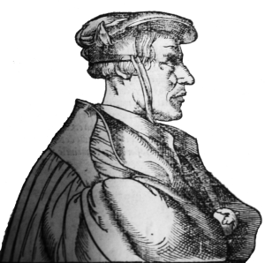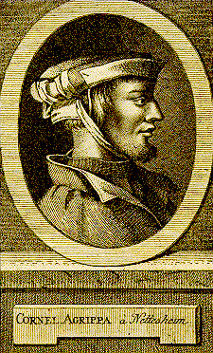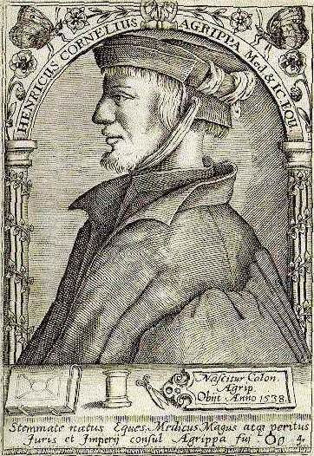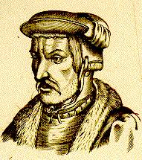
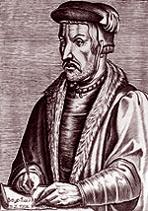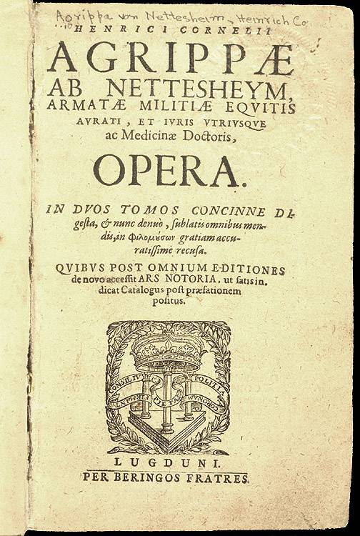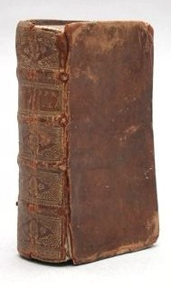

Heinrich Cornelius Agrippa von Nettesheim was a German magician and occult writer, astrologer, and alchemist. He may also be considered an early feminist.

Contents
- 1 Life
- 2 Writings
- 3 Modern ions of Agrippa's works
- 4 Further reading
- 5 See also
- 6 External links

Life
He was born of minor noble birth in Cologne September 15, 1486; according to his student Johann Weyer, Agrippa died in Grenoble, in 1535, and while no evidence places Agrippa clearly after 1534 there is little reason to doubt Weyer.
In 1509, he taught at the University of Dole in France, lecturing on Johann Reuchlin's De verbo mirifico; as a result, Agrippa was denounced, behind his back, as a "Judaizing heretic." Agrippa's vitriolic response many months later did not endear him to the University.
In 1510, he studied briefly with Johannes Trithemius, and Agrippa sent him an early draft of his masterpiece, De occulta philosophia libri tres, a kind of summa of early modern occult thought. Trithemius was guardedly approving, but suggested that Agrippa keep the work more or less secret; Agrippa chose not to publish, perhaps for this reason, but continued to revise and rethink the book for twenty years.
He was for some time in the service of Maximilian I, probably as a soldier in Italy, but devoted his time mainly to the study of the occult sciences and to problematic theologico-legal questions, which exposed him to various persecutions through life, usually in the mode described above: he would be denounced for one sort of heresy or another, privately, and would then reply with venom considerably later. Apart from losing several positions, however, it does not appear that Agrippa was persecuted in any significant fashion.
During his wandering life in Germany, France and Italy he worked as a theologian, physician, legal expert and soldier.
After Agrippa's death, rumors circulated about his having summoned demons. In the most famous of these, Agrippa, upon his deathbed, released a black dog which had been his familiar. This black dog resurfaced in various legends about Faustus, and in Goethe's version became the "schwarze Püdel" Mephistopheles.
Contrary to much received opinion, however, there is no evidence whatever that Agrippa was seriously accused, much less persecuted, for his interest in or practice of magical or occult arts during his lifetime.
In the nineteenth century, he was mentioned in some of Mary Shelley's work's. In the gothic novel Frankenstein, Agrippa's works were read admired by curious and young Victor Frankenstein. In the short story The Mortal Immortal, Agrippa himself appears as one of the characters.

[] Writings
Agrippa is perhaps best known for his books. An incomplete list:
- De incertitudine et vanitate scientiarum atque artium declamatio invectiva (The Speech Attacking the Uncertainty and Vanity of the Sciences and the Arts, 1526; printed in Cologne 1527), a skeptical satire of the sad state of science. This book, a significant production of the revival of Pyrrhonic skepticism in its fideist mode, was to have a significant impact on such thinkers and writers as Montaigne, Rene Descartes, and Goethe.
- De occulta philosophia libri tres (Three Books About Occult Philosophy, Book 1 printed Paris 1531; Books 1-3 in Cologne 1533). This summa of occult and magical thought, Agrippa's most important work in a number of respects, sought a solution to the skepticism proposed in De vanitate. In short, Agrippa argued for a synthetic vision of magic whereby the natural world linked to the celestial and the divine through Neoplatonic participation, such that the ordinarily licit natural magic was in fact validated by a kind of demonic magic stemming ultimately from God. By this means Agrippa proposed a magic that could resolve all epistemological problems raised by skepticism in a total validation of Christian faith. The book was a major influence on such later magical thinkers as Giordano Bruno and John Dee, but was ill-understood after the decline of the Occult Renaissance concomitant with the Scientific Revolution. The book (which circulated in manuscript long before it was published) is often cited in discussions of Albrecht Dürer's famous engraving Melancholia I (1514). (Note that Philosophy of Natural Magic: Complete Work on Natural Magic, White & Black Magic, 1569, ISBN 1-56459-160-3, is simply book 1 of De occulta philosophia libri tres.)
- Declamatio de nobilitate et praecellentia foeminei sexus (Declamation on the Nobility and Preeminence of the Female Sex, 1529), a book on the theological and moral superiority of women.
A spurious Fourth book of occult philosophy, sometimes called Of Magical Ceremonies, has also been attributed to him; this book first appeared in Marburg in 1559 and was certainly not by Agrippa.
(A semi-complete collection of his writings were also printed in Lyon in 1550; more complete ions followed.)

[] Modern ions of Agrippa's works
- De occulta philosophia libri tres. Ed. Vitttoria Perrone Compagni. Leiden and Boston: Brill, 1992: ISBN 90-04-09421-0.
- Three Books Of Occult Philosophy. Trans. J. F. ed by Donald Tyson. St. Paul, MN: Llewellyn, 1993: ISBN 0-87542-832-0.
- Declamation on the Nobility and Preeminence of the Female Sex. Trans. Albert Rabil, Jr. Chicago: University of Chicago Press, 1996: ISBN 0-226-01059-7
No proper modern ion of De vanitate presently exists.

[] Further reading
- Lehrich, Christopher I. The Language of Demons and Angels. Leiden and Boston: Brill, 2003: ISBN 90-04-13574-X. The only in-depth scholarly study of Agrippa's occult thought.
- Nauert, Charles G. Agrippa and the Crisis of Renaissance Thought. Urbana: University of Illinois Press, 1965: ASIN B000BANHI6. The first serious bio-bibliographical study.
- van der Poel, Marc. Cornelius Agrippa, the Humanist Theologian and His Declamations. Leiden and Boston: Brill, 1997: ISBN 90-04-10756-8. Detailed examination of Agrippa's minor orations and the De vanitate by a Neo-Latin philologist.
- Yates, Frances A. Giordano Bruno and the Hermetic Tradition. The University of Chicago Press, 1964: ISBN 0-226-95007-7. Provides a scholarly summary of Agrippa's occult thoughts in the context of Hermeticism.

[] See also
- Pentagram
- Paracelsus

[] External links

- Website devoted to Agrippa's Life
- Astrology & Magic of Agrippa
- Writings of Agrippa
- Article in the Catholic Encyclopedia
- 'The Occult Science of Talismanic Correspondences' - A key to Agrippa's Tables by David Cramb Wilson
- 'General Table of Correspondences' Compiled by David Cramb Wilson
- biography
===============================================================================================================================
END

