About Cornelius Henricus Agrippa
De occulta philosophia. (Cologne, Johann Soter), 1533

http://www.xs4all.nl/~bph/hermgnos-39.html

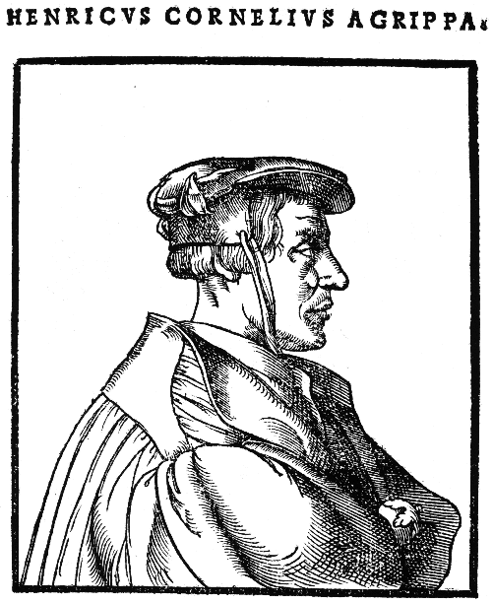
Agrippa of Nettesheim (1486-1535) is one the promotors of Hermetic thought in Europe. During his chequered existence he lived in Italy from 1511 to 1517. There, in Pavia, he lectured on the Hermetica and Ficino's commentary on the Corpus Hermeticum.
In 1510 Agrippa met Johannes Trithemius, who encouraged him to complete De occulta philosophia (1533), a compendium of Renaissance magic , which although not profoundly philosophical, was neverteless highly influential. Giordano Bruno was amongst those who used the work intensively.
In book I, Agrippa divides the universe into three areas, conforming to the Neoplatonic scheme: the world of the elements, the world of the heavens or spheres, and the world of the divine intelligence. Natural magic, celestial or sphere-oriented magic and ceremonial magic respectively correspond with these three worlds. All of it falls under philosophy, which in turn can be divided into three parts: natural philosophy (including the art of healing), mathematics (including astrology) and theology.
Agrippa adopts the magia naturalis and related spiritus theory from Ficino's De vita coelitus comparanda but does not confine himself to the intermediary world of spheres; he also concentrates on the divine intelligence and tries to manipulate the influence of spiritual forces beyond the stars: this makes his magic demonic. He bases himself on Asclepius:
and Mercurius Trismegistus writes, that an image rightly made of certain proper things, appropriated to any one certain angel, will presently be animated by that angel. Of the same also Austin makes mention in his eighth book De civitate Dei.
What Agrippa conveniently omits is that Augustine strongly disapproved of these practices.
Agrippa far exceeds the mild Platonized magic of Ficino and unlike Ficino, does not attempt to force his sources into a Christian framework. He writes:
No man is ignorant that evil spirits, by evil, and prophane arts may be raised up, as Psellus saith sorcerers are wont to do.
In book II, on celestial magic, Agrippa emphasizes the necessity of mathematics, because everything is determined by measure and number. The art which is directly associated is music. The pricus theologicus here: Pythagoras. Agrippa repeatedly quotes from the Corpus Hermeticum:
And Mercurius in his book which he calls De Communi [XII], saith, all that is in the world is moved wither by increase, or decrease.
We may thus infer that Agrippa included not only the Asclepius but also the treatises of the Corpus Hermeticum in his magic philosophy, which causes the Hermetic doctrine to be developed in a magical direction.
In book III, on ceremonial magic, Agrippa concurs with the De caelestis hierarchia of Dionysius Areopagita and continues the Hermetic-cabbalistic tradition as it was begun by Pico and adopted by Reuchlin and Trithemius. Hermes Trismegistus appears in this context as one of the philosophers to prophesy the Trinity:
Also Mercurius Trismegistus in Asclepius mentioneth the Son of God in divers places; for he saith my God and Father begat a Mind, a work divers from himself; and elsewhere, Unity begets Unity, and reflecteth his flagrant love on himself; and in Pimander (...) saith, the author of regeneration is the Son of God, the man by the will of the one only God.
It is clear from De occulta philosophia that Agrippa wishes for a Christianity free of magic; on the other hand he continues to believe in the value of magic, even the most dangerous one.

Literature: H.C. Agrippa. De occulta philosophia, hrsg. von K.A. Nowotny, Graz 1967; H.C. Agrippa, Three Books of Occult Philosophy, Transl. J. Freake, Ed. D. Tyson, St. Paul (Minn) 1997 D.P. Walker Spiritual and demonic magic from Ficino to Campanella, London 1958, pp. 90-6; F.A. Yates Giordano Bruno and the hermetic tradition, London 1964, pp. 130-43.

