Sir John Woodroffe 1865–1936
http://en.wikipedia.org/wiki/Sir_John_Woodroffe
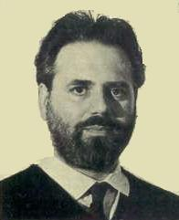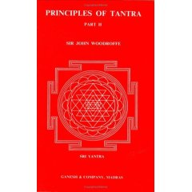

Sir John Woodroffe (1865–1936), also known by his pseudonym Arthur Avalon, received his B.C.L. (Bachelor of Civil Law) from University College, Oxford. He moved to India, where he practised law. He became Advocate-General of Bengal and in 1915 Chief Justice at the Calcutta High Court. There, he was especially enthusiastic in siding with British authority against Indian nationalists, moreso than his contemporaries on the bench. He also was appointed Standing Counsel to the Government of India. He was appointed Tagore Law Professor at Calcutta University. After retiring to England he became Reader in Indian Law at the University of Oxford, and finally moved to France in his retirement, where he died in 1936.
Woodroffe, however, lived somewhat of a double life in India. Alongside his judicial duties he studied Sanskrit and Hindu philosophy, especially the system of Shākta Tantra, as a disciple of Shiva Chandra Vidyarnarva Battacharya. As the first Western scholar of Tantra, he played an important role in bringing interest to the subject, though in the process sanitized Tantra of some elements that Westerners may have considered unsavory. Because many contemporary scholars and pandits - both Western and Indian - were calling Tantra the scourge of India and a threat to Western domination, Woodroffe's scholarship was tremendously important in providing a clearer view of what Tantra actually was, what the Tantras themselves actually contained, and what Tantrikas actually practiced. In trying to justify Tantra, however, his work was often flawed, contradicting itself, and often bending over backwards to show that Tantra was deeply rooted in, and the ultimate manifestation of, the principles of Vedānta.
Despite popular belief, Woodroffe was not a very apt Sanskritist (according to his biographer Kathleen Taylor, many Indologists believe he couldn't even read the script very well), and thus relied heavily on his Bengali friends - especially the extensive secret help of Atal Behari Ghose - for translations of various Sanskrit texts. With their help, he translated some twenty original Sanskrit texts, most under his pseudonym Arthur Avalon (which he admitted in the preface to the first work published under his own name, Shakti and Shakta, was a composite identity that included not only himself, but his Bengali collaborators, especially Ghose).
He published and lectured prolifically and authoritatively on Indian philosophy and a wide range of Yoga and Tantra topics. His work helped to unleash in the West a deep and wide interest in Hindu philosophy and Yogic practices.
His most popular and influential book, a major contribution to the appreciation of Indian philosophy and spirituality, is The Serpent Power – The Secrets of Tantric and Shaktic Yoga (Dover Books), which is the source of many modern Western appropriations of Kundalini practice.
Other writings (published under his own name, as well as Arthur Avalon) include:
- Shakti and Shakta
- Principles of Tantra (2 vols)
- Kamakalavilasa
- Introduction to the Tantra Śãstra
- Mahanirvana Tantra (Tantra of the Great Liberation)
- Hymns to the Goddess and Hymn to Kali
- The World as Power
- The Garland of Letters
- Bharati Shakti: Essays and Addresses on Indian Culture
- India: Culture and Society
- Is India Civilized? Essays on Indian Culture
==========================================================================================

