Osho Nataraj Meditation
Osho Nataraj Meditation is dance as a total meditation.
Disappearing in the dance, then relaxing into silence and stillness, is the route inside for this method.
“Forget ‘the dancer’ – the center of the ego – become ‘the dance.’ That is the meditation. Dance so deeply that you forget completely that ‘you’ are dancing and begin to feel that you are the dance. The division must disappear, then it becomes a meditation. Dance is good in itself – as far as it goes it is good. After it, you will feel fresh, young. But it is not meditation yet. the dancer must go... until only the dance remains...” – Osho

First stage: 40 minutes
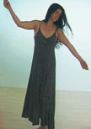 | With eyes closed dance as if possessed. Let your unconscious take over completely. Do not control your movements or be a witness to what is happening. Just be totally in the dance.

Second stage: 15 minutes
Keeping your eyes closed, lie down immediatly. Be silent and still | 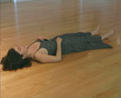

3. Third stage: 5 minutes
 | Dance in celebration and enjoy.

