Rajneesh Chandra Mohan Jain- OSHO - 1931-1990
http://en.wikipedia.org/wiki/Rajneesh
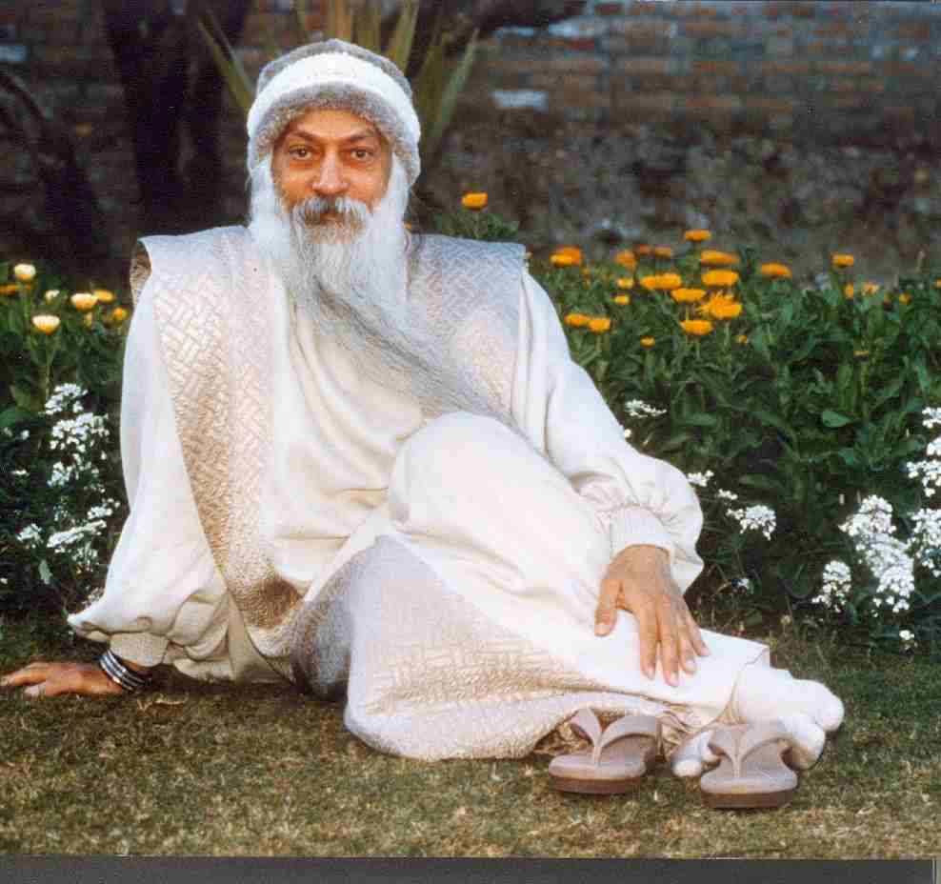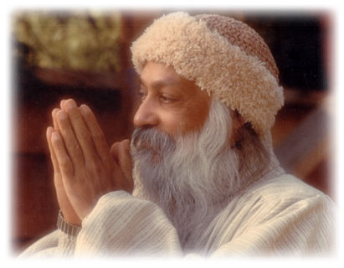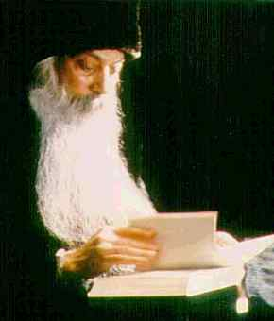
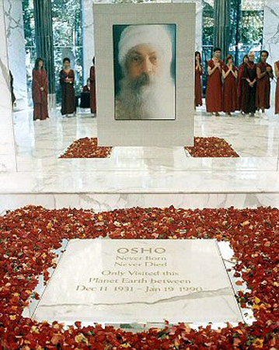
Rajneesh Chandra Mohan Jain (December 11, 1931 - January 19, 1990), better known during the 1970s as Bhagwan Shree Rajneesh and later taking the name Osho, was an Indian spiritual teacher. He lived in India and in other countries including, for a period the United States, and was held centrally by the Osho-Rajneesh movement, a controversial spiritual and philosophical movement. The name Osho means "the friend"

Contents
[hide]
- 1 Rajneesh's philosophy
  - 1.1 Rajneesh on meditation
  - 1.2 Childhood and youth
- 2 Rajneeshi / Sannyasin movements
  - 2.1 The Commune
  - 2.2 The U.S. chapter
  - 2.3 Back in Pune
- 3 Names and titles
- 4 Further reading
- 5 References
- 6 External links

[edit] Rajneesh's philosophy
Rajneesh claimed that the greatest values in life are (in no specific order) love, meditation and laughter, and that the highest grace in life was in experiencing spiritual enlightenment. He said this enlightenment is the normal state of being for all that makes up the cosmos, but one is distracted from realizing that one is experiencing it - particularly by the human activity of thought, as well as by emotional ties to societal expectations, and consequent fears and inhibitions.
He said his philosophies arose from various spiritual sources. He was a prolific speaker (both in Hindi and English) on various spiritual traditions including those of Buddha, Krishna, Guru Nanak, Jesus, Socrates, Zen masters, Hassidism, Sufism and many others. He attempted to ensure that no "system of thought" would define him, since he believed that no philosophy can fully express the truth. He said that his was a "philosophy of no philosophy".
An experienced orator, he said he spoke to convey his message, but that his only reason was to convince his listeners to start on a path of meditation.
He was often called the "sex guru" after some speeches in the late 1960s on sexuality. These were later compiled under the title From Sex to Superconsciousness. According to him, "For Tantra everything is holy, nothing is unholy", and all repressive sexual morality was self-defeating, since one could not transcend sex without experiencing it thoroughly and consciously. Later, he told the Washington Post that he had sex "with more women than any other man in history."^{[1]}

[edit] Rajneesh on meditation
According to Rajneesh, meditation is a state of thoughtlessness beyond mind that is neither concentration nor spiritual thoughts. He said it is something that can just happen, a state that one can be in, not something that one can do. He said it is very difficult for modern man to just sit and be in meditation, so he devised some techniques to take one into meditation. He believed these techniques allow a person to "unburden" by expressing whatever is repressed in him.
Some of these preparatory exercises can also be found in western psychological therapies (i.e. gestalt therapy), such as altered breathing, gibberish, laughing or crying. His most significant meditation techniques are referred to as Active Meditations, such as "Dynamic Meditation", "Kundalini Meditation", "Nadabrahma", "Nataraj", and are quite physically demanding.
He also reintroduced minimal parts of several traditional meditation techniques, stripped of what he saw as ritual and tradition, and retaining what he considered to be the most therapeutic parts. He also believed that, given sufficient practice, the meditative state can be achieved and maintained while performing everyday tasks and that enlightenment is nothing but being continuously in a meditative state.

[edit] Childhood and youth
Rajneesh was born at Gadarwara, a small village in Narsinghpur District of Madhya Pradesh state in India. At the time, an astrologer predicted that he might die before he was seven years old according to the birth chart.^{[citation needed]} His parents, who were Jains, sent him to be with his maternal grandparents until he was seven years old.
Rajneesh said this was a major influence on his growth because his grandmother gave him the utmost freedom and respect, leaving him carefree; without an imposed education or restrictions.
Rajneesh said that a child's development is negatively affected if during their first seven years they are forced to learn and their dignity is ignored. He says ideally it should be the opposite.
This, as he put it, was what happened to him. When he joined his first school, he was able to discuss with and convince his teacher, who was very strict with children. Rajneesh explains that if the child receives respect, he is more obedient to his parents. If the parents ignore the child's individuality, the child would in turn ignore them. (My Life in Orange, a memoir of Tim Guest's time as a child in Bhagwan's communes, explores the ways those teachings affected the children of Bhagwan's disciples, in both positive and negative ways.)
After Rajneesh was seven, he went back to his parents. Rajneesh explained that he received a similar kind of respect from his paternal grandfather who was staying with them. He was able to be very open with his grandfather. His grandfather used to tell him, "I know you are doing the right thing. Everyone may tell you that you are wrong. But nobody knows which situation you are in. Only you can decide in your situation. Do whatsoever you feel is right. I will support you. I love you and respect you as well."
Rajneesh said he became spiritually enlightened on 21 March 1953, when he was 21 years old. He said he dropped all effort and hope and after an intense seven-day process went out at night to a garden, where he sat under a maulshree tree. During the course of this evening, he said he underwent the powerful breakthrough experience that is sometimes referred to as satori (in the Zen tradition), or samadhi (in the Hindu tradition). He said he experienced this process solely as a result of his natural efforts to penetrate into the ultimate nature of reality.
He finished his studies and during the 1960s served as philosophy professor at the University of Jabalpur while touring India, lecturing on his philosophy.

[edit] Rajneeshi / Sannyasin movements
The movement which arose around Rajneesh is somewhat different from a traditional Sannyasa -- sometimes termed neo-Sannyasin.

[edit] The Commune
In 1969 a group of Rajneesh's disciples established a foundation to support his work and allowed him to drop his university job. They settled in an apartment in Mumbai where he gave daily discourses and received visitors. The number and frequency of visitors soon became too much for the place, overflowing the apartment and bothering the neighbours. A much larger apartment was found on the ground floor (so the visitors would not need to use the elevator, a matter of conflict with the former neighbours).
On September 26, 1970 he initiated his first disciple or sannyasin at an outdoor meditation camp, one of the large gatherings where he lectured and guided group meditations.
The new apartment also proved insufficient and the climate of Mumbai was deemed very bad for Rajneesh's health. So, in 1974, on the 21st anniversary of his enlightenment, a caravan of cars departed from the Mumbai apartment to the newly purchased property in Koregaon Park, in the city of Pune, a four hour trip from Mumbai. Pune had been the secondary residence of many wealthy families from Mumbai because of the cooler climate (Mumbai lies in a coastal wetland, hot and damp, Pune is inland and much higher so it is drier and cooler).
The two adjoining houses and 6 acres of land became the nucleus of an Ashram and those two buildings are still at the heart of the present day Osho International Commune. This space allowed for the regular audio and video recording of his discourses and, later, printing for worldwide distribution, which allowed him to reach far larger audiences internationally. Rajneesh taught at the Pune ashram from 1974 to 1981.

[edit] The U.S. chapter
In 1981, Rajneesh went to the United States in search of better medical care (he suffered from diabetes and severe back problems) and also, allegedly, to escape tax evasion charges in India. His followers, at his request, bought (for US$6 million) a ranch in Wasco County, Oregon, previously known as "The Big Muddy", but later renamed Rajneeshpuram where they settled for the next several years.
At its largest, Rajneeshpuram consisted of some 7,000 members on a 6.25-square-mile ranch 10 miles from Antelope. It included homes, meditation centers, its own road system, power grid, bus service, schools for children, and a small airport.
Disagreements over zoning rules and building codes in the beginning continued to escalate between not only his followers and the inhabitants of Wasco County, but eventually with the rest of the state. His followers, known as Rajneeshees, settled en bloc in Antelope, Oregon, and were able to elect a majority of the town council. They did this after the incorporation of Rajneeshpuram as a city was invalidated by the Oregon Legislature.
Comments by his public spokeswoman, Ma Anand Sheela, only increased tensions. Matters were not helped by Rajneesh's vow of silence, or the 90 Rolls-Royces his followers bought him as gifts - they said that he wanted 365 cars so that he had a new one for each day of the year (technically, he did not have income or own any property). One of his followers explains this in what is called "Face to Faith Parable of the Rolls Royces." When the Rajneeshees subsequently recruited homeless people from across the United States to settle at Rajneeshpuram, it was widely seen as an attempt to use the ballot box to seize control of Wasco County.
In 1984, a bioterrorist attack involving salmonella typhimurium contamination in the salad bars of the 10 restaurants at The Dalles, Oregon, was traced to the Rajneeshee group.^{[2][3]} The attack sickened about 750 people and hospitalized forty-five; none died. It was the first known bioterrorist attack of the 20th century in the United States, and is the largest germ warfare attack in U.S. history. Eventually Sheela and Ma Anand Puja, one of Sheela's close associates, confessed to the salmonella attack (the test run of a plan to incapacitate large numbers of Wasco County residents on an upcoming election day) and to attempted poisonings on county officials.
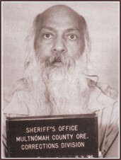
Osho Rajneesh

In May 1985, Sheela called a meeting of Rajneesh's inner circle to plot the assassination of Charles Turner, the U.S. Attorney for Oregon, after the attorney was appointed to head a grand jury investigation into the commune. Catherine Jane Stubbs, known as Ma Shanti Bhadra, volunteered to be the killer. She later bought weapons and scouted Turner's property.
In September 1985, Sheela quit her post as Rajneesh's secretary, and fled to Europe, allegedly with a large amount of the commune's money. After she and twenty of her confederates left, Rajneesh called for an investigation of what she had been doing, during which some of the foregoing came to light.
In late October 1985, Rajneesh was arrested in North Carolina as he was allegedly fleeing the U.S. Though his lawyers had approached the federal grand jury in Portland, Oregon that was about to secretly indict Rajneesh and some of his followers for alleged immigration crimes, and offered for him to be available to them, that offer was refused. Soon after, a Wasco County grand jury returned indictments against Sheela and two others, charging them with the attempted murder of Swami Devaraj, Bhagwan's personal doctor. Rajneesh, on advice of his lawyers entered an "Alford plea," or no-contest plea, in regard to the immigration crimes, and was given a suspended sentence on condition that he leave the country.

[edit] Back in Pune
On January 19, 1990, four years after his arrest, Rajneesh died, with "heart failure" being the publicly reported cause. Prior to his death, Rajneesh had claimed that his rapid health decline was caused by his poisoning with the element thallium by U.S. authorities while he was in prison. He claimed a plot led by the CIA and President Ronald Reagan to assassinate him had been carried out due to their fear of his controversial and counter-cultural teachings combined with his powerful ability to influence people. There has never been any evidence to support this claim; thallium poisoning causes dramatic hair loss within one week of exposure; Rajneesh never experienced any abnormal hair loss and died with a full beard.
Rajneesh was chronically ill most of his adult life and was exceptionally sensitive to smells and chemicals, a condition known as "multiple chemical sensitivity." Those wishing to meet him were first sniffed by helpers to make sure they were not wearing perfume. It was widely reported that he was addicted to the prescription drug Valium in the 1980s and was a heavy user of nitrous oxide gas. On the CBS television show 60 Minutes, Ma Anand Sheela claimed that Rajneesh took sixty milligrams of Valium every day. When questioned by journalists about this allegation, however, Rajneesh categorically denied it, adding that Sheela was in no position to know what medication he was given, this being a matter between him and his personal physician.
In a 1998 preface to Books I Have Loved, Rajneesh's personal dentist, Swami Devageet, states that Rajneesh dictated three books under the influence of nitrous oxide: Glimpses of a Golden Childhood, Notes of a Madman, and Books I Have Loved. Referring to his own nitrous oxide use, Rajneesh himself stated that "Actually oxygen and nitrogen are basic elements of existence. They can be of much use, but for reasons the politicians have been against chemicals of all kinds, all drugs."
After the Rajneeshpuram commune was abandoned, it was discovered that Rajneesh had installed nitrous oxide spigots in his home by his bedside. This was widely reported in newspapers and verified first hand by the FBI and former Oregon Congressman Jim Weaver, who wrote the following in a newspaper article:
A few years later, I went through the abandoned city of Rajneeshpuram and saw things that were almost unbelievable. Ma Anand Sheela's headquarters, a group of mobile homes pieced together, was a hive of secret doors and hidden tunnels, her private room a command post with electronic listening gear tapped into every room in the development. The Bhagwan's parquet-paneled quarters had nitrogen oxide spigots by his bedside, and was surrounded by huge bathrooms with multiple showers.
Rajneesh was 58 years old when he died. His ashes were placed in his newly built bedroom in one of the main buildings (LaoTsu House) at his last home place, his Ashram in Pune, India. The epitaph reads, "OSHO. Never Born, Never Died. Only Visited this Planet Earth between Dec 11 1931 - Jan 19 1990."

[edit] Names and titles
Rajneesh was known as Acharya Rajneesh (teacher Rajneesh) during his early years as a spiritual teacher.
In 1971 he is said to have asked his disciples to start calling him "Bhagwan Shree Rajneesh." The Sanskrit word Bhagwan means "Blessed one" (historically, it is used to refer to a Hindu god, such as Bhagwan Ram or Bhagwan Krishna or to a spiritually awakened being in Mahayana Buddhism). It is also used to denote individuals who possess a great wealth of spiritual knowledge. Shree (more commonly transliterated as Shrī or Śrī) in Sanskrit means "spiritual wealth" and is thus roughly equivalent to the English word "Lord". It derives this meaning from its use as another name Lakshmi, the Hindu goddess of prosperity.
In February 1989, following a request by his disciple Harideva, Rajneesh changed his name to "Osho". 'Osho' is an ancient Japanese term that is used to address a spiritual master in certain Zen traditions. The name "Osho" in this context means "The Friend". An earlier explanation given for the name was that it was derived from William James' term, "oceanic", referring to the oceanic experience.
The name Osho, like the name Rajneesh, may be the subject of trademark in certain countries.

[edit] Further reading
- Sue Appleton, Bhagwan Shree Rajneesh: The Most Dangerous Man Since Jesus Christ (Osho Intl) 1987 ISBN 3893380019
- Ma Satya Bharti, Death Comes Dancing: Celebrating Life With Bhagwan Shree Rajneesh (Routledge) 1981 ISBN 0710007051
- Satya Bharti Franklin, The Promise of Paradise: A Woman's Intimate Story of the Perils of Life With Rajneesh (Station Hill Press) 1992 ISBN 0882681362
- Judith M. Fox, Osho Rajneesh. Studies in Contemporary Religion Series, No. 4 (Signature Books) 2002 ISBN 1560851562 Excerpts.
- Tim Guest, My Life in Orange: Growing up with the Guru (Harvest Books) 2005 ISBN 015603106X
- Hugh Milne, Bhagwan: The God that Failed (St Martins Pr.) 1987 ISBN 0312001061 Osho's one-time bodyguard
- Rosemary Hamilton, Rosemary Lansdowne, Hellbent for Enlightenment: Unmasking Sex, Power, and Death With a Notorious Master (White Cloud Press) 1998 ISBN 1883991153
- Win McCormack, Oregon Magazine: The Rajneesh Files 1981-86 (New Oregon Publishers, Inc.) 1985 ISBN B000DZUH6E
- Bob Mullan, Life as Laughter: Following Bhagwan Shree Rajneesh (Routledge & Kegan Paul Books Ltd) 1984 ISBN 0710200439
- Osho, Glimpses of a Golden Childhood (Osho Viha) 1997 ISBN 8172610726
- Osho, Autobiography of a Spiritually Incorrect Mystic (St. Martin's Griffin) 2001 ISBN 0312280718
- Donna Quick, A Place Called Antelope: The Rajneesh Story (August Pr.) 1995 ISBN 0964311801
- Bernard Gunther, Swami Deva Amit Prem, Dying for Enlightenment: Living with Bhagwan Shree Rajneesh (Harper & Row) 1979 ISBN 0060635274

[edit] References
- ^ Washington Post, July 25, 1979
- ^ Bioterrorism in History - 1984: Rajneesh Cult Attacks Local Salad Bar, WBUR
- ^ [http://www.rickross.com/reference/rajneesh/rajneesh8.html AP The Associated Press/October 19, 2001

[edit] External links
- Read Osho's books online
- Oshoworld - The Osho World Foundation
- Meditation Unlimited - a scientific approach to inner reality... Two of Osho's disciples discuss meditation.
- Sam's Life of Osho downloadable paperback
- Osho on the Mystical Site www.mysticism.nl
=================================================================================================================================
END

