SYMBOLS
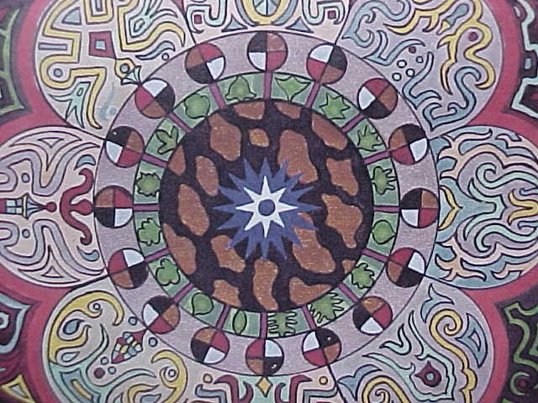
Consider these suggestions as to what the symbols written ages ago really mean.
If you consider that the symbols mean something other then shown here, that's fine. Let your inner spirit take you and lift you in search of ancient truths. Maybe these thoughts relative to symbols will move your own mind to consider what lies hidden behind ancient words.
THE TEMPLE
CHERUBIM
THE ARK OF THE COVENANT & NOAHS ARK
MANNA
TWELVE TRIBES
OSIRIS
THE LION OF JUDAH

THE TEMPLE
Temple : Let me suggest to you that the term Temple used in the Bible is actually referring to the human brain.
We see in Exodus 26:33 the reference that really suggests an ancient description of the temple is actually an anatomically correct description of the human brain.
Exodus26:33 And thou shalt hang up the veil under the taches, that thou mayest bring in thither within the veil the ark of the testimony: and the veil shall divide unto you between the holy place and the most holy.
Note that there is a veil or curtain dividing the Holy Place from the Most Holy Place. The outer room was the Holy Place and the inner room was the most holy place.
The human brain has an outer covering called Dura Mater which means hard mother. The inner most sensitive area is called Pia Mater which means Tender Mother. Dura Mater the outer, and Pia Mater the inner of the human brain, are separated from each other by something called Arachnoid which is the web, or the curtain or the veil.
One other point directing us to the brain as the actual temple of the Bible.
Acts7:48 Howbeit the most High dwelleth not in temples made with hands;

CHERUBIM
Cherubim : Let me suggest to you that the term Cherubim used in the Bible is actually referring to the Cerebrum of the brain .
The Biblical Cherubim are found in the temple. The temple is actually a symbol of the Brain. The job of the Cherubim in the temple was to cover the Holy Place or Mercy Seat.
The Cerebrum is the covering of the brain . In fact the root word which is Cere means to cover.

THE ARK OF THE COVENANT
NOAHS ARK
Let me suggest to you that the Ark of the Covenant is actually the Arc of the Covenant and Noahs Ark is actually Noahs Arc.
What is an Arc ?. An Arc is defined as a continuous passage of an electric current between two or more separated carbon or other electrodes. Nerve impulses in the human body are triggered across synapse's. These are electrical impulses. In the brain the impulse Arcs from one receptor to the other.
As we are in meditation we are receiving light energy through the Pineal Gland which then causes Arcs of electricity from receptor to receptor. The covenant is the electrical light message flowing to us from above that keeps us forever in harmony with the universal power.
As we take ourselves within during deep struggles. The storms are crashing about on every side. But the same electrical Arcs lift us , and when the storm has finally stopped, we find we are standing on the mountain top .
We have taken our animal nature, both positive and negative, (two of every kind) with us and weathered the storm. These are inner experiences of consciousness achieved through electrical Arcs, or should I say Arks.
Oh, and by the way. If angles of light cause Arcs in the brain, would we be reasonable to suggest Archangels or should we say Arcangles

MANNA
Let me suggest to you that Biblical Manna is actually brain sugar. In the Old Testament God poured down Manna to feed those crossing the desert. Manna from Heaven. We are instructed in the same Bible that the Kingdom of Heaven is within us which would mean it is located in the brain and mind.
So let us consider for a moment, Manna coming down from the higher realms of consciousness via the brain.
What is Manna ? It is a saccharine exudation. It is of the root of mannite which means sugar.
Now let us go to the brain . We find that brain sugar is Galactose. Galactose is a milky sugary substance.
Exodus 3:8 "to bring them up to a good land, flowing with milk and honey. (Galactose ?)
And we live in a galaxy called the Milky Way !

TWELVE TRIBES
Let me suggest to you that the Twelve Tribes are actually the Twelve Signs of the Zodiac and the Twelve Cranial Nerves of the Human Brain.
Numbers 17:2 " take every one of them a rod according to the house of their father, to the house of their fathers, twelve rods ".
The house would reasonably be considered as a Zodiacal house. This is further substantiated in Job 38:32 where the question is " Can you bring forth Mazzaroth". Mazzaroth is the 12 signs of the zodiac.
So 12 tribes, 12 signs, and there must a a coordinating mark within the human body, since the cosmos as the universal brain is exactly as the human brain.
In the human brain what do we find. Twelve Cranial Nerves. Olfactory, Optic, Motor Oculi, Trochlear, Trifacial, Abducent, Facial, Auditory, Glosso-pharyngeal, Pneumogastric (or Vagus), Spinal accessory, and Hypoglossal.
The 12 tribes in the Book, the 12 signs in the sky, the 12 cranial nerves in us.
Of course.

OSIRIS
Let me suggest to you that the God Osiris is actually the Open Eye or Third Eye or Pineal Gland of the brain.
If you look in a medical dictionary you will see that OS is a symbol for the word open.
Iris, well you all know what that means.
OS IRIS , the open eye. Thus when we meditate, and stimulate the Pineal Gland we are awakening the great god Osiris.
Now take a look at Supernova 1987a on the Cosmos page. Hes baaack !

THE LION OF JUDAH
The Lion of Judah. What could that be.? The enlightenment entering from the East or the right side. The enlightenment coming from the right hemisphere of the brain. I think I can make that work because of the book of Numbers in the Bible.
Numbers 2:3 And on the east side toward the rising of the sun shall they of the standard of the camp of Judah pitch throughout their armies:
Remember, when you look North, East is always on the right side.
There we have the Tribe of Judah at the East. The Sun being the domicile of the Lion. The Lion of Judah. Enlightenment from the right hemisphere.
Oh by the way Numbers 2:9 in the Bible says that there were 186,400 people in the Camp of Judah.
The constant speed of light.

Keep watching as we add more interesting symbols that most of our world has taken literally and by doing so, missed the boat. What boat ? Oh Im talking in symbols, I guess.

