HEALING
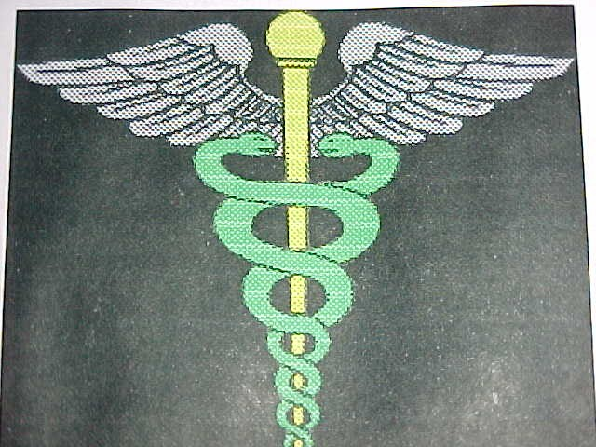
INDEX
Why Are Some People Healed And Others Not ?
Understanding What Goes on Inside Of Us
What Must Increase, What Must Decrease
God Can Do Nothing ? Cancer For Healing Follow The Sun
The Season of Your Soul

HEALING THE BODY
WHY ARE SOME PEOPLE HEALED AND OTHERS NOT ?
Our confusion relative to healing is part of the traditional religious concept of God as a man. An individual aside from ourselves who heals one person but does not heal another. To understand the nature of physical healing we have to understand the nature of God. God being I AM is the vital part of our own consciousness. As such when our consciousness is filled with the higher power there can be dominion over the lower, when on the other hand the lower is stronger, then the God power is inhibited and disease can prevail.

TO UNDERSTAND THE INSIDE
ONE MUST LOOK AND UNDERSTAND THE OUTSIDE
The human body is a microcosm of the universe. As it is without so it is within. There are the storms that afflict the earth outside and there are the storms that afflict the body inside. There is the winter that takes the very life out of the earth, there is the winter of the soul that takes the very life out of the body. There is no God that can change that. February will come whether we like it or not. There is no God that can change that. Things will occur, storms will afflict the earth and no one can prevent it, no God can stop it. And as it is without so it is within.

HE MUST INCREASE, WE MUST DECREASE
These are the words of John The Baptist ( who represents the Earth, ) speaking of Jesus who represents the Sun. When the power of the Sun increases, the earth brings forth fruit. There is an abundance in the land. When the earth overwhelms the sun then there is darkness, there is winter and the leaves fall from the trees and life becomes dormant.

DO YOU UNDERSTAND NOW ?
We must keep in meditation so as to keep the Sun high in its orb that there may be healing and there may be life. When we allow the earth to be strong we overcome the sun. Within us it becomes winter. Just as outside, winter brings death and it is the same inside. When we fall away from our meditation we bring forth the winter of the soul and the very life force is subdued. At that point disease is very hard to contain. Especially in the case of serious disease, it is absolutely essential that our meditation keeps the sun shining brightly within. For if we fall away there is darkness and disease thrives in the dark. Thus it is not God but ourselves. When we inhibit the God power within we then give power to disease. And just as outside, when the cold and darkness grow severe there is no God that can do a thing about it.

GOD CAN BE POWERLESS ?
IS THERE SCRIPTURE TO PROVE THAT ?
In symbolic mysticism the word "iron" stands for the human mind and its thought process. If we consider the construction of the temple we find in 1 Kings 6:7, that when the temple was being built "there was neither hammer nor axe nor any tool of IRON heard in the house". This means the temple is built in silence (meditation), there are no tools of iron ( human thought). Now what impacts against the healing process ?. Human thought, stress, the mind. How does the Bible describe this.
Understanding that iron means human thought in the mystical language, we see something very interesting in Judges 1:19. It says that the Lord was with Judah and he (meaning God) drove out the inhabitants of the mountains. (This means that there is no human thought allowed in the higher realms of consciousness). But the scripture goes on to say " but he could not drive out the inhabitants of the valley because they had chariots of IRON." The valley is the lower carnal consciousness and the chariots of iron are the vehicles of thought that we allow to ride through our minds. These thoughts cannot be subdued by God.

THUS WHAT DO WE SAY OF HEALING
We are subjected to the same storms within our body as the earth is subjected to outside. There is a winter of the soul, a dark time of the soul within as there is without. We must continually dwell in the Sun by staying close to our meditation. If we do, we will have the power of the inner sun during the times of illness. This is so important for people with serious illness. If they are not in meditation, the sun goes out. The cold inner winds blow and the earth crumbles. All the prayer in the world cannot replace the power of the sun, within or without.
CANCER
It is especially important that people who have Cancer not allow the sun to go down. It is important that a person with cancer stay in the warmth of the inner sun. Doctors call it remission. Once the chariots of iron ( the negative thoughts and stress) are allowed to run through the aspects of the mind, once the sun is hidden by the clouds of the mind and its thoughts, the storm can become so overwhelming that there may be no turning back.

FOR YOUR HEALTH AND YOUR LIFE,
FOLLOW THE SUN
In Joshua 10:13 it says that as Joshua went through his battle he commanded the sun to stand still. It says " and the Sun stood still and the moon stayed until the people had avenged themselves upon their enemies". This means that the higher light of the divine consciousness ( sun) reflecting on the emotions of our human psyche (moon), will cause the enemies (fears, stress and disease), to flee.

THE SEASON OF YOUR SOUL
Within each of us there is either a summer or a winter. If it is winter within then disease can be a serious threat. We must stay in divine meditation until the Sun rises to the pinnacle of Leo. King of Kings, the Lion of Judah. For there is where our healing lies. And remember, if chariots of iron are free to roam the caverns of your mind, God cannot drive them out. Don't you let them in.

