ETA CARINA
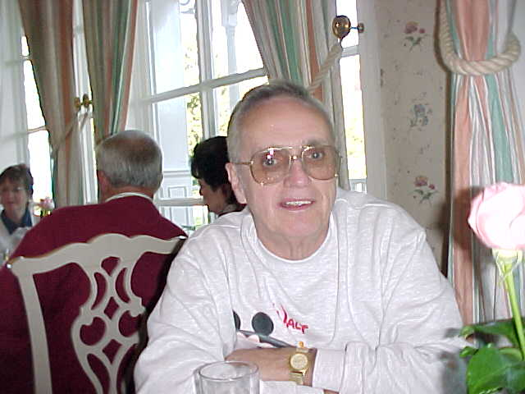
THE KEY TO EDEN
HIDDEN MEANINGS CHROMOSOME TWENTY TWO
PHYSICIST JOHN GRIBBINS
NATIONAL GEOGRAPHIC THE BOOK OF REVELATION ETA CARINA
KRIS DAVIDSON, ASTROPHYSICIST SEVENTH KEEL OF THE SHIP
COSMIC PROTEIN FIRST BORN LEAVEN BOOK OF LIFE
MEDITATION ON THE ZODIAC THE ZODIACAL MAP LION OF JUDAH
DAVIDS SON LASERS FROM ETA CARINA THE LADDER IN THE NEBULA
SALVATION 144,000 GENES THE DAYS OF THE SEVENTH ANGEL

TRANSCRIBED FROM THE HIDDEN MEANINGS CONFERENCE CENTER
What I consider to be a most significant accomplishment in our work is connecting the opening of the Genetic code we are now seeing in today's headlines, with the opening of the Book of Life that we see in the Book of Revelation.
We have what is described as a Book of Life, in the Book of Revelation. If this book of life is the Genetic code and it is being opened then we have a significant fulfillment occurring in our life time.

USA TODAY
USA Today called the decoding of chromosome 22 equivalent to finishing the first chapter in the book of life. Here the scientists are telling us that they have opened the Book of Life. If what they say is correct, then we have a direct link to the Book of Revelation.

FROM NASA
The last paragraph in talking of DNA states that “ A description of the molecular code reads like an encrypted message. Here NASA is telling us that the Genetic code reads like a secret or encrypted message.

Physicist John Gribbins from " Q Is For Quantum"
DNA contains reading instructions and active punctuation marks that indicate where a particular message begins and ends. The molecule also makes use of error checking strategies that ensure for example that the cell does not begin to read DNA in the middle of a sentence or skip part of an instruction.
Here physicist John Gribbins describes to us how the genetic code is like a book that we pick up and read. Only this book is read by the cells in your body.

October 1999 National Geographic
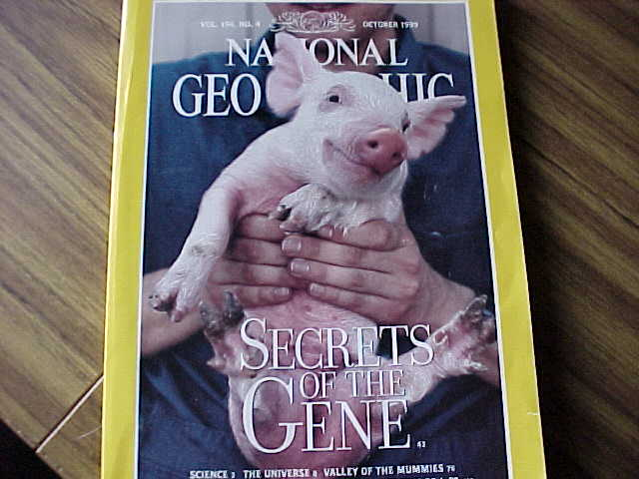
The article in National Geographic makes the following statement.
From the matter that makes up the universe to the strands of DNA that make us who we are, scientists are steadily unlocking the secrets of the age.
Here is National Geographic telling us that decoding the DNA is unlocking the secrets of the age.

THE BOOK OF REVELATION
But when we go into the Book of Revelation we see that no human is able to open the book of life.
Revelation5:3 And no man in heaven, nor in earth, neither under the earth, was able to open the book, neither to look thereon.
Revelation5:4 And I wept much, because no man was found worthy to open and to read the book, neither to look thereon.
So we have to look for something that is not human. Something that is cosmic in nature.

ENTER ETA CARINA
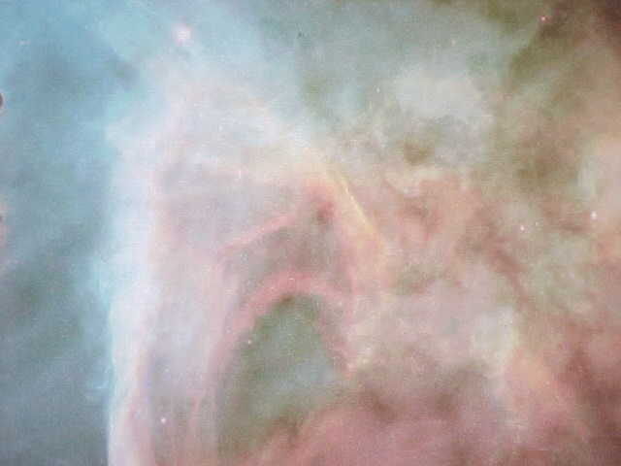
What we have previously discussed is the fact that it is the angles of light from Eta Carina that is opening gates in the brains of the wise who are now touching DNA. The book of life.
But how do we connect Eta Carina to all of what is going on in the Genetic Revolution?

FROM KRIS DAVIDSON, ASTROPHYSICIST, UNIVERSITY OF MINNESOTA
Occasionally something happens in astronomy that is so bewildering that it makes astronomers nervous, said Kris Davidson (Son of David) a university of Minnesota Astrophysicist. This is weird. We don't understand.
There are about 6000 stars in the sky visible to the naked eye said, Davidson, We understand them all with the sole exception of Eta Carina. There is no theoretical explanation for it.
We have something going on that is beyond the ability of science to define. There is no explanation for it. This means it is worthy of examination.

ETA MEANS SEVENTH
Revelation5:5 And one of the elders saith unto me, Weep not: behold, the Lion of the tribe of Juda, the Root of David, hath prevailed to open the book, and to loose the seven seals thereof.
Note that the in referring to the Book it mentions the 7 seals.

CARINA: THE KEEL OF THE SHIP
Carina means the Keel of a Ship. This is taken from the ship Argo of the myth Jason and Argonauts where the keel of the ship gave instructions in times of crisis.
The connection comes when we see that Protein which is the substance which changes DNA has a root in Greek which is the word prow which means the front of the hull of a ship.
So Protein and Carina both are connected to the hull of a ship and in this case it is the ship that gives instructions.

LOOKING FOR A COSMIC PROTEIN
We are looking for a cosmic protein because the human protein enzyme is unable to overcome the “incurable diseases”.
KILL THE FIRST BORN AND REMOVE THE LEAVEN FROM THE HOUSE
In the Book of Exodus we are told that the first born must die and leaven must be cleaned from the house if we are to passover to the other side. In other words we cannot look to that which is of the earth.
Protein Enzyme is that substance which changes DNA. Protein means first and Enzyme means leaven. We must look for the cosmic protein enzyme.
So Carina meaning the Keel of the Ship Argo is connected to the ship that gives instructions. It is the 7th. And it is the only visible star in the universe that defys description.

BUT WHO CAN OPEN THE BOOK OF LIFE ?
Revelation5:5 And one of the elders saith unto me, Weep not: behold, the Lion of the tribe of Juda, the Root of David, hath prevailed to open the book, and to loose the seven seals thereof.
Now here is the reference to the Lion of the tribe of Judah.
Leo is the domicile of the Sun. It is light.
Jesus is the Light of the world. Light.
The Tribe of Judah was positioned at the point of the rising sun.
Let us look at that scripture
Numbers2:3 And on the east side toward the rising of the sun shall they of the standard of the camp of Judah pitch throughout their armies:
The Lion Leo is the symbol of zodiacal light. Light from above. Which would connect with Eta Carina which is currently sending out lasers of light to all parts of the universe.
We see these lasers screaming from Eta Carina. This is the light energy defined in the Book of Revelation as the Lion of Judah.

JOHN JOCELYN, MEDITATION ON THE ZODIAC
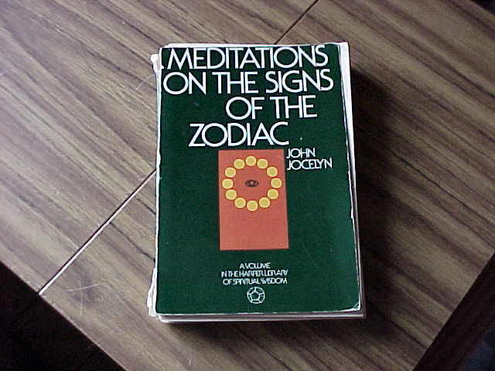
In His book Meditation on the Signs of the Zodiac, John Jocelyn describes the zodiacal sign Leo thusly.
Page 101, The Lion indicative of the Gospel of St. Mark is the symbol for the strength that pulses throughout the world making all things possible of fulfillment and surging through the world as creative power.
This certainly would fit with the Book of Revelation attributing to the Lion the power to open the book. And in the same vein fulfilling all things in the correction of mutant DNA.
Jocelyn continues on page 103
No sign of the Zodiac can be fully understood without the knowledge of its polar opposite and this is vital in speaking of Leo for through this sign and its opposite Aquarius, man is raised from the dead which means that he is Christ born and becomes a sun initiate.
John Jocelyn was a Christian Bible teacher. What he is showing us here is extremely important because it brings together Leo ,the Lion of Judah, and Aquarius. So what is happening now via the Lion can happen because its opposite is Aquarius which is the age we are entering at this time.
We have solved the riddle of the sphinx through Eta Carina. The human face Aquarius, and the body of the Lion Leo. Or the Virgin birth human to Christ consciousness Leo ,or September Virgo to August Leo.
Jocelyn goes on
The Son of Man resident in the opposite sign Aquarius offers his purified soul to the Son of God. Thus the Son of man , that is Aquarius, refines and raises its forces to meet the Son of God from the Sun in Leo. As the physical Sun calls forth the blossoms of the plants thus the spiritual Christ sun develops mans consciousness to a full I AM.
The Hebrew name of the sign of the Lion is Arieh. This word is used of the Lion hunting down his prey. What is the prey of the Lion in this case.

THE LION, THE SERPENT AND THE SHIP
I am going to show you an ancient Zodiacal map.
Here you will see the Lion with his feet over the head of the serpent Hydra, just about to descend upon it .
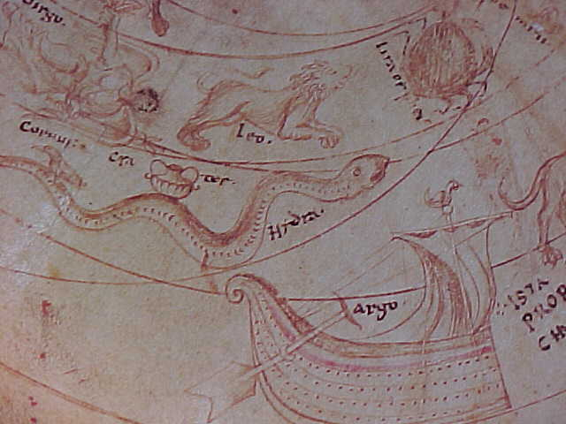
In other words the meaning here is that the Lion overwhelms the Serpent. We know the serpent as shown to us by Jeremy Narby to be the metaphysical symbol of DNA.
Thus as the Book of Revelation tells us it is the light energy that overcomes the genetic strand and corrects the DNA.
Now if you look right below the serpent what do you see. The Argo. Eta Carina.
What are we looking for here. Eternal Life. Overcoming the serpent. Correcting the mutant DNA. Jason took instructions from the Keel of the Ship Argo (Eta Carina) and was able to find the Golden Fleece which gave healing. I am saying that the Golden Fleece is opening up the genetic strands of DNA and overcoming the mutant of diseased body and diseased consciousness.
Interestingly, in order to get the Golden Fleece the myth tells us that Jason had to overcome the serpent that watched over it and guarded it. So the Lion overcomes the serpent DNA and the Argo or Eta Carina overcomes the serpent DNA.

THE LION OF JUDAH IS JESUS ?
Yes Lion of Judah is Jesus.
The Greek name for Jesus has a numerical value of 888 which is the Mythical Sun. The Lion. The Light.
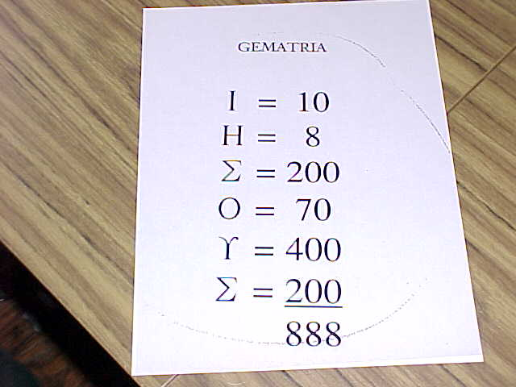
Now back to Revelation 5:5 telling us of this light that prevails to open the book. What also does it say?
Revelation5:5 And one of the elders saith unto me, Weep not: behold, the Lion of the tribe of Juda, the Root of David, hath prevailed to open the book, and to loose the seven seals thereof.

THE ROOT OF DAVID
The light opens the Book. The Book is DNA. The light is coming from Eta Carina. If that is correct look who is the director of the project tracking Eta Carina. His name has been all over the world in news articles about the 7th Angel.
The Root of David. The son of David. So here we have Eta Carina which fits the other parts of the code. We have the light coming from it, and we have the person who is in charge of this project and his name, DAVIDSON , Kris Davidson. Davids-Son. The root of David.

LASER LIGHT FROM ETA CARINA
It is light the opens the book and looses the 7seals.
So we have the brain, the spine, the Pineal Gland or single eye and light. And together we have them opening the book of the life.
Now if it is light that is opening the Book of Life or DNA, where is that light coming from.
We see the laser lights coming down from Eta Carina. The 7th angle or angel that we will cover in a few minutes. The Keel of the Ship. Protein meaning the prow of the ship. Keel and Prow. Prow is the bow the forwad part of the hull of the ship. Keel is the part that runs from the front to the stern of the hull of the ship.
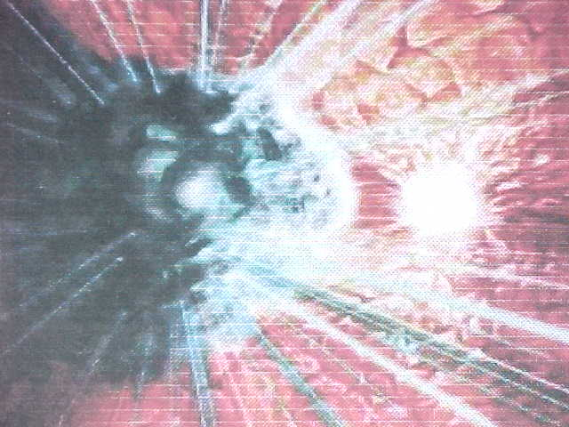
I am proposing to you that it is Eta Carina or light from above that is now opening the Book of Life which is the Book of Genetics or DNA.

THE LADDER IN THE NEBULA
There is some additional evidence in Eta Carina that I want to share with you. Jeremy Narby told us that the ancients would show serpents, or twisted or winding stairs as DNA. Here we see comments of astronomer Nancy Hathaway.
The discovery of jets, waves, a shock front, and an unknown structure that looks like a ladder in the nebula surrounding the massive star Eta Carina.

THE FOUR BEASTS
Revelation5:6 And I beheld, and, lo, in the midst of the throne and of the four beasts, and in the midst of the elders, stood a Lamb as it had been slain, having seven horns and seven eyes, which are the seven Spirits of God sent forth into all the earth.
In the midst of the throne and the 4 beasts is the brain and the four aspects of human nature, physical, intellectual, emotional, spiritual. The elders represent the earth, the cosmos, cosmic consciousness, and the 7 horns and 7 eyes represent enlightenment and power which comes as the seals or chakras are opened by the cosmic light. The lamb is the pineal gland which had been slain because it was atrophied. It is the stone that the builders rejected.

WE ARE ALL JUDGED BY THE BOOK
Let me show you what appears to me to be a DNA reference in this scripture.
Revelation20:12 And I saw the dead, small and great, stand before God; and the books were opened: and another book was opened, which is the book of life: and the dead were judged out of those things which were written in the books, according to their works.
Did you ever wonder about that. According to their works. According to what is done by you and by your ancestors. The book is thus written by us. The book, what we do and what our ancestors do, changes the book.
The original book written by God has been changed. Things that should be there are not and things that should not be there, are. The cells in the body are confused and as a result the body becomes sick and sometimes very very sick. We have added to the book and we have taken away from the book and what does Revelation say.
Revelation22:18 For I testify unto every man that heareth the words of the prophecy of this book, If any man shall add unto these things, God shall add unto him the plagues that are written in this book:
Revelation22:19 And if any man shall take away from the words of the book of this prophecy, God shall take away his part out of the book of life, and out of the holy city, and from the things which are written in this book.
Nature reads the book. The book has been changed, and since the message is wrong the person gets sick . The book is violated and nature or God cannot tolerate it.

SALVATION
But now comes salvation. Something comes that can wipe the slate clean. Something comes that can restore us to the book of life. But take heart because the first chapter in the book of life has been opened.
A newspaper article from USA Today. The correspondent Tim Friend
LIFES FIRST CHAPTER
Chromosome decoding is genetic milestone
By: Tim Friend USA Today, Tuesday Dec 7 1999
Scientists say they have decoded an entire human chromosome, an achievement they call the equivalent of finishing the first chapter in the book of life.
The breakthrough is a milestone for the international Human Genome Project, which is attempting to map and create an encyclopedia of genetic coding for the 90,000 or so genes that constitute a human being.
The ability to decipher this first human chromosome and others to follow will help unlock the secrets of what causes disease and aging and how humans are similar and different from other creatures.
This gives us for the first time a glimpse of the landscape of an entire human chromosome and it gives us confidence that this can be done for the other chromosomes and other mammals, Francis Collins director of the National Human Genome Research Institute said last week.
Can you understand.?
"Scientists say they have decoded an entire human chromosome an achievement they call the equivalent of finishing the first chapter in the book of life."
The light will make it possible for the corrections to be made in the book and we will then be judged not guilty. In other words the mutations will be healed.
Where are we trying to get with this scripturally. Revelation 13:18 tells us about the sign of the beast 666. It adds up to 9 and metaphysically 9 is the number of consciousness. So it is a consciousness damaged by genetic mutations that is the beast. The evil of the world.

THE ANCIENT 144,000
Revelation14:1 And I looked, and, lo, a Lamb stood on the mount Sion, and with him an hundred forty and four thousand, having his Father's name written in their foreheads.
Something is written. Thus it is in a book form but it is inside of a living being. Again we have the reference to a book written within the body. The book of life. What is interesting is that the number is 144,000.
Time Magazine in an article called beyond 2000 comments on the genetic revolution. And they back up what we have previously showed you. The discovery has been made on the number of genes in a human being.
The Time Magazine article says.Meanwhile the imminent mapping of the human genome, all 140,000 genes, could lead to rapid advances in treating heart disease etc.
So we have an indication from present day scientific studies that the 140,000 being saved with the information written in the brain which would change the mutant genetic code , is indeed referring to DNA.

BUT WHEN DOES THIS ALL OCCUR ?
Revelation10:7 But in the days of the voice of the seventh angel, when he shall begin to sound, the mystery of God should be finished, as he hath declared to his servants the prophets.
Which came first the name of the star or the writings in the Bible. Well Eta Means 7th. It is angles of light as we can see
The 7th Angle. Reasonable ?
Revelation10:7 But in the days of the voice of the seventh angel, when he shall begin to sound, the mystery of God should be finished, as he hath declared to his servants the prophets
So we have the 7th, we have the angles of light. We have the 7th Angle and what is it. Eta Carina. Carina is the Keel of the Ship. The scripture says when the voice of the 7th angel shall begin to sound.
The Keel of the Ship sounded by instructing Jason in times of trouble. The Keel of the Ship is sounding now, instructing us in times of trouble. The Seventh Angle has sounded. The time is now..

