I Ching
http://en.wikipedia.org/wiki/I_Ching

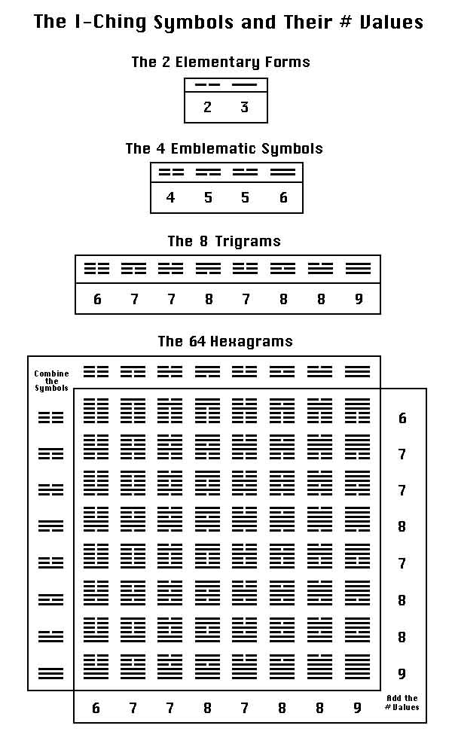
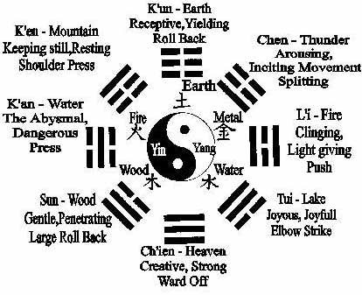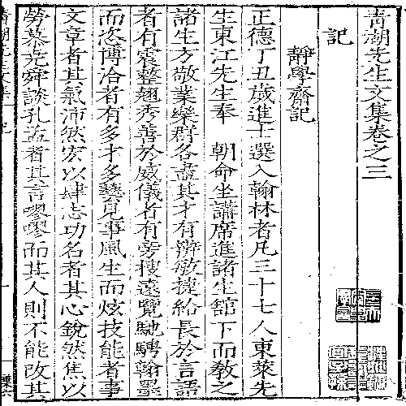
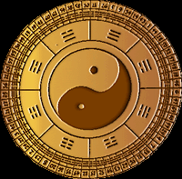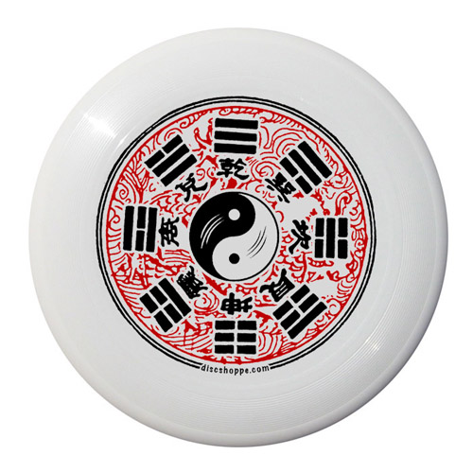

The I Ching (often spelled as I Jing, Yi Ching, Yi King, or Yi Jing ; also called "Book of Changes" or "Classic of Changes") is the oldest of the Chinese classic texts. A symbol system designed to identify order in what seem like chance events, it describes an ancient system of cosmology and philosophy that is at the heart of Chinese cultural beliefs. The philosophy centers on the ideas of the dynamic balance of opposites, the evolution of events as a process, and acceptance of the inevitability of change (see Philosophy, below). In Western cultures, the I Ching is regarded by some as simply a system of divination; many believe it expresses the wisdom and philosophy of ancient China.
The book consists of a series of symbols, rules for manipulating these symbols, poems, and commentary.

Contents
[hide]
- 1 Implications of the title
- 2 History
  - 2.1 Traditional view
  - 2.2 Western ("Modernist") view
- 3 Structure
  - 3.1 Trigrams
  - 3.2 Hexagram Lookup Table
  - 3.3 The hexagrams
- 4 Unicode
- 5 Philosophy
  - 5.1 Binary sequence
- 6 Divination
- 7 Symbolism
- 8 Influence on Western culture
- 9 Translations
- 10 References
- 11 External links

[] Implications of the title
- 易 (yì), when used as an adjective, means "easy" or "simple", while as a verb it implies "to change".
- 經 (jīng) here means "classic (text)", which derived from its original meaning of "regularity" or "persistency", implying that the text describes the Ultimate Way which will not change throughout the flow of time.
The conception behind this title, thus, is profound. It has three implications:
- Simplicity - the root of the substance. The fundamental law underlying everything in the universe is utterly plain and simple, no matter how abstruse or complex some things may appear to be.
- Variability - the use of the substance. Everything in the universe is continually changing. By comprehending this one may realize the importance of flexibility in life and may thus cultivate the proper attitude for dealing with a multiplicity of diverse situations.
- Persistency - the essence of the substance. While everything in the universe seems to be changing, among the changing tides there is a persistent principle, a central rule, which does not vary with space and time.
(易一名而含三義：易簡一也；變易二也；不易三也。 commented on by Zheng Xuan (鄭玄 zhèng xúan) in his writings Critique of I Ching (易贊 yì zàn) and Commentary on I Ching (易論 yì lùn) of Eastern Han Dynasty).
Due to the profound ideas conveyed by the title itself, it is practically impossible to arrive at an unbiased translation which could preserve the original concepts intact. The translation of the title into English used to be Book of Changes, though a slightly more accurate name, Classic of Changes, appears more frequently in recent use.

[] History

[] Traditional view
Traditionally it was believed that the principles of the I Ching originated with the mythical Fu Hsi (伏羲 Fú Xī). In this respect he is seen as an early culture hero, one of the earliest legendary rulers of China (traditional dates 2852 BCE-2738 BCE), reputed to have had the 8 trigrams (八卦 bā gùa) revealed to him supernaturally. By the time of the legendary Yu (禹 Yǔ) 2070 BC–2061 BC, trigrams had supposedly been developed into 64 hexagrams (六十四卦 lìu shí sì gùa), which were recorded in the scripture Lian Shan (《連山》 Lián Shān; also called Lian Shan Yi). Lian Shan, meaning "continuous mountains" in Chinese, begins with the hexagram Bound (艮 gèn), which depicts a mountain (::|) mounting on another and is believed to be the origin of the scripture's name.
After the traditionally recorded Xia Dynasty was overthrown by the Shang Dynasty, the hexagrams are said to have been re-deduced to form Gui Cang (《歸藏》 Gūi Cáng; also called Gui Cang Yi), and the hexagram Field (坤 kūn) became the first hexagram. Gui Cang may be literally translated into "return and be contained," which refers to earth as the first hexagram itself indicates. At the time of Shang's last king, Zhou Wang, King Wen of Zhou is said to have deduced the hexagram and discovered that the hexagrams beginning with Force (乾 qián) revealed the rise of Zhou. He then gave each hexagram a description regarding its own nature, thus Gua Ci (卦辭 guà cí, "Explanation of Hexagrams").
When King Wu of Zhou, son of King Wen, toppled the Shang Dynasty, his brother Zhou Gong Dan is said to have created Yao Ci (爻辭 yáo cí, "Explanation of Horizontal Lines") to clarify the significance of each horizontal line in each hexagram. It was not until then that the whole context of I Ching was understood. Its philosophy heavily influenced the literature and government administration of the Zhou Dynasty (1122 BCE - 256 BCE).
Later, during the time of Spring and Autumn (722 BCE - 481 BCE), Confucius is traditionally said to have written the Shi Yi (十翼 shí yì, "Ten Wings"), a group of commentaries on the I Ching. By the time of Han Wu Di (漢武帝 Hàn Wǔ Dì) of the Western Han Dynasty (circa 200 BCE), Shi Yi was often called Yi Zhuan (易傳 yì zhùan, "Commentary on the I Ching"), and together with the I Ching they composed Zhou Yi (周易 zhōu yì, "Changes of Zhou"). All later texts about Zhou Yi were explanations only, due to the classic's deep meaning.

[] Western ("Modernist") view
In the past 50 years a "Modernist" history of the I Ching has been emerging, based on context criticism and research into Shang and Zhou dynasty oracle bones, as well as Zhou bronze inscriptions and other sources (see below). These reconstructions are dealt with in a growing number of books, such as The Mandate of Heaven: Hidden History in the I Ching, by S. J. Marshall, and Richard Rutt's Zhouyi: The Book of Changes, (see References, below). Scholarly works dealing with the new view of the Book of Changes include doctoral dissertations by Richard Kunst and Edward Shaughnessy. These and other scholars have been helped immensely by the discovery, in the 1970s, by Chinese archaeologists, of intact Han dynasty era tombs in Mawangdui near Changsha, Hunan province. One of the tombs contained more or less complete 2nd century BCE texts of the I Ching, the Dao De Jing and other works, which are mostly similar yet in some ways diverge significantly from the "received," or traditional, texts preserved by the chances of history.
The tomb texts include additional commentaries on the I Ching, previously unknown, and apparently written as if they were meant to be attributed to Confucius. All of the Mawangdui texts are many centuries older than the earliest known attestations of the texts in question. When talking about the evolution of the Book of Changes, therefore, the Modernists contend that it is important to distinguish between the traditional history assigned to texts such as the I Ching (felt to be anachronistic by the Modernists), assignations in commentaries which have themselves been canonized over the centuries along with their subjects, and the more recent scholarly history aided by modern linguistic textual criticism and archaeology. Many hold that these perspectives are not necessarily mutually exclusive, but, for instance, many Modernist scholars doubt the actual existence of Fuxi, think Confucius had nothing to do with the Book of Changes, and contend that the hexagrams came before the trigrams. Modern scholarship comparing poetic usage and formulaic phrasing in this book with that in ancient bronze inscriptions has shown that the text cannot be attributed to King Wen or Zhou Gong, and that it likely was not compiled until the late Western Zhou, perhaps ca. the late 9th century BC. Rather than being the work of one or several legendary or historical figures, the core divinatory text is now thought to be an accretion of Western Zhou divinatory concepts. As for the Shi Yi commentaries traditionally attributed to Confucius, scholars from the time of the 11th century A.D. scholar Ouyang Xiu onward have doubted this, based on textual analysis, and modern scholars date most of them to the late Warring States period, with some sections perhaps being as late as the Western Han period.

[] Structure
The text of the I Ching is a set of predictions represented by a set of 64 abstract line arrangements called hexagrams (卦 guà). Although just the numbers 1 to 64 could have been used, the ancient Chinese instead used a figure composed of six stacked horizontal lines (爻 yáo). Each line is either Yang (an unbroken, or solid line), or Yin (broken, an open line with a gap in the centre). With six such lines stacked from bottom to top there are 2⁶ or 64 possible combinations, and thus 64 hexagrams represented.
The hexagram diagram is conceptually subdivided into two three-line arrangements called trigrams (卦 guà). There are 2³, hence 8, possible trigrams. The traditional view was that the hexagrams were a later development and resulted from combining the two trigrams. However, in the earliest relevant archaeological evidence, groups of numerical symbols on many Western Zhou bronzes and a very few Shang oracle bones, such groups already usually appear in sets of six. A few have been found in sets of three numbers, but these are somewhat later. Note also that these numerical sets greatly predate the groups of broken and unbroken lines, leading modern scholars to doubt the mythical early attributions of the hexagram system (see, e.g., Shaugnessy 1993).
Each hexagram represents a description of a state or process. When a hexagram is cast using one of the traditional processes of divination with I Ching, each of the yin or yang lines will be indicated as either moving (that is, changing), or fixed (that is, unchanging). Moving (also sometimes called "old", or "unstable") lines will change to their opposites, that is "young" lines of the other type -- old yang becoming young yin, and old yin becoming young yang.
The oldest method for casting the hexagrams, using yarrow stalks, is a biased random number generator, so the possible answers are not equiprobable. While the probability of getting young yin or young yang is equal, the probability of getting old yang is three times greater than old yin. The yarrow stalk method was gradually replaced during the Han Dynasty by the three coins method. Using this method, the imbalance in generating old ying and old yang was eliminated. However, there is no theoretical basis for indicating what should be the optimal probability basis of the old lines versus the young lines. Of course, the whole idea behind this system of divination is that the oracle will select the appropriate answer anyway, regardless of the probabilities.
There have been several arrangements of the trigrams and hexagrams over the ages. The bā gùa is a circular arrangement of the trigrams, traditionally printed on a mirror, or disk. According to legend, Fu Hsi found the bā gùa on the scales of a tortoise's back. They function rather like a magic square, with the four axes summing to the same value (e.g., using 0 and 1 to represent yin and yang, 000 + 111 = 111, 101 + 010 = 111, etc.).
The King Wen sequence is the traditional (i.e. "classical") sequence of the hexagrams used in most contemporary ions of the book. The King Wen sequence was explained for the first time in STEDT Monograph #5, where it is shown to contain within it a demonstration of advanced mathematical knowledge.

[] Trigrams
The solid line represents yang, the creative principle. The open line represents yin, the receptive principle. These principles are also represented in a common circular symbol (☯), known as taijitu (太極圖), but more commonly known in the west as the yin-yang (陰陽) diagram, expressing the idea of complementarity of changes: when Yang is at top, Yin is increasing, and the reverse.
In the following lists, the trigrams and hexagrams are represented using a common textual convention, horizontally from left-to-right, using '|' for yang and '¦' for yin, rather than the traditional bottom-to-top. In a more modern usage, the numbers 0 and 1 can also be used to represent yin and yang, being read left-to-right.
There are eight possible trigrams (八卦 bāguà):

 | Trigram Figure | Binary Value | Name | Nature | Direction | Elemental
1 | ||| (☰) | 111 | Force (乾 qián) | heaven (天) | northwest | Lingam
2 | ||¦ (☱) | 110 | Open (兌 duì) | swamp (澤) | west | Water
3 | |¦| (☲) | 101 | Radiance (離 lí) | fire (火) | south | Sol
4 | |¦¦ (☳) | 100 | Shake (震 zhèn) | thunder (雷) | east | Fire
5 | ¦|| (☴) | 011 | Ground (巽 xùn) | wind (風) | southeast | Air
6 | ¦|¦ (☵) | 010 | Gorge (坎 kǎn) | water (水) | north | Luna
7 | ¦¦| (☶) | 001 | Bound (艮 gèn) | mountain (山) | northeast | Earth
8 | ¦¦¦ (☷) | 000 | Field (坤 kūn) | earth (地) | southwest | Yoni

The first three lines of the hexagram, called the lower trigram, are seen as the inner aspect of the change that is occurring. The upper trigram (the last three lines of the hexagram), is the outer aspect. The change described is thus the dynamic of the inner (personal) aspect relating to the outer (external) situation. Thus, hexagram 04 ¦|¦¦¦| Enveloping, is composed of the inner trigram ¦|¦ Gorge, relating to the outer trigram ¦¦| Bound.

Hexagram Lookup Table
Upper →  Lower ↓ | |||  Ch'ien  Heaven | |¦¦  Chên  Thunder | ¦|¦  K'an  Water | ¦¦|  Kên  Mountain | ¦¦¦  K'un  Earth | ¦||  Sun  Wind | |¦|  Li  Flame | ||¦  Tui  Swamp
|||  Ch'ien  Heaven | 1 | 34 | 5 | 26 | 11 | 9 | 14 | 43
|¦¦  Chên  Thunder | 25 | 51 | 3 | 27 | 24 | 42 | 21 | 17
¦|¦  K'an  Water | 6 | 40 | 29 | 4 | 7 | 59 | 64 | 47
¦¦|  Kên  Mountain | 33 | 62 | 39 | 52 | 15 | 53 | 56 | 31
¦¦¦  K'un  Earth | 12 | 16 | 8 | 23 | 2 | 20 | 35 | 45
¦||  Sun  Wind | 44 | 32 | 48 | 18 | 46 | 57 | 50 | 28
|¦|  Li  Flame | 13 | 55 | 63 | 22 | 36 | 37 | 30 | 49
||¦  Tui  Swamp | 10 | 54 | 60 | 41 | 19 | 61 | 38 | 58

The hexagrams
The text of the I Ching describes each of the 64 hexagrams, and later scholars added commentaries and analyses of each one; these have been subsumed into the text comprising the I Ching.
Each hexagram's common translation is accompanied by the corresponding R. Wilhelm translation, which is the source for the Unicode names.
  Hexagram | R. Wilhelm
  01. |||||| Force (乾 qián) | The Creative
  02. ¦¦¦¦¦¦ Field (坤 kūn) | The Receptive
  03. |¦¦¦|¦ Sprouting (屯 chún) | Difficulty at the Beginning
  04. ¦|¦¦¦| Enveloping (蒙 méng) | Youthful Folly
  05. |||¦|¦ Attending (需 xū) | Waiting
  06. ¦|¦||| Arguing (訟 sòng) | Conflict
  07. ¦|¦¦¦¦ Leading (師 shī) | The Army
  08. ¦¦¦¦|¦ Grouping (比 bǐ) | Holding Together
  09. |||¦|| Small Accumulating (小畜 xiǎo chù) | Small Taming
  10. ||¦||| Treading (履 lǚ) | Treading (Conduct)
  11. |||¦¦¦ Prevading (泰 tài) | Peace
  12. ¦¦¦||| Obstruction (否 pǐ) | Standstill
  13. |¦|||| Concording People (同人 tóng rén) | Fellowship
  14. ||||¦| Great Possessing (大有 dà yǒu) | Great Possession
  15. ¦¦|¦¦¦ Humbling (謙 qiān) | Modesty
  16. ¦¦¦|¦¦ Providing-For (豫 yù) | Enthusiasm
  17. |¦¦||¦ Following (隨 suí) | Following
  18. ¦||¦¦| Corrupting (蠱 gǔ) | Work on the Decayed
  19. ||¦¦¦¦ Nearing (臨 lín) | Approach
  20. ¦¦¦¦|| Viewing (觀 guān) | Contemplation
  21. |¦¦|¦| Gnawing Bite (噬嗑 shì kè) | Biting Through
  22. |¦|¦¦| Adorning (賁 bì) | Grace
  23. ¦¦¦¦¦| Stripping (剝 bō) | Splitting Apart
  24. |¦¦¦¦¦ Returning (復 fù) | Return
  25. |¦¦||| Without Embroiling (無妄 wú wàng) | Innocence
  26. |||¦¦| Great Accumulating (大畜 dà chù) | Great Taming
  27. |¦¦¦¦| Swallowing (頤 yí) | Mouth Corners
  28. ¦||||¦ Great Exceeding (大過 dà guò) | Great Preponderance
  29. ¦|¦¦|¦ Gorge (坎 kǎn) | The Abysmal Water
  30. |¦||¦| Radiance (離 lí) | The Clinging
  31. ¦¦|||¦ Conjoining (咸 xián) | Influence
  32. ¦|||¦¦ Persevering (恆 héng) | Duration
  Hexagram | R. Wilhelm
  33. ¦¦|||| Retiring (遯 dùn) | Retreat
  34. ||||¦¦ Great Invigorating (大壯 dà zhuàng) | Great Power
  35. ¦¦¦|¦| Prospering (晉 jìn) | Progress
  36. |¦|¦¦¦ Brightness Hiding (明夷 míng yí) | Darkening of the Light
  37. |¦|¦|| Dwelling People (家人 jiā rén) | The Family
  38. ||¦|¦| Polarising (睽 kuí) | Opposition
  39. ¦¦|¦|¦ Limping (蹇 jiǎn) | Obstruction
  40. ¦|¦|¦¦ Taking-Apart (解 xiè) | Deliverance
  41. ||¦¦¦| Diminishing (損 sǔn) | Decrease
  42. |¦¦¦|| Augmenting (益 yì) | Increase
  43. |||||¦ Parting (夬 guài) | Breakthrough
  44. ¦||||| Coupling (姤 gòu) | Coming to Meet
  45. ¦¦¦||¦ Clustering (萃 cuì) | Gathering Together
  46. ¦||¦¦¦ Ascending (升 shēng) | Pushing Upward
  47. ¦|¦||¦ Confining (困 kùn) | Oppression
  48. ¦||¦|¦ Welling (井 jǐng) | The Well
  49. |¦|||¦ Skinning (革 gé) | Revolution
  50. ¦|||¦| Holding (鼎 dǐng) | The Cauldron
  51. |¦¦|¦¦ Shake (震 zhèn) | Arousing
  52. ¦¦|¦¦| Bound (艮 gèn) | The Keeping Still
  53. ¦¦|¦|| Infiltrating (漸 jiàn) | Development
  54. ||¦|¦¦ Converting The Maiden (歸妹 guī mèi) | The Marrying Maiden
  55. |¦||¦¦ Abounding (豐 fēng) | Abundance
  56. ¦¦||¦| Sojourning (旅 lǚ) | The Wanderer
  57. ¦||¦|| Ground (巽 xùn) | The Gentle
  58. ||¦||¦ Open (兌 duì) | The Joyous
  59. ¦|¦¦|| Dispersing (渙 huàn) | Dispersion
  60. ||¦¦|¦ Articulating (節 jié) | Limitation
  61. ||¦¦|| Centre Confirming (中孚 zhōng fú) | Inner Truth
  62. ¦¦||¦¦ Small Exceeding (小過 xiǎo guò) | Small Preponderance
  63. |¦|¦|¦ Already Fording (既濟 jì jì) | After Completion
  64. ¦|¦|¦| Not-Yet Fording (未濟 wèi jì) | Before Completion
The hexagrams, though, are mere mnemonics for the philosophical concepts embodied in each one. The philosophy centres around the ideas of balance through opposites and acceptance of change.

[] Unicode
The hexagram symbols range from U+4DC0 – U+4DFF (19904 – 19967) in Unicode.

[] Philosophy
Gradations of binary expression based on yin and yang -- old yang, old yin, young yang or young yin (see the divination paragraph below) -- are what the hexagrams are built from. Yin and yang, while common expressions associated with many schools known from classical Chinese culture, are especially associated with the Taoists.
Another view holds that the I Ching is primarily a Confucianist ethical or philosophical document. This view is based upon the following:
- The Wings or Appendices are attributed to Confucius.
- The study of the I Ching was required as part of the Civil Service Exams. These exams only studied Confucianist texts.
- It is one of the Five Confucian Classics.
- It does not appear in any surviving ions of the Dao Zheng.
- The major commentaries were written by Confucianists, or Neo-Confucianists.
Both views may be seen to show that the I Ching was at the heart of Chinese thought, serving as a common ground for the Confucian and Taoist schools. Partly forgotten due to the rise of Chinese Buddhism during the Tang dynasty, the I Ching returned to the attention of scholars during the Song dynasty. This was concomitant with the reassessment of Confucianism by Confucians in the light of Taoist and Buddhist metaphysics, and is known in the West as Neo-Confucianism. The book, unquestionably an ancient Chinese scripture, helped Song Confucian thinkers to synthesize Buddhist and Taoist cosmologies with Confucian and Mencian ethics. The end product was a new cosmogony that could be linked to the so-called "lost Tao" of Confucius and Mencius.

[] Binary sequence
In his article Explication de l'Arithmétique Binaire (1703) Gottfried Leibniz writes that he has found in the hexagrams a base for claiming the universality of the binary numeral system. He takes the layout of the combinatorial exercise found in the hexagrams to represent binary sequences, so that ¦¦¦¦¦¦ would correspond to the binary sequence 000000 and ¦¦¦¦¦| would be 000001, and so forth.
The binary arrangement of hexagrams is asociated with the famous Chinese scholar and philosopher Shao Yung (a neo-Confucian and Taoist) in the 11th century. He displayed it in two different formats, a circle, and a rectangular block. Thus, he clearly understood the sequence represented a logical progression of values. However, while it is true that these sequences do represent the values 0 through 63 in a binary display, there is no evidence that Shao understood that the numbers could be used in computations such as addition or subtraction.

[] Divination
Main article: I Ching divination
The I Ching has long been used as an oracle and many different ways coexist to "cast" a reading, i.e., a hexagram, with its dynamic relationship to others.

[] Symbolism



The flag of South Korea, with Taeguk in the center with four trigrams representing Heaven, Water, Earth, and Fire (beginning top left and proceeding clockwise).
The Flag of South Korea contains the T'ai Chi symbol, or tàijítú, (yin and yang in dynamic balance, called taeguk in Korean), representing the origin of all things in the universe. The taeguk is surrounded by four of the eight trigrams, starting from top left and going clockwise: Heaven, Water, Earth, Fire.
The flag of the Empire of Vietnam used the trigram number 30 and was known as cờ quẻ Ly (Li trigram flag) because the trigram represents South. Its successor the Republic of Vietnam connected the middle lines, turning it into trigram number 1. (see Flag of the Republic of Vietnam).

[] Influence on Western culture
Main article: I Ching's influence
The I Ching has influenced countless Chinese philosophers, artists and even businesspeople throughout history. In more recent times, several Western artists and thinkers have used it.

[] Translations
- Anthony, Carol K. & Moog, Hanna. I Ching: The Oracle of the Cosmic Way. Stow, Massachusetts: Anthony Publishing Company, Inc., 2002. ISBN 1-890764-00-0. The publisher's internet address is www.ichingoracle.com.
- Balkin, Jack M. 2002. "The Laws of Change: I Ching and the Philosophy of Life". New York: Schocken Books. ISBN 0-8052-4199-X
- Benson, Robert G. 2003. I Ching for a New Age: The Book of Answers for Changing Times. New York: Square One Publishers.
- Blofeld, J. 1965. The Book of Changes: A New Translation of the Ancient Chinese I Ching. New York: E. P. Dutton.
- Huang, A. 1998. The Complete I Ching: the Definitive Translation From the Taoist Master Alfred Huang. Rochester, N.Y: Inner Traditions.
- Hua-Ching Ni. 1999. I Ching: The Book of Changes and the Unchanging Truth. (2nd ion). Los Angeles: Seven Star Communications.
- Karcher, Stephen, 2002. I Ching: The Classic Chinese Oracle of Change: The First Complete Translation with Concordance. London: Vega Books. ISBN 1-84333-003-2. The publisher can be found at www.chrysalisbooks.co.uk. This version manages to pull together a wide variety of sources and interpretations into a coherent, intelligible whole which is generally easier to understand than the Wilhelm/Baynes ion. Especially interesting are its multiple translations of the Chinese words used and the concordance at the end.
- Legge, J. 1964. I Ching: Book of Changes. With introduction and study guide by Ch'u Chai and Winberg Chai. New York: Citadel Press.
- I Ching, The Classic of Changes, The first English translation of the newly discovered second-century B.C. Mawangdui texts by Edward L. Shaughnessy, Ballantine, 1996. ISBN 0-345-36243-8.
- Wilhelm, R. & Baynes, C., 1967. The I Ching or Book of Changes, With forward by Carl Jung. 3rd. ed., Bollingen Series XIX. Princeton NJ: Princeton University Press (1st ed. 1950).
- Lynn, Richard J. 1994, The Classic of Changes, A New Translation of the I Ching as Interpreted by Wang Bi. New York: Columbia University Press. ISBN 0-231-08294-0
- Wei, Wu 2005. "I Ching, The Book Of Answers" Power Press ISBN 0-943015-41-3 New revised ion, interpreted by Wu Wei. Appears to follow the Wilhelm and Baynes translation real well, leaving out the sometimes confusing mechanics. Would be handy to use in conjunction with Wilhelm and Baynes when divining for the lay person.
- Cheng Yi translated by Cleary, Thomas 1988, 2003. "I Ching: The Book of Change" Shambala Library, Boston, London ISBN 1-59030-015-7

References
- Herbie Brennan, 1973. The Syncronistic Barometer, Analog, August 1973.
- Marshall, S. 2001. The Mandate of Heaven: Hidden History in the I Ching. Columbia University Press
- Rutt, R. 1996. Zhouyi: The Book of Changes. Curzon Press.
- Reifler, Samuel. 1974. "I Ching: A New Interpretation for Modern Times." Bantam New Age Books. ISBN 0-553-27873-8
- Shaughnessy, Edward L. (1993). “I ching 易經 (Chou I 周易)”, pp.216-228 in Loewe, Michael (ed.). Early Chinese Texts: A Bibliographical Guide, (Early China Special Monograph Series No. 2), Society for the Study of Early China, and the Institute of East Asian Studies, University of California, Berkeley, ISBN 1-55729-043-1.

[] External links
- Zhou Yi - Original text and commentaries in Chinese
- The Daily I Ching - Free website with information and archived wisdom from the I Ching
- I CHING Bookmarks - Directory of I Ching sites
- The I Ching on the Net includes full text translations of the I Ching, commentaries and other links.
- I Ging - Das Buch der Wandlungen, in german
- I Ching at the Open Directory Project
- The Key to the I Ching - An article about understanding hexagrams through schema theory.
- Text of Book I of Wilhelm/Baynes translation 3rd. ed., Bollingen Series XIX (Princeton NJ: Princeton University Press, 1967, 1st ed. 1950)
- History of Chue Style Six Kinships Hexagram Yi Jing
- Dedicated website to study I Ching (en and fr)
- I-ching - Philosophy and Practice - An introduction to the study of I-ching (Book of Changes); includes online course.
- Le Symbiotic Yi King
- Nu Yi Dao - Nu (Thelemic) Divination Coins also free Macintosh 'I Ching Calculator' download
- i-ching.com Virtual I-Ching coin toss and I-Ching Reading
- I Ching I Ching ancient coins and playing

=====================================================================================================================

END

