Inquisition

http://en.wikipedia.org/wiki/Inquisition

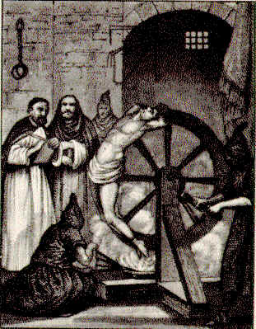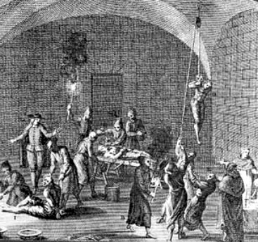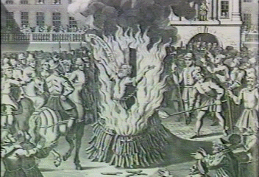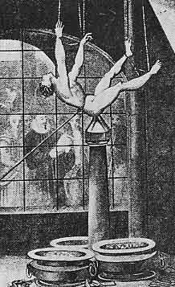

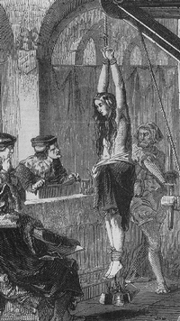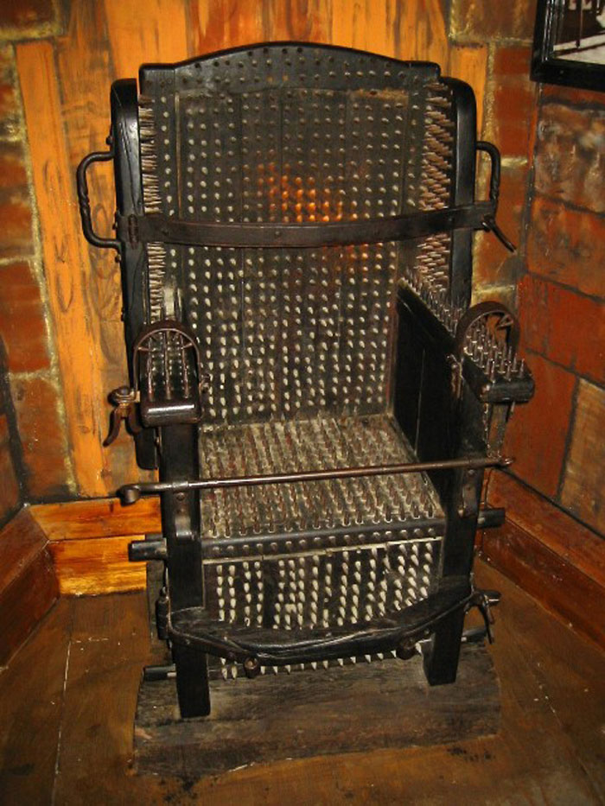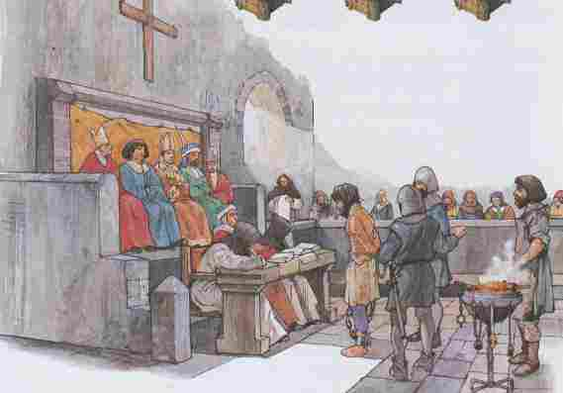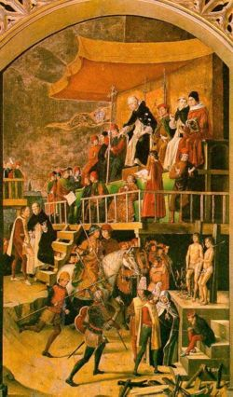

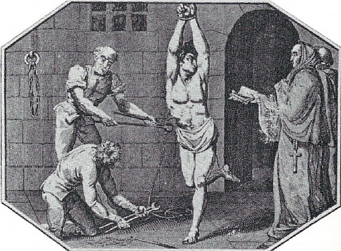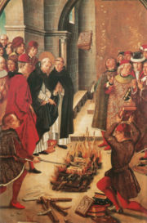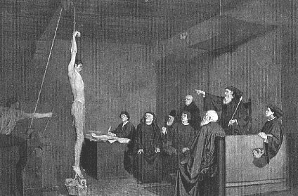

Inquisition (capitalized I) is broadly used, to refer to things related to judgment of heresy by the Catholic Church. It can mean an ecclesiastical tribunal or institution from the Roman Catholic Church for combating or suppressing heresy, a number of historical expurgation movements against heresy (orchestrated by the Roman Catholic Church), or the trial conducted against a heretic.

Contents
- 1 Origin of the term
- 2 Ancient origins
- 3 Inquisition tribunals and institutions
- 4 Historic Inquisition movements
  - 4.1 Medieval Inquisition
  - 4.2 Spanish Inquisition
  - 4.3 Portuguese Inquisition
  - 4.4 Roman Inquisition
- 5 Other uses of the word "Inquisition"
- 6 Derivative works
- 7 See also
- 8 External links
- 9 References
  - 9.1 Online works

Origin of the term
The word inquisition (from the Latin: inquisitio) is the act of inquiring. It was broadly used in law, before the Medieval Inquisition, to refer a common law procedure of inquiring into a matter, investigating, usually through interrogation, and by use of force (see Argumentum ad baculum). Through time, it was gradually associated with judging heresy against Christianity.

[] Ancient origins
Christianity and the Christian Church were from the beginning of their history suffering from two threats: external persecution by the Roman Emperors, and internal strife caused by theological disputes.
Early examples are the Jerusalem Council reported in Acts of the Apostles (Chapter 15) and the many occasions, in which the Apostle Paul defends his own apostleship, and urges Christians in various places to beware of false teachers, or of anything contrary to what was handed to them by him. The epistles of John and Jude also warn of false teachers, as does the writer of the Book of Revelation.
Since the 2nd century, Church authorities (bishops and local synods) reacted to these disputes by condemning some theologians as heretics and defining doctrine more clearly to combat perceived errors. In this way, orthodoxy (Greek: the right view) was defined contrast to heresy (wrong choice). The most notable heresies were Gnosticism, Marcionism, Montanism and various forms of Monarchianism. During this period, those condemned for heresy were excommunicated from the Church community and only readmitted after having recanted the controversial opinions. Bishops and other church leaders were stripped of their offices and had to resign valuables placed in their care.
When Constantine I adopted Christianity in 313, he among other things hoped that the new religion would help unify the Empire. However, such expectations were threatened by the appearance of heresies inside of the Church. Constantine felt compelled to involve himself with these doctrinal or disciplinary struggles, as in the case of the Donatists or the Arians. He tried to enforce decisions reached by the Church by banishing obstinate opponents - clergy and laity - of these decisions. Non-Christians however were not concerned by these measures. Some of his successors, while leaning to the sides of the Arians, increased their use of force in Church matters, regularly banishing bishops from their sees. Theodosius, an unequivocal supporter of Orthodox Christianity, also made Christianity the official religion of the Empire.
The first heretic to be executed was Priscillian of Avila. Having been condemned for heresy by a synod, he appealed to the Emperor Maximus; the latter, however, had Priscillian and six of his followers beheaded at Treves in 385. This act was approved by a synod which met at Treves in the same year, though the most prominent bishops of that time, Ambrose of Milan, Martin of Tours and Pope Siricius protested against Priscillian's execution, largely on the jurisdictional grounds that an ecclesiastical case should not be decided by a civil tribunal, and worked to reduce the persecution.
Another heretic to be executed in 1600 was Giordano Bruno who is seen by some as a martyr to the cause of free thought.
The Catholic Encyclopedia notes that "various penal laws were enacted by the Christian emperors against heretics as being guilty of crime against the State. In both the Theodosian and Justinian codes they were styled infamous persons ... In some particularly aggravated cases sentence of death was pronounced upon heretics, though seldom executed in the time of the Christian emperors of Rome."^{[1]} Though the death penalty was seldom executed during the Early Middle Ages, these laws nonetheless later served as the basis of the prosecution of heretics, especially after Emperor Frederick II had confirmed these rulings.

[] Inquisition tribunals and institutions
Before the twelfth century, the Catholic Church had already suppressed heresy. However, it was ad hoc, as the Church had no structured system for suppressing heresy. So the suppressions were generally slow and without a pattern.
In the twelfth century (Episcopal inquisition), the Catholic Church together with non-secular governments started to gradually develop a structured way to deal with heresy. In that time, Church Councils (composed of bishops and archbishops) used local authorities to persecute heretics. Inquisition was, by then, referred to by the Church as "Inquisitio Haereticae Pravitatis Sanctum Officium", or "Holy Office of Inquisition into Heretical Wickedness".
Later in the thirteenth century (Papal inquisition), the pope assigned the Dominican Order for the duty of inquisitors. Since then Inquisitors were few (always less than 10), acting by the name of the Pope with full authority. They judged heresy alone, using local authorities to put a tribunal and persecute heretics. Since the end of the fifteenth century(Spanish Revolution) they were ruled by a Grand Inquisitor. Inquisitors persisted through time until the nineteenth century.
In the sixteenth century, in Roman Inquisition, the Pope Paul III established a system of tribunals, ruled by the "Supreme Sacred Congregation of the Roman and Universal Inquisition", staffed by cardinals and other officials. In 1908 it was changed to "Supreme Sacred Congregation of the Holy Office" by Saint Pope Pius X.
In 1965, the "Supreme Sacred Congregation of the Holy Office" was changed again to Congregation for the Doctrine of the Faith, which persists down to today.

[] Historic Inquisition movements
Historians distinguish between four different manifestations of the Inquisition: the Medieval or Episcopal Inquisition, the Spanish Inquisition, the Portuguese Inquisition and the Roman Inquisition.
Because of its objective, combatting heresy, the Inquisition had jurisdiction only over baptized members of the Church (which, however, encompassed the vast majority of the population). Non-Christians could still be tried for blasphemy by secular courts. Also, most of the witch trials were held by secular courts.

[] Medieval Inquisition
Main article: Medieval Inquisition
The Medieval Inquisition is a term historians use to describe the various inquisitions that started around 1184, including the Episcopal Inquisition (1184-1230s) and later the Papal Inquisition (1230s). It was in response to large popular movements throughout Europe considered apostate or heretical to Christianity, in particular Catharism and Waldensians in southern France and northern Italy. These were the first inquisition movements of many that would follow.

[] Spanish Inquisition
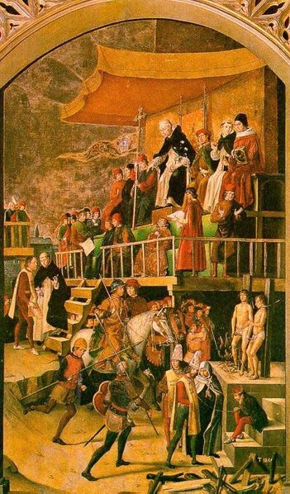
Representation of an Auto de fe, (1475).
Many artistic representations depict torture and the burning at the stake as occurring during the auto da fe. Actually, burning at the stake usually occurred after, not during the ceremonies.

Main article: Spanish Inquisition
The Spanish Inquisition was set up by King Ferdinand and Queen Isabella of Castile in 1478 with the approval of Pope Sixtus IV. In contrast to the previous Inquisition, it operated completely under royal authority, though staffed by secular clergy and orders, and independently of the Holy See. It aimed primarily at converts from Judaism and Islam (who were still residing in Spain after the end of the Moor control of Spain), who were suspected of either continuing to adhere to their old religion (often after having been converted under duress) or having fallen back into it, and later at Protestants; in Sicily and Southern Italy, which were under Spanish rule, it targeted Greek Orthodox Christians. After religious disputes waned in the 17th century, the Spanish Inquisition more and more developed into a secret police against internal threats to the state.
The Spanish Inquisition would subsequently be employed in certain Spanish colonies such as Peru and Mexico. The Spanish Inquisition continued in the Americas until Mexican Independence and was not abolished in Europe until 1834.
In the public imagination, the Spanish Inquisition continues as a proverbial example of religious persecution. Some scholars however have opined that the numbers of the Spanish inquisition's victims have been greatly exaggerated, that the Inquisition is one of the features of a Black Legend. Also, some argue that the Spanish Inquisition was responsible in part for averting in Spain the kind of religious wars that plagued France and Germany. Similar arguments are made about averting witch trials in Spain.

[] Portuguese Inquisition
Main article: Portuguese Inquisition
The Portuguese Inquisition was established in Portugal in 1536 by the King of Portugal, João III, as a Portuguese analogue of the more famous Spanish Inquisition.
Main article: Goa Inquisition
The Goa Inquisition was the office of the Inquisition acting in the Indian city of Goa and the rest of the Portuguese empire in Asia. Established in 1560, it was aimed primarily at wayward new converts from Hinduism.

[] Roman Inquisition
Main article: Roman Inquisition
Pope Paul III established, in 1542, a permanent congregation staffed with cardinals and other officials, whose task was to maintain and defend the integrity of the faith and to examine and proscribe errors and false doctrines. This body, the Congregation of the Holy Office, now called the Congregation for the Doctrine of the Faith, part of the Roman Curia, became the supervisory body of local Inquisitions. The Pope appoints one of the cardinals to preside over the meetings. There are usually ten other cardinals on the Congregation, as well as a prelate and two assistants all chosen from the Dominican Order. The Holy Office also has an international group of consultants, experienced scholars of theology and canon law, who advise it on specific questions.
Arguably the most famous case tried by the Roman Inquisition was that of Galileo Galilei in 1633.

[] Other uses of the word "Inquisition"
Even though the last Inquisition (The Spanish Inquisition) ended in 1834 almost 200 years ago, the word "Inquisition" remains a part of modern vocabulary; even those with no interest in European history associate it with negative meanings.[1] Because of the negative images associated with the Inquisition, the term has taken on a pejorative usage, and is often used to express disapproval, and is often used in a non-neutral manner, and not as a neutral historical descriptor.
- Emperor Qianlong's literary inquisition in Qing Dynasty China.
- In modern American politics, United States Senate investigations are often called "Inquisitions" as a means of expressing disapproval of the investigators. For example some people call the Second Red Scare an inquisition.
- Robert Anton Wilson's book The New Inquisition (ISBN 1-56184-002-5) is critical of the application of the Scientific Method in the 20th century.

[] Derivative works
The Inquisitions have been the subject of many cultural works. Some include:
- The Spanish Inquisition was the subject of a classic Monty Python sketch ("Nobody expects the Spanish Inquisition!").
- The short story by Edgar Allan Poe, The Pit and the Pendulum was set during the Spanish Inquisition.
- In the alternative history novel The Two Georges by Harry Turtledove and Richard Dreyfuss, the Spanish Inquisition remains active, in Spain itself and throughout Latin America, during the whole of the Twentieth Century.
- A body known as the Inquisition exists in the fictional Warhammer 40,000 universe.
- Mel Brooks's 1981 film The History of the World, Part I contains a musical number about the Spanish Inquisition.
- In Terry Pratchett's Small Gods, the Omnian church has a Quisition, with sub-sections Inquisition and Exquisition.
- In J.K. Rowling's 2003 book Harry Potter and the Order of the Phoenix, Professor Dolores Umbridge sets up an Inquisition at Hogwarts School of Witchcraft and Wizardry, with herself as the High Inquisitor.
- The "Dark Ages" setting in the World of Darkness (WoD) fantasy universe makes heavy use of the Inquisition as that particular setting takes place during the early 13th century.
- The computer game "Lionheart: Legacy of the Crusader" made by the late Black Isle Studios uses the Spanish Inquisition as a key plot for the storyline and development of the game.
- Man of La Mancha is a Broadway musical which tells the story of the classic novel Don Quixote as a play within a play, performed by prisoners as they await a hearing with the Spanish Inquisition.

[] See also
- The Inquisition Myth
- Witchhunt
- Konrad von Marburg
- Malleus Maleficarum
- Inquisitorial system
- List of Grand Inquisitors of Spain
- Historical revisionism (political)
- Histoire de l'Inquisition en France
- Michael Servetus
- Vatican Secret Archives

[] External links
- Frequently Asked Questions About the Inquisition by James Hannam
- Books on the Inquisition
- Catholic Encyclopedia: "Inquisition"
- Catholic Answers: "The Inquisition"
- The Protestant Inquisition:"Reformation" Intolerance and Persecution by Dave Armstrong
- "The Immeasurable Curiousity of Edward Peters", p.4 as found in the Pennsylvania Gazzette, a publication of the University of Pennsylvania
- "One Cheer for the Inquisition" online copy of the Catholic Dossier article by Gerard Bradley, Professor of Law, University of Notre Dame.
- Spain and the Spaniard
- Scholarly studies including Lea's History
- Jewish Virtual Library on the Spanish Inquisition
- Jewish Encyclopedia of 1906 on the Inquisition
- The first papal Inquisition and the Cathars of the Languedoc
- Nobody Expects the Mosaic Inquisition! This Rock, July-August 1998, by Jimmy Akin
- Galileo Project: Christianity: Inquisition
- Spanish Inquisition (1478-1813) (in spanish language)
- Index of the court proceedings and other documents of the Portuguese Inquisition (in Portuguese)
- Clandestine Judaism in the Shadow of the Inquisition, Dr. Rivkah Shafek Lissak

[] References
- Edward Burman, The Inquisition: The Hammer of Heresy (Sutton Publishers, 2004) ISBN 0-7509-3722-X
  - A new ion of a book first published in 1984, a good, well-written and objective general history based on the main primary sources.
- Edward M. Peters, Inquisition. (University of California Press, 1989). ISBN 0-520-06630-8
  - A brief, balanced inquiry, with an especially good section on the 'Myth of the Inquisition' (see The Inquisition Myth). This is particularly valuable because much of the history available in English of the Inquisition was written in the 19th century by Protestants interested in documenting the dangers of Catholicism or Catholic apologists demonstrating that the Inquisition had been an entirely reasonable judicial body without flaws.
- Henry Kamen, The Spanish Inquisition: A Historical Revision. (Yale University Press, 1999). ISBN 0-300-07880-3
  - This revised ion of his 1965 original contributes to the understanding of the Spanish Inquisition in its local context.
- Cecil & Irene Roth, A history of the Marranos, Sepher-Hermon Press, 1974.
- Simon Whitechapel, Flesh Inferno: Atrocities of Torquemada and the Spanish Inquisition (Creation Books, 2003). ISBN 1-84068-105-5
- William Thomas Walsh, Characters of the Inquisition (TAN Books, 1997). ISBN 0-89555-326-0
- Parker, Geoffrey “Some Recent Work on the Inquisition in Spain and Italy” Journal of Modern History 54:3 1982
- Given, James B Inquisition and Medieval Society New York, Cornell University Press, 2001
- Henry Charles Lea, A History of the Inquisition of Spain (4 volumes), (New York and London, 1906–1907).
- J.A. Llorente, “Historia Critica de la Inquisicion de Espana”
- W.T. Walsh, “Isabella of Spain,” (1931).
- Genaro Garcia, “Autos de fe de la Inquisicion de Mexico,” (1910).
- F. Garau, “La Fee Triunfante,” (1691-reprinted 1931).
- V. Vignau, “Catalogo... de la Inquisicion de Toledo,” (1903).
- J. Baker, “History of the Inquisition,” (1736).
- J. Marchant, “A Review of the Bloody Tribunal,” (1770).
- E.N Adler, “Autos de fe and the Jew,” (1908).
- Ludovico a Paramo, “De Origine et Progressu Sanctae Inquisitionis,” (1598).
- J.M. Marin, “Procedimientos de la Inquisicion” (2 volumes), (1886).
- R. Cappa, “La Inquisicion Espanola,” (1888).
- A. Paz y Mellia, “Catalogo Abreviado de Papeles de Inquisicion,” (1914).
- M. Jouve, “Torquemada,” (1935).
- Sir Alexandr G. Cardew, “A Short History of the Inquisition,” (1933).
- G. G. Coulton, “The Inquisition,” (1929).
- Ramon de Vilana Perlas, “La Verdadera Practica Apostolica de el S. Tribunal de la Inquisicion,” (1735).
- H.B. Piazza, “A Short and True Account of the Inquisition and its Proceeding,” (1722).
- A.L. Maycock, “The Inquisition,” (1926).
- H. Nickerson, “The Inquisition,” (1932).
- L. Tanon, “Histoire des Tribunaux de l’Inquisition,” (1893).
- A. Herculano, “Historia da Origem e Estabelecimento da Inquisicao em Portugal,” (English translation, 1926).
- Henry Kamen, The Spanish Inquisition: A Historical Revision. (1999).
- Simon Whitechapel, Flesh Inferno: Atrocities of Torquemada and the Spanish Inquisition (Creation Books, 2003).
- Miranda Twiss, The Most Evil Men And Women In History (Michael O'Mara Books Ltd., 2002).
- Geoffrey Parker “Some Recent Work on the Inquisition in Spain and Italy” Journal of Modern History 54:3 1982
- Warren H. Carroll, "Isabel: the Catholic Queen" Front Royal, Virginia, 1991 (Christendom Press)

[] Online works
- Ludwig von Pastor, History of the Popes from the Close of the Middle Ages; Drawn from the Secret Archives of the Vatican and other original sources, 40 vols. St. Louis,
- B.Herder 1898
- Joseph de Maistre, tr. John Fletcher, Letters on the Spanish Inquisition, London : Printed by W. Hughes, 1838 (composed 1815):— late defense of the Inquisition by the principal author of the Counter-Enlightenment.
- Sister Antoinette Marie Pratt, A.M., The attitude of the Catholic Church towards witchcraft and the allied practices of sorcery and magic, A Dissertation Submitted to the Faculty of Philosophy of The Catholic University of America, Washington, D.C. June 1915, reprinted 1982, New York : AMS Press, ISBN 0-404-18429-4 - Google Books
Retrieved from "http://en.wikipedia.org/wiki/Inquisition"
Categories: Inquisition | Religious law
===================================================================================================================================
END

