Hilton Hotema 1878 – 1970

http://en.wikipedia.org/wiki/Hilton_Hotema

http://torrentsplanet.com/other-torrents/hilton-hotema-pdf-books_95419.html

SEE, for Book Descriptions - ETEXTS - 2 - Book Collections - Health Research Catalog

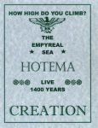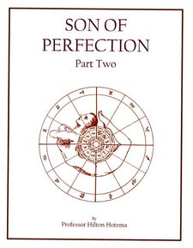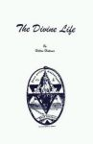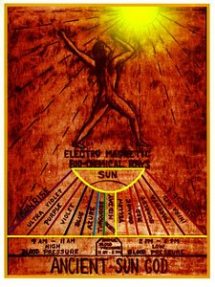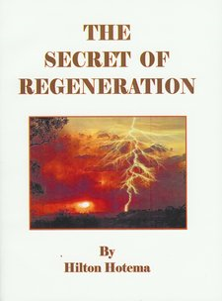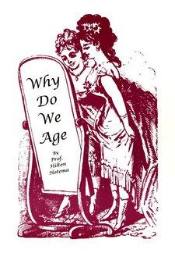

Hilton Hotema, born George R. Clements (7 February 1878, Fitchburg, Massachusetts - 1970),^{[1]} was a 20th century American alternative health writer, esoteric author and mystic, who also adopted the names Kenyon Klamonti and Dr. Karl Kridler.

Background
Hilton Hotema authored many books on many subjects including dietetics, fasting, fruitarianism, breatharianism, vitality, cellular regeneration, longevity, higher consciousness, spirituality, alternative medicine and ancient wisdom, published by Health Research Books, Washington. He collaborated with Herbert Shelton ^{[2]}, and Hereward Carrington.^{[3]} His contemporaries included Walter Siegmeister, Theos Bernard, Alexis Carrel and Johnny Lovewisdom, who wrote about related subjects.
In Man's Higher Consciousness, Hotema wrote that man was designed to live 80,000 to 100,00 years, before his teeth and alimentary canal were subject to degeneration. It was published in 1952 as Man's Miraculous Unused Power using the pen name Kenyon Klamonti.^{[4]} According to the Natural Hygiene Society, Hotema believed he would live until 150. ^{[5]} Hotema is documented in the book The Struggle Between Religion & Science by Marshall J. Gauvin.

Publications
- Ancient Secret Of Personal Power (Tetragrammaton) (1960)
- Ancient Sun God (1956)
- Awaken The World Within (1963)
- Breath Of Life And The Flame Divine (1957)
- Cosmic Creation (Second Edition) (1958)
- Cosmic Creation Part One (1956)
- Cosmic Science Of The Ancient Masters
- Cosmic Science of the Ancient Masters (2nd edition)
- Creation: Cosmic Radiation In Florida
- Divine Life (1963)
- Empyreal Sea - Live 1400 Years (1964)
- Facts of Nutrition: Vegetarianism & Longevity (1957)
- Fasting Story #1:
- Fasting Story #2: Wilborn, Carrington, Tanner, Hotema & Hanish
- Genesis Of Christianity (1967)
- Geriatrics
- Glorious Resurrection
- Golden Dawn
- Great Law (1963)
- Great Red Dragon
- Health Thru Scientific Nutrition
- Hidden Creator (1961)
- How High Do You Climb?
- How I Lived To Be Ninety (1966)
- Kingdom Of Heaven
- Land Of Light - The Tarot (1959)
- Law of Life And Human Health
- Live 1400 Years: Empyreal Living Sea (How High Do You Climb)
- Live Better: Ancient Unknown Knowledge (1963)
- Live Longer (1959)
- Living Fire & God’s Law Of Life: Sacred Wisdom of the Ancients
- Long Life In Florida (1962)
- Lost Wisdom of the Ancient Masters
- Lost Word Of Freemasonry (1967)
- Magic Beam
- Magic Temple (1968)
- Magic Wand (1956)
- Magic World (Magicalism) (1967)
- Man’s Higher Consciousness
- Man’s Miraculous Unused Powers (4 volumes)
- Mysterious Sphinx
- Mystery Man Of The Bible
- Mystery Of Man
- New Super Sprays Endangering Your Health
- Orthopathy (Elementary Orthopathy): New Science Of Health & Natural Healing
- Perfect Creation
- Pre-Existence Of Man #1
- Pre-Existence Of Man #2
- Pythagoras
- Science Of Organic Dietetics
- Secrets Of Regeneration
- Son Of Perfection #1
- Son Of Perfection #2
- Soul's Secret (1958)
- Virgin Birth
- We Do Not Die
- Why Do We Age (1959)

References
- ^ http://www.librarising.com/astrology/celebs/hiltonhotema.html Libra Rising Astrology
- ^ Virgin Birth, Shelton & Hotema, Health Research Books, Washington
- ^ Fasting Story, Carrington, Tanner, Hotema and Hanish
- ^ http://www.aberree.com/v09/n07p13.html The Complete Abereree
- ^ "George R. Clements (AKA Hilton Hotema, AKA Kenyon Klamonti) claimed he became a vegan at 9 years of age after reading a book about health at school. He also claimed he lived as a breatharian-fruitarian for almost 80 years and would "live to be 150 years of age." He only managed to reach 92." http://naturalhygienesociety.org/diet3.html#9 Natural Hygiene Society

http://www.librarising.com/astrology/celebs/hiltonhotema.html

Hilton Hotema chart
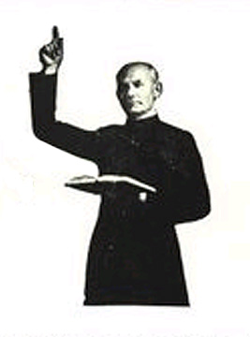  Hilton Hotema  (1878-1970) | Born: George R. Clement  Feb.7, 1878, time unknown  Fitchburg, Massachsetts  USA 71W48 42N35  Noon Positions LMT  Sun in Aquarius 18°50'  Moon in Aries 16°51'  Mercury in Capricorn 23°45'  Venus in Pisces 9°27'R  Mars in Taurus 4°55'  Jupiter in Capricorn 22°47'  Saturn in Pisces 18°57'  Uranus in Leo 27°48'R  Neptune in Taurus 13°43'R  Pluto in Taurus 23°44'  Eris in Pisces 13°57'  Fruitarian/breatharian and author of many books  including Man's Higher Conciousness(1962),  Awakening the World Within(1963), The Great  Law(1963), The Secret of Regeneration(1963), and  The Magic Temple(1968). Died at the age of 92
Health and longetivity expert Hilton Hotema displays the uniqueness and pioneering characteristics of his Sun in Aquarius and Moon in Aries placements. The Sun here is brilliant and unconventional and makes the expression of truth and freedom the the central priorities of the life. The ruler Uranus is in Leo and in mutual reception so that these truths are used to elevate the dignity or divinity in man. Moon in Aries seeks challenge, activity, and newness, and is often reputed to be aggressive or impatient. Mercury in Capricorn thinks logically and realistically and relies on organization and hard work. They have an interest in business, economy, time, and aging. Mercury conjuncted by Jupiter expands the mind and knowledge and usually gives good advice. Venus in Pisces is sensitive, impressionable, emotional, compassionate, and romantic. They are very much into music, art, film, photography, and the occult arts. Mars in Taurus is very practical and resourceful and good at buying, selling, owning or building(he built his own house at the age of 78!). They are also sensual, stubborn, possessive, and bullyish. Mars conjuncted by Neptune is active in film, art, music, and mysticism, and is subject to deception and energy drain. Jupiter in Capricorn is big on time, economy, frugality, and fasting. They study buisness, politics, economics, and gerontology or the study of aging. Saturn in Pisces is serious and sensitive and an excellent student of artistic or paranornmal subjects. They are keenly feeling and perceptive and try to bridge imagination and inspiration with reality. Uranus in Leo is proud, showy, brilliant, and believes in free love and the divinity of man. Neptune in Taurus has a sensitive and intuitive understanding of money and material matters. They also make fine artists, musicians, and agrarians or green thumbs. Pluto in Taurus becomes obsessed with matter and material things and seeks physical or bodily regeneration.

