Edward Carpenter 1844-1929
http://en.wikipedia.org/wiki/Edward_Carpenter

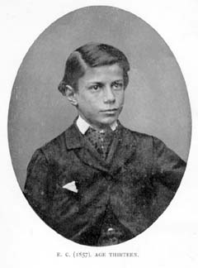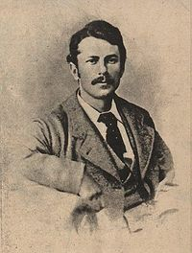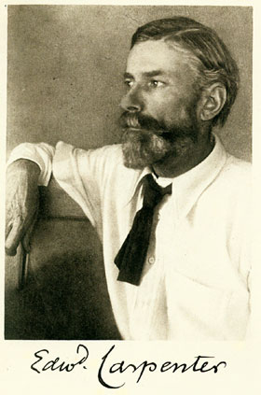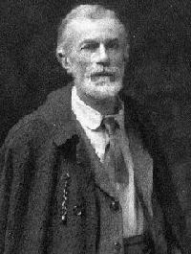
=======================================================================================================
Edward Carpenter (29 August 1844 – 28 June 1929) was an English socialist poet, anthologist, and an early homosexual activist.

Contents
- 1 Early life
- 2 Influence and activism
- 3 Death
- 4 Notes
- 5 Works
- 6 External links

Early life
Born in Brighton, Carpenter was educated like all his brothers at Brighton College where his father was a governor. He then attended Trinity Hall, Cambridge before joining the Church of England as a curate, "as a convention rather than out of deep conviction".^{[1]} He was heavily influenced by the minister at his church, the leader of the Christian Socialist movement.
Carpenter left the church in 1874 and became a lecturer in astronomy and music, moving to Leeds as part of an early outreach programme. He hoped to lecture to the working classes, but found that his classes were attended by middle class people, many of whom showed little active interest in the subjects he taught. Disillusioned, he moved to Chesterfield, but finding the town dull, after a year he based himself in Sheffield. Here he finally came into contact with manual workers, and he began to write poetry. Despite his obvious affinity for labourers, he was invited to become a tutor to the future George V. He politely rejected the post.
In Sheffield, Carpenter became increasingly radical. Influenced by Henry Hyndman, he joined the Social Democratic Federation and attempted to form a branch in the city. The group instead chose to remain independent, and became the Sheffield Socialist Society.
Contact made through lectures and the Socialist Society enabled Carpenter to further his relationships. He moved in with a tenant farmer and his family in Bradway. Becoming interested in farming and influenced by the ideas of John Ruskin, he quit his lectureship to start a simpler life market gardening in Millthorpe, Derbyshire. He met George Merrill, a working class man, on a train, and they struck up a relationship, eventually moving in to live fairly openly in a same sex relationship. Two men of different classes living together fairly openly as a couple was almost unheard of in England in the 1890s, but they would remain partners for the rest of their lives.
E. M. Forster was close friends with the couple, and he claimed the George Merrill was the inspiration for his novel Maurice (which remained unpublished until 1971 due to its homosexual content) . Carpenter was also a significant influence on the author D. H. Lawrence, whose Lady Chatterley's Lover can be seen as a heterosexualised Maurice.
During this period, Carpenter received a pair of sandals from a friend in India, and began to manufacture them, on a small-scale. This was the first successful introduction of sandals to Britain.
He was a good friend of John Haden Badley and would visit Bedales School when his nephew Alfred Francis Blakeney Carpenter was a student there.

[edit] Influence and activism
In 1883, Carpenter joined the Social Democratic Federation, and in 1885 he left with William Morris to join the Socialist League. Never committing to any narrow doctrine, he dabbled in the Labour Church movement, and studied Eastern Religion, travelling to Ceylon and India in 1890. On his return he developed a kind of "mystic socialism" which produced campaigns against air pollution and vivisection, promoted vegetarianism and "rational dress", a reaction to Victorian clothing which included the making and wearing of sandals. These ideas were considered crackpot by many in the Left — in The Road to Wigan Pier (1937), George Orwell famously ridicules "every fruit-juice drinker, nudist, sandal wearer [and] sex maniac" in the Socialist movement.
Carpenter achieved growing acclaim for his Whitman-esque poetry and became involved in defending Fred Charles of the Walsall Anarchists in 1892. Later he became a founder member of the Independent Labour Party in 1893, with George Bernard Shaw among others. His pacifism led him to become a vocal opponent of first the Second Boer War and then the First World War.
In the 1890s, Carpenter began to campaign against discrimination on the grounds of sexual orientation. He strongly believed that homosexuality was a natural orientation for people of a third sex. His 1908 book on the subject, The Intermediate Sex, would become a foundational text of the LGBT movements of the 20th century. Carpenter also both supported and drew inspiration from the Women's movement.
His groundbreaking 1908 anthology of poems, Iolaus - anthology of friendship was a huge underground success, leading to a more advanced knowledge of homoerotic culture. It went to a second British edition in 1906 and a third edition in 1927. The New York 1917 edition is now available as a free online e-book.
Carpenter was an infuence on photographer Ansel Adams. In his early manhood Adams was... "devoted to the comparative-religious poetry of Edward Carpenter, who had close links with the Theosophical community of Halcyon, in Southern California" (Anne Hammond, Ansel Adams: Equivalent as Expression.).

[edit] Death
On December 30, 1910 he had written:
"I should like these few words to be read over the grave when my body is placed in the earth; for though it is possible I may be present and conscious of what is going on, I shall not be able to communicate..."
Unfortunately the existence of his request was not discovered until several days after his burial. The closing words form the epitaph engraved on his tombstone:
"Do not think too much of the dead husk of your friend, or mourn too much over it, but send your thoughts out towards the real soul or self which has escaped — to reach it. For so, surely you will cast a light of gladness upon his onward journey, and contribute your part towards the building of that kingdom of love which links our earth to heaven."
He died 13 months after suffering a paralytic stroke and was interred in Mount Cemetery at Guildford in Surrey.

[edit] Notes
- ↑ Philip Taylor's Biography of Carpenter, Phillip Taylor 1988
Edward Carpenter: An Exposition and an Appreciation, Edward Lewis 1915

[edit] Works
- Towards Democracy (1883)
- England's Ideal (1887)
- Civilization: Its Cause and Cure (1889)
- Homogenic love and its place in a free society (1894).
- Love's Coming of Age (1896)
- Days with Walt Whitman (1906)
- Iolaus - anthology of friendship (1908) (as editor)
- The Intermediate Sex: a Study of Some Transitional Types of Men and Women (1908).
- The intermediate types among primitive folk (1914), in Selected writings, vol. 1, Gay Men's Press, London 1984.
- My Days and Dreams (1916) (his autobiography)
- Pagan & christian creeds: their origin and meaning (1920).
- Never Again!.
- The healing of Nations and the hidden sources of their strife.

[edit] External links
- edwardcarpenter.net - A web-based archive of works by Edward Carpenter
- Edward Carpenter's biographic sketch at Find A Grave
- Spartacus on Edward Carpenter
- A 12-page Tribute to Edward Carpenter
- Works by Edward Carpenter at Project Gutenberg
===============================================================================

