Rafal T. Prinke - The Wroclaw codex of the Magical Calendar.
Article originally published in The Hermetic Journal, 28 (1985), 26-29.
http://www.levity.com/alchemy/wroclaw.html

THE WROCLAW CODEX OF THE MAGICAL CALENDAR
The importance of the Magical Calendar attributed to Tycho Brahe was discussed by Adam McLean in his edition of it (Magnum Opus Hermetic Sourceworks No. 1). He also compared the engraved Latin version published in 1620 with the manuscript copy in Vienna and found that the latter contains a number of misspellings and therefore that the published version is earlier. But is it the original or was there an earlier manuscript version?
When I was looking through the book Die Rosenkreutzer by Will-Erich Peuckert, I found there a short note about a manuscript entitled Ein immerwahrender naturlich-magischer Calender which, at that time (1928), was in the Breslauer Universitatsbibliothek. The note was not repeated in later, rewritten, editions of the same book which appeared under the title Das Rosenkreutz. As the title was similar to that of the Magical Calendar, I got interested in the matter and when an opportunity occured I went to Wroclaw (Breslau) to see if the MS is still there, and if so to examine it. Fortunately, the University Library was not destroyed during the war and I found the MS in a very good condition.
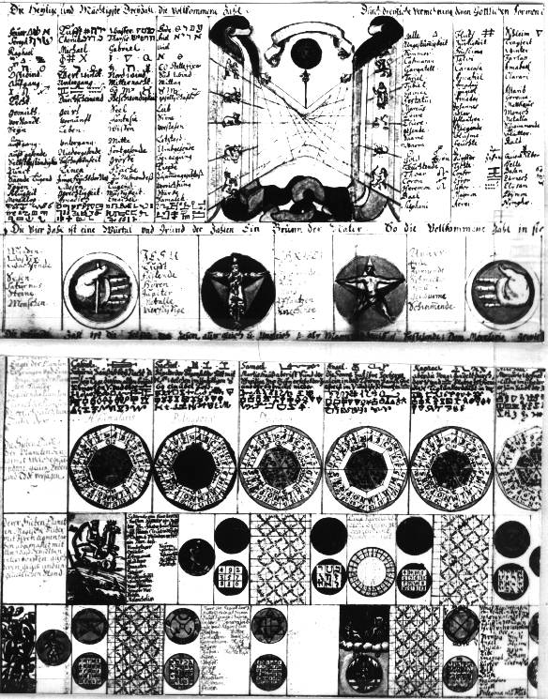
It consists of three sheets of very thick parchment, inscribed on one side only, and it can be seen that once they were joined together and formed one big table of correspondences (each of the three sheets is in large quarto format). The inscriptions and drawings are in many colours, the letters are cursive, and the language is German throughout. Both the layout and the content of the Wroclaw Codex are almost exactly the same as those of the engraved plate (with a few minor exceptions), so the relationship between them must be much closer than between the published calendar and the Vienna Codex. The most important thing, therefore, is to establish its date or, at least, which one of the two is earlier and possibly original. There are some clues which make it possible to put forward a hypothesis about it. First of all it is the handwriting, which is certainly early 17th or even may be late 16th century though, of course, it is difficult to date the handwriting to within a few years, as an elderly person would write in the style he had learned in his youth. The next point is that the MS is very beautifully executed suggesting "originality", especially as I have not found any misspellings or other mistakes. The latter fact also seems to indicate that the author of the Wroclaw Codex was not just a copyist but knew something about the subject matter of it, which is further suggested by the colouring of the various seals and talismanic figures according to the traditional colour correspondences of the planets and signs of the Zodiac. The use of parchment indicates that it had a great importance for the author or possessor; it cannot indicate an earlier date as one of the astronomical tables refers to the Old Style and the New Style calendars (just as in both the other versions) and therefore the earliest possible date is 1582.
Perhaps the most important and informative clue is the fact that the Wroclaw Codex is not attributed to Tycho Brahe, nor to Trithemius, nor to any other more or less improbable author. However, the other two names associated with the calendar remain in their places: in the bottom left hand corner we read:
Auth. Johan Baptista
Groschedel ab Aicha
and on the right side at the same level:
Joh: Theodore de Bry
Excudebr.
This is again a suggestion that this manuscript is the original of the Latin engraved plate published in 1620. It has not been associated with Tycho Brahe yet when it was made and only the names of actual authors were recorded. It may also be noticed that the engraved version has "BABTISTA", while the MS has the correct spelling "Baptista", so it seems that the engraver made a mistake while copying it.
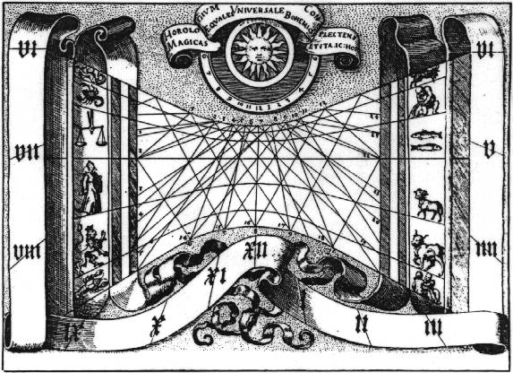
One more considerable difference is the big sun-dial diagram (used by Adam McLean as the frontispiece to his edition). Besides being slightly different in graphic design, the MS version has the signs of the Zodiac in different arrangement: they start with Aries in the middle of the left hand column and go upwards in the clockwise direction, while in the published version they start on the right hand column and go downwards (also in the clockwise direction). The engraved design has some Arabic numbers on the network of lines in the centre, while the MS has the same in Roman numerals and additionally two columns of figures on each side (four in all), each of which is surmounted by the letters "St. M." (probably "Stunde" and "Minuten", i.e. hours and minutes, as the figures suggest, e.g. 17.3, 16.12, 14.14. etc.). I know too little about sun-dials to judge which of these schemes is more correct astronomically (but the MS seems to be more precise). The inscriptions above the sun reads : "Eine Allgemeine Sonen Uhr" ("A Universal Sun Dial") as compared to the printed version's "The Universal clock, encompassing magical equalities, and striking the hours accordingly in Bohemia". It is possible that the "Bohemia" was added in order to make the Tycho Brahe association more credible. The great astronomer lived in Prague, Bohemia, as the court of Emperor Rudolph II, but he came there only in 1597, so "Bohemia" and "1582" are mutually exclusive as far as Brahe is concerned.
All these facts clearly suggest that the Wroclaw Codex is earlier than the published Latin version of the Magical Calendar (and, of course, than the Vienna Codex), and may even be the original copy. As it is not attributed to any improbable authors, I am inclined to believe that Groschedel and de Bry are its real authors. Adam McLean observed that Groschedel, who was the author of two alchemical books, was rather a compiler than an original writer. Since the Magical Calendar is a magnificent compilation, his authorship is quite probable. Also, if we accept that the published version was engraved by de Bry (or under his supervision), then it is probable that the Wroclaw MS was drawn by him. All the small pictures and sigils are exactly identical with the engraved ones, even in such minute details as the tents behind Moses in the top right hand corner and the "horns" on his head. They are executed with great artistry and precision, and the calligraphy is also very nice. If this hypothesis is correct, it may have considerable importance for our understanding of the role played by Johan Theodore de Bry in the Rosicrucian hermetic revival. Besides being a publisher and engraver of hermetic works, he may have also produced manuscript drawings, etc. for individuals or groups (the Rosicrucian Order, if such existed, or circles connected with such eminent hermetists as Fludd, Maier, Sendiviogius, Boehme, etc.).
I wanted to give a list of colours used in the Wroclaw Codex but, on second thoughts, I decided that it would be too complex and would take up too much space to be worth publishing. However, if any of the readers is interested in it, I will be able to supply the colouring instructions individually on request.
It is also interesting that the MS of the Magical Calendar is bound together with a manuscript copy of the well known Rosicrucian text D.O.M.A., about which I will write separately. It is difficult for me to date the leather binding but it is certainly not later than the 18th century. Curiously enough, Manly Palmer Hall, who obviously did not know about the Wroclaw MS, added the Magical Calendar plate to his edition of D.O.M.A. Perhaps he was guided by his intuition which told him that these two texts are somehow connected?

