Rafal T. Prinke - Lampado trado.
Article originally published in The Hermetic Journal, 30 (1985), 5-14.
http://www.levity.com/alchemy/lampado.html

LAMPADO TRADO

From the Fama Fraternitatis to the Golden Dawn
The concept of "tradition" is variously defined and usually not very precisely. For the purpose of this article I propose to understand it as a succession of people or groups that were in contact with those immediately preceding and succeeding them, passing on a certain body of teachings. Those teachings remain the same in crucial matters though they undergo many changes on the surface. The changes are the main causes of schisms and sectarian attitudes within almost every tradition. It is enough to mention all the christian denominations each of which traces its roots to the person of Jesus Christ, or the many rites of Freemasonry stemming from the Grand Lodge of England. The study of traditions is in many ways similar to genealogical research where the descendants of one person all have the same name but their personality traits may be radically different due to the genetic inheritance from the female ancestors who may be compared to the outside influence on occult groups and teachers. In this article I would like to trace just one "genealogical" succession within the whole "tree" of the Hermetic Tradition. My hypothesis already presented to the readers of the Hermetic Journal [1] is that there existed a Rosicrucian order which appeared simultaneously or shortly after the publication of the Manifestos of Andreae and his circle but was not connected with them. The most important work produced by that group was the text known as D.O.M.A. which was first published with some additional material in Geheime Figuren (Altona 1785-88) and later reprinted several times, also in English translations [2].
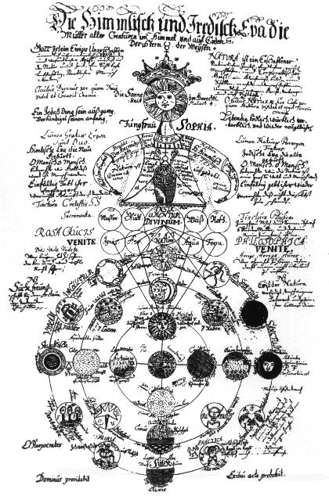
In the University Library in Wroclaw (Breslau), the capital of Silesia, I have found a manuscript copy of the D.O.M.A. text bound together with a manuscript of The Magical Calendar [3]. It was mentioned by Peuckert [4] who thought it to date from the second half of the 17th century on the basis of paleographic analysis. He even says that the earliest date possible is 1620 which is well before all other known manuscript versions of the same text. The most comprehensive study of several versions of the D.O.M.A. text to date is M.P. Hall's introduction to his edition of it [5]. The variants known to him are the following:
1) the Ms in his possession, published in facsimile with the English translation, dated to the second half of the 18th century (probably 1775-80),
2) the Sachse Ms, belonging to Dr Julius Sachse of Philadelphia and sold away by his daughter, dated to the beginning of the 18th century,
3) the Hauser Ms, later sold to a British collector, dated to the 18th century,
4) the Hitchcock Ms, later in an American library, imperfect copy, date unknown,
5) the Russian Ms, details unknown,
6) the French Ms, dated to about 1775.
The Sachse Ms is the oldest of the six and M.P. Hall even states that "there is a remote possibility that it may be the archetype from which the others were taken" (p. 38). However, on the basis of the four reproductions of it which he published after Sache's work [6], it is possible to show that it is also a copy. The plate shown on the right of p. 37 has the title "Figura divina Theosoph: Cabal: nec non Magia, Philosophia et Magia" which is an obvious error made by the copyist. The last word should be "Chimia" as in the other versions, instead of repeating "Magia" for the second time, which has no sense.The bottom left hand corner shows a sign composed of four arrows, which properly belongs to the central one of the small circles in the diagram. The Wroclaw Ms of D.O.M.A. is written in black, red and green ink. On both sides of the paper. The handwriting is less ornate, which suggests, along with other characteristics, that it belongs to the second half of the 17th century, as already mentioned. I have collated it with the Hall Ms and found quite a number of minor discrepancies, though in general it is exactly identical. All the plates are the same and in the same order.
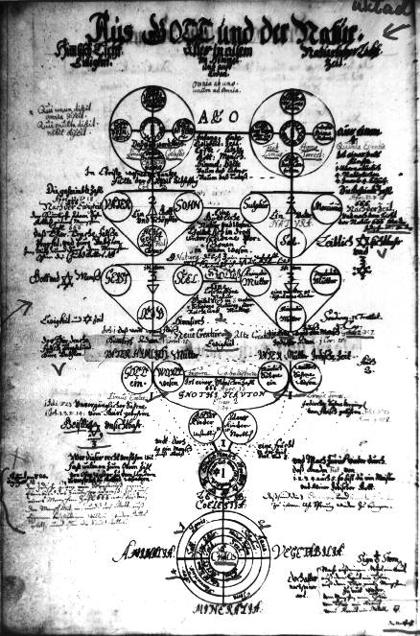
It is obviously impossible to describe all those differences here, as at least one version should be reproduced so that the readers could follow my explanations. In general the Wroclaw Ms seems to be more logical and consonant with the hermetic tradition. For example, on the plate mentioned above, in the central part, there are words, "Sulphur philosophorum" on the left and "Sal philosophorum" on the right. In both Sachse and Hall Mss they are quite prominently written above the lower section of symbols in small circles while in the Wroclaw Ms and in the Altona publication they are placed on top of the two circles closer to the center. The latter placing is obviously correct and in keeping with the symbolic content of the plate. Another example is from the plate "Virgin Sophia", where in the lower right hand corner there are two small circles, one of which contains a symbol similar to Dee's Monas and the other has a double-headed bird (Phoenix, as the text says), in the Hall Ms these symbols are in each other's position, though the texts describing them remain in the original place and thus the "Monas" symbol is described as Phoenix, while the bird is described as a divining rod. The same mistake is repeated once more on the same plate with the circles of "The Raven's Head" and "Incombustible Oil". All the errors of this and similar kinds can be found in all the Mss and the Altona printing but I have not found anything like that in the Wroclaw Ms, which seems to suggest that it may have been the original or a very early copy into which the mistakes had not yet crept in. There is however one point of special interest which confirms my hypothesis that this is the original of all the other D.O.M.A. texts. On the plate entitled "Of God and Nature" (pl. 10 in Hall) there is an inscription added in a different hand (i.e. later) in the lower left hand part. In the other versions (i.e. Hall Ms and Altona) this note is incorporated into the text and moved up to the middle part of the plate.
Another note in a different hand, much later and in brown ink, is added in the lower left hand part of the "Figura Divina" plate. It is a reference to the work "Licht (?) der Natur" (I am not sure of the first word) by Anonimus von Schwarz" published in Frankfurt and Leipzig in 1706. As this note does not appear in Hall or in Altona, the Wroclaw Ms must have been copied by others between these two additions were made. Summing up, I suggest that the Wroclaw Ms of D.O.M.A. is the original of all the other texts and was produced in the second half of the 17th century (most probably around 1650).

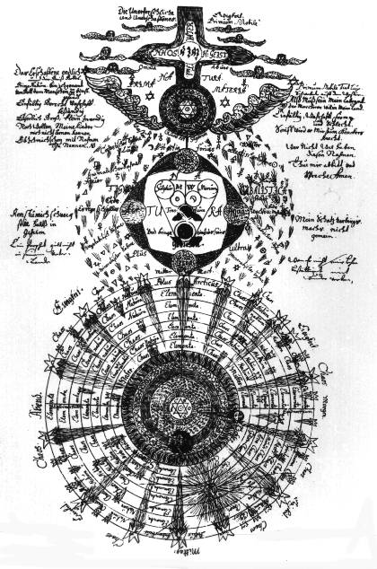
Now, the question arises who was its author or authors? To answer it is quite difficult as there is nothing in the text itself that would be of any help however, we can speculate that the D.O.M.A., manuscript from Wroclaw was produced in Silesia, i.e. that it was not brought there from some other part of Europe. If so, then we have a number of people connected with Rosicrucianism to take under consideration. First of all there is Jacob Boehme in Zgorzelec (Goerlitz) at the beginning of the 17th century. The influence of his thought on the D.O.M.A. is obvious in many fragments of the text though the diagrams are not similar to those in the Gichtel edition of his works. But, as M.P. Hall pointed out, Gichtel's illustrations are independent of Boehme's text and therefore the D.O.M.A. illustrations may have been inspired by Boehme in the same way. One of Boehme's friends and students was Abraham von Franckenberg, also from Silesia (actually he lived in Wroclaw), who was the first editor of the Teutonic Philosopher's writings. Von Franckenberg was actively interested in Rosicrucianism, which is confirmed by his extant letters which he exchanged with various people in all parts of Europe. He travelled to the towns where the Rosicrucian Order is said to have been active, especially Gdansk (Danzig), where he stayed on several occasions. Gdansk was the place of publication of several early Rosicrucian documents and replies to the Fama for example:
De Fratribus Rosae Crucis by Henrico Neuhusio (Neuhaus). 1610 (?) and 1617
Echo der ... Fraternitet des Lobl. Ordens R.C. by Julius Sperber, 1615 and 1620, one of the most important and influential early Rosicrucian documents.
Assertion oder Bestatigung der Fraternitet R.C., 1616.
Exemplarischer Beweis, dass das in der Fama und Confession ..., 1616.
Proeludium de castitate etc. Scriptum ad Ven. Fratres R.C., 1617.
Schnelle Botschaft an die Philosophische Fraternitet vom R.C., by Valentin Tschirness, 1617, the same was published a year earlier in Goerlitz and thus shows the connection of Silesian and Gdansk Rosicrucian circles.
Ohne die Reformation, 1618, an edition of Fama and Confessio.
Pia et utilissima admonitio de Fratribus R.C. by Henrico Neuhusio, 1622 and 1628, apparently the same work as he first one above, which would mean it had four editions in Gdansk; it should be noted that it is against Rosicrucians.
Gdansk was also an important centre of alchemical activities at the time, with such eminent practitioners as Alexander von Suchten (actually Zuchta, as he came from a Polish noble family). Von Frankenberg also mentioned Rosicrucians in his writings, one of which includes a complicated mandala-like illustration of a definitely Rosicrucian character [7]. He formed a group of students of Pansophia, which is the term earlier used in "the fourth manifesto" Speculum Sophicum Rhodo-Stauroticum. One of his students became famous as the mystical poet Angelus Silesius.
Finally, one of the most important Rosicrucian works after the initial manifestos was Die wahrhafte und volkommene Bereitung des philosophischen Steins der Bruederschafft aus dem Orden des Gulden und Rosen Kreutzes by Sincerus Renatus, published in Wroclaw (again!) in 1710. The author's real name was Sigmund Richter and he lived in Hartmannsdorf near Kamienna Gora (Landeshut) in Silesia. It is generally believed that Richter described a real order and that his book is the missing link between the older Rosicrucians and those of the 18th century. If so, then it is quite possible that the Silesian order produced the D.O.M.A. text as an "A.B.C." for its neophytes. The influences of Boehme, von Franckenberg and the early Rosicrucian publications are all brought together in this document circa 1650. And there is one more influence, that of alchemy. It is usually overlooked that the only modern author quoted by name in the D.O.M.A. is the great Polish alchemist Michael Sendivogius, mentioned on the right of the plate "Of God and Nature" (plate 10 in Hall).
All these influences add to the philosophical content of the D.O.M.A. but not to its way of presentation. This, I believe, can be traced to one of the early letters to the Rosicrucian Brotherhood which was published together with the Fama and Confessio (Cassel 1616 edition). The letter is entitled Sendschreiben mit kurtzern Philosophischen Discurs an die Gottweise Fraternitet des Loblichen Ordens des Rosen Creutzes.
I have found a copy of it in the Poznan University Library bound together with Fama Remissa and the work by Andreas Libavius defending the Order and bearing the letters D.O.M.A. on the title page. The book is in leather (probably 17th century) and stamped with "R. C." (18th or even 19th century) on the first page.
"The Short Philosophical Discourse" added to the letter seems to be very much in the character of the D.O.M.A. text and is similarly presented, though much shorter and without any diagrams. As it will not take much space, I enclose a verbatim translation in extenso:
A BRIEF DISCOURSE with a tenuous picture
of sacred Philosophy as well as the summa of wisdom.
IEHOVA TRIUNUS
All from Nothing
The Spirit of God moved upon the Water
CHAOS:
Primary Hyle of the Wise
Everything was created from Water
Firmament, Minerals, Vegetables, Animals
MACROCOSM
From the Centre and Quintessence
MICROCOSM
The most perfect creature of all creatures
MAN
The Image of God the Eldest
The immortal Soul : the invisible Celestial Fire
After the Error : Behold the MESSIAH
The Light of Grace and Nature
LILI. The Prime Matter of perfect Body
The Matrix of Medial Cosmos
Balsam and Mummy
The Magical Magnet in the incomparable Microcosm
The Water of the Wise, from which everything
and in which everything, which rules everything,
in which it is erred and in which the error corrects itself.
Sane Mind in Sane Body
Indefatigable prayer
Patience and Time
Matter, Vessel, Furnace, Fire, Coction
[a misprinted line]
The beginning, the middle and the End
Admit nothing alien and without perfecting that alien thing
That which is sought by the Wise is in Mercury.
FONTINA DIAPHANA [?]
Double Mercury
The Rotation of the Spheres of all Planets
And, behold, in a moment the fumes blacken
THERE WILL SHINE
DEATH AND LIFE
Regeneration and Renovation
The fixed beginning, the middle and the END
The sum and foundation of all magical secrets
R. [?] Quintessence of Macro and Microcosm
without Mercury
Philosophical
Invisible, Coelestial, living Fire
Salts of Metals or a.q.S. [?]
Let the art of philosophical magic be rotating,
solving, coagulating and fixing.
The Sum of Medicine
in which there is
great Wisdom, perfect Sanity and
sufficient Power.
All from One and All to One
Impatience and Ostentation ... ["ad Orcum" ?]
Enough has been said
simply and plainly: reject all malice
The obstacle of Pathmos [?]
Let the will of IEHOVA be done
Glory to the Only God.
By the Fire, finally,
the Name and the Age:
paVLVs.
It can therefore be concluded that the D.O.M.A. text was a descendant of all the principal influences which, taken together, constitute what is now called "Rosicrucianism", and that the main line of descent goes back to the circle of Jacob Boehme's students. It can further be suggested that the text was produced in Silesia around 1650 by a group connected with Abraham von Franckenberg and other "pansophists". Most probably it was not allowed to make many copies of it at first, though it may be supposed that Johannes Kelpius took one of them to America in 1694, a later copy of which may have been the Sachse Ms. The original Silesian group made itself known again through the work of Sigmund Richter (Sincerus Renatus) and then spread all over Germany, Austria, Poland, Russia and other countries as the well known Order of the Golden and Rosy Cross. This coincided with the appearance of more copies of the D.O.M.A. in wide circulation from France to Russia, leading to its final publication in Altona in 1785 and 1788. The Rosicrucian "genealogy" in the 18th century, as given by K.R.H. Frick [8], is as follows:
"Sincerus Renatus"
Herman Fictuld
Schleiss von Loewenfeld
Johann Christopher Woellner
It is interesting that Woellner, whose importance in the development of the German Golden and Rosy Cross cannot be underestimated, also came from Silesia, from Dobrzenice (Dobritz). He also seems to have been active in the publication of the Altona print as well as in the creation of the last phase of that period of Rosicrucianism, i.e. that of the Fratres Lucis or the Asiatic Brethren. Their leader was Hans Heinrich von Ecken und Eckhoffen otherwise known as "Magister Pianco", the author of Der Rosenkreutzer in seiner Bloesse (1781) where he described the system of grades later used by the Golden Dawn initiates. Another leader of the same order was a Jew named Hirschfeld who supplied kabbalistic and Talmudic knowledge. The Order of Asiatic Brethren was incorporated in Berlin but later its centre seems to have been in Austria. It was active for at least two decades in the 19th century and it is quite probable that it was the "Rosicrucian Order" into which Kenneth R. H. Mackenzie was initiated. The Jewish teachings incorporated into the order make the next important connection, namely that with a Frankfurt Jewish Masonic Lodge mentioned by Gershom Scholem [9] which was called "The Hermetic Order of the Golden Dawn" and which is said to have existed "from the days of Napoleon". The only conclusion may be that it was the original source for Mathers' order of the same name and that Freulein Sprengel and other "Chiefs" were real people. One of the latters' mottos was "Frater Lux e Tenebris" which is reminiscent of Fratres Lucis, especially as he seems to have been the principal source of information for Mathers. Thus it seems that the Golden Dawn and its later offshoots, too numerous to be mentioned here, were in the direct line of succession of the Rosicrucian Tradition, just as it claimed, and not a mere reconstruction. The tradition, as outlined above, is just one branch of the tree of "hermetic genealogy" and does not exclude other traditions stemming from the same source but coming down to us through other ways.
References:
[1] "The Jagged Sword and Polish Rosicrucians" in Journal of Rosicrucian Studies No. 1.
[2] A facsimile edition was published in Berlin in 1919, while English translations were published in Chicago in 1935 and in A Christian Rosenkreutz Anthology, New York 1968. The edition of Franz Hartmann was incomplete and distorted.
[3] See my article "The Wroclaw Codex of the Magical Calendar", in The Hermetic Journal No. 28
[4] Die Rosenkreutzer, 1928
[5] Codex Rosae Crucis, Los Angeles 1938
[6] The German Pietists of Provincial Pennsylvania, Philadelphia 1895
[7] See my article "The Great Work in the Theatre of the World" in A Compendium on the Rosicrucian Vault, Edinburgh 1984
[8] Die Erleuchteten, Graz 1973, tables V and VI
[9] Quoted by Gerald Suster in his afterword to Israel Regardie's What You Should Know About the Golden Dawn, Phoenix 1983.

