The kabbalistic-alchemical altarpiece in Bad Teinach
By Adam McLean. From the Hermetic Journal 12, Summer, 1981, pages 21-26.

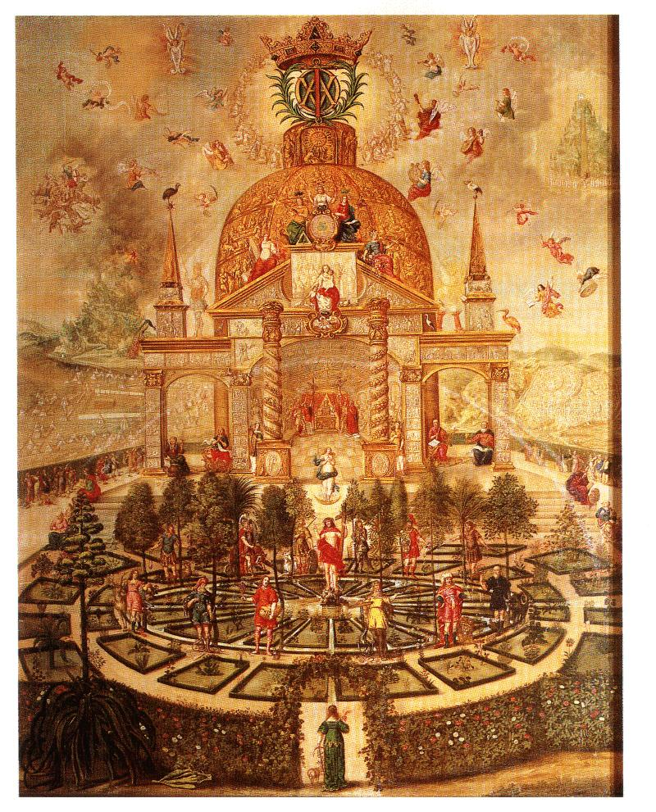
The Kabbalistic-Alchemical Altarpiece in a small church in the town of Bad Teinach near Calw in Germany, is, I believe, of the greatest esoteric value. I have at present little information on its outward history, though it is dated 1673 and seems to have been prepared at the instigation of Princess Antonia (1613-1679), so I will therefore concentrate in this article on the symbolism of the painting.
The painting's central panel, which is all we shall concern ourselves with here, shows us a Rose Garden surrounded by a hedgerow bearing red and white roses. Outside the garden in the background on the left is a four-square military camp, while on the right we see a city founded on a circular plan. In the centre foreground, a bowered gate opens into the garden and a female figure is seen standing upon the threshold, pausing at her entry to gaze at the wonders before her. She bears in her right hand her flaming heart, while on her left she leans upon a staff in the form of an anchor cross. Thus she represents the Soul of Man standing at the threshold of spiritual illumination, with the fire of enthusiasm and love burning within the heart, and the anchored foundation of the Soul in the central mystery of the Cross of Christ.
The Soul gazes into the garden, and here we are reminded of the Rosarium or Rose Garden of the Virgin, the medieval picture of the enclosed domain in which the human soul can commune with the Sophia-Wisdom aspect of the Spirit. Within this Rose Garden are two realms - a circular garden and a domed Mystery Temple. The soul must first traverse the circular garden before the soul reaches the outer court of the Temple which stands upon a podium of seven steps.
THE CIRCULAR GARDEN
The garden is centred upon the figure of the resurrected Christ, standing upon a rock and holding his Cross. From his body there flows a stream of blood forming a pool at the centre of the circle. Around him the garden is segmented into three rings of twelve flower beds each bearing their own particular plants, and we see 12 figures standing around the circumference of the inner ring (which is within the pool of the Christ Blood). These twelve figures are constellated with an array of symbols which are too complex to analyse here, but for example they appear with various animals, they hold symbolic objects, have certain colourings and they each stand at sacred trees which grow at the boundary of the inner ring. These trees are as follows, counting clockwise from the figure just to the right of the Christ :-
Laurel - Cypress - Willow - Fig - Cedar - Fir - Olive - Apple - Pomegranate - Almond - Palm - Oak.
The twelve figures are representatives of the 12 tribes of the Israelites, or the twelve Apostles and can also be related to the Zodiac Signs. Thus the first stage of the Soul's encounter with the garden requires an experience of the twelve archetypes on all levels, as the twelve sacred trees, or twelve animal forms, etc. The Soul has to inwardly experience how the one spiritual energy manifests in the lower worlds divided twelvefold. Only by reintegrating this twelvefoldness can the Soul gain true perception of the unity that lies beyond, here the Christ figure in the centre of the circular garden. This is the sublime mystery of the Twelve + One at the Centre.
Once the Soul has achieved this integration, she will stand in the position of the Christ Being. This position is the point of spiritual incarnation in the natural world, the Malkuth of the Kabbalists, and in this painting we see clearly a Tree of Life glyph of the Kabbalists, displayed with female figures marking the Sephiroth. This Tree of Life spans the garden and temple, it unites these two realms within the soul's experience of the spiritual reality of the Rose Garden. We can outline it as follows
The Supernal Triad Kether, Chokmah, Binah, is indicated by the three crowned female figures at the centre of the dome of the temple. Although they cannot be seen on the detail of the illustration here, on the original painting the head of Kether is surrounded by a nimbus of seven eyes, Chokmah by seven stars, and Binah by a nimbus of seven flames, which provides an interesting interpretation of the usual meanings of these Sephiroth. Kether at the Crown of the Tree has the gift of seeing into the higher reaches of the spiritual world, Chokmah bears the Wisdom of the Stars, and Binah has the fire of illuminated Understanding. (These are an example of just a small detail of the symbolism, and the whole painting is truly profound in its detailed encapsulation of esoteric wisdom in pictorial form).
To the right below Chokmah on the pediment of the Temple we see the figure of Chesed, and below and to the left of Binah, is pictured Geburah. Completing the intermediate Triad is Tiphareth, depicted as the woman with the two children, one child held up, the other standing below her. Tiphareth stands at the special point of the tree mirroring in her essence the above and the below.
The lower Triad is composed of Netzach, as the female figure bearing fruiting branches and standing at the base of the right BOAZ column of the Temple, Hod at the base of the left JACHIN column plucks at her harp, and in the centre below them standing upon a crescent moon is Yesod.
Now one can clearly see that the Christ figure occupies the 10th place, that of Malkuth. To harmonise with the presentation of the Sephiroth as Goddess forms, we must realise that this is the point of the incarnation of the Spirit in Matter, and thus the Soul figure entering the Garden will initially come to occupy this Sephira. Christ is here seen as the representative of humanity, rather than in his aspect as part of the Godhead. Once the Soul stands consciously on Malkuth, the individual being can see, at least in dim outline, the Tree of Life with the higher Sephiroth stretching above the Soul. Thus this perception unites the experience of circular Zodiac Garden, the Astral world of Archetypes, with the higher realms of the Spiritual World (the Devachanic Worlds) pictured by the Temple.
THE TEMPLE
This temple is approached by ascending a podium of seven stages, at the corners of which we see the Four Evangelists with their animal symbols of the elements. On the left - Matthew (the Man) and John (the Eagle), and on the right - Luke (the Lion) and Mark (the Bull). The temple is domed with a central sanctuary below, outside of which stands two columns, Boaz and Jachin. The Boaz column on the left bears around it a clockwise helix of seven turns formed of animals going 'two by two', while the Jachin column has a helix of seven anticlockwise turns with flowers and fruit forms. Above on the pediment of the sanctuary are, two obelisks that connect symbolically with these columns, the Fire Obelisk on the left and the Water Obelisk on the right. Beside the water obelisk stands the Angel with 'a face like the Sun' (see Apocalypse Chapter 10), while beside the fire obelisk is the great image of gold, silver, brass and iron from Nebuchadnazzer's Dream (see Daniel 2, 31).
In two outer porticos we see the four major Prophets of the Old Testament. Under the left, Jeremiah and Daniel, and under the right, Ezekiel and Isaiah, each bearing characteristic symbols.
Within the sanctuary, Aaron with his breastplate officiates at the altar, beside which are raised the Cross of the Crucifixion of Christ and a Cross with a crucified serpent (an important alchemical symbol, which appears for example in the alchemist Nicholas Flamel's Hieroglyphic Symbols, which was supposedly based upon a Jewish esoteric book). The crucified serpent is connected with Moses (see Numbers chapter 21). We have here a meeting of the old Moses mysteries with the Christian mystery of the Resurrection. At the apex of the pediment above the sanctuary, we see the figures of Kether Chokmah and Binah as outlined before. Various bird forms, which connect with alchemical stages are seen. Beside Chokmah, we note the PHOENIX, while beside Binah an EAGLE is visible. Beneath the figure of Tiphareth, a PELICAN in its piety nourishes its young upon its own blood. Elsewhere is seen the PEACOCK with its resplendent tail, and other birds with alchemical connections are also to be found in this painting. 'Above at the top of the dome of the temple we see the vision of the Twenty Four Elders around the Throne of God (see the Apocalypse chapter 4). Here we are in the highest regions of the spiritual world.
Various angelic Hierarchies with musical instruments resound the harmonies of the spheres around the crwoned emblem of the (A) Alpha and (O) Omega, the Beginning and the End of all Being, which is placed in nimbus of light standing at the top of the Temple's dome.
At the highest point of this dome stand the three archetypal Initates of the Jewish Tradition, Elijah, Moses, and Enoch. These three represent the three different streams of initiation, though these are unified in that all achieved their spiritual vision on a mountain top - with Elijah it was Mount Carmel, Enoch was translated from the brow of Mount Moriah, and Moses, of course, had his vision on Mount Sinai. The perhaps also relate to the Transfiguration of Christ on the mountain before his three disciples Peter, James and John, when Moses and Elias appeared with Christ and the three disciples wished to erect three tabernacles to worship these three facets of the Spirit.
On the left of the Temple, the camp must be that of the Israelite journey to the Promised land with the Tabernacle in the Wilderness, the Temple itself is a representation of Solomon's Temple, while on the right, Jerusalem, is the city built in the form of a temple. Thus we have three archetypal temple forms.
The whole painting seen in totality, presents to us a picture of path to consciousness of the spirit, through an initiation experience gained by working symbolically with this temple. It thus incorporates kind of esoteric masonry with various alchemical and kabbalistic facets and it could also perhaps have some Rosicrucian connections. This was a 'teaching painting' designed for Princess Antonia, who was of the family of Frederick I, Duke of Wurttemberg, alchemist and occultist, who in 1603 was invested into the Order of the Garter by James I. Perhaps we see here the record of a late 17th century continuation of the esotericism of the Rosicrucian movement within a closed fraternity (the painting was probably never intended to be seen outside of a small group of people working with its symbolism). One suspects that it would be most valuable to enquire further into the background of the personalities involved in this esoteric group.
A fascinating and extremely detailed description, analysis and interpretation of this altarpiece is found in a German book by an Anthroposophical writer (not available in English) :- Harnischfeger, Ernst. Mystic im Barock : Das Weltbild der Teinacher Lehrtafel 228 pages many illustrations.Verlag Urachhaus, Postfach 13 10 53, 7000 Stuttgart 1, Germany.

