Notes on the 'Twelve Keys of Basil Valentine'
By Adam McLean. First published in the Hermetic Journal 1987.
http://www.levity.com/alchemy/twelve_keys.html

Notes on the 'Twelve Keys of Basil Valentine'
Adam McLean
The 'Twelve Keys of Basil Valentine' is recognised as one of the most important and influential of alchemical works. It was first published in 1599 as a text only piece but achieved its widest distribution as part of a compendium the Tripus Aureus (Golden Tripod) edited by Michael Maier and published by Lucas Jennis at Frankfurt in 1618. This was later included in the more massive compendium Musæum Hermeticum also published by Jennis in 1625.
The earliest edition did not have any illustrative plates but Lucas Jennis provided twelve engraved plates (probably by Merian), one for each of the 'keys'. These plates obviously drew on the allegorical descriptive imagery of the text, but added a coherence to the symbolism. The text is obscure, and teases the reader with paradox and riddling allegory in the best traditions of alchemical material of that period,
"The twofold fiery male must be fed with a snowy swan, and then they must mutually slay each other and restore each other to life; and the air of the imprisoned fiery male will occupy three of the four quarters of the world, and make up three parts of the imprisoned fiery male, that the death-song of the swans may be distinctly heard; then the swan roasted will become food for the King, and the fiery King will be siezed with great love for the Queen, and will take his fill of delight in embracing her, until they both vanish and coalesce into one body."
However, I believe that it was the addition of the twelve emblematic figures that made the work more approachable and led to it becoming a popular and influential work. Indeed sometimes these twelve emblems are themselves referred to as the 'Keys' of Valentine.
I will not attempt in this short article to analyse the text and its relationship to the emblems, however, I would like to present some notes that may help others to penetrate this rich and complex mass of symbolism. Often in attempting to grasp within our thought the ideas illustrated by the images or sense with our feelings the symbolic patterns that are worked into such esoteric documents, we can get lost and discouraged if we merely jump headlong into the mass of symbolism. We need some esoteric tools (in computer terms, a disassembler) to unravel the code and label some of the more obvious structural elements. Once we have an entry point into the esoteric code we can work this into meditative exercises that slowly reveal the spiritual essence woven into the allegorical emblematic structure. Readers of this Journal will be aware that my approach to such sequences of emblems is to see them as a whole entity, rather than as individual emblems. It is my belief, confirmed by my experience of working with such emblem structures, that the designers of such emblem systems worked various patterns into the symbolism of the whole sequence, so that echoes, pairings, invertions, mirrorings of symbols occur across the individual emblems. Often I find that an emblem system seems to have (at least one) underlying geometric pattern and when the emblems are arranged in this pattern much of the confusing fog of symbolism will dissipate and the sequence begins to take on a coherent form. Thus my work with the Rosarium series, the Crowning of Nature , the Mylius engravings, the Lambspring, and other such sequences.
As part of a long term project to produce a compendium of such emblem systems, I have been working with the Basil Valentine Keys, and decided to include this article as notes on some work in progress rather than a final polished interpretation. It may be useful for others to follow up these indications and see where they lead.
At this point in my investigations it is not entirely clear which of the possible geometric arrangements of the twelve emblems will lead to the deepest penetration of their symbolic subject matter. There may indeed be a number of simultaneously valid arrangements, so I will confine my remarks here to the appearance of triple symbolism in the emblem sequence as a whole.
Those who have read my commentary to the Mylius Engravings will find there (on page 104) that I identified an elaborate sevenfoldness (22 sets of 7 interlinked symbols in all) in the 28 Mylius engravings. These engravings were published in Mylius' Philosophica Reformata in 1622, and a number of these emblems are obviously derived from the Twelve Keys and indeed from the symbolic material in the extended poem The Twelve Gates of George Ripley.
The particular grouping of symbols I will explore here is not a sevenfold one but the appearance of symbols across the whole series of emblems in sets of three. This will provide some insights into the inner geometry of theTwelve Keys . I have provided here all twelve of the illustrations so that the reader can follow this threefold mapping of symbols.
3 Roses 1 5 12

3 Lions 5 11 12

3 Hearts 5 9 11

3 Flasks 5 6 7

3 Classical Gods 1 6 11
[Saturn-Neptune-Mars]

3 Male/Female groups dominant 1 6 9

3 Snakes 2 9 12

3 Wielded swords 2 8 11

3 Furnaces 1 6 12

3 Angel winged figures 2 5 8

3 Circles 7 9 10

3 Arrows 3 5 8

3 Animals devouring 3 11 12

3 Sceptres 1 6 8

3 where birds play a major role 3 8 9
[cocks-crows-four birds]

3 where birds play minor role 2 4 6
[bird on sword-peacock weathervane-swan]

3 Crowned creatures 2 3 5
[snake-cockerel-lion]

3 Tools/instruments held by men 5 6 12
[bellows-flask-tongs]

3 Objects held by women 1 5 11
[flower-heart with sun & moon]

3 Sun-Moon-Mercury symbols 2 10 12
I hope this list may encourage the reader to seek for other triplicities in the symbols, or indeed to find some other way of approaching and making comprehensible this complex net of symbols.
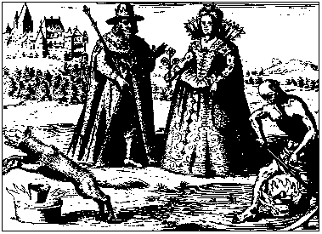
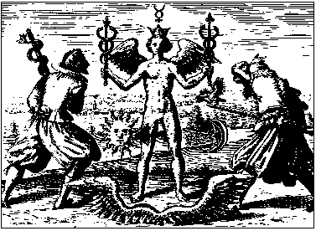
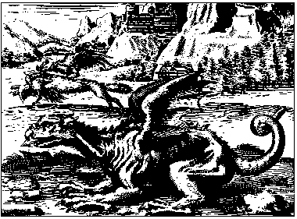
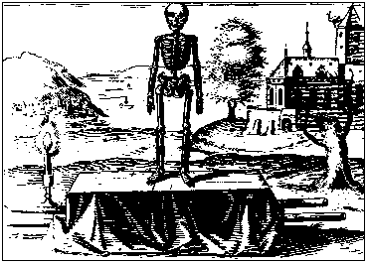
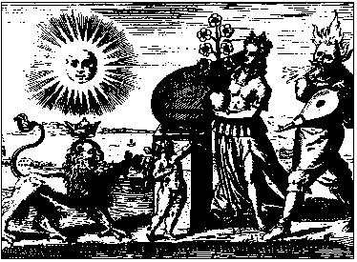
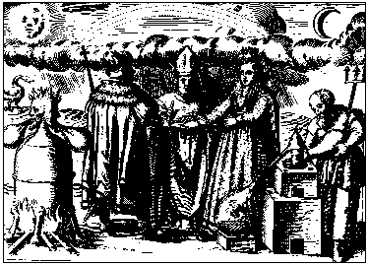
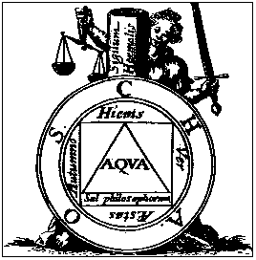
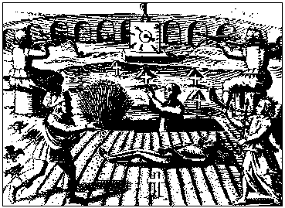
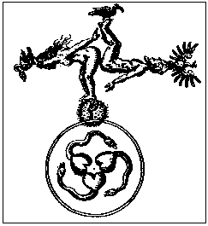
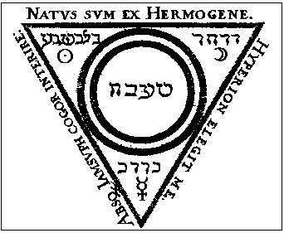
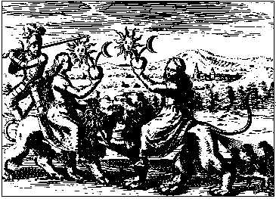
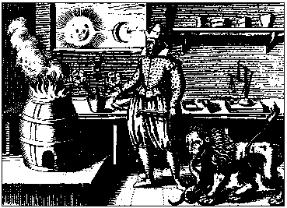
The Hermetic Musæum reprinting of the Twelve Keys included a short appendix emphasising the threefold aspects involved in the practice of the twelve 'keys.' Here an especial emphasis is placed on interpreting the alchemical work through the Paracelsian doctrine of the 'Three Principles' – Salt, Sulphur and Mercury, and an emblem is given to further draw our attention to the importance of the number three in the work.
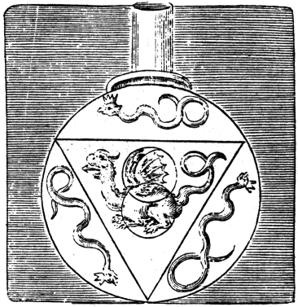
The flask contains the triangle and the three serpents of the three Alchemical Principles surrounding the double mercurial dragon – both in its winged-ethereal (volatile and spiritual) aspect and in its earthly-bodily (fixed and material) form.
It may be interesting to view the triple appearance of the symbols in the Twelve Keys as mirroring :-
a salt, contractive, restricting, crystallising tendency,
a sulphurous, expansive, radiating, dissolving tendency,
and a mercurial, flowing, interweaving, dynamic equilibrium of forces, always seeking to balance the opposing energetics of the salt and sulphur in any outer phenomenon or inner experience.

