Labarinto and the Tarrochi of Mantegna
by Adam McLean.

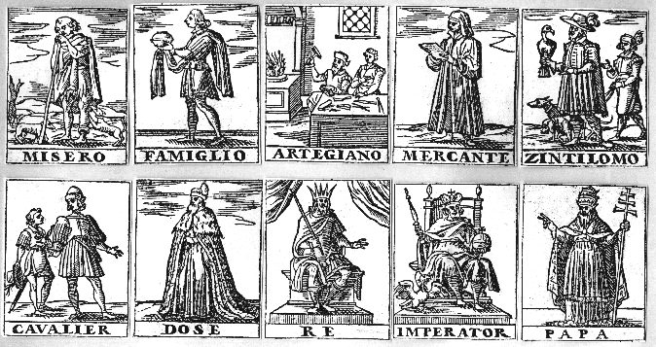
In 1616 a very curious book was published in Venice, the Labarinto by Andreas Ghisi. The title page reads
"The Labyrinth, newly published by the distinguished Andrea Ghisi, nobleman of Venice, in which are seen 1260 figures, all ready for service, each conforming and corresponding, speaking one to another, and infallibly, on the third turn, the imagined figure will be known, with its secret presented."
This consisted of a dedication and short dedication to Giovanni Bembo, the Doge of Venice, with a word square as a tribute to him, consisting of 21x21 letter squares, followed by a sequence of 22 page openings each labelled with a letter of the alphabet. On each of these openings were 60 small block figures in four rectangular groups of fifteen. The same set of 60 figures appeared on each page opening, but in a different permutation. The figures in the 1616 edition were based on the Tarocchi of Mantegna (see my article in the Autumn 1983 issue of the Hermetic Journal). The Tarocchi of Mantegna are divided into 5 sets of ten images
1st decade The different social conditions of humankind
2nd decade The nine muses and Apollo
3rd decade The seven Liberal Arts with Poetry, Philosophy and Theology
4th decade The seven Cardinal Virtues with spirits of Life, Time and the Cosmos
5th decade Seven Planets and the three higher spheres
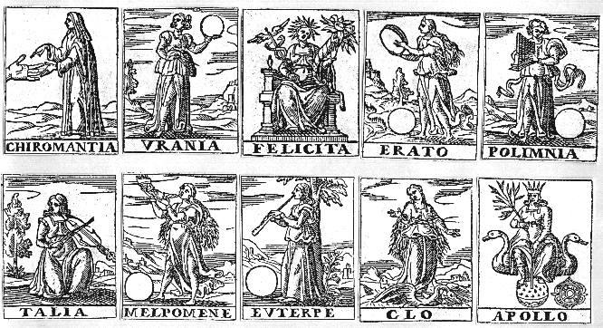
The Labarinto uses this series of 50 images, with a number of minor changes. 'Chiromantia' and 'Felicita' replace 'Calliope' and 'Terpsichore' of the 2nd decade. 'Mathematica' replaces 'Arithmetica' from the 3rd decade, 'Industria' replaces 'Cosmico' in the 4th decade, and 'Quatro Orbi' replaces 'Prima Causa' in the 5th decade. The additional ten images in a similar style seem to be linked in polarised pairs :-
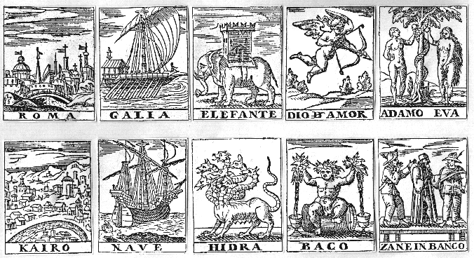
Kairo - Roma
Galia - Nave
Elefante - Hidra
Dio d'Amor [God of Love or Cupid] - Baco [Bachus]
Adam Eva - Zane in Banco [scene on a platform]
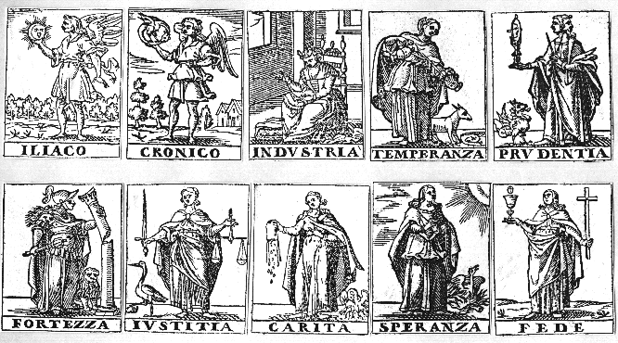
The Labarinto was presented as a game, enigma or mathematical puzzle, the rules for which are not easy to decipher, though they probably involve permutations or perhaps the symmetries of group theory. Ghisi mentions that the outcome of his 'game' depends entirely on the genius of the player. In the copy of this work in the Stirling-Maxwell collection in Glasgow University Library, the following catalogue entry has been pasted in:
"A very curious Block-book, containing 60 different woodcut figures, with xylographic inscriptions, worked in red ink, so arranged on 22 leaves as to appear in different positions. Under the form of an arithmetical puzzle or labyrinth, according to the Libri Catalogue, "The work contains a solution of one of the most complicated problems, both of the theory of numbers and geometry of position, which even to write in algebraic signs would give some difficulty."
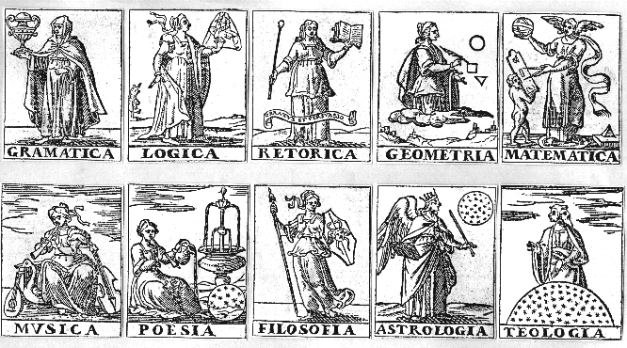
The first edition of the Labarinto (Venice, 1607) is extremely rare, however there is a copy in the British Library. It is of a slightly larger format than the 1616 edition and uses a different set of 60 images. The British Library copy has some manuscript notes pasted in at the end, in which someone has tried to solve the problem posed by this work, using series of tables of numbers based on the arrangements of the emblems on the sequence of page openings.
The title page mentions 1260 figures though there are actually 1320 (22 x 60), so that this may mean that one opening of the 22 is some kind of key to using the others.
An English version was published at London in 1610.
Wits laberynth, or, The exercise of idlenesse. Containing an artificiall textvre of two thovsand two hvndred and sixtie figures, so placed and disposed, as by the helpe of a briefe direction for that purpose, you may tell which of them any man thinketh. As also by the same observation, to discouer any name, or number, that shall bee imagined. Besides an ample and large svjiect for those that affect such ingenious recreations, by the sharpnesse of their own conceits, to drawe out many other delightfull varieties. First composed in Italian, and now Englished and augm. London, Printed by T. Purfoot, and are to be sold by I. Budge, 1610.
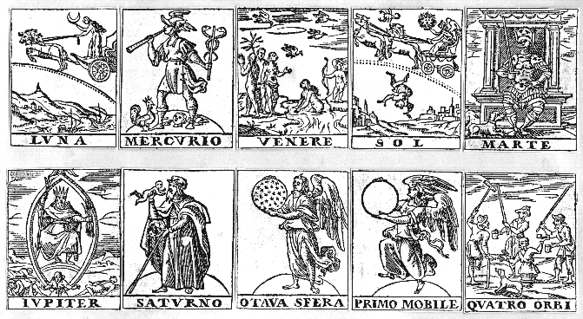
Whether this work has any hermetic import I am unable to say, as I have not been able to solve its enigmatic structure. The use of the Tarocchi of Mantegna derived emblems may have little significance, since the first edition used another set of images. However, the fact that the work was published in this form in 1616, during the explosion of hermetic and alchemical publications, is very suggestive that some hermetic riddle is woven into its strange structure. Labarinto and the Tarrochi of Mantegna
by Adam McLean.

In 1616 a very curious book was published in Venice, the Labarinto by Andreas Ghisi. The title page reads
"The Labyrinth, newly published by the distinguished Andrea Ghisi, nobleman of Venice, in which are seen 1260 figures, all ready for service, each conforming and corresponding, speaking one to another, and infallibly, on the third turn, the imagined figure will be known, with its secret presented."
This consisted of a dedication and short dedication to Giovanni Bembo, the Doge of Venice, with a word square as a tribute to him, consisting of 21x21 letter squares, followed by a sequence of 22 page openings each labelled with a letter of the alphabet. On each of these openings were 60 small block figures in four rectangular groups of fifteen. The same set of 60 figures appeared on each page opening, but in a different permutation. The figures in the 1616 edition were based on the Tarocchi of Mantegna (see my article in the Autumn 1983 issue of the Hermetic Journal). The Tarocchi of Mantegna are divided into 5 sets of ten images
1st decade The different social conditions of humankind
2nd decade The nine muses and Apollo
3rd decade The seven Liberal Arts with Poetry, Philosophy and Theology
4th decade The seven Cardinal Virtues with spirits of Life, Time and the Cosmos
5th decade Seven Planets and the three higher spheres
The Labarinto uses this series of 50 images, with a number of minor changes. 'Chiromantia' and 'Felicita' replace 'Calliope' and 'Terpsichore' of the 2nd decade. 'Mathematica' replaces 'Arithmetica' from the 3rd decade, 'Industria' replaces 'Cosmico' in the 4th decade, and 'Quatro Orbi' replaces 'Prima Causa' in the 5th decade. The additional ten images in a similar style seem to be linked in polarised pairs :-
Kairo - Roma
Galia - Nave
Elefante - Hidra
Dio d'Amor [God of Love or Cupid] - Baco [Bachus]
Adam Eva - Zane in Banco [scene on a platform]
The Labarinto was presented as a game, enigma or mathematical puzzle, the rules for which are not easy to decipher, though they probably involve permutations or perhaps the symmetries of group theory. Ghisi mentions that the outcome of his 'game' depends entirely on the genius of the player. In the copy of this work in the Stirling-Maxwell collection in Glasgow University Library, the following catalogue entry has been pasted in:
"A very curious Block-book, containing 60 different woodcut figures, with xylographic inscriptions, worked in red ink, so arranged on 22 leaves as to appear in different positions. Under the form of an arithmetical puzzle or labyrinth, according to the Libri Catalogue, "The work contains a solution of one of the most complicated problems, both of the theory of numbers and geometry of position, which even to write in algebraic signs would give some difficulty."
The first edition of the Labarinto (Venice, 1607) is extremely rare, however there is a copy in the British Library. It is of a slightly larger format than the 1616 edition and uses a different set of 60 images. The British Library copy has some manuscript notes pasted in at the end, in which someone has tried to solve the problem posed by this work, using series of tables of numbers based on the arrangements of the emblems on the sequence of page openings.
The title page mentions 1260 figures though there are actually 1320 (22 x 60), so that this may mean that one opening of the 22 is some kind of key to using the others.
An English version was published at London in 1610.
Wits laberynth, or, The exercise of idlenesse. Containing an artificiall textvre of two thovsand two hvndred and sixtie figures, so placed and disposed, as by the helpe of a briefe direction for that purpose, you may tell which of them any man thinketh. As also by the same observation, to discouer any name, or number, that shall bee imagined. Besides an ample and large svjiect for those that affect such ingenious recreations, by the sharpnesse of their own conceits, to drawe out many other delightfull varieties. First composed in Italian, and now Englished and augm. London, Printed by T. Purfoot, and are to be sold by I. Budge, 1610.
Whether this work has any hermetic import I am unable to say, as I have not been able to solve its enigmatic structure. The use of the Tarocchi of Mantegna derived emblems may have little significance, since the first edition used another set of images. However, the fact that the work was published in this form in 1616, during the explosion of hermetic and alchemical publications, is very suggestive that some hermetic riddle is woven into its strange structure.

