Hermetic Symbolism in a Masonic Engraving
Article by Adam McLean originally published in the Hermetic Journal Winter 1987.

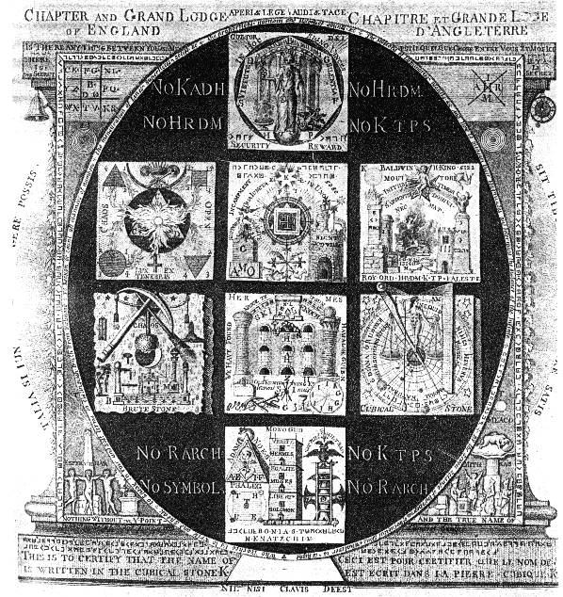
I reproduce here the final plate in a set of six copperplate engravings found in the archives of a masonic lodge in Bamberg in Germany. These were however of English origin, being engraved by P. Lambert R.A. and published in London in 1789. This sixth plate from the series is especially rich in symbolism and as much of which has obvious hermetic undertones it especially attracted my interest. I am grateful to Joscelyn Godwin for bringing this item to my attention. I am not a masonic scholar so am in no sense qualified to analyse the symbolism from that standpoint, however, there are so many hermetic resonances that I think it may be instructive to examine the symbolic content from the hermetic viewpoint. At the very least we can see how hermetic ideas were woven into the complex symbolism of late 18th century Masonry in England.
This engraving shows an egg-shaped space set within a square frame, here stylised into an architectural form. Around three sides of this square setting is a message spelt out in the Royal Arch cipher or secret masonic script. The key to this is given in the top left and right hand corners of the square
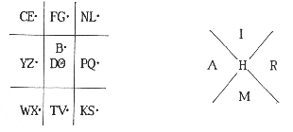
Thus taking the angles of the relevant square C is , E (since it is dotted) is , F is , G (dotted) is , and so on, K is , S is , while from the central square we see that B is , D is , and O is notated . This particular arrangement of the letters is a blind however, and does not decipher the text, but merely serves to illustrate the principle of the cipher without giving away the secret message too easily. I have not taken the time to work out the cipher, there being barely enough text to do a letter frequency analysis, but there seem to be three separate encipherings each section being separated by a key symbol. I understand, however, that the texts were decoded in an article in Ars Quatuor Coronatorum, Vol III, 1890, pp. 36-37, though I have not been able to consult this in preparing this article.
The lower side of the square has in English "Nothing without the V point and the true Name of …", while below this on the plinth is written "This is to certify that the Name of … is written in the Cubical Stone K". In the circular radiance that appears from behind the square setting we have the Latin phrase "If you can comprehend these things, you know enough", and in the centre at the bottom of the plinth we have "Unless the Key is not missing". Such teasing statements are of course found on early hermetic and alchemical emblems, a well known example being Khunrath's Amphitheatre Engravings which use similar phrases to taunt the reader, but this was a common device in many earlier works. I understand that these particular phrases are found inscribed on the regalia of a Companion of the Royal Arch.
Around the circumference of the oval space we find a much more comprehensible statement:
Who teaches us to write and speak,
To speak in fair and soft terms,
To distinguish truth from falsehood,
To reckon and count all manners of numbers,
The mensuration of lines, superfices, solids,
The proportion, harmony and discords of sound,
The motion of luminaries, planets,
And how to measure their magnitude
and determine the distance of the Infinite.
[word(s) in cipher]
By the seven science of the 7 degrees of the Cubical Stone,
Whatever is, is right.
In the dark space within the oval, is placed:
No Kadosh No Heredom
No Heredom No Knights Templar
No Royal Arch No Knights Templar
No Symbols No Royal Arch
Linking to the statement at the centre bottom of the plate
"Unless the Key is not missing"
The central space is taken up by a pattern of eight squares bearing elaborate symbolism. Two of these are shaded to appear as three dimensional blocks rather than flat planes-the one on the left being the Brute Stone, whilst that on the right is labelled the Cubical Stone. The six remaining squares form a pattern, which can be wrapped up to form a cube.
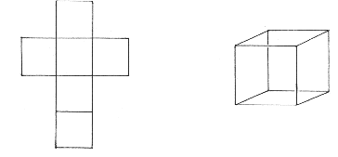
The panel in the lower corner of the outer square shows the Mithraic mysteries with a 'priest' celebrating at an altar formed from two flat square stones and a cube. This image is also seen on one of the squares.
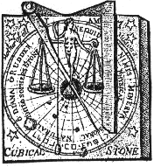
First we will consider the 'Brute Stone' and the 'Cubical Stone'. The Cubical Stone shows the cosmic space of the planetary spheres and the realm of the stars. On the earth stands Diana the 'Queen of Heaven' bearing seven breasts. Four symbolic objects are shown-the square, compass, plumb-line and scales, suggesting the geometric patterns of harmony that are found in the cosmos. Beneath her feet is the 'Physical, Moral, Natural Philosopher's Stone'. This picture echoes the symbolism of one of Robert Fludd's well known diagrams.
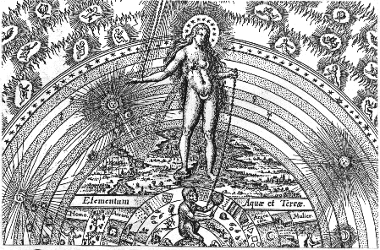
Contrasting with this on the left side of the diagram is the Brute Stone.
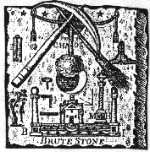
Here a tree is seen upside down spanning the worlds, its roots in the Sun, its branches spreading downwards through the realm of the Moon towards the earth. Again this calls to mind another of Fludd's famous diagrams.
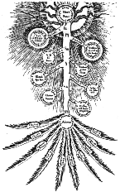
The Brute Stone also bears various masonic symbols - the pickaxe and broom, the metronome or pendulum accurately beating time, while in the lower left we see a mallet, square and level. This is the realm of the world bounded by measurement (both of space and time). At the lower centre of this is a temple with two pillars and central sanctuary and obelisk, suggesting that the spiritual can be found in this world of measurement by the right application of the cosmic spiritual principles of mensuration and proportion. At the top centre of this stone is seen a cord with tassels set across two rings. This implies a kind of veil or barrier between the cosmic world of the planetary spheres and the outer physical world below, this gulf being spanned by the inverted tree, the descent of the spiritual principles from above as a living force, rather than abstract principles.
The six other squares form the surfaces of a cube when folded up, so we can suggest that this is to be placed upon the Brute Stone, representing the earthly world, and capped by the Cubical Stone, to form an altar of aspiration. This altar thus contains in a coded form the essence of the work of spiritualising the material world (the square between these two stones has at its top centre a sketch of this altar). This set of six faces of the cube seems to work especially with the symbolism of the Three, the Four and the Seven.
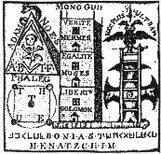
Thus the lowest square has a triangular pyramid, a square tower of three storeys (associated with Truth, Egality, Liberty - Hermes, Moses and Solomon) and a seven runged ladder. There are also found other archetypal symbols familiar in alchemy - the serpent, the double-headed eagle, the skull and the tetramorph.
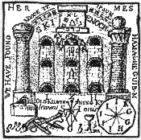
Architectural symbols are repeated on some of the other squares. Thus, the second from bottom shows us the wall of a three-storeyed building, each storey having three arched openings or niches. Below on the left a nonagon bears nine letters possibly associated with these niches. Twin pillars, another symbolic element common to this set of squares frame the triple building, and (as we have noted earlier) in the central space above is the archetypal form of an altar formed from a cube and two slabs of stone. This has a triangle with nine letters set around it in cipher and from it radiates out beams of light, and what appears to be a rainbow (also bearing nine letters in cipher) forms an arc around the tower. In the small detail of this square we find a menorah (seven-branched candlestick) and also a chalice.
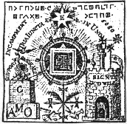
The third from bottom is a figure centred upon a radiant circular form set upon a cross like stem. The radiant form bears a triangle and square at its centre, while above flames a seven pointed star (labelled with an 'E'). To the left is seen a square obelisk upon which is a a rose above which hovers a dove. This is labelled 'support' and 'morality' while the plinth of the obelisk has 'AMO' (Love). The round castellated tower to the right is the 'sign of God's Will'. Thus Love and Will are balanced. At the top of this tower is a pillar with a book at its top and a lunar pennant or flag with the image of the Moon. Three Templar crosses are set above. This figure recalls the form of Robert Fludd's Rose on a Cross.
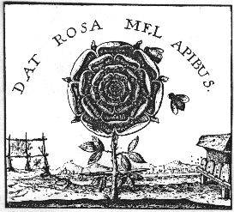
The square or face to the left is openly hermetic in conception centred on the Caduceus or Mercury symbol. At its centre is an upward pointing triangle and set on top a downward pointing triangle of flames, thus forming the Seal of Solomon. This can also be seen as Sulphur, the radiating fire-principle. At each corner of this square are seen geometrical figures, triangles, square and circle, with numbers 1, 2, 3, 4 arranged so as to illustrate mirror symmetries and reflections. Thus :-
4 3
1 2
when mirrored become
3 4
2 1

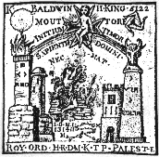
The square on the right seems more directly masonic in symbolism. Four towers are set in a rectangular arrangement. The square tower in the left foreground set upon a rough built plinth and crowned with fire is partnered by the obelisk on the right with a bull's head. In the background left is a circular tower on a rough built plinth, while a castellated round tower is placed in the background right. In the centre a figure seems to be offering a sacrifice at a rough built altar while above the figure of a child is seen in a Templar Cross. The masonic interpretation of this particular set of symbols are not known to me.
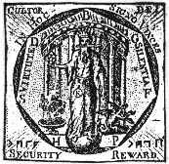
The final square at the top of the oval space is an elaborate symbolic statement of the operative use of this whole complex of symbolism of the Cubic stone. A heptagon set in a circular space radiates outwards beams of light, while around it is the statement familar in Rosicrucian circles 'In Hoc Signo Vinces' - 'By this sign you are successful'. A priestly figure crowned with the spirit (H.P. ='High Priest' ?) stands on a globe of the world set in front of a six-columned temple. He extends his right hand holding six stars while his left points to a triple headed dragon. Thus he attempts to unite the above and the below-the realm of the cosmic spirit with that of the inner dragon. To his right is a vessel burning incense signifying the purification of the ritual space through air and fire. Between his teeth he holds a dagger while upon his vestments is a seven sided medallion with a 'K'.

