Capillary Dynamolysis
By Adam McLean. First published in the Hermetic Journal 1980.
http://www.levity.com/alchemy/kolisko.html

In the early 1920's, Lilly Kolisko working upon a suggestion made by Rudolf Steiner, the founder of Anthroposophy, devised a method for experimentally investigating the workings of the etheric forces in material substance. She called this technique 'Capillary Dynamolysis' and continued to investigate and refine the method until she died in 1976. She applied it particularly to researching the etheric forces working in the domain of agriculture, testing various composting methods, and using it to investigate the disease processes in plants, animals and man, that are the result of etheric imbalance. Later in an amazing series of experiments, she was able to show directly the influence of the planets on substance, particularly revealed at critical conjunctions, oppositions and eclipses.
I believe her work to be of the greatest importance, as she has provided us with an experimental tool for investigating the etheric forces, and truly laid the foundations of a modern alchemical experimental methodology.
The technique she pioneered is beautifully simple, and is basically a qualitative repeatable scientific test, which reveals the workings of the etheric forces in substance. A measured standard quantity (10 cc) of the substance to be tested, say a plant sap, is placed in a shallow glass vessel in which is stood a vertical cylinder (about 12 inches high) of filter paper (a rectangular piece rounded and closed upon itself).
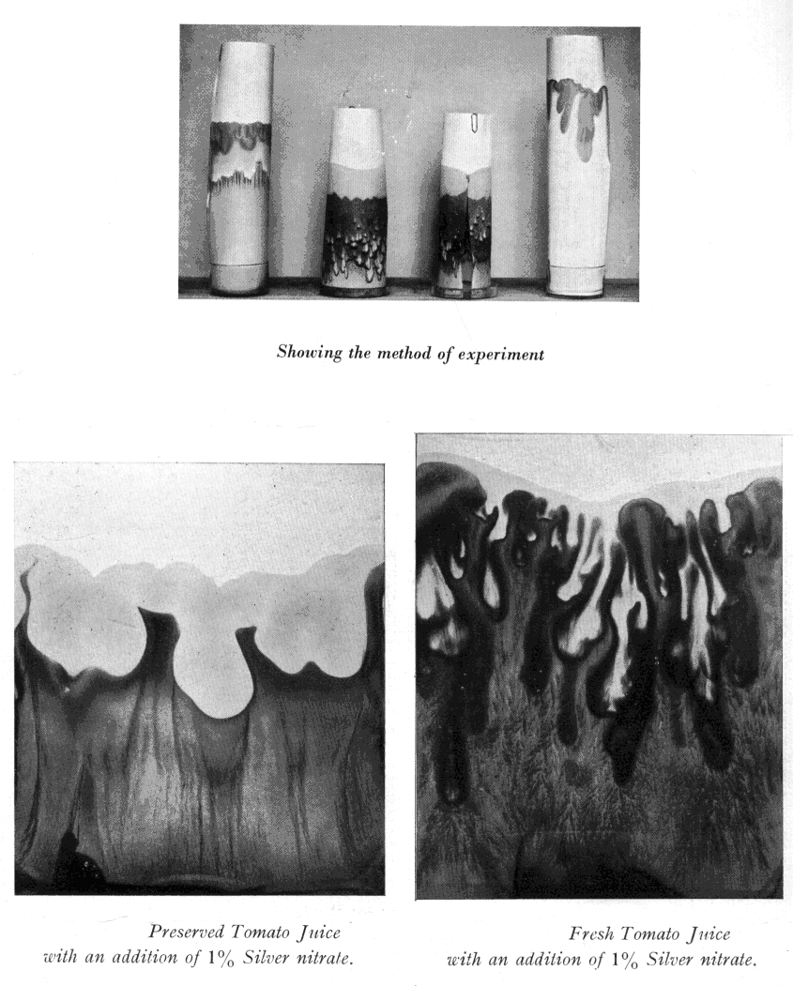
The solution is allowed to rise up the filter paper until it is all absorbed, and the filter paper is then left to dry completely. Then the formative forces working in this substance are revealed through a development process. This involves repeating the proceedure above with the dried filter paper, but this time placing in the vessel a dilute solution of one of the soluable salts of the planetary metals. 1% solutions were found to be the most successful. The choice of the developing solution depends on which aspect of the etheric forces one is studying.
Gold Chloride for the Sun
Mercuric Chloride for Mercury
Silver Nitrate for the Moon
Stannous Chloride for Jupiter
Copper Sulphate for Venus
Lead Nitrate for Saturn
Iron Sulphate for Mars
This part of the experiment should be done in good natural light, as light is essential in developing the forms. One finds revealed through these experiments, patterns of colour and form on the filter paper, which are a kind of shadow image of the etheric forces working in the substance. This is a qualitative test rather than a quantitative one. That is, unlike laboratory capillary analysis, where one measures the height the substance rises on the filter paper, here we look at the nature of the forms displayed, and consider the strength of these forms, and the ways in which they metamorphose when different test solutions are used.
Thus this test can be used to give an indication of how much life force remains in plant substances preserved using different preservation methods. I show the results obtained using fresh apple juice and fresh tomato juice, and here we see the strong forms that characterise the activity of the etheric forces revealed by the silver nitrate. By comparison the preserved juices show a definite lack of form. This test can also be used to show that homoeopathic dilutions of substances have definite formative forees working within these dilutions, which in the higher potencies have only a few molecules of the potentised substance in the measured quantity of test solution.
Lilly Kolisko extended her work to include a series of experiments relating astronomical events to observable changes in the pattern of the planetary metals when they are allowed to rise through the filter paper. For this she chose an eclipse of the Sun, and the two illustrations shown are from the sequence of experiments she undertook during the total eclipse of the Sun of l9th June 1936. Over the period of the eclipse, she performed a large number of standard capillary dynamolysis tests, starting the day before the eclipse and continuing till the day after. The experiments were performed on the hour at hourly intervals, to provide a full record of the event, but as the time of the eclipse approached on 19th June at 4.56 am, these were performed at ten minute intervals up to the period of totality, when the experiments were repeated each minute.
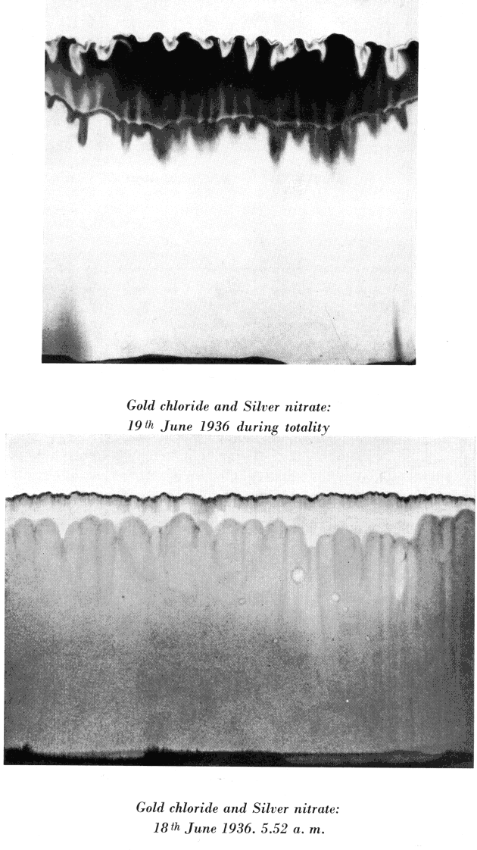
Thus a complete record of the period of the eclipse was made and also control experiments for the day before and the day after. One of the tests she ran at that time involved the simultaneous use of Gold Chloride and Silver Nitrate as the test solution, Gold reflecting the Sun forces and Silver the Moon. A thorough description of this experiment together with illustrations of the resulting filter paper patterns, was published in 1936. I reprodude here only two of this series, one from during the totality of the eclipse itself and the other from the same time on the day before the eclipse.We see clearly how the silver forms have risen during the eclipse event to dominate the gold colours.
I believe we should come to recognise in these capillary dynamolysis experiments of Lilly Kolisko, a kind of continuation in twentieth century terms of alchemical experimentation. We read in many alchemical texts of how experiments were repeated again and again awaiting the right cosmic moment when some definite change in the experimental substances could be seen. We can also see a parallel between the filter paper and the alchemical retort, within which the test substances interacted and the colours and forms were revealed. The alchemist created in the space of their retorts, delicately balanced equilibria of substances which were sensitive to any change in the etheric environment, or the forces working within the test substance. I think we can recognise in alchemical writings deseriptions of such equilibria, some of which involved not just solid/liquid and liquid/ liquid phases but also liquid/gaseous phases. The alchemist mused over such experiments, gazing into the retort watching for a sign, some subtle change that indicated the presence of the etheric forces. Such an alchemist would. I feel, be quite at home with Lilly Kollsko's work.
I believe that the work of Lilly Kolisko has provided for us a foundation stone upon which future alchemical experimentation can be built. The etheric forces, of course, can never be described in quantitative terms and this has led established Science, ruled by quantity, to deny their existence, as materialistic Science has no method for investigating these forces directly. Lilly Kolisko has provided a bridge between esoteric Science and quantitative science, as using exact scientific methods, she was able to create a qualitative scientific method for observing the influence of the etheric forces in substance, through experiments which are readily repeatable. I hope that her work can be continued and extended as I can see that upon its foundations a qualitative ccience of the etheric forces can be built, a new alchemy and Etheric Science.

Lilly Kolisko
Agriculture of Tomorrow Capillary Dynamolysis Gold and the Sun (eclipse of 19th June 1936)
Gold and the Sun (eclipse of 20th May 1947)
The Moon and the Growth of Plants
Eugen and Lilly Kolisko
Silver and the Human Organism
Lead and the Human Organism

