An account of an experiment to grow a tree of silver
By Adam McLean. First published in the Hermetic Journal 1980.
http://www.levity.com/alchemy/tree_of_silver.html

An account of an experiment to grow a tree of silver
By Adam McLean
This experiment involves no special subtle transmutation, but the chemically respectable process of the precipitation of metallic silver from a solution of silver nitrate by the chemically more electropositive metallic mercury. For the first experiment (A) a 10% solution was used - 10 grams silver nitrate made up to 100 ml solution in water. About 20 grams of metallic mercury was introduced into the solution at normal room temperature in a 100 ml round bottomed flask, in small quantities at a time. As the mercury entered the transparent solution a brown precipitate immediately formed as a kind of veil in the solution, but within a few minutes this disappeared. One observed within the space of 15 minutes, small growths forming on the surface of the bubble of mercury, and within a hour a kind of grey mossy precipitate had formed around the mercury which had been completely transformed. As the experiment had reached a stasis and equilibrium, more mercury was introduced and within a further 12 hour small tree like growths began to press up out of the mossy precipitate at the bottom of the flask. These forms were very delicate and the slightest vibration disintegrated them. After a third addition of mercury, more rigid crystals of silver began to form within a further hour or so. These rigid crystals began to act as the trunks for the trees of silver which precipitated in the form of ramifying branches and fine leafy structures. These were much more stable and indeed the forms survived some few weeks.
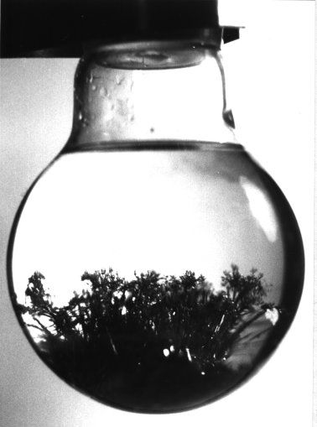
A second experiment (B) was undertaken with a more dilute solution 5% silver nitrate, though with the same experimental method, and in this case a pattern more of radiating outward crystals shaped itself.
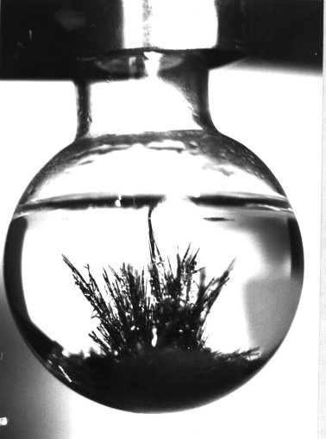

Note: precautions must be taken when working with mercury as it is extemely toxic. See the pages on safety in alchemical experiments

