Adam McLeans Gallery of alchemical images Beccafumi Series
http://www.alchemywebsite.com/amcl_beccafumi.html
This is early series of ten woodcuts by Domenico Beccafumi, also known as Meracino or Mecuccio. He was working in the early decades of the 16th century in Siena, and these woodcuts are thought to date to the period 1525-1540. They show a process in which the philosopher-alchemist and the laboratory worker-alchemist, begin by finding the seven metals, personified as Greek Gods lurking in the mountains, gathering these and leading them through a transformation process in the laboratory. These are amongst the earliest printed depictions of alchemical imagery.
Go back to alchemical images index page

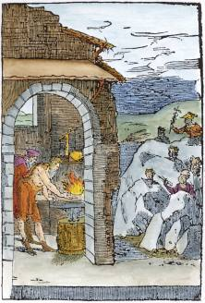  BC01. | 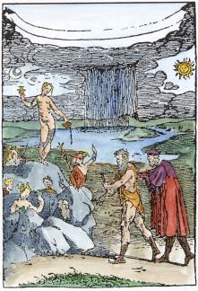  BC02. | 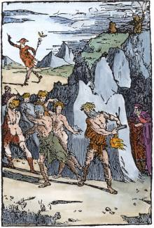  BC03. | 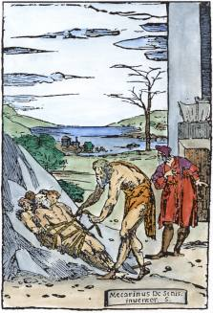  BC04.
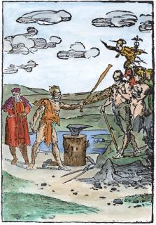  BC05. | 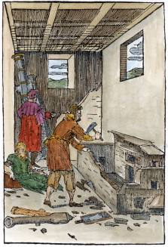  BC06. | 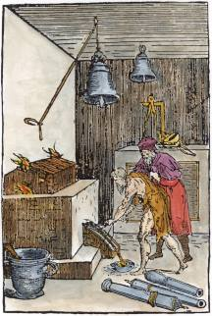  BC07. | 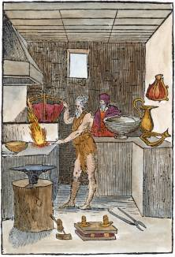  BC08.
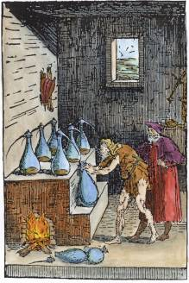  BC09. | 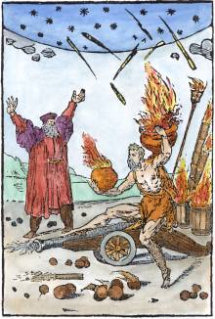  BC10.

