Adam McLean's Gallery of alchemical images
http://www.levity.com/alchemy/
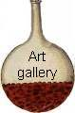
Galleries of coloured alchemical emblems

Over the past ten years or so I have been making handcoloured emblems by painting with watercolours copies of woodcuts and engravings from printed books and some manuscript drawings. In colouring these I made use of my intensive study of the original coloured manuscripts of the 15th to 18th centuries, which have been the main focus of my research over the past years.
I have often found that by contemplating and meditating on these handcoloured images one can resonate with and enter into the complex symbolic world of alchemy.
I regret that I can only supply these images as these small thumbnails on this internet web site. Earlier in 1999 I did place full page images on this site, but some people just took these without my permission and used them in their own web sites and in other projects. One person in particular even claimed he had copyright over an image that I painted and is still hanging on my kitchen wall ! Thus I have had to restrict these pictures to these small thumbnails which are too small to use especially for printing.

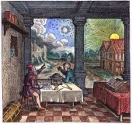  A001. An image of the astrologer consulting the heavens. From Robert Fludd's Utriusque cosmi historia, Vol II. | 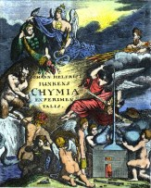  A002. Frontispiece engraving from Johann Helfrich JÜNGKEN, Chymia experimentalis, Frankfurt, 1701. | 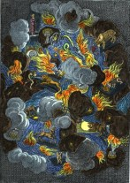  A003. Engraving from Michel de Marolles, Tableaux du temple des muses, Paris, 1655. | 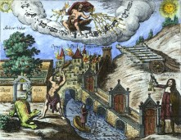  A004. Engraving from Gottfried Moebius, Neu-Angezundt-Hell-brennendes Feuer, oder Mercurial-Liecht..., Augsburg, 1680.
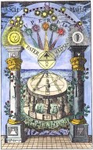  A005. Frontispiece to an 18th century German book entitled 'the compass of the wise'. | 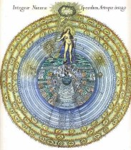  A006. The Macrocosm and the Microcosm. Frontispiece from Robert Fludd's Utriusque cosmi historia. | 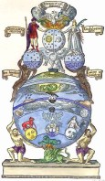  A007. Woodcut from Andreas Libavius Commentariorum alchymiae. | 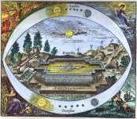  A008. Frontispiece from Balduin's Aureum superius et inferius.

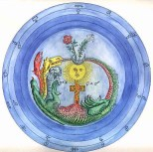  A009. Redrawn from a manuscript in the Manly Palmer Hall collection. | 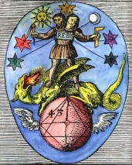  A010. Sixth woodcut from the series in Basil Valentine's Azoth. | 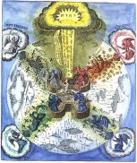  A011. Man at the centre of the fortress of health, protected by the angels. From Robert Fludd's Medicina catholica. | 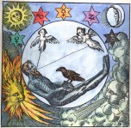  A012. Seventh woodcut from the series in Basil Valentine's Azoth.
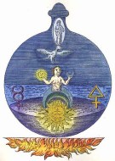  A013. Engraving from Barchusen's version of the 'Crowning of Nature'. | 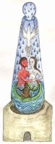  A014. Redrawn from a 15th century manuscript in the British Library, Harley 2407. | 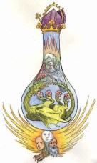  A015. Redrawn from a 14th century manuscript in Cracow of Al-Razi's 'Opera Medicinalia'. | 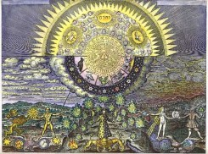  A016. Large engraving of the polarities in the macrocosm and the microcosm, from J.D. Mylius Opus medico-chymicum. Landscape formatm

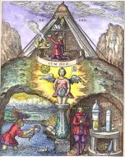  A017. From Theophilus Schweighardt's 'Mirror of the Rosicrucian wisdom'. | 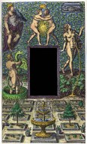  A018. Frontispiece from Beroalde de Verville's Le Voyage des princes fortunez. | 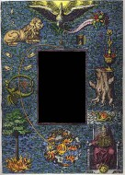  A019. Frontispiece from Beroalde de Verville's Le Tableau des riches inventions. | 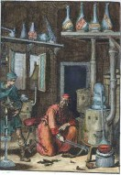  A020. An alchemist, possibly Irenaeus Philalethes, in his laboratory. From Pyrotechnia ofte Vuur-stook-Kunde, Amsterdam, 1687.
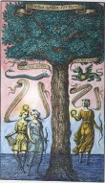  A021. Frontispiece from Baro Urbigerus, Aphorismi Urbigerani, London, 1690. | 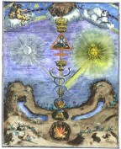  A022. Engraving from, Le triomphe hermetique, Amsterdam, 1689. | 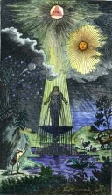  A023. Frontispiece to 'Brunnen der Weissheit' in Fünff curieuse chymische tractätlein, Frankfurt, 1757. | 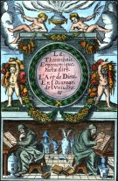  A024. Woodcut frontispiece from Annibal Barlet Le vray et methodique cours..., Paris, 1651.

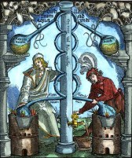  A025. Woodcut from Hieronymus Braunschweig Das Buch zu distillieren, Strassburg, 1519. | 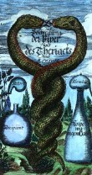  A026. Engraved frontispiece from Moses Charas Neu-erfahrne Proben von der Viper... , Frankfurt, 1679. | 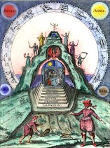  A027. Engraving 3 from Stefan Michelspacher Cabala, Spiegel der Kunst und Natur, Augsburg, 1615. | 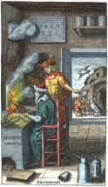  A028. Frontispiece to J. J. Becher Oedipus chimicus, Amsterdam, 1664.
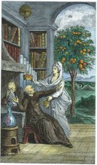  A029. Engraving from Sabine Stuart de Chevalier Discours philosophique, Paris, 1781. | 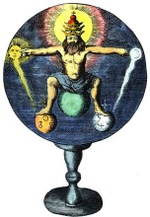  A030. Frontispiece from Johann de Monte-Snyders Metamorphosis planetarum, Amsterdam 1663. | 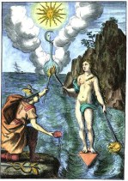  A031. Frontispiece from Nicolas de Locques Les Rudiments de la Philosophie Naturelle, Paris, 1665. | 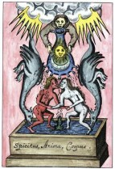  A032. Figure from Elias Ashmole Theatrum chemicum britannicum, London, 1652.

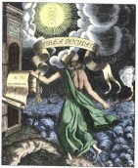  A033. Frontispiece from Knorr von Rosenroth Kabbala Denudata, Sulzbach 1677. | 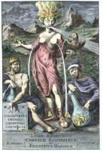  A034. Frontispiece from Christopher Love Morley Collectanea chymica Leydensia, Leiden, 1693. | 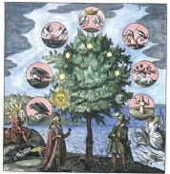  A035. Frontispiece from Johann Daniel Mylius Philosophia reformata, Frankfurt, 1622. | 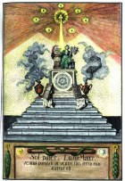  A036. Frontispiece from manuscript version of Georg von Welling Opus mago-cabbalisticum.
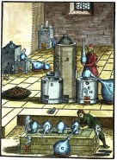  A037. Woodcut from Lazarus Ercker Beschreibung allerfurnemisten mineralischen Ertzt unnd Bergkwercks arten, Frankfurt, 1598. | 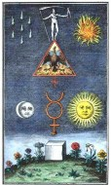  A038. 18th century engraving based on work of Basil Valentine. | 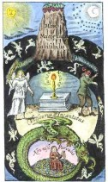  A039. Engraving from Thomas Vaughan Lumen de lumine, London, 1651. | 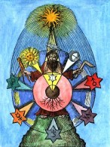  A040. Woodcut from 'Cabala chemica' in Volume VI of Theatrum chemicum, Hamburg, 1659.

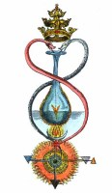  A041. Figure from an 18th century manuscript entitled Bibliotheque des sages. | 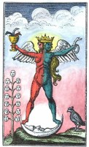  A042. Engraving of hermaphrodite from an 18th century version of the Rosarium philosophorum. | 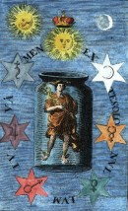  A043. Engraving from Baro Urbigerus, Besondere chymische Schrifften, Hamburg, 1705. | 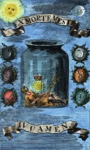  A044. Engraving from Baro Urbigerus, Besondere chymische Schrifften, Hamburg, 1705.
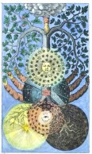  A045. Tree of dark and light from Valentine Weigel Studium Universale, 1695. | 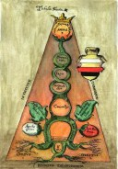  A046. Illustration from a manuscript in the British Library, MS. Sloane 3667, a 17th century copy of George Ripley Marrow of Alchemy. | 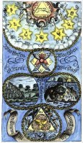  A047. Frontispiece to Hermetis Trismegisti Erkäntnüss der natur, Hamburg, 1706. | 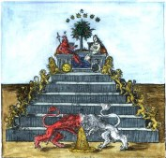  A048. Pyramid of lions, from Andreas Libavius, Alchymia, Frankfurt, 1606.

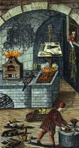  A049. Frontispiece from Johann Gottfried Kiessling, Relatio practica Leipzig, 1752. | 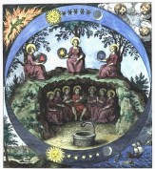  A050. Engraving from Musaeum hermeticum, Frankfurt, 1625. | 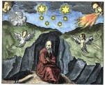  A051. Engraving from J.D. Mylius Philosophia reformata, Frankfurt, 1622. | 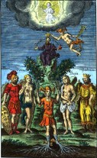  A052. Frontispiece from Adolph Christoph Bentz, Philosophische Schau-Bühne Nurnberg, 1706.
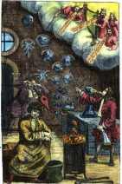  A053. Frontispiece Johann Georg Schmid, Der von Mose u. denen Propheten übel urtheilende Alchymist Chemnitz, 1706. | 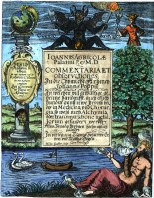  A054. Frontispiece engraving from Joannis Agricola Commentariorum, Notarum, Observationum & Animadversionum in Johannis Poppii chymische Medicin, Leipsig, 1638. | 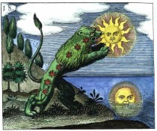  A055. Engraving from J.D. Mylius Philosophia reformata, Frankfurt, 1622. | 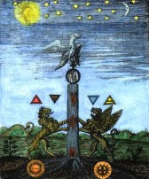  A056. Engraving from Giovanni Lacinio, Pretiosa margarita..., Leipsig, 1714.

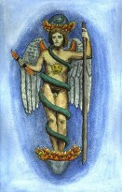  A057. Image of Phanes emerging from the world egg. Redrawn from a sculpured relief by Adam McLean. | 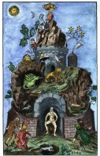  A058. Redrawn from the frontispiece engraving to Denis Zachaire Die Natürliche Philosophia, 1724. | 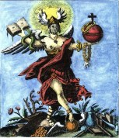  A059. Engraving from J. A. Siebmacher, Das güldene Vleiss, Nurnberg, 1737. | 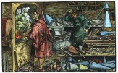  A060. Woodcut from Francesco Petrarcha, Das Glückbuch Beydes des Guten und Bösen, Augsburg, 1539.
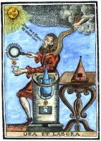  A061. 'Ora et labora' woodcut from Medicinisch-chymisch- und alchemistische Oraculum, Ulm 1755. | 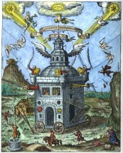  A062. The Invisible college of the Rosicrucians, Theophilus Schweighardt Speculum sophicum rhodo-stauroticum, 1618. | 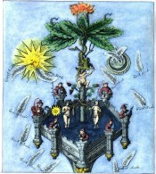  A063. Section of Ripley Scroll from engraving in David Beuther, Universal und particularia, Hamburg, 1718. | 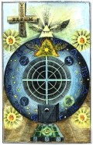  A064. Frontispiece from Jacob Boehme, 'Signatura Rerum' in Theosophische Werken, Amsterdam, 1682.

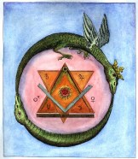  A065. Engraving from I.C. H., Das Hermes Trimegists, Leipsig, 1782. | 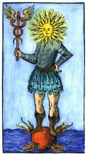  A066. Woodcut from Johann Sternhals Ritter-Krieg, Erfurt, 1595. | 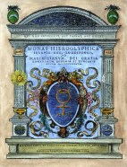  A067. Engraved title from John Dee, Monas hieroglyphica, Antwerp, 1564. | 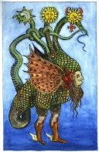  A068. Woodcut of triple-headed dragon from Giovanni Battista Nazari Il metamorfosi metallico, Brescia, 1564.
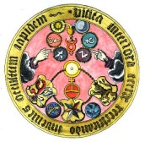  A069. Vitriol acrostic (originally from Basil Valentine) in Johann Neithold Aureum Vellus; oder Güldenes Vleiss, Frankfurt, 1733. | 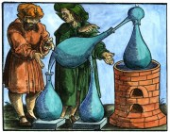  A070. Woodcut from Geber De alchimia libri tres, Strassburg, 1631. | 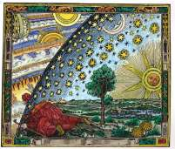  A071. Peering through the cosmic sphere - illustration from 'L'atmosphere: meteorologie populaire',Paris 1888, by Camille Flammarion. | 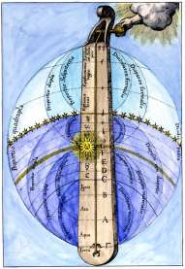  A072. The Divine monochord Utriusque Cosmi Historia, 1617 by Robert Fludd.

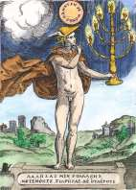  A073. Hermetic silence - emblem from Achille Bocchi Symbolicarum quaestionem de universo genere, 1574. | 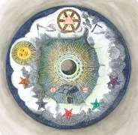  A074. Masonic/alchemical image from Die Theoretischen Brüder oder zweite Stufe der Rosenkreutzer, 1785. | 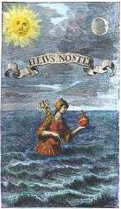  A075. Mercury emerging from the sea, J.E Muller Wunder-Materie, 1707. | 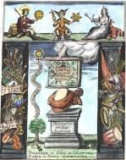  A076. Engraving from Ashmole's Theatrum Chemcicum Britannicum, 1652.
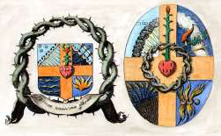  A077. Alchemical heraldry from D. Lagneau Harmonie chymique, 1636. | 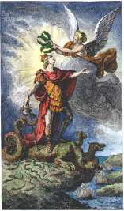  A078. Engraving from Sabine Stuart de Chevalier, Discours philosophique, 1781. | 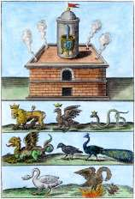  A079. Engraving from Michael Maier, Tripus aureus, 1618. | 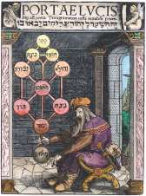  A080. . Joseph ben Abraham Gikatilla, Portae lucis, 1516.

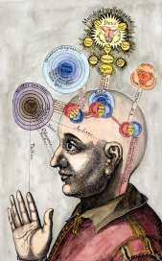  A081. The mind of the microcosm from Robert Fludd Utriusque cosmi... historia, 1619. | 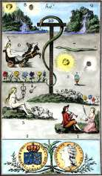  A082. Frontispiece from Etteilla Les sept nuances de l'oeuvre philosophique-hermétique, 1785. | 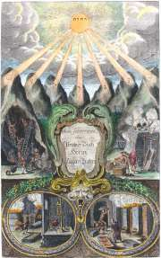  A083. Frontispiece from Lazarus Ercker Aula subterranea, 1672. | 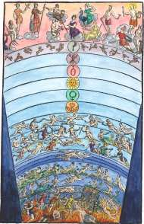  A084. Frontispiece from Natalis Comes Mythologiae, 1616
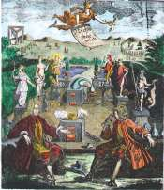  A085. Count Cajetani and Baron von Klettenberg dispute in an alchemical garden Besondere Curieuses Entrevue, 1721. | 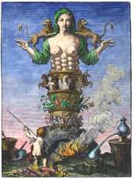  A086. Frontispiece engraving from Urban Hjärne Actorum Chemicorum Holmiensium, 1753 | 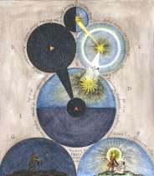  A087. Engraving from Robert Fludd Medicina Catholica, 1629. | 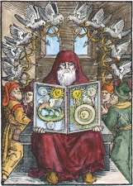  A088. Frontispiece woodcut from Zadith ben Hamuel De Chemia Senioris, 1566.

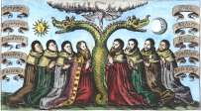  A089. Engraving from Ashmole, Theatrum Chemicum Britannicum, 1652. | 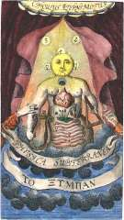  A090. Frontispiece from Becher Physica subterranea, 1703. | 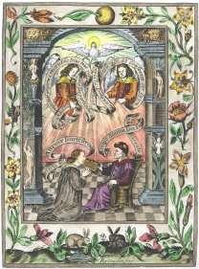  A091. Engraving one from Norton's 'Ordinall' in Ashmole, Theatrum Chemicum Britannicum, 1652. | 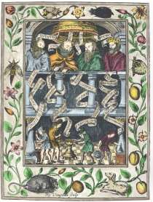  A092. Engraving two from Norton's 'Ordinall' in Ashmole, Theatrum Chemicum Britannicum, 1652.
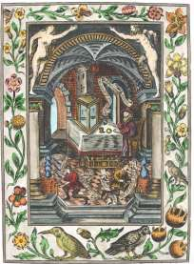  A093. Engraving three from Norton's 'Ordinall' in Ashmole, Theatrum Chemicum Britannicum, 1652. | 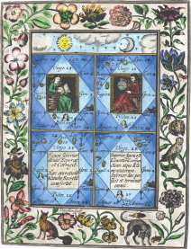  A094. Engraving four from Norton's 'Ordinall' in Ashmole, Theatrum Chemicum Britannicum, 1652. | 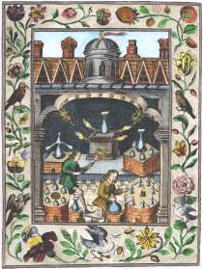  A095. Engraving five from Norton's 'Ordinall' in Ashmole, Theatrum Chemicum Britannicum, 1652. | 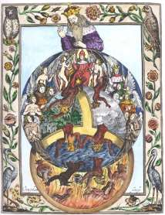  A096. Engraving six from Norton's 'Ordinall' in Ashmole, Theatrum Chemicum Britannicum, 1652.

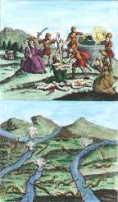  A097. Engraving of Flamel's hieroglyphic figures from Des berühmten Philosophi Nicolai Flamelli Chymische Werke, 1751. | 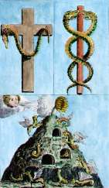  A098. Engraving of Flamel's hieroglyphic figures from Des berühmten Philosophi Nicolai Flamelli Chymische Werke, 1751. | 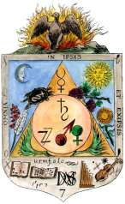  A099. Redrawn from engraving in Jean Brouaut, Traité de l'eau de vie, 1646. | 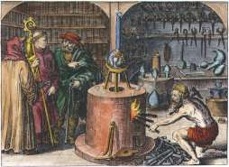  A100. Engraving on titlepage of Maier, Tripus aureus, 1618.
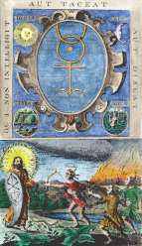  A101.Frontispiece from Johann Schütze Ein altes, sehr schönes und herrliches Tractätlein von dem Gebenedeyten Stein, 1682. | 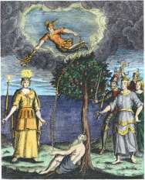  A102. Frontispiece from Vanderbeeg Manuductio Hermetico-philosophica, 1739. | 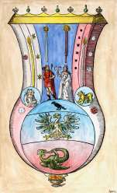  A103. Woodcut from Libavius Commentariorum alchymiae, 1606. | 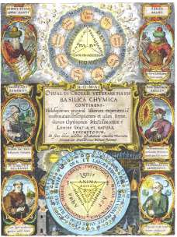  A104. Engraved title page of Oswald Croll Basilica chymica, 1609.

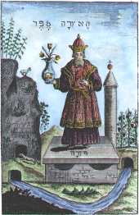  A105.Frontispiece from Abraham Eleazar,Uraltes chymisches Werck, Erfurt, 1735. | 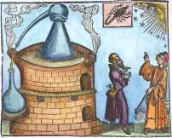  A106. Woodcut from Hieronymus Brunschweig Das Buch zu distillieren, [1517.] | 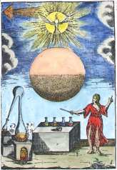  A107. Engraving from work of Giovanni Battista Diana Paleologo (1656-1744). | 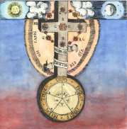  A108. Redrawn from Theophilus Schweighardt Pandora sextae aetatis, 1617.
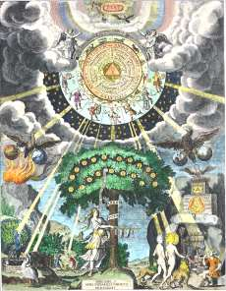  A109.Engraving from Malachias Geiger Microcosmus hypochondriacus, Munich, 1651. | 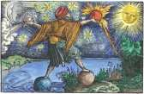  A110. Woodcut from Petrarch Das Glüchbuch, Augsburg, 1539. | 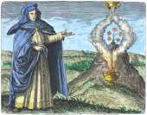  A111. Maria the Jewess from Maier Symbola aurea mensae, Franckfurt, 1617. | 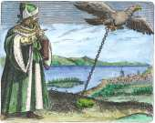  A112. Avicenna from Maier Symbola aurea mensae, Franckfurt, 1617.

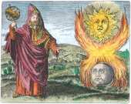  A113. Hermes Trismegistus from Maier Symbola aurea mensae, Franckfurt, 1617. | 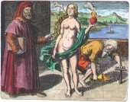  A114. Democritus from Maier Symbola aurea mensae, Franckfurt, 1617. | 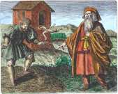  A115. Morienus from Maier Symbola aurea mensae, Franckfurt, 1617. | 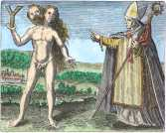  A116. Albertus Magnus from Maier Symbola aurea mensae, Franckfurt, 1617.
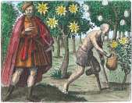  A117. Sendivogius from Maier Symbola aurea mensae, Franckfurt, 1617. | 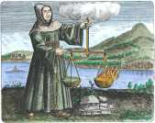  A118. Roger Bacon from Maier Symbola aurea mensae, Franckfurt, 1617. | 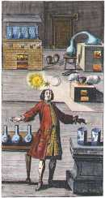  A119. Frontispiece from C.F. Sabor Practica naturae vera, 1721. | 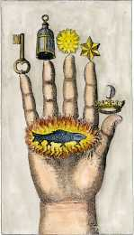  A120. The hand of the philosophers from J.J. Hollandus, Chymische Schrifften, Vienna, 1773.

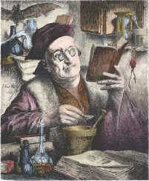  A121. Engraving by E. van Hove, Der Alchemist, 1883. | 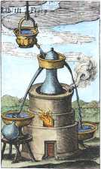  A122. 17th century engraving of distillation apparatus. | 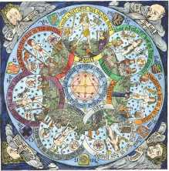  A123. 15th century astrological woodcut. | 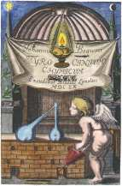  A124. Frontispiece from Jean Beguin, Tyrocinium chymicum, 1660
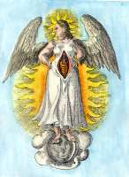  A125. Image from the Aurora consurgens. | 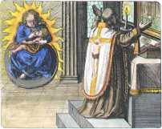  A126. Melchior Cibinensis from Maier Symbola aurea mensae, Franckfurt, 1617. | 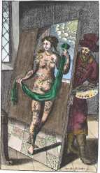  A127. Frontispiece from Arnold Bachimius-Destonius, Pan-Sophia Enchiretica 1682. | 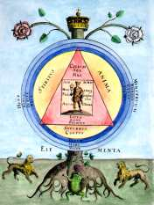  A128. Engraving from Samuel Norton, Alchymiæ complementum..., 1630.

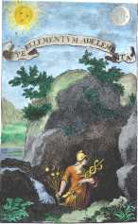  A129. Engraving from Baro Urbigerus Besondere chymische Schrifften, 1705. | 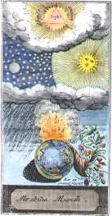  A130. Engraving one from Johannes de Maldini Mirabilia Mundi, 1754. | 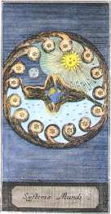  A131. Engraving two from Johannes de Maldini Mirabilia Mundi, 1754. | 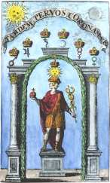  A132. Engraving from Baro Urbigerus Besondere chymische Schrifften, 1705.
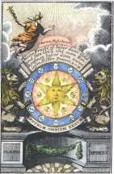  A133. Frontispiece engraving from Drey curieuse chymische tractätlein, 1774. | 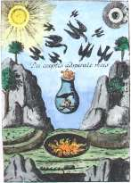  A134. Frontispiece engraving from Microcosmische vorspiele des neuen Himmels und der neuen Erde, 1744. | 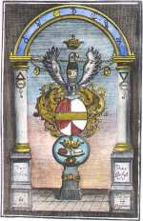  A135. Frontispiece engraving from Hermann Fictuld Der längst gewünschte und versprochene Chymisch-Philosophische Probier-Stein, 1740. | 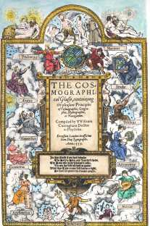  A136. Woodcut title page The Cosmographical Glasse, 1559.

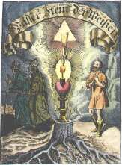  A137.Frontispiece from Siebmacher Wasserstein der Weysen, 1704. | 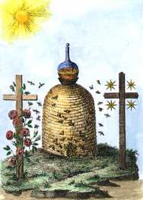  A138.Frontispiece from Geheimnisse einiger Philosophen und Adepten, 1780. | 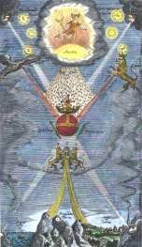  A139.Frontispiece from Alexander von Suchten Chymische Schrifften, 1680. | 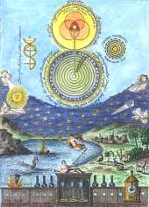  A140. Frontispiece from Carl Herrmann Gravel Fontina Bernhardi revelata, 1750.
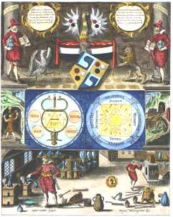  A141. Engraving one from Michelspacher Cabala: Spiegel der Kunst und Natur, 1615. | 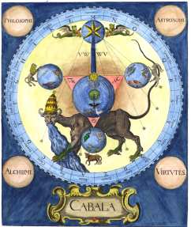  A142. Engraving two from Michelspacher Cabala: Spiegel der Kunst und Natur, 1615. | 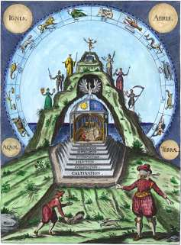  A143. Engraving three from Michelspacher Cabala: Spiegel der Kunst und Natur, 1615. | 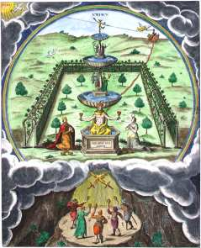  A144. Engraving four from Michelspacher Cabala: Spiegel der Kunst und Natur, 1615.

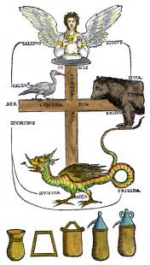  A145. Woodcut from Petrus Bonus, Pretiosa margarita novella, Venice, 1546, | 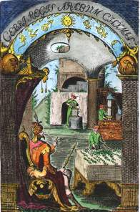  A146. Frontispiece from Geber, Summa perfectionis Magisteri, Danzig, 1682. | 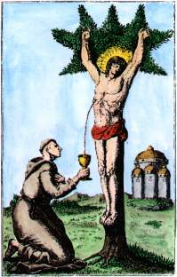  A147. Engraving from Vincentius Koffsky, Hermetische schriften, Nurnberg, 1786. | 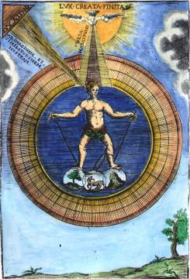  A148. Engraving from G. B. Diana Paleologo, Sacra Universal Filosofia, Lucca, 1713.
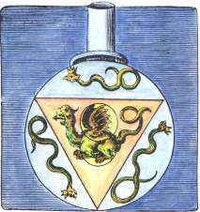  A149. Engraving from Valentine's 'Twelve Keys' in the Musaeum hermeticum, Frankfurt 1678. | 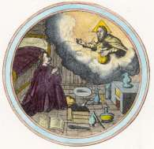A150. Emblem 2 from Barchusen, Elementa chemiae, Leiden, 1718. | 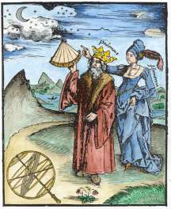A151. Reisch, Margarita Philosophica, Freiburg 1504. | 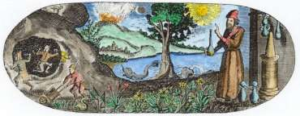A152. From titlepage of J.B. Van Helmont Opera Omnia, Franckfurt, 1682.

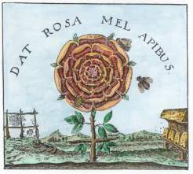  A153. Engraving from Robert Fludd, Summum bonum, Frankfurt 1629. | 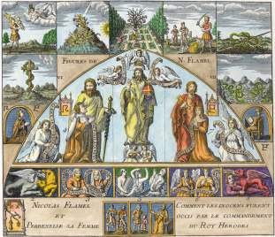  A154. Engraving from later edition of Flamel in Jean Maugin de Richenbourg, Bibliotheque des philosophes chimiques, Paris, 1741. | 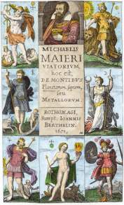  A155. Engraved title page from Michael Maier, Viatorium, hoc est, de montibus planetarum septem seu metallorum, Rouen, 1651. | 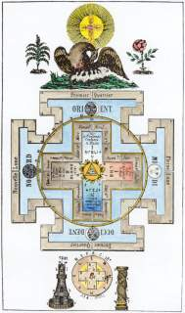  A156. Engraving, 19th Century.
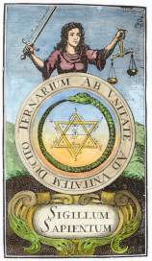  A157. Frontispiece engraving from Johann Michael Faust Philalethes Illustratus Frankfurt, 1706. | 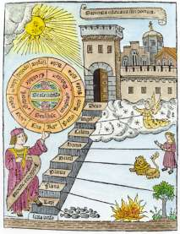  A158. Woodcut from Ramon Lull, Liber de ascensu et descensu intellectus, Valencia, 1512. | 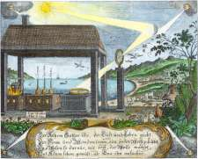  A159. Engraving from Christian Friedrich Sendimir von Siebenstern Chymischer Monden-schein, Frankfurt, 1739. | 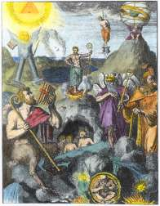  A160. Engraving from De Hooghe, Hieroglyphica oder Denkbilder der alten Völker, Amsterdam, 1744.

