**James Fergusson 1808 – 1886**

<http://en.wikipedia.org/wiki/James_Fergusson_(architect)>

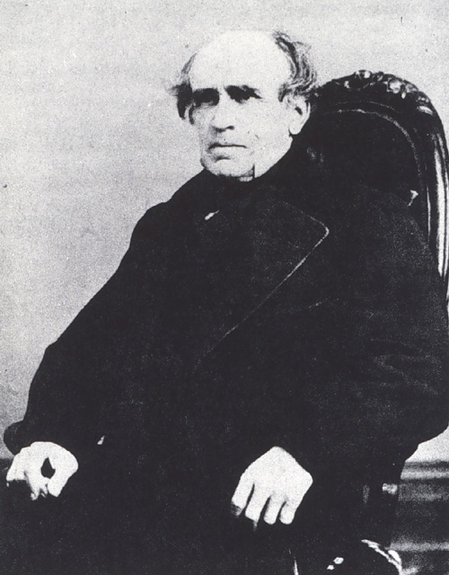 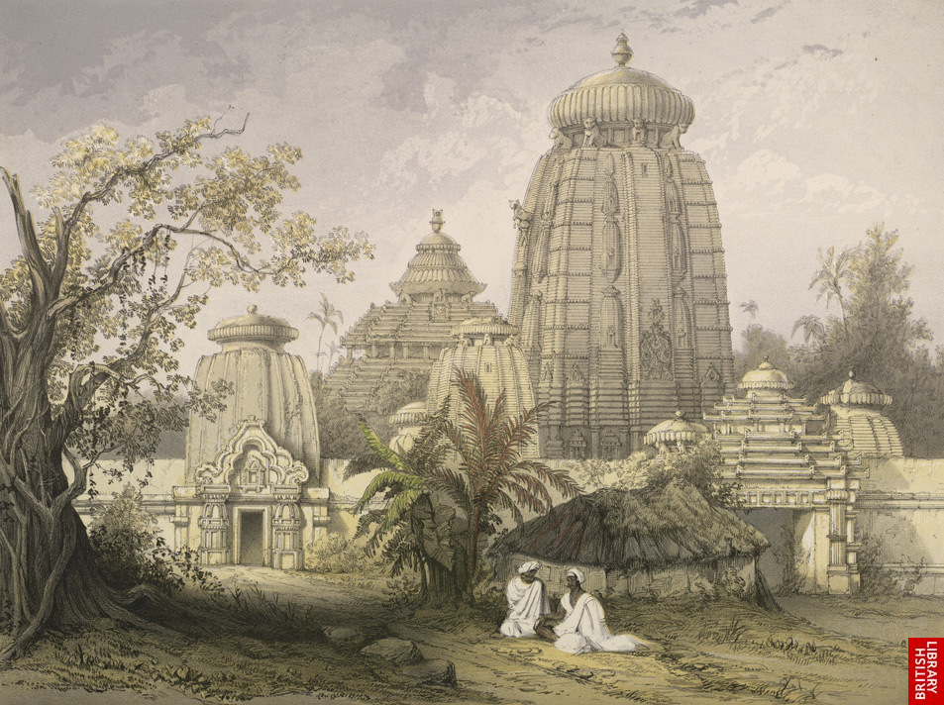

**James Fergusson** ([22 January](http://en.wikipedia.org/wiki/January_22) [1808](http://en.wikipedia.org/wiki/1808)-[9 January](http://en.wikipedia.org/wiki/January_9) [1886](http://en.wikipedia.org/wiki/1886)), a [Scottish](http://en.wikipedia.org/wiki/Scotland) writer on [architecture](http://en.wikipedia.org/wiki/Architecture), was born at [Ayr](http://en.wikipedia.org/wiki/Ayr). His father was an army surgeon.

After being educated first at the [Royal High School](http://en.wikipedia.org/wiki/Royal_High_School_%28Edinburgh%29), [Edinburgh](http://en.wikipedia.org/wiki/Edinburgh), and afterwards at a private school at Hounslow, James went to [Calcutta](http://en.wikipedia.org/wiki/Calcutta) as partner in a mercantile house. Here he was attracted by the remains of the ancient architecture of India, little known or understood at that time. The successful conduct of an indigo factory, as he states in his own account, enabled him in about ten years to retire from business and settle in [London](http://en.wikipedia.org/wiki/London). The observations made on Indian architecture were first embodied in his book on *The Rock-cut Temples of India*, published in 1845.

The task of analysing the historic and [aesthetic](http://en.wikipedia.org/wiki/Aesthetic) relations of this type of ancient buildings led him further to undertake a historical and critical comparative survey of the whole subject of architecture in *Tile Handbook of Architecture*, a work which first appeared in 1855. This did not satisfy him, and the work was reissued ten years later in a much more extended form under the title of *The History of Architecture* (edited by [George Kriehn](http://en.wikipedia.org/wiki/George_Kriehn) in 1910).

The chapters on [Indian architecture](http://en.wikipedia.org/wiki/Indian_architecture), which had been considered at rather disproportionate length in the Handbook, were removed from the general History, and the whole of this subject treated more fully in a separate volume, *The History of Indian and Eastern Architecture*, which appeared in 1876, and, although complete in itself, formed a kind of appendix to *The History of Architecture*. Previously to this, in 1862, he issued his *History of Modern Architecture*, in which the subject was continued from the [Renaissance](http://en.wikipedia.org/wiki/Renaissance) to the present day, the period of modern architecture being distinguished as that of revivals and imitations of ancient styles, which began with the Renaissance.

The essential difference between this and the spontaneously evolved architecture of preceding ages Fergusson was the first clearly to point out and characterize. His treatise on *The True Principles of Beauty in Art*, an early publication, is a most thoughtful metaphysical study. Some of his essays on special points in archaeology, such as the treatise on *The Mode in which Light was introduced into* [*Greek Temples*](http://en.wikipedia.org/wiki/Greek_Temples), included theories which have not received general acceptance. His real monument is his History of Architecture (later edition revised by [R. Phen Spiers](http://en.wikipedia.org/w/index.php?title=R._Phen_Spiers&action=edit&redlink=1)), which, for grasp of the whole subject, comprehensiveness of plan, and thoughtful critical analysis, stands quite alone in architectural literature.

He received the gold medal of the [Royal Institute of British Architects](http://en.wikipedia.org/wiki/Royal_Institute_of_British_Architects) in 1871. Among his works, besides those already mentioned, are: *A Proposed New System of Fortification* (1849), *Palaces of Ninevek and Persepolis restored* (1851), *Mausoleum at Halicarnassus restored* (1862), *Tree and Serpent Worship* (1868), *Rude Stone Monuments in all Countries* (1872), and *The Temples of the Jews and the other Buildings in the Haram Area at Jerusalem* (1878). The sessional papers of the Institute of British Architects include papers by him on *The History of tile Pointed Arch*, *Architecture of Southern India*, *Architectural Splendour of the City of Beeja pore*, on the *Erechtkeum* and on the *Temple of Diana at Ephesus*.

Although Fergusson never practiced architecture he took a keen interest in all the professional work of his time. He was adviser with [Austen Layard](http://en.wikipedia.org/wiki/Austen_Layard) in the scheme of decoration for the [Assyrian](http://en.wikipedia.org/wiki/Assyria) court at [The Crystal Palace](http://en.wikipedia.org/wiki/The_Crystal_Palace), and indeed assumed in 1856 the duties of general manager to the Palace Company, a post which he held for two years.

In 1847 Fergusson had published an Essay on the Ancient Topography of Jerusalem, in which he had contended that the [Mosque of Omar](http://en.wikipedia.org/wiki/Mosque_of_Omar) was the identical church built by [Constantine the Great](http://en.wikipedia.org/wiki/Constantine_the_Great) over the tomb of our Lord at Jerusalem, and that it, and not the present church of the [Holy Sepulchre](http://en.wikipedia.org/wiki/Holy_Sepulchre), was the genuine burial-place of Jesus. The burden of this contention was further explained by the publication in 1860 of his Notes on the Site of the Holy Sepulchre at [Jerusalem](http://en.wikipedia.org/wiki/Jerusalem); and [The Temples of the Jews](http://en.wikipedia.org/w/index.php?title=The_Temples_of_the_Jews&action=edit&redlink=1) and the other Buildings in ihe Haram Area at Jerusalem, published in 1878, was a still completer elaboration of these theories, which are said to have been the origin of the establishment of the Palestine Exploration fund.

His manifold activities continued till his death, which took place in London on the 9th of January 1886.

## References

* *This article incorporates text from the* [Encyclopædia Britannica *Eleventh Edition*](http://en.wikipedia.org/wiki/Encyclop%C3%A6dia_Britannica_Eleventh_Edition)*, a publication now in the* [*public domain*](http://en.wikipedia.org/wiki/Public_domain)*.*

## External links

* [James Fergusson, Chronological Table of Writings](http://www.ne.jp/asahi/arc/ind/fergusson/chrono_uni.htm)