http://calculquebec.ca/en/home/11-english/news/496-gregory-newby-joins-compute-canada-as-cto

**Gregory Newby joins Compute Canada as CTO**

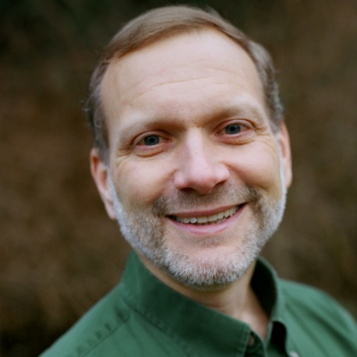

Compute Canada announced Dr. Gregory Newby would be their new new Chief Technology Officer as of January 1st. Dr. Newby joins Compute Canada from Saudi Arabia where he led the planning and acquisition for a world-class supercomputer for King Abdullah University of Science and Technology in Thuwal. Prior to his role as Manager of the KAUST Supercomputing Core Laboratory, Dr. Newby was the Director of the Arctic Region Supercomputing Center during his 11-year stay at the University of Alaska Fairbanks.  A passionate advocate for using information technology to benefit society, Dr. Newby volunteers as Director and CEO of Project Gutenberg, which offers more than 46,000 free eBooks worldwide.

“We are thrilled to have Greg join our team. His impressive background will be extremely beneficial as we plan to optimize our systems and work to ensure our national platform keeps pace with the explosion of data-intensive research,” said Mark Dietrich, President and CEO of Compute Canada.

Compute Canada is preparing for a renewal and consolidation of its systems across Canada with the welcomed announcement of the *Canada Foundation for Innovation's Cyberinfrastructure Initiative.*

“The Chief Technology Officer will play an important role in planning, coordinating, and leading the procurement and deployment of advanced computing resources across Canada, based on the needs of the research community.  This will ensure that all researchers in Canada can access modern facilities for computationally-based research, engineering, analysis and discovery, “ says Dugan O’Neil, Chief Science Officer at Compute Canada.

*Source:* [*Compute Canada*](http://www.ccomputecanada.ca)

=======================================================================================