Harvard Classics, originally known as Dr. Eliot's Five Foot Shelf 1909 - Wikipedia Aug. 27 2015
https://en.wikipedia.org/wiki/Harvard_Classics
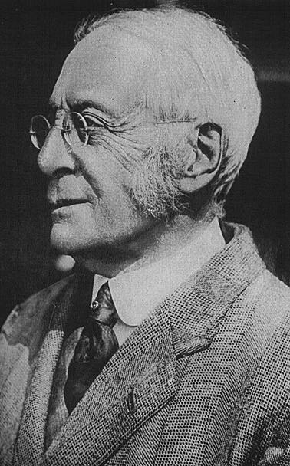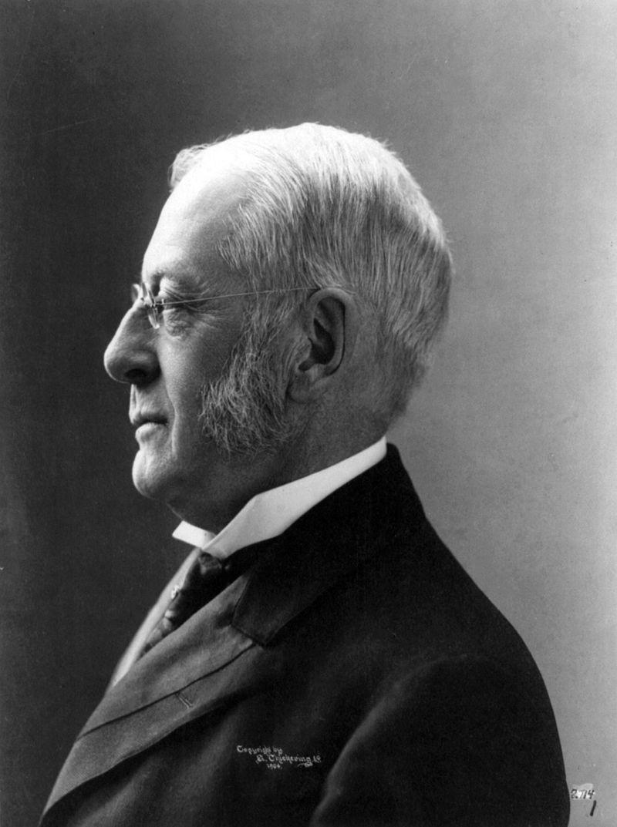
Charles William Eliot, compiler and editor of the Harvard Classics anthology. 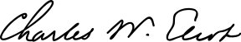
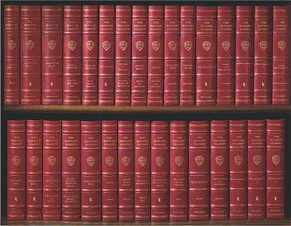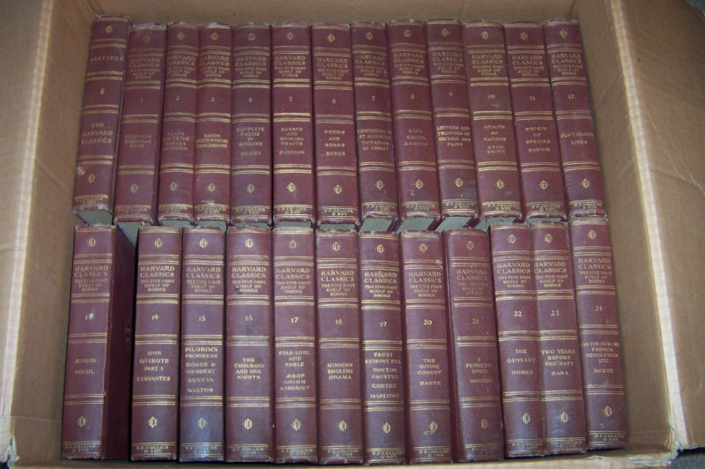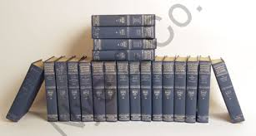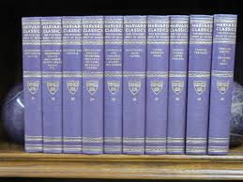
The Harvard Classics, originally known as Dr. Eliot's Five Foot Shelf, is a 51-volume anthology of classic works from world literature, compiled and edited by Harvard University president Charles W. Eliot and first published in 1909.^{[1]}
Eliot had stated in speeches that the elements of a liberal education could be obtained by spending 15 minutes a day reading from a collection of books that could fit on a five-foot shelf. (Originally he had said a three-foot shelf.) The publisher P. F. Collier and Son saw an opportunity and challenged Eliot to make good on this statement by selecting an appropriate collection of works, and the Harvard Classics was the result.
Eliot worked for one year with William A. Neilson, a professor of English; Eliot determined the works to be included and Neilson selected the specific editions and wrote introductory notes.^{[1]} Each volume had 400-450 pages, and the included texts are "so far as possible, entire works or complete segments of the world's written legacies."^{[2]} The collection was widely advertised by Collier and Son, in Collier's and elsewhere, with great success.

Contents
- 1 Contents
  - 1.1 The Harvard Classics Shelf of Fiction
- 2 Enduring success
- 3 Similar compendia
- 4 References
- 5 Further reading and external links

Contents
- Vol. 1: FRANKLIN, WOOLMAN, PENN
  - His Autobiography, by Benjamin Franklin
  - The Journal of John Woolman, by John Woolman (1774 and subsequent editions)
  - Fruits of Solitude, by William Penn
- Vol. 2. PLATO, EPICTETUS, MARCUS AURELIUS
  - The Apology, Phaedo, and Crito, by Plato
  - The Golden Sayings, by Epictetus
  - The Meditations, by Marcus Aurelius
- Vol. 3. BACON, MILTON'S PROSE, THOS. BROWNE
  - Essays, Civil and Moral, and New Atlantis, by Francis Bacon
  - Areopagitica and Tractate of Education, by John Milton
  - Religio Medici, by Sir Thomas Browne
- Vol. 4. COMPLETE POEMS IN ENGLISH, MILTON
  - Complete poems written in English, by John Milton
- Vol. 5. ESSAYS AND ENGLISH TRAITS, EMERSON
  - Essays and English Traits, by Ralph Waldo Emerson
- Vol. 6. POEMS AND SONGS, BURNS
  - Poems and songs, by Robert Burns
- Vol. 7. CONFESSIONS OF ST. AUGUSTINE, IMITATION OF CHRIST
  - The Confessions, by Saint Augustine
  - The Imitation of Christ, by Thomas á Kempis
- Vol. 8. NINE GREEK DRAMAS
  - Agamemnon, The Libation Bearers, The Furies, and Prometheus Bound, by Aeschylus
  - Oedipus the King and Antigone, by Sophocles
  - Hippolytus and The Bacchae, by Euripides
  - The Frogs, by Aristophanes
- Vol. 9. LETTERS AND TREATISES OF CICERO AND PLINY
  - On Friendship, On Old Age, and letters, by Cicero
  - Letters, by Pliny the Younger
- Vol. 10. WEALTH OF NATIONS, ADAM SMITH
  - The Wealth of Nations, by Adam Smith
- Vol. 11. ORIGIN OF SPECIES, DARWIN
  - The Origin of Species, by Charles Darwin
- Vol. 12. PLUTARCH'S LIVES
  - Lives, by Plutarch
- Vol. 13. AENEID, VIRGIL
  - Aeneid, by Virgil
- Vol. 14. DON QUIXOTE, PART 1, CERVANTES
  - Don Quixote, part 1, by Cervantes
- Vol. 15. PILGRIM'S PROGRESS, DONNE & HERBERT, BUNYAN, WALTON
  - The Pilgrim's Progress, by John Bunyan
  - The Lives of Donne and Herbert, by Izaak Walton
- Vol. 16. THE THOUSAND AND ONE NIGHTS
  - Stories from the Thousand and One Nights
- Vol. 17. FOLKLORE AND FABLE, AESOP, GRIMM, ANDERSON
  - Fables, by Aesop
  - Children's and Household Tales, by Jacob and Wilhelm Grimm
  - Tales, by Hans Christian Andersen
- Vol. 18. MODERN ENGLISH DRAMA
  - All for Love, by John Dryden
  - The School for Scandal, by Richard Brinsley Sheridan
  - She Stoops to Conquer, by Oliver Goldsmith
  - The Cenci, by Percy Bysshe Shelley
  - A Blot in the 'Scutcheon, by Robert Browning
  - Manfred, by Lord Byron
- Vol. 19. FAUST, EGMONT, ETC. DOCTOR FAUSTUS, GOETHE, MARLOWE
  - Faust, part 1, Egmont, and Hermann and Dorothea, by Johann Wolfgang von Goethe
  - Dr. Faustus, by Christopher Marlowe
- Vol. 20. THE DIVINE COMEDY, DANTE
  - The Divine Comedy, by Dante Alighieri
- Vol. 21. I PROMESSI SPOSI, MANZONI
  - I Promessi Sposi, by Alessandro Manzoni
- Vol. 22. THE ODYSSEY, HOMER
  - The Odyssey, by Homer
- Vol. 23. TWO YEARS BEFORE THE MAST, DANA
  - Two Years Before the Mast, by Richard Henry Dana, Jr.
- Vol. 24. ON THE SUBLIME, FRENCH REVOLUTION, ETC., BURKE
  - On Taste, On the Sublime and Beautiful, Reflections on the French Revolution, and A Letter to a Noble Lord, by Edmund Burke
- Vol. 25. AUTOBIOGRAPHY, ETC., ESSAYS AND ADDRESSES, J.S. MILL, T. CARLYLE
  - Autobiography and On Liberty, by John Stuart Mill
  - Characteristics, Inaugural Address at Edinburgh, and Sir Walter Scott, by Thomas Carlyle
- Vol. 26. CONTINENTAL DRAMA
  - Life is a Dream, by Pedro Calderón de la Barca
  - Polyeucte, by Pierre Corneille
  - Phèdre, by Jean Racine
  - Tartuffe, by Molière
  - Minna von Barnhelm, by Gotthold Ephraim Lessing
  - William Tell, by Friedrich von Schiller
- Vol. 27. ENGLISH ESSAYS: SIDNEY TO MACAULAY
- Vol. 28. ESSAYS: ENGLISH AND AMERICAN
- Vol. 29. VOYAGE OF THE BEAGLE, DARWIN
  - The Voyage of the Beagle, by Charles Darwin
- Vol. 30. FARADAY, HELMHOLTZ, KELVIN, NEWCOMB, ETC
  - The Forces of Matter and The Chemical History of a Candle, by Michael Faraday
  - On the Conservation of Force and Ice and Glaciers, by Hermann von Helmholtz
  - The Wave Theory of Light and The Tides, by Lord Kelvin
  - The Extent of the Universe, by Simon Newcomb
  - Geographical Evolution, by Sir Archibald Geikie
- Vol. 31. AUTOBIOGRAPHY, BENVENUTO CELLINI
  - The Autobiography of Benvenuto Cellini
- Vol. 32. LITERARY AND PHILOSOPHICAL ESSAYS
  - Essays, by Michel Eyquem de Montaigne
  - Montaigne and What is a Classic?, by Charles Augustin Sainte-Beuve
  - The Poetry of the Celtic Races, by Ernest Renan
  - The Education of the Human Race, by Gotthold Ephraim Lessing
  - Letters upon the Aesthetic Education of Man, by Friedrich von Schiller
  - Fundamental Principles of the Metaphysic of Morals, by Immanuel Kant
  - Byron and Goethe, by Giuseppe Mazzini
- Vol. 33. VOYAGES AND TRAVELS
  - An account of Egypt from The Histories, by Herodotus
  - Germany, by Tacitus
  - Sir Francis Drake Revived, by Philip Nichols
  - Sir Francis Drake's Famous Voyage Round the World, by Francis Pretty
  - Drake's Great Armada, by Captain Walter Bigges
  - Sir Humphrey Gilbert's Voyage to Newfoundland, by Edward Haies
  - The Discovery of Guiana, by Sir Walter Raleigh
- Vol. 34. FRENCH AND ENGLISH PHILOSOPHERS, DESCARTES, VOLTAIRE, ROUSSEAU, HOBBES
  - Discourse on Method, by René Descartes
  - Letters on the English, by Voltaire
  - On the Inequality among Mankind and Profession of Faith of a Savoyard Vicar, by Jean Jacques Rousseau
  - Of Man, Being the First Part of Leviathan, by Thomas Hobbes
- Vol. 35. CHRONICLE AND ROMANCE, FROISSART, MALORY, HOLINSHEAD
  - Chronicles, by Jean Froissart
  - The Holy Grail, by Sir Thomas Malory
  - A Description of Elizabethan England, by William Harrison
- Vol. 36. MACHIAVELLI, MORE, LUTHER
  - The Prince, by Niccolò Machiavelli
  - The Life of Sir Thomas More, by William Roper
  - Utopia, by Sir Thomas More
  - The Ninety-Five Theses, To the Christian Nobility of the German Nation, and On the Freedom of a Christian, by Martin Luther
- Vol. 37. LOCKE, BERKELEY, HUME
  - Some Thoughts Concerning Education, by John Locke
  - Three Dialogues Between Hylas and Philonous in Opposition to Sceptics and Atheists, by George Berkeley
  - An Enquiry Concerning Human Understanding, by David Hume
- Vol. 38. HARVEY, JENNER, LISTER, PASTEUR
  - The Oath of Hippocrates
  - Journeys in Diverse Places, by Ambroise Paré
  - On the Motion of the Heart and Blood in Animals, by William Harvey
  - The Three Original Publications on Vaccination Against Smallpox, by Edward Jenner
  - The Contagiousness of Puerperal Fever, by Oliver Wendell Holmes
  - On the Antiseptic Principle of the Practice of Surgery, by Joseph Lister
  - Scientific papers, by Louis Pasteur
  - Scientific papers, by Charles Lyell
- Vol. 39. PREFACES AND PROLOGUES
- Vol. 40. ENGLISH POETRY 1: CHAUCER TO GRAY
- Vol. 41. ENGLISH POETRY 2: COLLINS TO FITZGERALD
- Vol. 42. ENGLISH POETRY 3: TENNYSON TO WHITMAN
- Vol. 43. AMERICAN HISTORICAL DOCUMENTS
- Vol. 44. SACRED WRITINGS 1
  - Confucian: The sayings of Confucius
  - Hebrew: Job, Psalms, and Ecclesiastes
  - Christian I: Luke and Acts
- Vol. 45. SACRED WRITINGS 2
  - Christian II: Corinthians I and II and hymns
  - Buddhist: Writings
  - Hindu: The Bhagavad-Gita
  - Mohammedan: Chapters from the Koran
- Vol. 46. ELIZABETHAN DRAMA 1
  - Edward the Second, by Christopher Marlowe
  - Hamlet, King Lear, Macbeth, and The Tempest, by William Shakespeare
- Vol. 47. ELIZABETHAN DRAMA 2
  - The Shoemaker's Holiday, by Thomas Dekker
  - The Alchemist, by Ben Jonson
  - Philaster, by Beaumont and Fletcher
  - The Duchess of Malfi, by John Webster
  - A New Way to Pay Old Debts, by Philip Massinger
- Vol. 48. THOUGHTS AND MINOR WORKS, PASCAL
  - Thoughts, letters, and minor works, by Blaise Pascal
- Vol. 49. EPIC AND SAGA
  - Beowulf
  - The Song of Roland
  - The Destruction of Dá Derga's Hostel
  - The Story of the Volsungs and Niblungs
- Vol. 50. INTRODUCTION, READER'S GUIDE, INDEXES
- Vol. 51. LECTURES
  - The last volume contains sixty lectures introducing and summarizing the covered fields: history, poetry, natural science, philosophy, biography, prose fiction, criticism and the essay, education, political science, drama, travelogues, and religion.

The Harvard Classics Shelf of Fiction
The Harvard Classics Shelf of Fiction was selected by Charles W. Eliot, LLD (1834-1926), with notes and introductions by William Allan Neilson. It also features an index to Criticisms and Interpretations.
- Vol. 1. HENRY FIELDING 1
  - The History of Tom Jones, part 1, by Henry Fielding
- Vol. 2. HENRY FIELDING 2
  - The History of Tom Jones, part 2, by Henry Fielding
- Vol. 3. LAURENCE STERN, JANE AUSTEN
  - A Sentimental Journey, by Laurence Sterne
  - Pride and Prejudice, by Jane Austen
- Vol. 4. SIR WALTER SCOTT
  - Guy Mannering, by Sir Walter Scott
- Vol. 5. WILLIAM MAKEPEACE THACKERAY 1
  - Vanity Fair, part 1, by William Makepeace Thackeray
- Vol. 6. WILLIAM MAKEPEACE THACKERAY 2
  - Vanity Fair, part 2, by William Makepeace Thackeray
- Vol. 7. CHARLES DICKENS 1
  - David Copperfield, part 1, by Charles Dickens
- Vol. 8. CHARLES DICKENS 2
  - David Copperfield, part 2, by Charles Dickens
- Vol. 9. GEORGE ELIOT
  - The Mill on the Floss, by George Eliot
- Vol. 10. HAWTHORNE, IRVING, POE, BRET HARTE, MARK TWAIN, HALE
  - The Scarlet Letter and "Rappaccini's Daughter", by Nathaniel Hawthorne
  - "Rip Van Winkle" and "The Legend of Sleepy Hollow", by Washington Irving
  - "Eleonora", "The Fall of the House of Usher", and "The Purloined Letter", by Edgar Allan Poe
  - "The Luck of Roaring Camp", "The Outcasts of Poker Flat", and "The Idyl of Red Gulch", by Francis Bret Harte
  - "Jim Smiley and His Jumping Frog", by Samuel L. Clemens
  - "The Man Without a Country", by Edward Everett Hale
- Vol. 11. HENRY JAMES, JR.
  - The Portrait of a Lady, by Henry James
- Vol. 12. VICTOR HUGO
  - Notre Dame de Paris, by Victor Marie Hugo
- Vol. 13. BALZAC, SAND, DE MUSSET, DAUDET, DE MAUPASSANT
  - Old Goriot, by Honoré de Balzac
  - The Devil's Pool, by George Sand
  - The Story of a White Blackbird, by Alfred de Musset
  - "The Siege of Berlin", "The Last Class—The Story of a Little Alsatian", "The Child Spy", "The Game of Billiards", and "The Bad Zouave", by Alphonse Daudet
  - "Walter Schnaffs’ Adventure" and "Two Friends", by Guy de Maupassant
- Vol. 14. JOHANN WOLFGANG VON GOETHE
  - Wilhelm Meister's Apprenticeship, by Johann Wolfgang von Goethe
- Vol. 15. GOETHE, KELLER, STORM, FONTANE
  - The Sorrows of Young Werther, by Johann Wolfgang von Goethe
  - The Banner of the Upright Seven, by Gottfried Keller
  - The Rider on the White Horse, by Theodor Storm
  - Trials and Tribulations, by Theodor Fontane
- Vol. 16. LEO NIKOLAEVITCH TOLSTOY 1
  - Anna Karenina, part 1, by Leo Tolstoy
- Vol. 17. LEO NIKOLAEVITCH TOLSTOY 2
  - Anna Karenina, part 2, and Ivan the Fool, by Leo Tolstoy
- Vol. 18. FYODOR DOSTOEVSKY
  - Crime and Punishment, by Fyodor Dostoevsky
- Vol. 19. IVAN TURGENEV
  - A House of Gentlefolk and Fathers and Children, by Ivan Turgenev
- Vol. 20. VALERA, BJØRNSON, KIELLAND
  - Pepita Jimenez, by Juan Valera
  - A Happy Boy, by Bjørnstjerne Bjørnson
  - Skipper Worse, by Alexander L. Kielland

Enduring success
As Adam Kirsch, writing for Harvard magazine in 2001, notes, "It is surprisingly easy, even today, to find a complete set of the Harvard Classics in good condition. At least one is usually for sale on eBay, the Internet auction site, for $300 or so, a bargain at $6 a book. The supply, from attics or private libraries around the country, seems endless — a tribute to the success of the publisher, P.F. Collier, who sold some 350,000 sets within 20 years of the series' initial publication".^{[1]}
The hardcover set of the Harvard Classics (now in the public domain) was still being offered by Easton Press until 2010, but now only paperback versions are available through Kessinger Publishing.
The Five-Foot Shelf, with its introductions, notes, guides to reading, and exhaustive indexes, may claim to constitute a reading course unparalleled in comprehensiveness and authority.
—Notes on the Lectures by William Allan Neilson

Similar compendia
The concept of education through systematic reading of seminal works themselves (rather than textbooks), was carried on by John Erskine at Columbia University, and, in the 1930s, Mortimer Adler and Robert Hutchins at the University of Chicago, carried this idea further with the concepts of education through study of the "great books" and "great ideas" of Western civilization. This led to the publication in 1952 of Great Books of the Western World, which is still in print and actively marketed. In 1937, under Stringfellow Barr, St. John's College introduced a curriculum based on the direct study of "great books". These sets are popular today with those interested in homeschooling.

References

• Adam Kirsch, The "Five-foot Shelf" Reconsidered, Harvard Magazine, Volume 103, Number 2. November–December 2001
- • Dr. Eliot's Five-Foot Shelf of Books: Toward a Centennial of The Harvard Classics, Papers on Language and Literature - Find Articles

Further reading and external links
- Harvard Classics (all volumes) at the Internet Archive (Archive.org)
- Harvard Classics (Bookshelf) Online version at Project Gutenberg
- Complete Harvard Classics at MobileRead free downloads in Sony BBeB/LRF, Mobipocket/PRC, and eBookwise/IMP formats
- Metafilter: Dr. Eliot's Five Foot Shelf
- David Mehegan, "The reading of life: A story about a grandfather, a box of old books, and the meaning of success," Boston Globe, December 23, 2006. Viewed Sept. 26, 2007
- From the History Files: A Love of Libraries - Harvard Classics
- An Ongoing Review and Discussion of the Harvard Classics
- Eliot, Charles W., ed. The Harvard Classics and Harvard Classics Shelf of Fiction. 1909–1917 Online version at Bartleby.
- "The Complete Harvard Classics By Volume - Free PDF Downloads". MyHarvardClassics.com.
- "The Harvard Classics". Feedbooks.
- "The Harvard Classics Shelf of Fiction". Feedbooks.
- "The complete MobileRead edition of the Harvard Classics".
- Greater Books - a site documenting lists of "great books," classics, and canons, including Harvard Classics
============================================================================================================

